**ANALYZING THE ANNOTATION CHOICES IN VISUALIZATIONS**

**INTRODUCTION**

Annotations are essential in the field of data visualization since they play a vital role in communicating information and improving comprehension. This project undertakes a thorough analysis of the decisions made in selecting annotations for a certain visualization, carefully examining each component of its design structure. Through careful examination of the implementation and appropriateness of annotation features, our goal is to reveal valuable information about successful annotation tactics and possible areas for enhancement. Utilizing the structure of influencing factors described in the chapter, we explore the intricacies with regard to project and graph annotation, providing suggestions for maximizing their effectiveness. With this forensic examination, we aim to enhance our comprehension of annotation principles of design and stimulate inventive methods for visual communication.

**DATA CONSIDERED**

In this project we are going to consider the diamonds data which is taken from the ggplot2 package. The data summary is as shown below.

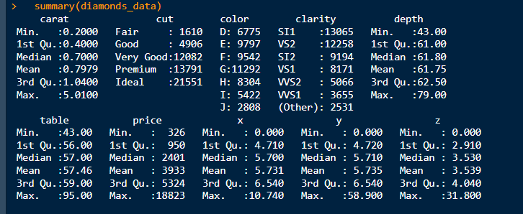

The Diamonds dataset, obtained using the ggplot tool, provides a detailed overview of multiple characteristics of diamonds. The data includes information on carat weight, cut quality, color grade, clarity grade, depth, table width, pricing, and measurements (x, y, z). The carat weight varies between 0.20 and 5.01 carats, with an average of approximately 0.80 carats. The depth ranges from 43.00% to 79.00%, with an average of around 61.75%, while the table width ranges from 43.00% to 95.00%, with an average of approximately 57.46%. The price range varies from $326 to $18,823, with an average of approximately $3,933. The dimensions (x, y, z) show significant variation, ranging from a minimum of 0 mm to a maximum of 10.74 mm for x, 58.90 mm for y, and 31.80 mm for z. This dataset is a helpful resource for examining the attributes and pricing patterns of diamonds. It provides insights into the aspects that influence the value and desirability of diamonds.

**PLOT CONSIDERED FOR THIS ASSIGNMENT**

The scatterplot considered in this assignment was created from the weight of the diamond variable on the x-axis, the price in US dollars variable on the y-axis and the size variable used was the diamonds width. This plot will be used to answer the questions that follows.

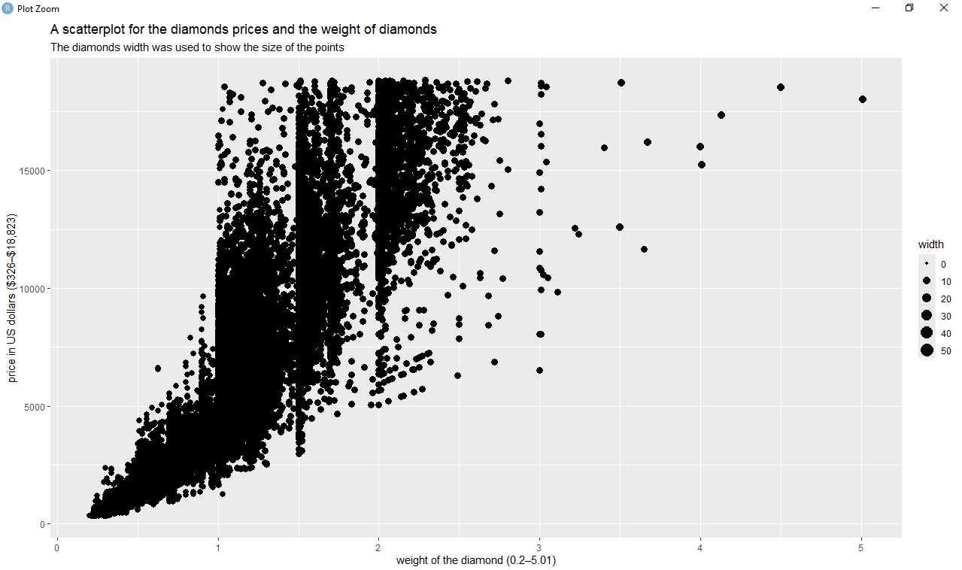

1. Annotation features deployed in the above plot.

Annotation features have been implemented in the plot to provide an explanation.   
  
a. Axis Labels: The x-axis has been designated as "weight of the diamond (0.2–5.01)" to represent the range of carat weights, while the y-axis, on the other hand, is annotated as "price in US dollars ($326–$18,823)" to illustrate the range of diamond prices. The annotations offer crucial background for reading the plot and comprehending the elements being shown.   
  
b. Heading and Subheading: The text includes a headline, "A scatterplot for the prices and weight of diamonds," and a subtitle, "The width of the diamonds was used to represent the size of the points." These annotations provide a concise overview and supplementary details on the plot, respectively, aiding the spectator in quickly understanding the plot's intention and significant characteristics.   
  
c. Data Points: The data points on the graph correspond to individual diamonds and each point represents a distinctive combination of carat weight and price. These points function as annotations, visually representing the data and allowing the observer to see patterns and correlations between the variables.   
  
d. Width Legend: The width of the diamonds determines the size of the points on the plot. A legend is included to illustrate the spectrum of diamond widths corresponding to various point sizes. The use of this annotation feature enriches the plot by introducing an extra layer of information, enabling viewers to visually assess and compare the dimensions of diamonds based on their width.   
  
The integration of axis labels, title, subtitle, data points, and width legend collectively and effectively annotates the plot, furnishing viewers with essential context, insights, and interpretive aids to comprehend the correlation between diamond weight, price, and width.

1. How suitable are the choices and deployment of these annotation features? If they are not, what do you think they should have been?

The selection and implementation of annotating features within the plot tend to be appropriate, offering crucial context and facilitating comprehension. Below is an evaluation of each annotating feature and its appropriateness:   
  
a. Axis Labels: Axis labels accurately communicate the variables depicted on both axes, offering distinct information regarding the weight in carats and price variations of the diamonds. This option is appropriate since it aids viewers in comprehending the magnitude and measurements of the depicted data.   
  
b. Title and Subtitles: The title concisely highlights the substance of the plot, while the subtitle offers further details on the utilization of diamond width to represent point size. The annotations improve the plot by offering a precise explanation of its aim and technique. They are appropriate for facilitating viewer comprehension.   
  
c. Data Points: Data points function as visual depictions of individual diamonds, enabling observers to perceive patterns and connections between the weight of the diamond and price. This option is appropriate since it corresponds to the plot's goal of illustrating the range of diamond prices according to their weights.   
  
d. Width Caption: The dimension of the width legend offers a frame of reference for understanding the significance of the point sizes, illustrating the spectrum of diamond widths that are depicted by varying point sizes. The annotation feature is appropriate since it assists readers in comprehending the significance of differences in point size within the plot.   
  
In general, the selection and implementation of annotation characteristics in the plot effectively communicate information regarding the value of diamonds and weights. However, in order to augment the efficacy of the plot, it may be advisable to contemplate the inclusion of supplementary annotations. For instance, one can enhance data visualizations by adding annotations to highlight anomalies or patterns in certain data points, or by including labels to identify particular diamonds. In addition, enhancing viewer comprehension could be achieved by including more comprehensive details on the dataset's origin, methodology, or any pertinent insights.

1. Go through the set of ‘Influencing factors’ from the latter section of the book’s chapter to help shape your assessment and to possibly inform how you might tackle this design layer differently.

Based on the given influencing elements, this is how they could impact the evaluation and possible modifications for the design layer of annotation in the scatterplot mentioned above:   
  
Developing Your Brief:   
  
When selecting a color palette, it is crucial to ensure that it is appropriate for the target media, such as screen display or print, in terms of potential output formats. Ensuring that the colors in the scatterplot are compatible with CMYK is essential for maintaining consistency and print quality, especially if it is meant for print.   
Given the continued prevalence of black and white printing, it is crucial to guarantee the legibility of the scatterplot even when color is absent. This may entail utilizing changes in luminosity or texture to differentiate between data points.   
Data Analysis:   
  
An accurate comprehension of the data's attributes, including its kind (nominal or quantitative) and distribution, will have an impact on choices for color application. When representing categorical data, it is crucial to ensure that the color palette has distinguishable tones in order to enhance legibility.   
Analyzing the extent and arrangement of numerical values might provide insights for determining the color scale and categorization intervals employed in the display. This guarantees that the color encoding accurately portrays the range and patterns of the data.   
Developing Your Editorial Mindset:   
  
The editorial focus is crucial in choosing the specific components of the data that should be highlighted in the graphic. Strategically utilizing color to highlight significant insights or threshold values can improve the effectiveness of the plot in conveying crucial information.   
By highlighting specific characteristics or patterns using color, the plot can direct viewers' focus towards important sections and enhance editorial significance. One approach could be to utilize contrasting colors or different levels of intensity to emphasize particular data points or patterns.   
In order to guarantee that the annotation selections in the scatterplot correspond with the intended use, medium, and features of the data, it is important to consider the impacting variables mentioned above. Adjustments may entail fine-tuning the color palette to ensure compatibility with print, optimizing color selections based on the type and distribution of data, and strategically employing color to highlight important insights.

1. Also, considering the range of potential annotation features, what would you do differently or additionally?

In order to improve the annotations in the scatterplot, the following strategies will be employed:   
  
1. Assigning Colors to Data Points Based on Color Variable: I will allocate distinct colors to the data points according to the levels of the color variable in the diamonds dataset. This would enable clear distinction between diamonds of different hues, facilitating viewers in effortlessly identifying and comparing color groups within the plot. By utilizing color as an annotation attribute, observers can promptly identify patterns and trends associated with diamond color and its influence on pricing.   
  
2. Faceting the Plots by Cut Variable: I will divide the scatterplot into several smaller plots, each representing a different level of the cut variable in the dataset. The subplot will depict distinct cut qualities such as Fair, Good, Very Good, Premium, and Ideal. This will enable viewers to examine the fluctuations in diamond pricing across various cut categories. Facetting allows for a more thorough examination of the correlation between carat weight and price within each cut category. This improves the level of detail in the analysis and offers further insights.   
  
  
By implementing these tactics, the scatterplot will be supplemented with supplementary annotation functionalities, offering viewers improved insights and interactivity to investigate the correlations between diamond characteristics and pricing.

The plot is displayed below.

