A COMPREHENSIVE EVALUATION OF VISUALIZATION ANNOTATIONS

INTRODUCTION

Visualization is an effective technique for conveying intricate data, and annotations play a crucial role in assisting comprehension. This project involves conducting a thorough analysis of the annotation choices made in a specific visualization. We will carefully examine each layer of the visual structure with great attention to detail. Through the process of isolating the individual elements of a project and analyzing the annotations on a chart, we assess their appropriateness and efficiency in enhancing understanding. Using the model of influencing factors described in the chapter, we analyze the reasoning underlying these layout decisions and suggest alternate methods for enhancing their effectiveness. In this analytical investigation, our goal is to uncover the complexities of annotation design and provide light on approaches to create more engaging and informative visualizations.

DATA USED IN THIS ASSIGNMENT

We are going to consider the midwest data taken from the ggplot2 package in R. this data has the following structure.

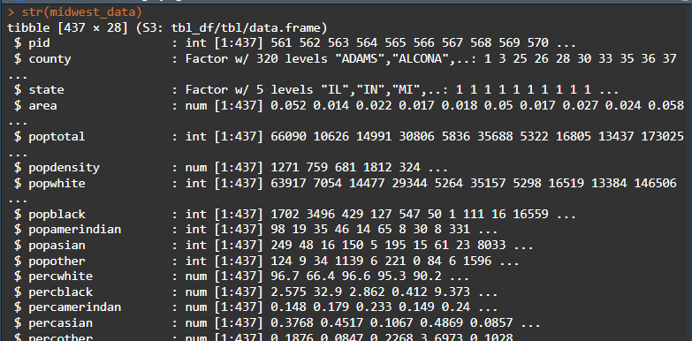

The dataset, named `midwest_data`, is a tibble that consists of 437 observations and 28 variables. These variables represent a wide range of demographic and socioeconomic characteristics of counties in the Midwest region of the United States. The key variables in the dataset are as follows: `pid` (county identifier), `county` (county title), `state` (state name), `poptotal` (total population), `popdensity` (the nation's density), `popwhite` (white population), `popblack` (black population), `popasian` (Asian populace), `percwhite` (percentage of white population), `percblack` (the proportion of black population), `popadults` (adult population), `perchsd` (the proportion of adults with high school diploma), `percollege` (percentage of grownups with college degree), `percbelowpoverty` (the proportion of population below poverty line), `inmetro` (indicator for whether county is in urban area), and `category` (categorical grouping).   
  
This dataset provides a complete perspective on the demographic and socioeconomic attributes of counties in the Midwest. It offers significant insights for doing various studies and research projects. We are going to use this data for this assignment by creating an initial plot which is will then be used to answer the question that follows.

Using the county variable on the x-axis and total population variable on the y-axis the plot created is then displayed below.

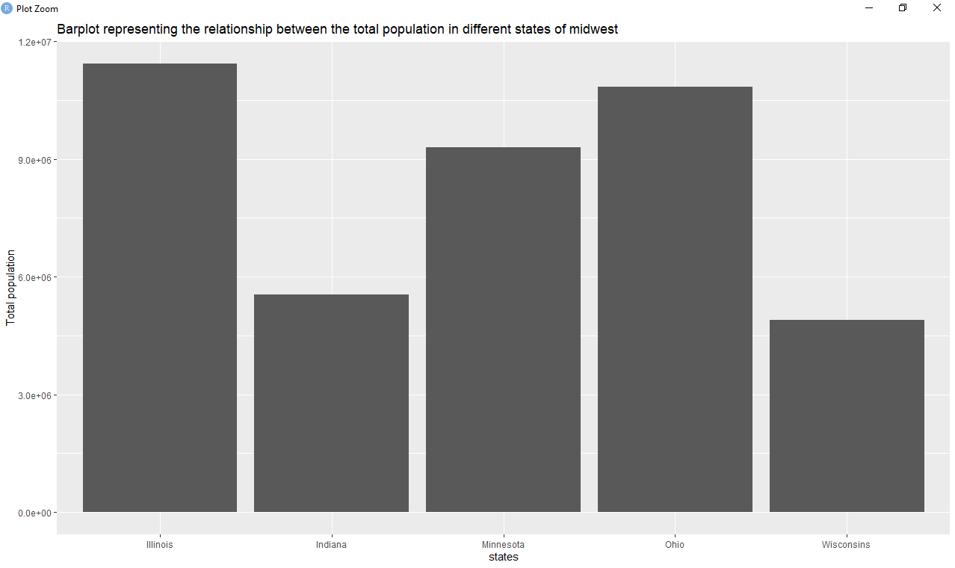

1. Annotation features deployed in the above plot.

Annotation features used in the barplot are described below:  
  
a. Title Annotation: The barplot features a concise title that accurately reflects the graph's content, enabling readers to comprehend its essence. The title functions as a concise explanation and offers context for evaluating the data depicted in the graphic.  
  
b. Axis Labels and Legends: The barplot incorporates axis labels for both the x-axis (representing the states) and y-axis (representing the overall population), clearly showing the variables being depicted on each axis. In addition, the presence of a caption on the graph would indicate the representation of categorical variables or groups, so enhancing the interpretation and offering further context.  
  
c. Varied Bar Sizes: The barplot utilizes varying sizes of bars to accurately depict the total population of several states in the Midwest's region. The magnitude of each bar is proportional to the population's size of the corresponding state, enabling viewers for comparing population levels among different states. The annotation tool efficiently communicates the extent of demographic disparities among states and enables data comparison and analysis.  
  
In summary, the annotation elements utilized in the barplot efficiently communicate information about the factors being plotted, offer context for comprehension, and aid viewers in comprehending and analyzing the data.

1. How suitable are the choices and deployment of these annotation features? If they are not, what do you think they should have been?

The selection and implementation of annotation elements in the bar graphs are generally appropriate for efficiently communicating data regarding the overall population of countries in the United States Midwest region. Below is an evaluation of the annotations features and their appropriateness:   
  
a. Heading Annotation: The title succinctly encapsulates the essence of the graph, offering visitors a lucid comprehension of its contents. This option is appropriate because it enables viewers to promptly comprehend the primary subject or theme of the storyline.   
  
b. Axis Labels and Legends: The axis labels unambiguously describe the variables that are displayed on each axis, with the x-axis indicating states and the y-axis representing the total population. This option is appropriate since it offers crucial background information for understanding the data depicted in the graph. Nevertheless, if the graph includes categorical variables or groupings, it might be advantageous to incorporate a legend to visually represent them. In the absence of a legend, viewers may encounter difficulty in comprehending the significance of distinct bar colors or classifications.   
  
c. Varied Bar Sizes: The utilization of diverse bar sizes effectively depicts the population of distinct states, enabling viewers to visually compare population levels among states. This option is appropriate since it effectively represents the extent of demographic disparities among states and enables the comparison and study of data.   
  
In general, the selection and implementation of annotation elements in the barplot effectively communicate information regarding the overall population of states in the Midwest region. Adding a legend to the graph to show categorical variables or groupings would increase clarity and enhance viewers' comprehension. Furthermore, maintaining uniformity in the labeling and layout across the plot would enhance its legibility and comprehensibility.

1. Go through the set of ‘Influencing factors’ from the latter section of the book’s chapter to help shape your assessment and to possibly inform how you might tackle this design layer differently.

Given the stated influencing elements, this is how they impact the evaluation of the barplot's design layer and provide information for prospective modifications:   
  
Reliable Design:   
  
Clarity: The barplot should provide a clear representation of the overall population of states in the Midwest. It should also indicate the source of the data, such as government census data, and any criteria or modifications used during data collection and processing. By providing this information, it guarantees the reliability and transparency of the content, thereby cultivating confidence with the audience.   
Constraints: It is crucial to specify any constraints of the data or the representation itself, such as the absence of data or biases in the sampling process. This aids viewers in comprehending the background and any limitations of the analysis, hence guaranteeing precision in interpretation.   
Inclusive Design:   
  
Revised: The level of annotation should be carefully calibrated to offer enough support for comprehension without inundating viewers with an excessive amount of information. When quick understanding is important, it is necessary to favor brief explanations. However, for intrinsically intricate topic matters, more elaborate explanations may be required to facilitate understanding. Modulating the degree of annotation in accordance with the intricacy of the subject matter guarantees accessibility and usability for a wide range of readers.   
Sophisticated Design:   
  
To reduce clutter, annotations should be carefully integrated to offer structural or textual support without overwhelming the visualization or blocking the view of the data. It is important to carefully analyze the spatial and visual effects of adding annotation devices, making sure that they improve the visualization rather than take away from it. Utilizing dynamic features, such as the capability to display or conceal layers of information, can assist in organizing visual elements and presenting explanatory notes in a sophisticated and inconspicuous way.   
To summarize, taking into account the aspects that influence it helps guarantee that the design layer of the barplot enhances trustworthiness, accessibility, and elegance. The barplot may effectively communicate information while ensuring viewer confidence and interest by offering transparency, altering annotation levels for clarity, and minimizing visual distractions.

1. Also, considering the range of potential annotation features, what would you do differently or additionally?

In order to improve the annotation capabilities of the barplot, we can integrate further elements by utilizing the interactive features provided by the Plotly package. Here's how we can enhance the visualization:   
  
Interactive functionalities provided by the Plotly package:   
  
Employ Plotly's interactive functionalities to augment viewer engagement and facilitate discovery. As an illustration, incorporate hover-over tooltips to present supplementary details regarding each bar, such as the name of the state and its related population. This interactive feature enables users to dynamically explore the data and acquire insights by moving over individual bars.   
Implement click events to allow users to choose particular states or regions of interest, resulting in the barplot being automatically updated to display only the specified subset. This interactive feature improves user engagement and enables focused investigation of particular geographical locations in the Midwestern region.   
Integrate zooming and panning functionalities to enable users to examine the barplot more closely, which is especially beneficial for viewing extensive datasets or when analyzing certain areas of the plot with greater precision.   
Applying State Variable Levels to Color Bars:   
  
Allocate unique colors for the bars according to the amount of the states parameter. By employing a color-coded scheme to represent each state, observers can readily discern variations among states and visually recognize patterns or trends throughout the Midwest region. The utilization of categorized by color depiction enhances the aesthetic appeal of the bar graphs and facilitates the comprehension of data.   
Segmenting based on Midwest subregions:   
  
Partition the barplot into distinct subplots according to the subregions within the Midwest region, namely East North Central and West North Central. Facetting enables the examination of population distributions in several subregions, allowing for the identification of regional demographic disparities.   
Each facet corresponds to a distinct subregion, where bars are organized and colored based on the states inside that subregion. The use of a facetted technique allows viewers to easily compare the populations within and between subregions, which in turn facilitates a more in-depth investigation of demographic trends and discrepancies.   
By integrating these supplementary annotation features through the interactive functionalities of the Plotly software, the bar plot becomes more captivating, enlightening, and aesthetically pleasing. Viewers have the ability to interactively examine the data, acquire valuable knowledge, and perform significant comparisons, so improving their comprehension of population changes in the United States Midwest region.

The new plot is displayed below with the above features implemented.

