Name: Arshan Shaikh

Roll No.: - 70

WAD Assignment: 3 (GitHub version control)

Commands used:

git config --global user.name “H3llblazer”

git config --global user.email “csgo31040@gmail.com”

git init

git add .

git commit -m "Assignment 3"

git remote add origin <https://github.com/H3llb1azer/WAD-Assignment-3.git>

git push origin master

OUTPUT:

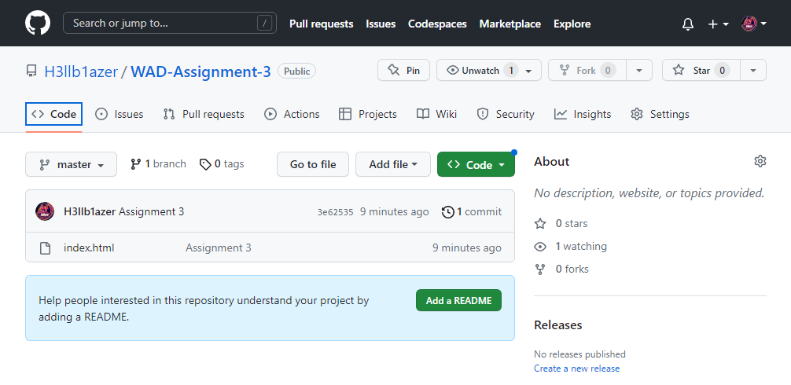

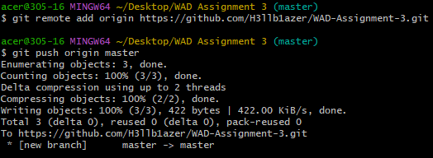

2ND Commit

