Delivery Organizer v1.1
User Manual



INDEX

1. Glossary 3
2. Application uses 3
3. Application privileges 3
4. Main screen 4
5. Deployments management 5
5.1. Deployments search screen “Deployment view” 5
5.2. Deployment details screen 7
5.3. Screen to Add/modify a deployment 7
5.4. Operators Planning Dashboard 9
5.5. Operators Acceptance Dashboard 11
6. Exports 13
6.1. Export Deployment View et Operators Planning Dashboard 13
6.2. Export Operators Acceptance Dashboard 13
7. Site surveys management 14
7.1. Life cycle of a site survey 14
7.2. Search/To Complete site Survey information 15
7.3. Sending site Survey to the operator 17
8. Contacts management 18
9. Reporting 19
9.1. RSM Reports 19
9.2. Date History 20
9.3. Graphical Reports 20
9.4. Statistic Reports 20
9.5. Orders Graphical Reports 21
10. Configuration 21
10.1. Link RSM – Network Engineer 21
10.2. Business Mail Templates Management 22

- Glossary

Site survey :

A group of information linked by default to a service telecom order and fill by RSM. Site survey contains technicals information and contacts information. Informations of this site survey will be sent to the operator. A site survey filled and sent to operator will be imported into a device.

TOM:

Application used to send service telecom orders to the operators. A new order TOM, at the sending, creates a site survey in SPO v3, a deployment in Delivery Organizer and generates a RSM notification.

SPO : Application to follow-up telecom devices deployed by Saint-Gobain
TAM: Telecom Asset Management
RFS: Ready for Services
CRD: Customer Request Date
CCD: Customer Contractual Date
TOM: Telecom Order Management
SGT Operation: Saint-Gobain Telecom Operation Service follows the operational deployments
SGT RSM: Saint-Gobain Telecom regional person in charge.
SGT Solution: Saint-Gobain Telecom study and project service.
QS: Quickstart

- Application uses

Delivery Organizer is a web application to manage telecom planning deployments for Saint-Gobain companies.

Web address, to access to Delivery Organizer is the following: http://service.sgt.saint-gobain.com/Delevery_Organizer/.

 You must use web browser Internet explorer 6.0.

- Application privileges

The following board lists privileges for each user group:

User | Delivery Organizer function(s) | Rights
SGT Operation Engineer / RSM | Deployment view  Access to modify a deployment in deployment view | Read/Write
SGT Operations Manager | Deployment view  Operators planning dashboard  Operators acceptance dashboard  SPO – Site Survey  Contact | Read/Write
Other user groups | Deployment view | Read
- Main screen

If your login and password are right, Delivery Organizer Main screen is displayed (Cf. figure2). This screen has scrolling menus. There are following menus:

- ‘View/Edit’: This menu gives you an access to management screen (deployment view, SPO - site surveys…) with read or write rights according to the privileges of your profile.

This menu gives you an access to the following elements:

- Deployment view : Readonly screen to consult deployments
- Operators planning dashboard: Deployment planning management screen
- Operators acceptance dashboard : Deployment date validation screen
- SPO - Site surveys: Site surveys management
- LTC Bulk Modification : Bulk update LTC information screen
- Contacts : contacts directory management

- ‘Configuration’ : This menu allows to configure functionality parameters on Delivery Organizer.

Menu items permit us to access these screens:

- Link RSM – Network Engineer : Manage link between RSM (and posibly network) and network engineer in order to previously fill deployment form.
- Business Mail Template Management: To update contact for mail templates.

- ‘Reporting’ : This menu give access to reporting screens from Delivery Organizer.

Menu items permit us to access these screens:

- RSM Reports : Reporting screen to display table and graphic to RSM.
- Date History: Screen to supervise date evolution.
- Graphical Reports : Screen to generate graphics.
- Statistics Reports : Screen to generate statistics
- Orders Graphical Reports : Screen to generate graphics on orders by carrier, action and sector.

- ‘SGT Applications’ : Commun menu to access all SGT applications.

- ‘Help’ : To access to the Delivery Organizer user help.

- Log Out : Menu used to disconnect Delivery Organizer.

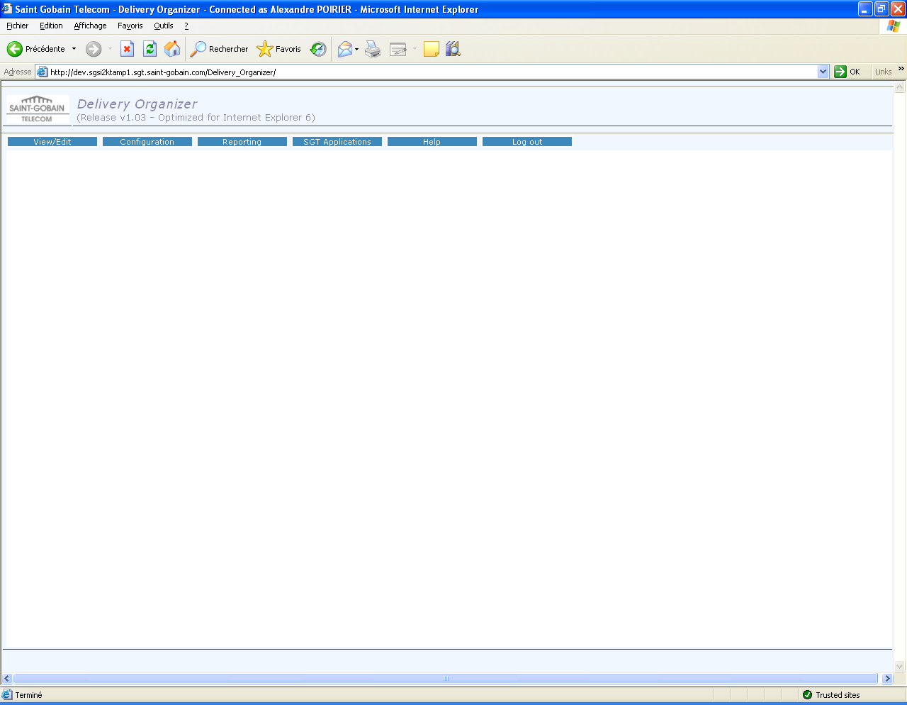

Figure 2. Main screen

- Deployments management

  - Deployments search screen “Deployment view”

The management of the telecom deployments is usable by selection of menu ‘view/edit’ and next you click on “Deployment view” element. A new window is opened and you consult or update a telecom deployment.

Search screen (Cf. figure3) give you possibility to filter devices by the following elements :

- Network Engineer
- RSM
- Order Id
- SGT Site Name
- Migration Date
- Status
- Action
- Carrier
- Network
- Sector
- Business Group Level
- Business Level

Table of results displays deployments groups by 50 devices, buttons ‘<<’ and ‘>>’ give an access respectively to display 50 previous deployments and the 50 next deployments. ‘SEARCH’ button is used to launch the deployments seeking. ‘Total Results’ caption indicates number of deployments requested.
After a research, it is possible to export deployments requested with the “Export” button.

Table of results have following information:

  - Order Id ou Site Code : unique identifier of the device.
  - SGT site name: Site name (Reference Saint-Gobain Télécom). A hypertext link is used to see the information reference site details.
  - Main Service Code
  - Backup Service Code
  - Order Details
  - Site Survey Status
  - Quickstart Option : Yes or No
  - Last update : Last update date of the deployment
  - Last user : Last user who has modified the deployment
  - CRD (Customer Request Date) Date :
  - Revised CCD (Customer Contractual Date) Date :
  - RFS (Ready For Service) Date :
  - QS (Quickstart) RFS Date :
  - Migration Date + Time
  - Status : : Deployment status (“On-going”, “RFS”, “Migrated”, ”SGT Accepted”, “Fully Accepted”, “Cancelled”)
  - Delivery Comments : Remarks about the delivery
  - Internal Comments

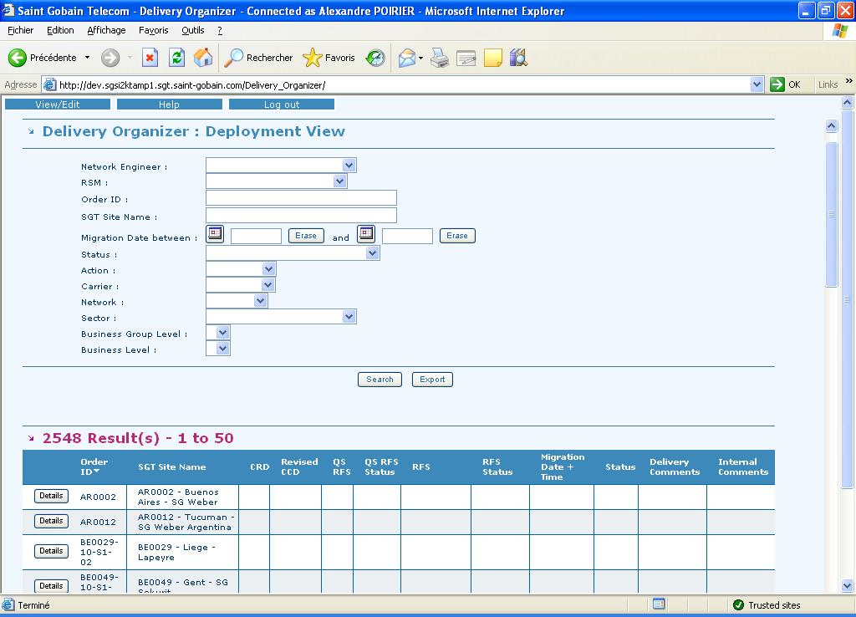
Figure 3. Deployment view screen

For each deployment, it is possible to display information details by a click on ‘DETAILS’ button to access to the figure 4.

  - Deployment details screen

This screen gives a global view on deployment information, with on the header, identifier SGT Site Name and order identification. The data are structured by information typology.

2 buttons are available on the head of the page. Below, a quick description of the purpose of each buttons:

  - Close : To close window
  - Modify : To access to the add/modification deployment form (screen figure 5).

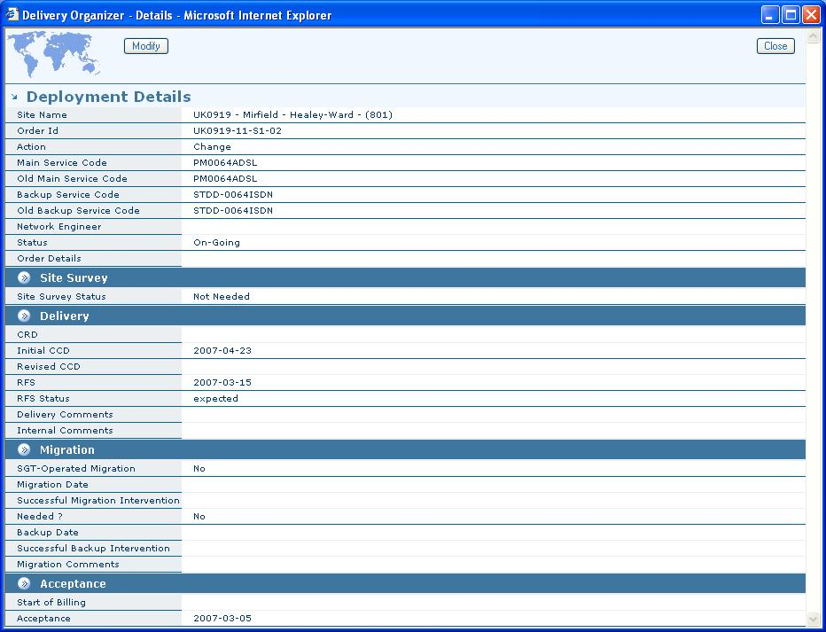

Figure 4. Details deployment screen

  - Screen to Add/modify a deployment

    - General description

The creation of deployment should be use carefully, only for some exceptions, indeed deployments are automatically created by the TOM application. You can access to this screen by click to the ‘Modify’ button of the deployment details screen or by click on ‘Add deployment’ button on the deployment search screens when you want to add a new deployment. According this two use case, form functions are the same. During a creation, it is important to insert a correct order identifier it will be automatically erase and the creation will not be possible.
Data can be filled out automatically; in this case it will be printed in a different font colour.


In every instance, manual fill out is always necessary. The information calculated automatically is triggered by the following events:

Calculated fields name | Event =>  change of value …
SGT Site Name | Order Id
Action | Order Id
Main Service Code | Order Id
Backup Service Code | Order Id
Old Main Service Code | Order Id
Old Backup Service Code | Order Id
Quickstart Option | Order Id
Site Survey Status | Order Id
CRD | Order Id
Carrier | Order Id
Network | Order Id

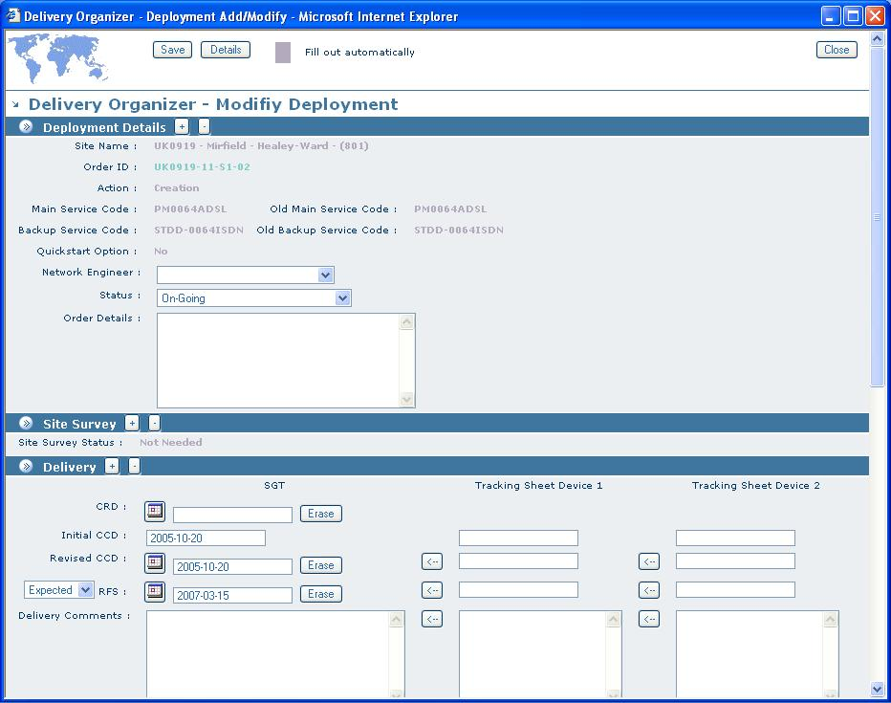

Figure 4. Add/Modify screen

    - Use case : Fill out device information

Form is splitted in sections. The fill out process is the following:

1 – In the section « Deployment Details », the ‘Order Id’ must be filled out in a first place.

2 – Import Tracking sheets information by a click on ‘<-’ button
3 – Fill out missing information as well as information with scanning the form the top to the bottom.

4 – To Save information complete, click on the ‘save’ button.

Remark : Status from this screen are limited. Unless RFS Date is not filled with a valid date and RFS Status is not on « Effective », « SGT Accepted » Status is not available. « Fully Accepted » Status is only available with the same conditions, and migration date should be filled.

The rule is the same for “Effective” RFS Status which needs a RFS date anterior or equals to day date.

Theses remarks are also valid on planification and validation screens. (screens are treated in the two following chapters).

  - Operators Planning Dashboard

The management of the telecom deployments is usable by selection of menu ‘view/edit’ and next you click on “Operators Planning Dashboard” element. A new window is opened and you consult or update a telecom deployment.

Search screen (Cf. figure6) gives you possibility to filter devices by the following elements :

- RSM
- Order Id
- SGT Site Name
- Status
- Action
- Carrier
- Network
- Sector
- Business Group Level
- Business Level
- Alert (CRD < CCD, RFS Expected > CCD, Void RFS two weeks after deployment creation, Void RFS two weeks before CCD)

Before making a research, it is possible to display or not information like SGT Site Name, Site Survey Status and Quickstart information by checking “yes” in the search screen.

Table of results displays deployments groups by 50 devices, buttons ‘<<’ and ‘>>’ give an access respectively to display 50 previous deployments and the 50 next deployments. ‘SEARCH’ button is used to launch the deployments seeking. ‘Total Results’ caption indicates number of deployments requested.
After a research, it is possible to export deployments requested with the “Export” button.

Table of results have following information:

  - Order Id ou Site Code : unique identifier of the device.
  - SGT site name: Site name (Reference Saint-Gobain Télécom). A hypertext link is used to see the information reference site details.
  - Main Service Code
  - Backup Service Code
  - Order Details
  - Site Survey Status
  - Quickstart Option : Yes or No
  - Last update : Last update date of the deployment
  - Last user : Last user who has modified the deployment

Editable fields
  - CRD (Customer Request Date) Date :
  - Revised CCD (Customer Contractual Date) Date :
  - RFS (Ready For Service) Date :
  - QS (Quickstart) RFS Date :
  - Migration Date + Time :
  - Status : Deployment status (“On-going”, “RFS”, “Migrated”, ”SGT Accepted”, “Fully Accepted”, “Cancelled”)
  - Delivery Comments : Remarks about the delivery
  - Internal Comments :

Unlike « Deployment view », fields described before can be edited in this screen. After all modifications are done, it is necessary to check boxes in the save column (under the modify button) from the deployments which need to be updated, and validate by click on ‘save’ button (on the right of the ‘add deployment’ button). In order to recognize which deployments have been saved, it appears with a yellow background colour. This is only available during the user session time (around two hours), for the next connexion, this marker will be reset.

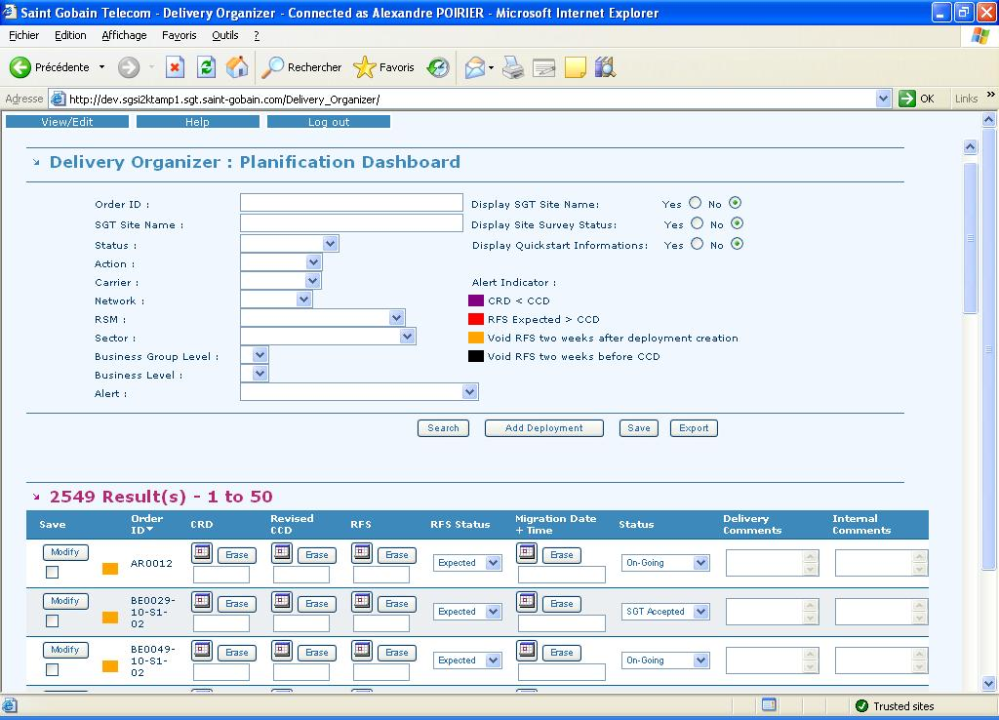
Figure 6. Operator planning dashboard

For each deployment, it is possible to access modification screen by a click on ‘Modify’ button to access to the figure 4.

This result screen could be ordered by following columns:

- Order ID
- CRD
- Revised CCD
- RFS
- Migration Date

You have to click on title column to order results. On the first click, deployments are sorted by increasing order on the selected criteria (indicated by an up arrow on the selected heading). On the second click on the same column will display results sorted by decreasing order (indicated by down arrow on the selected heading). On each column change, sort will be an increasing one.

  - Operators Acceptance Dashboard

The management of the telecom deployments is usable by selection of menu ‘view/edit’ and next you click on “Operators Acceptance Dashboard” element. A new window is opened and you consult or update a telecom deployment.

This section allows SGT Operation to validate delivery diaries with operators, that’s why status is initially set to ‘SGT Accepted‘. Dates could be validated without using deployment modification screen; moreover it is possible to change deployment status from this screen.

Search screen (Cf. figure7) gives you possibility to filter devices by the following elements:

- RSM
- Order Id
- SGT Site Name
- Status
- Action
- Carrier
- Network
- Sector
- Business Group Level
- Business Level
- Alert (CRD < CCD, RFS Expected > CCD, Void RFS two weeks after deployment creation, Void RFS two weeks before CCD)

Before making a research, it is possible to display or not information like SGT Site Name, Site Survey Status and Quickstart information by checking “yes” in the search screen.

Table of results displays deployments groups by 50 devices, buttons ‘<<’ and ‘>>’ give an access respectively to display 50 previous deployments and the 50 next deployments. ‘SEARCH’ button is used to launch the deployments seeking. ‘Total Results’ caption indicates number of deployments requested.

After a research, it is possible to export deployments requested with the “Export” button.

Table of results have following information:

  - Order Id ou Site Code : unique identifier of the device.
  - SGT site name: Site name (Reference Saint-Gobain Telecom). A hypertext link is used to see the information reference site details.
  - Main Service Code
  - Backup Service Code
  - Order Details
  - Site Survey Status
  - Quickstart Option : Yes or No
  - Last update : Last update date of the deployment
  - Last user : Last user who has modified the deployment

Editable fields
  - CCD (Customer Contractual Date) Date :
  - Revised CCD (Customer Contractual Date) Date :
  - RFS (Ready For Service) Date :
  - QS (Quickstart) RFS Date :
  - Migration Date + Time :
  - Start of Billing :
  - Acceptance : Remarks about the delivery
  - Statut : Deployment status (“On-going”, “RFS”, “Migrated”, ”SGT Accepted”, “Fully Accepted”, “Cancelled”)
Like « Operators Acceptance Dashboard » (figure 6), modifications should be saved according to check boxes and click ‘save’ button. After been saved, deployments will be displayed with a yellow background colour.

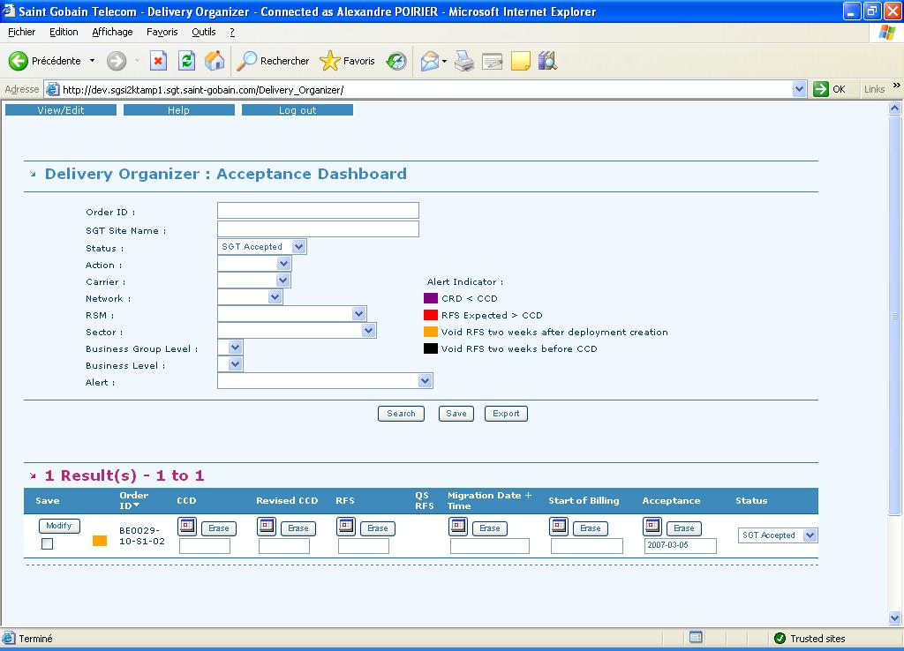
Figure 7. Operator acceptance dashboard

For each deployment, it is possible to access modification screen by a click on ‘Modify’ button to access to the figure 4.
- Exports

Each view described in previous chapters permit application user to export data from a result research into an Excel worksheet.

  - Export Deployment View et Operators Planning Dashboard

An Excel export from this two screens display the following data:

- Order Id
- SGT Site Name
- Action
- Main Service Code
- Backup Service Code
- Quickstart Option
- Order Details
- Order Date
- CRD
- Revised CCD
- QS RFS
- QS RFS Status
- RFS
- RFS Status
- Status
- Delivery Comments
- Delivery Criticity
- LTC evaluated
- LTC comments
- RSM
- Network

For each deployment resulting a research. While user does not make a research, he can not export data (the button only appears after a result research).

  - Export Operators Acceptance Dashboard

An Excel export from this screen display the following information:

- Order Id
- SGT Site Name
- Action
- Main Service Code
- Backup Service Code
- Quickstart Option
- Order Details
- Order Date
- CRD
- Initial CCD
- Revised CCD
- QS RFS
- RFS
- Migration Date & Time
- Acceptance
- Start of billing

- Site surveys management

  - Life cycle of a site survey

Site survey is created at the sending of a new order TOM or can be created manually in SPO v3. Indeed, a manually site Survey creation can be necessary in case of a VPN tunnel. Figure 8. describes life cycle of a site survey.

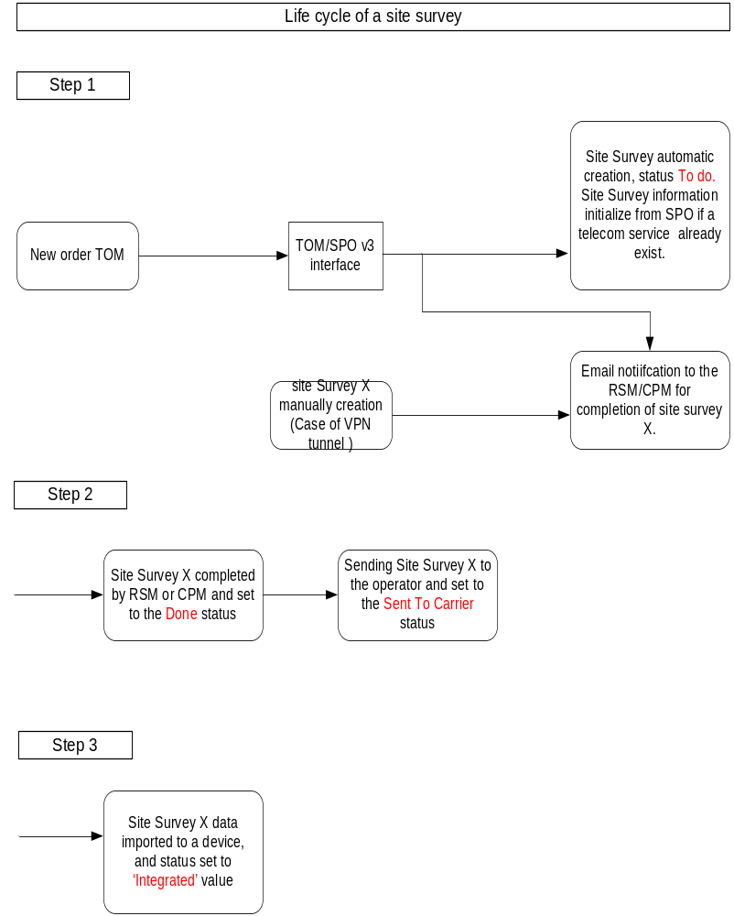

Figure 8. Life cycle of a site survey

  - Search/To Complete site Survey information

    - Site survey created with TOM (Data fill out by RSM )

When a new order is created in TOM, a new site survey is generated. RSM should fill necessary information for the installation of the telecom device in this survey site.

RSM has access to the site survey thanks to a hypertext link placed on notification mail or he access by connection to the SPO application. He can consult all site surveys in his perimeter. In SPO, site surveys access is available by click on menu view/edit and click on ‘Site surveys’ element. The site surveys management screen is displayed on figure 9. Site Surveys that must be fill out are in the ‘To do’ status and site surveys filled are in ‘Done’ status (or sent to the carrier so status ‘Sent to Carrier’).

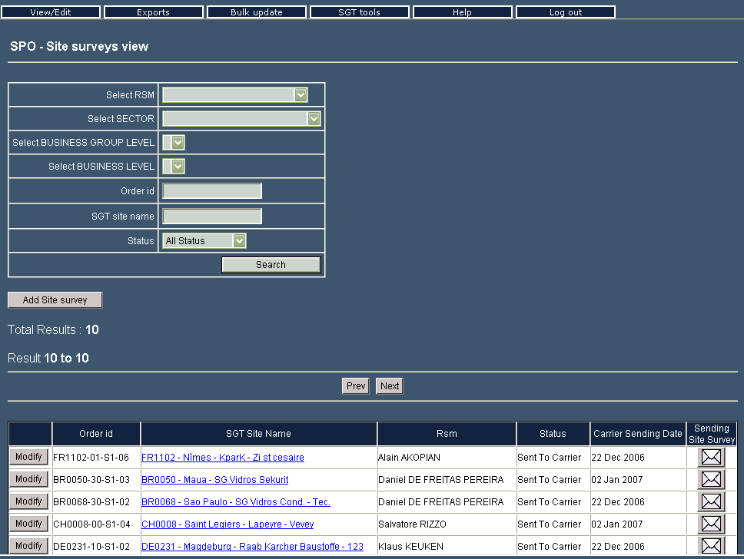

Figure 9. Site Survey management

Filters possible on this screen (figure 9.) are RSM filter, Sector/zone/company, by order id, SGT site name and a filter on the site Survey status. A site survey can be created manually with the ‘Add site survey’ button and for each survey in the result table, a ‘modify’ button gives you an access to update data.

Results table displays site survey group by ten elements, ‘Prev’ button and ‘Next’ button is used to see others site survey records.

Results table displays information order id, SGT site name, RSM, status, sending date to the operator and a ‘sending site survey’ button.

After a site survey search, you can click on ‘modify’ button to modify data. You access like this to the site Survey form. This form is visible on figure 10. It is split in many sections.

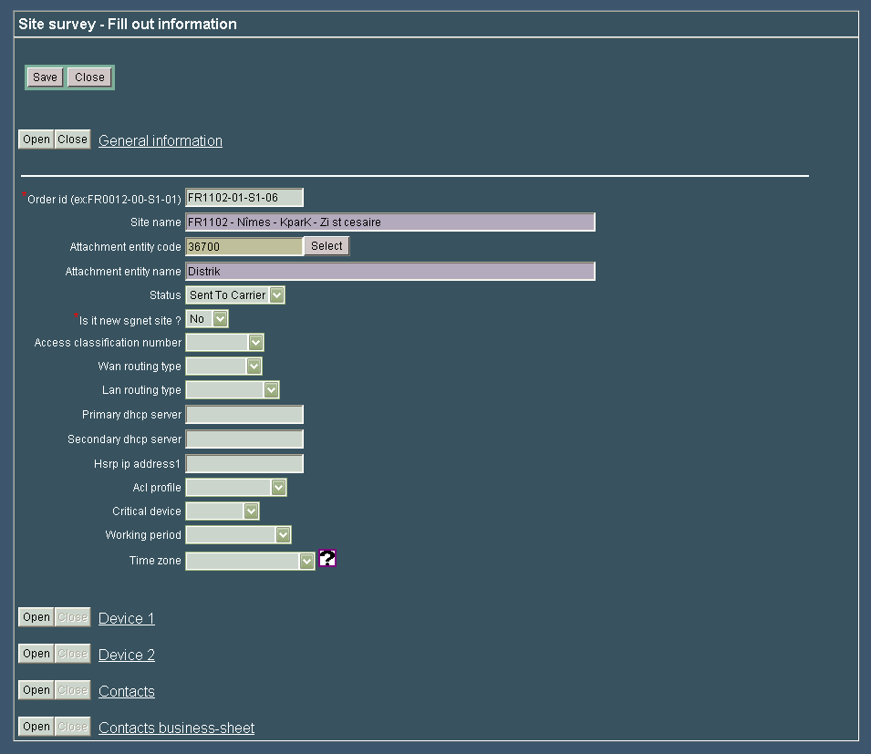
Figure 10. Formulaire site survey

In case of site Survey created at the sending of TOM order, order id and connection codes are initialized. Others informations can be fill if a telecom service already exists, RSM must to validate information.
Note that ‘contacts business sheet’ is displayed for information for users. Globally, purple form information can not be filled.

LAN routing type and WAN routing type information are filled automatically thanks to the access classification number’ value. ‘Time zone’ information has a list defined according to the geographical location. Device1 section contains first device information and device 2 contains the second device information. Contact section can be fill out quickly thanks to an ‘contact alias’. Informations with red star are mandatories information. When information is completed, RSM must set site Survey status to ‘Done’ and must save data by click on the save button.

    - Site survey created manually

Site survey can be created manually from site survey management screen represented figure 10. , thanks to ‘Add site Survey’ button. On the form displayed, informations with a red star are mandatories informations.

  - Sending site Survey to the operator

The recipient operator of a telecom service order must to receive technical information to active telecom service. It is required to send site Survey to the operator. Informations are sent in an Excel file. There is one format for each operator. This sending can be sent by RSM or SGT operation.

In SPO v3, the site Survey sending is unitary, thanks to the screen figure 10. Each line site Survey of the results table has button with an envelope in the column ‘sending site Survey’. A click on this button executes an extract of site survey information into an Excel file, then email is completed automatically. You have to drag and drop the Excel file to the email to attach it. So, Email can be sent. After click on the button with envelope, site survey is set to the status ‘Sent to carrier’, then, a sending date is completed in site survey.

 It is possible when you try to send a site Survey, a window warns you the following message: « Export currently run by XXX Please wait. ». Export function site survey is used by another user. This use isn’t exceeding 10 seconds. Passed this delay, you can try again a sending of site survey.

- Contacts management

SGT operations, RSMs have privileges to manage contacts. Contacts are managed in the same database than TAM contacts.

    - Contacts management

You can access to the management screen by click on menu view/edit and the click on ‘contacts’ menu. Figure 11. gives you a overview on contacts management screen.

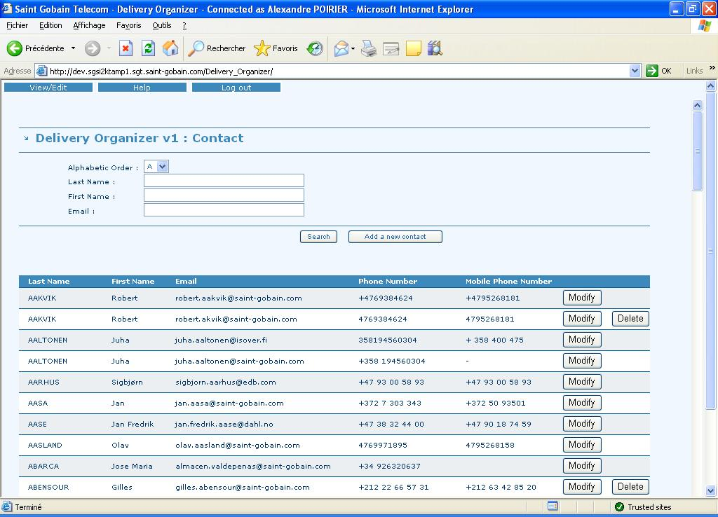
Figure 11. Contact screen

It is possible to filter by name alphabetic letter, by name, by first name or email. After a click on ‘search’ button, a table displays last name, first name, email, phone number, mobile phone number contacts resulting research.

For each contact, ‘Delete’ button is used to delete a contact. Delete is possible only if contact isn’t associated with a TAM site, and if it isn’t associated with a device, and if it isn’t associated with a business sheet, or a site survey in SPO.

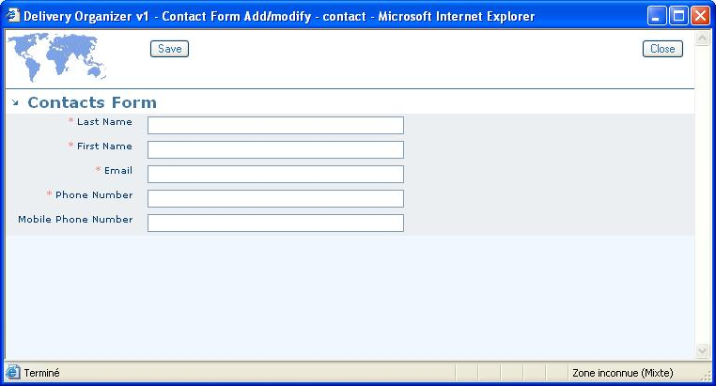

Figure 12. Contacts form

A ‘Modify’ button for each contact gives an access to the information changing. Click on ‘modify’ button open the figure 10 form, Informations with red star are mandatories. However, if a contact doesn’t have email address for example, it is possible to complete information by a dash character. Save button is used to save all data changes.

To add a contact, Click on ‘Add a new contact’ button in figure 10, blank form displays (figure 11.).

- Reporting

Delivery Organizer implements reporting module for administrators which allows to generate graphics and statistics on a definited period.

  - RSM Reports

This section permits to generate graphics for RSM people. On the one hand, some filters allow reducing elements to consider for creating graphics. So it is possible to filter on these following data:

- RSM
- Country Code
- Carrier
- Network
- Sector
- Zone
- Company

After that you should fill a starting date and an ending date to generate graphics on realised deployment.

If no date has been filled, application will be limited to the creation of a summation table of filters selected (Frame Delivery Report for), a table to show pending request number by action (Pending Deliveries) and a graphic (Pending deliveries sorted by RFS Date or revised CCD). It is a stacked histogram with deployment number on the Y axis and weeks on the X axis. (Begin from the current date to three more months). Legend identify by the way of colour, the date considerate for the creation (Revised CCD, Expected RFS, Confirmed RFS, Effective RFS) of each histogram.

In the case of date interval filled, a statistic table is generated, also a graphic about realised deployment on this period. To generate this data, only deployment on « Fully Accepted » status, whose actions are « Creation » or « Change » and with RFS date as date reference are used.
The table (Orders delivered), on the selected period, display total number of deployment, percentage on time, mean delay in day. Eventually a graphic presents the same kind of information on a complete year.

  - Date History

This section gives access on evolution date historic. For that, you need to select an order ID then a kind of date (RFS, CRD, CCD, QS RFS) on which you want to display historic. Historic is a table which contains modification date, old date value and new one.

  - Graphical Reports

This section permits to generate four kind of graphics (Number of deployments by revised CCD, Number of deployments by RFS Date, Number of deployments by Migration Date, Number of migrations realised) after having choose a starting date.

You could also filter results with following data:

- Country Code
- Carrier
- Network
- Sector
- Zone
- Company

The graphic Y axis represents deployment number and X axis represents time cut in weeks on one year.

  - Statistic Reports

It allows us to compare two dates (RFS / Migration Date, Acceptance / RFS, CCD / Revised CCD, RFS / CCD) on a defined period in order to obtain information about standard deviation, variance, average mean deviation, maximum deviation, minimum deviation and number of deployments.

You could also filter results with following data:

- Country Code
- Carrier
- Network
- Sector
- Zone
- Company

  - Orders Graphical Reports

In this section, you can generate two kinds of graphics on orders. First element creates graphic by carrier, graphic by action and graphic by sector and second element display details, on each sector, about number of orders by TOM action.

Each graphic is composed by the number of orders on Y axis and time on X axis (defined by starting and ending dates selected before). The reference date to calculate orders is the date in operator.

- Configuration

Application administrators have an access to this section. They can associate RSM (and network) to a network engineer and to manage mail templates.

  - Link RSM – Network Engineer

This screen displays existing links on application. It is so possible to modify existing ones, to add one and to delete one.

To modify existing links, you have to modify elements information on a link. (Each line is associated to a link) then save modification with « Save All Modifications » button. To delete an element, each line is associated to a « Delete » button.

To add a new element, you must select elements on the upper frame and to validate with the « Add this new link » button. When operation is done, it will be displayed in the list of existing links.

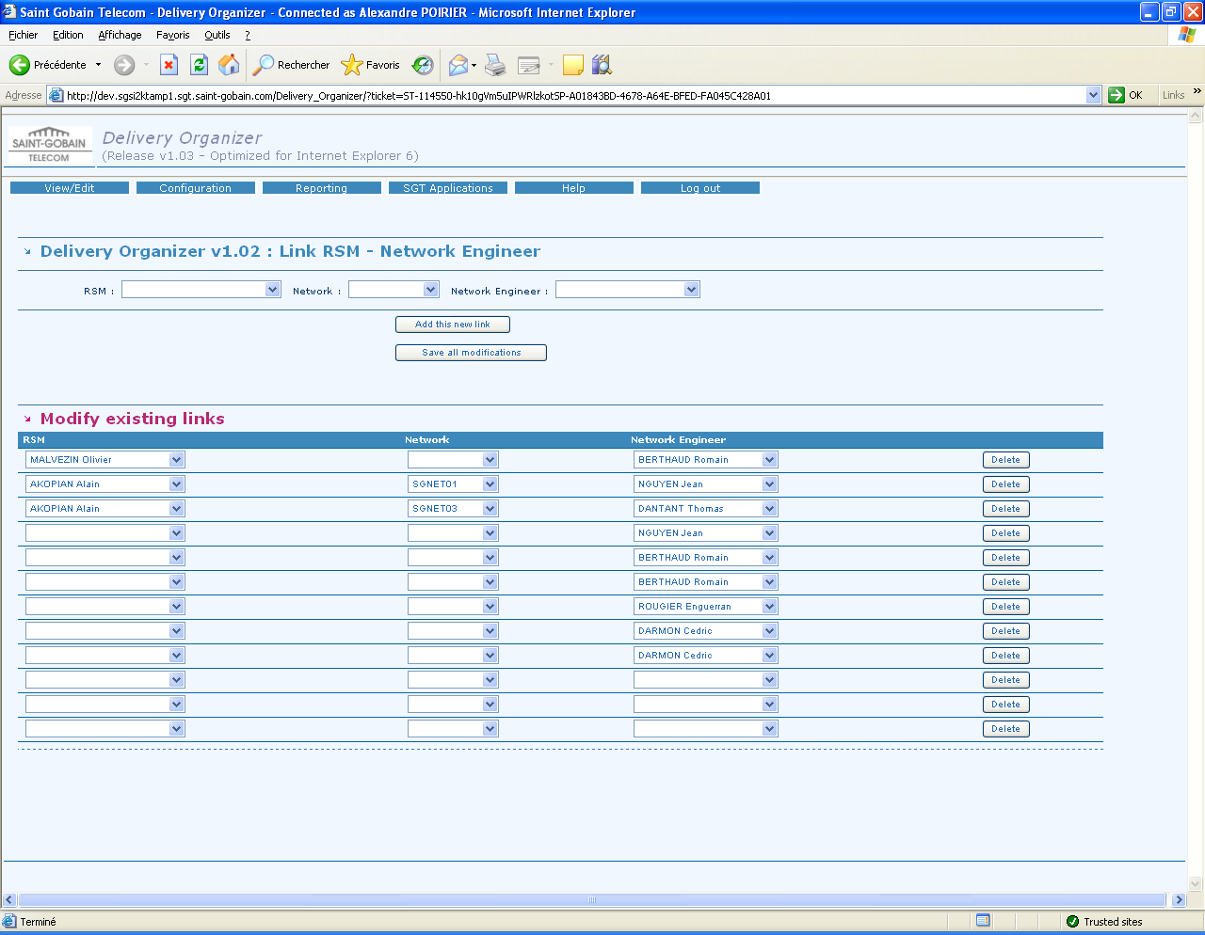
Figure 12. Screen to add, delete and modify links RSM – Network engineer

  - Business Mail Templates Management

This screen presents contacts linked to each mail template. The templates are displayed with different frames for each php file (name on orange background) in all these frames, elements are ordered by country code.

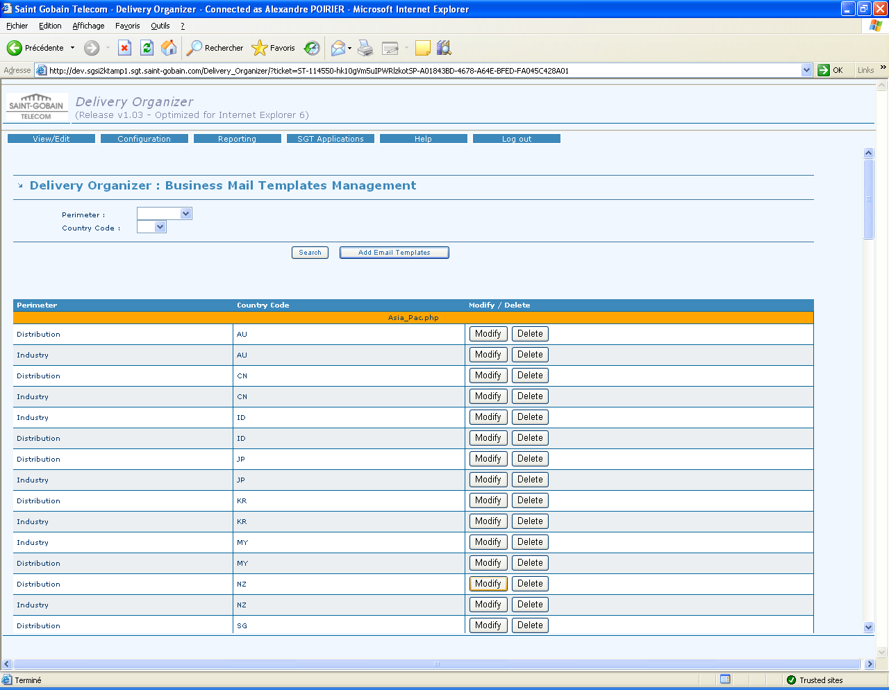
Figure 13. Screen to add, modify and delete mail templates.

For each template, a « Modify » button and a « Delete » button are associated. The « Delete » button permits to delete templates in the same line. The « Modify » button opens a popup which contains information on different contacts linked to template. (cf. Figure 14).

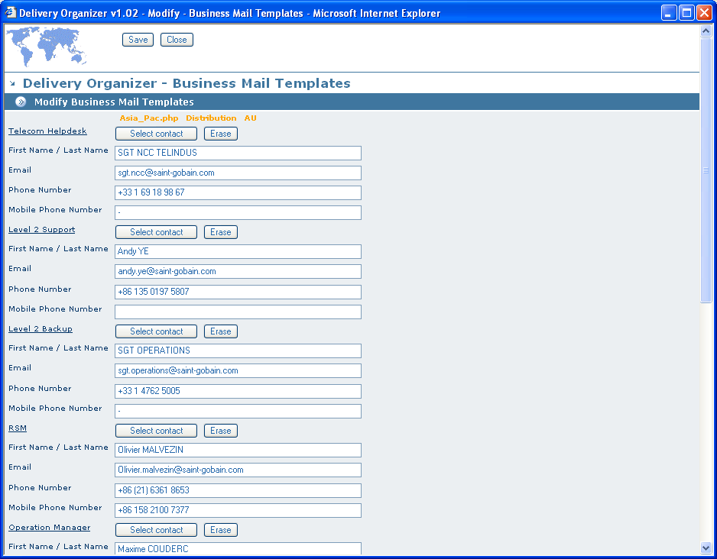
Figure 14. Popup form for template mail

In the same way, a template creation from « Add Email Templates » button allows to open this form with posibility to select a php file, a perimeter and a country code.

To add a new element, you must select elements on the upper frame and then to click on « Add this new link » button. When operation is validated, it will be displayed in the existing links menu.

