AlVault-(Medium)-Lab-HackerDNA

The objective of this challenge is to enumerate the web application, identify hidden endpoints or vulnerable functionalities and in this walkthrough, I’ll explain how I solved it step by step.

Challenge Information
URL : https://hackerdna.com/labs/alvaul
Difficulty: Medium
Category: Linux / web application

🔍 Initial Enumeration — Nmap Scan
nmap -sC -sV IP_Target
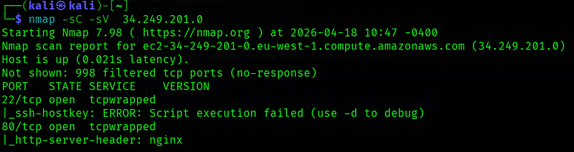
The scan shows that the host is online and reachable with low latency. Out of 1000 common ports, 998 are filtered, which indicates the presence of a firewall blocking most traffic. Only two ports are open: port 22 (SSH) and port 80 (HTTP). However, both ports are labeled as tcpwrapped, meaning the services are protected or intentionally hiding their details, likely due to security controls. Despite this, the scan reveals that the web server is running nginx.

🌐 Web Application Discovery
echo "IP_Target AlVault.hdan" | sudo /etc/hosts
After discovering port 80 was open, we accessed the web service in a browser. The page displays a simple website titled “Cybersecurity Solutions Inc.”, with a basic welcome message and minimal content. The site appears to be a default or placeholder page served by nginx, with no visible links, login forms, or dynamic features.
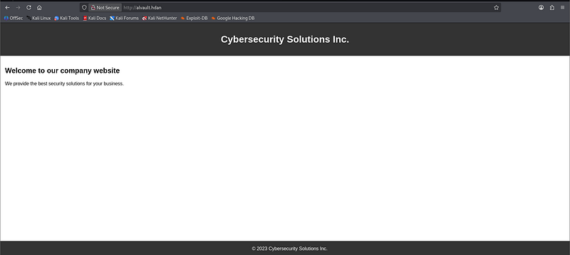
At this stage, there is no obvious functionality to exploit, which suggests that important content may be hidden. In a typical lab scenario, this means the next step is to perform directory and file enumeration (e.g., looking for hidden paths like/admin, /login, or /backup) or checking for virtual hosts. The simplicity of the page is likely intentional, indicating that deeper probing is required to uncover the actual attack surface.
by going to http://alvault.hdan/robots.txt we find interest location
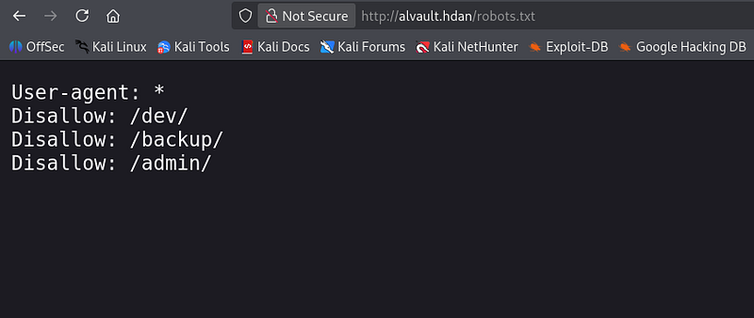
This directory name suggests a development environment, which is often less secure than production. In many labs, /dev/ can contain:
- Test pages or unfinished features
- Debug scripts
- Source code or configuration files
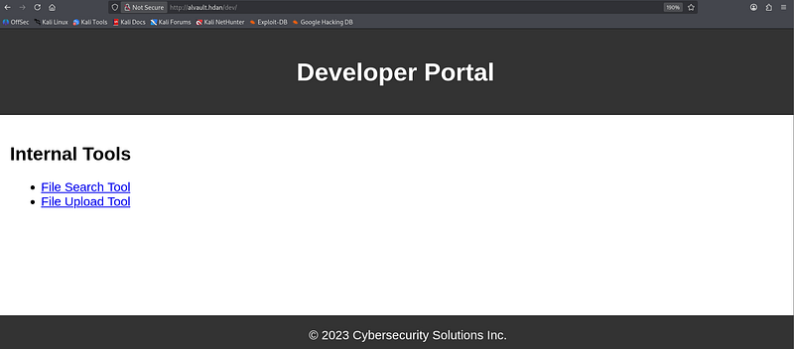
The page shown is a Developer Portal located at /dev/ and contains internal tools such as a File Search Tool and a File Upload Tool, which suggests that a development environment has been exposed publicly over HTTP. This could represent a security risk because development portals often lack strict access controls and may contain sensitive functionality like file handling features that, if improperly secured, could allow unauthorized access, file manipulation, or other vulnerabilities.
By using
gobuster dir -u http://alvault.hdan/dev/ -w /usr/share/wordlists/SecLists-master/Discovery/Web-Content/raft-medium-files.txt
We found
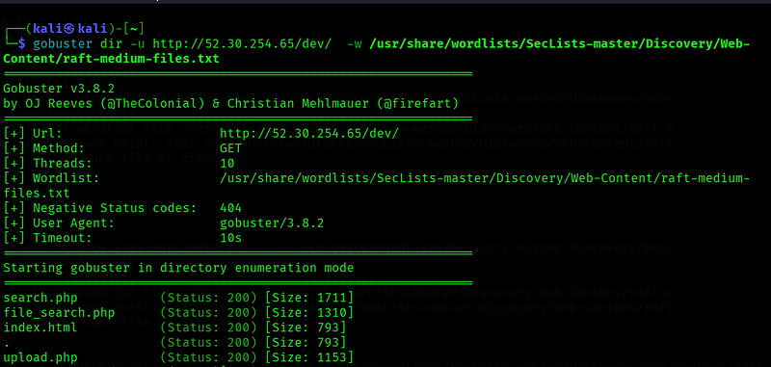
The screenshot shows a gobuster directory enumeration scan against/dev/ using a SecLists wordlist, and it successfully discovered several accessible files returning HTTP 200 status codes, including search.php, file_search.php, index.html, and upload.php. This indicates that the /dev/ directory is publicly accessible and contains functional PHP scripts related to file searching and file uploading, which could represent potential attack surfaces if input validation, authentication, or access controls are not properly implemented.
By going to http://alvault.hdan/dev/file_search.php we find interest location
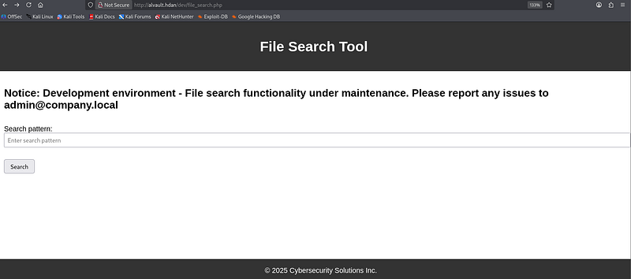
We found a search pattern that allow us to search file info like
- ID
- Key
- admin
- ssh
By using ssh we will find the username and password for ssh
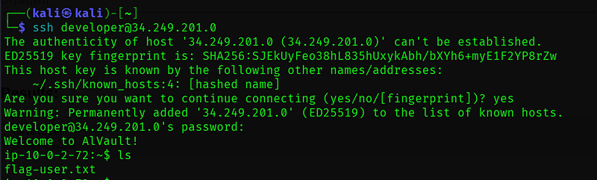
By using cat flag_user command to get the user flag

🔐Privilege Escalation to Root
sudo -l
To check the privilege of our user
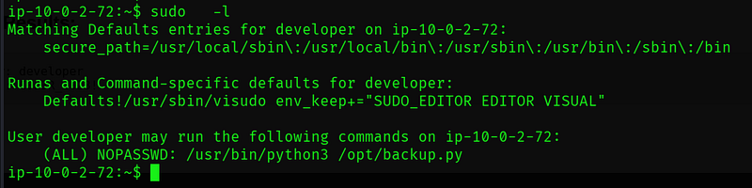
This output shows the result of running sudo -l, which lists what commands the user developer is allowed to run with elevated privileges. It reveals that the user can execute the command /usr/bin/python3 /opt/backup.py as root (or any user) without needing a password (NOPASSWD). This is important from a security perspective because if the backup.py script is writable or can be manipulated, it could potentially be abused to gain full system access (privilege escalation). Additionally, the environment keeps certain editor-related variables (SUDO_EDITOR, EDITOR, VISUAL) when running visudo, but the key takeaway is the unrestricted ability to run that Python script with root privileges.
mkdir -p '/home/developer/exploit; /bin/sh'
sudo /usr/bin/python3 /opt/backup.py
and then we enter the directory exploit to get root privilege :
/home/developer/exploit; /bin/sh

✅ Boom (root)
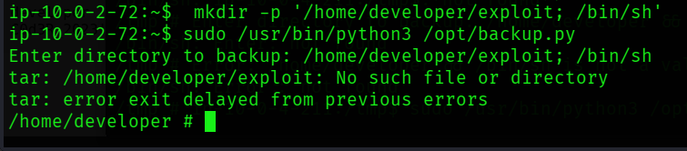
Then follow command :
whoami
cat /root/flag-root.txt

This walkthrough highlights how small misconfigurations and overlooked vulnerabilities can lead to full system compromise when approached methodically. By combining enumeration, careful analysis, and the right exploitation techniques, I was able to move step by step from limited access to full control. This process reinforced the importance of patience, understanding system behavior, and thinking critically rather than relying only on automated tools. Overall, the machine demonstrated that strong fundamentals in reconnaissance and privilege escalation are key to success in penetration testing.

