Coursework Report

Haroen Ahmed

40403712@napier.ac.uk

Edinburgh Napier University – Advanced Web Technologies (SET09103)



Contents

Introduction 1

Design 1

Enhancements 1

Critical Evaluation 2

Personal Evaluation 2

References 2

# Introduction

For my project I decided to create a Scottish Wildlife web app. This web app is about wild animals that live in Scotland. These animal can be found in several habitats and the web app provides information about these animals and their habitats for locals and tourists. This is the main feature of the web app. This can be achieved by clicking on any one of the links in the navigation bar at the top of the page, for example the reptile’s link will take the user to the reptile’s page where they can read information about them and their habitats.

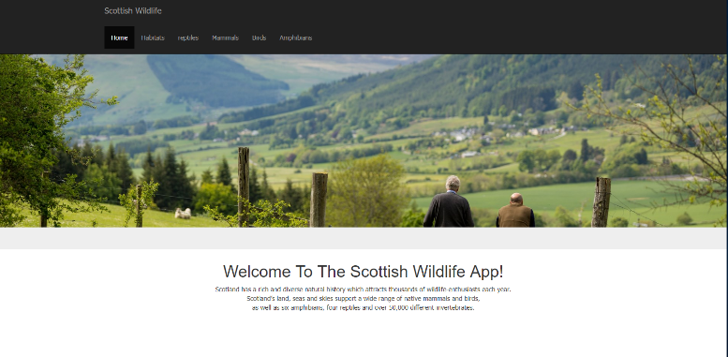

# Design

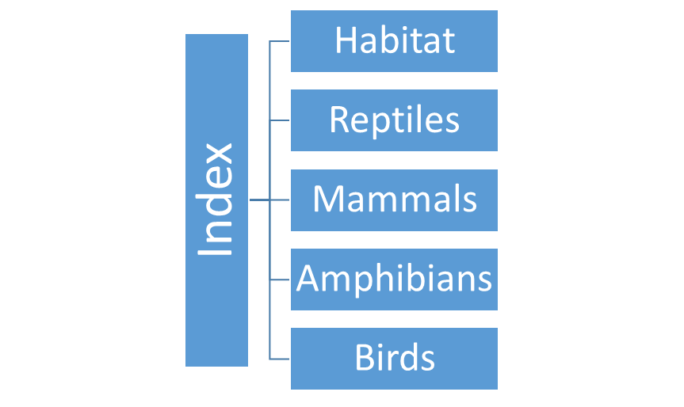

The previous image is an image of the navigation system used in the web app. I have structured it this way because I find it is the easiest way to navigate through a webpage. The layout is consistent throughout the web app, giving it a professional look and also making navigation simple and easy it easy for the user. The web app is structured keeping the user in mind. The layout, look and structure is laid out to be consistent and to make the users experience easy and less frustrating.

Coming to the choice of colours of the web app. I decided to keep the colour palette a plain and simple white and black. I was inspired to choose these colours by studying Wikipedia. Wikipedia keeps things plain and simple by using black and white as its colour palette. As it’s a website that provides a mass load of information, having colours could be distracting and disengage the user. My web app also provides information so I also decided to choose black and white as my colour choice.

# Enhancements

Due the lack of time and limited experience I was restricted to what I could create. If I had the necessary time and skills I would add a feature to the habitats section that would not only show a description of the habitats but would also show pictures of the animals that live within that habitat.

Due the time restriction I wasn’t able to mention every single wild animal that resides in Scotland. If I had more time I would create database that every wild animal that resides in the whole of Britain, and have the web app sectioned off by category of countries, then relevant sub categories. A cool feature that could be added to this is a map that pin points each animal species location, and upon click a small introduction video plays of the animal in its habitat.

Another useful feature I would add is a forum where users could interact with each other and hold discussions about the wildlife.

# Critical Evaluation

The main aim of the web app is to provide users with information. This is done by using a simple and easy way of navigation throughout the web app. This feature is the main feature of the product as it’s the main area that users will mostly engage with. I feel this navigation system works well and gives the user minimum to no frustration by keeping everything simple and easy to understand.

Another feature that makes the users life easy is the navigation highlight feature. The link the user visits in the navigation bar highlights and changes to a darker colour giving the user feedback that his/her interaction has been processed and they are on their desired page. This also serves as a reminder to the user as to which page they are currently browsing.

A feature of the web app that I feel doesn’t work as well as I expected is the modals that hold information and upon click open up and display this information. I feel as there is not much information in each modal, perhaps they were unnecessary. I would’ve been better to just have a small section in each habitats section that displays the relevant information. The modals is still a good idea and can work well, if I had more information to display.

Another feature that doesn’t work that well and could be improved is the web apps responsiveness when viewing on other devices. I feel it would be beneficial if the web app displayed correctly on all devices big and small. Due to the time restriction I was unable to do this.

# Personal Evaluation

This was my first time working on this type of project. Creating and designing using tools such as the Linux command line, Git, flask micro-framework and the programming language Python were all new to me and I had no previous experience or knowledge on how to use any of these systems. While working on the project I had to use any time I had to educate myself on how to effectively use these systems to achieve my goal. At the beginning it was really difficult and frustrating working alone and not being able to understand anything, but with persistence, and continuingly studying books, online resources and watching and working through video tutorials I managed to get a good grip on how to use these tools. Eventually I reached a point where I had the knowledge I needed to achieve my goal.

I feel I performed really well on this project. At first I was upset thinking I was thrown in the deep end and left, but now I see how it benefitted me. It gave me the opportunity to do things on my own without calling for help from others. I feel really proud of myself and feel I learnt a great deal more from this experience than just knowing how to use these tools.

# References

The content such as animal and habitat information was sourced from the following two webpages: <https://www.nature.scot/plants-animals-and-fungi/amphibians-and-reptiles><https://scottishwildlifetrust.org.uk/species/common-frog/>

All images used are sourced from Google Images:

<https://images.google.com/>

The Bootstrap framework used to create the website:

<https://getbootstrap.com/>

Learning Resources:

<https://www.codecademy.com/>

<https://www.openvim.com/>

<https://www.youtube.com/playlist?list=PL6gx4Cwl9DGDi9F_slcQK7knjtO8TUvUs>