**Explanation:**

### ****Stack Using Array:****

**Push (Insertion)**

Adds an element to the stack.

If the stack is full (top == 9), insertion is not allowed.

**Pop (Deletion)**

Removes the top element from the stack.

If the stack is empty (top == -1), deletion is not possible.

**Display**

Prints all elements from top to 0 in **LIFO (Last In, First Out) order**.

### ****Stack Using Linked List :****

**Push (Insertion)**

Creates a new node and inserts it at the top of the stack.

Updates top to point to the new node.

**Pop (Deletion)**

Removes the top node from the stack.

Updates top to point to the next node.

Deletes the removed node to free memory.

**Display**

Traverses the stack from top to nullptr, printing each element.

Ensures elements are displayed in **LIFO (Last In, First Out) order.**

**OutPut:**

**With Array:**

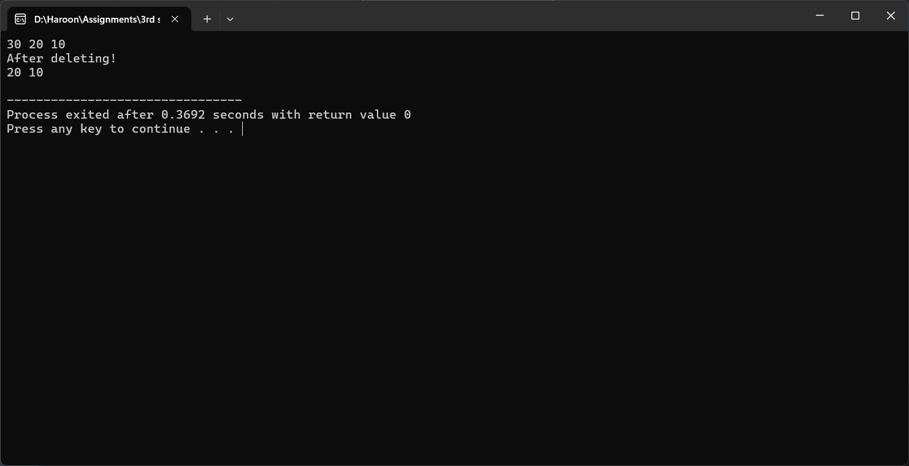

**With LinkedLists:**

