**Explanation:**

## ****1. Queue using Array****

**Enqueue:** Adds an element at the rear of the queue.

**Dequeue:** Removes an element from the front of the queue.

**Display:** Prints all elements in the queue from front to rear.

## ****2. Queue using Linked List****

**Enqueue:** Creates a new node and adds it at the rear of the queue.

**Dequeue:** Removes the front node of the queue.

**Display:** Traverses the linked list and prints all elements.

**OutPut:**

**With Array:**

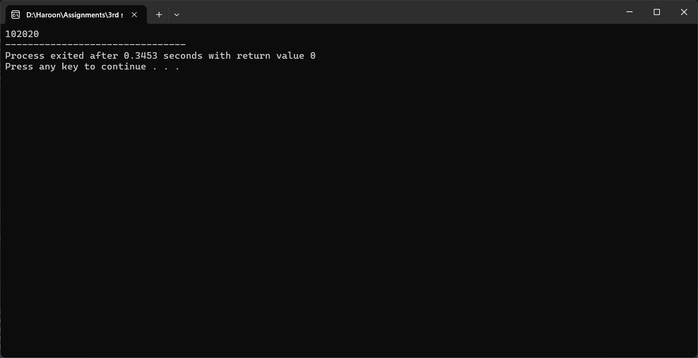

**With LinkedLists:**

