**Explanation:**

### Singly Linked List (Insert at Nth Position)

Inserting a node at a specific position in a **Singly Linked List** involves the following steps:

**Valid Position Handling**

* 1. If the position is **1**, the new node is inserted at the start (same as "Insert at Start").
  2. If the position is beyond the last node, the function should return an **error or handle it properly**.

**Creating & Linking the New Node**

* 1. A new node is dynamically allocated.
  2. The list is **traversed** until the desired position is reached.
  3. The new node is linked between the previous and next nodes.

**OutPut:**

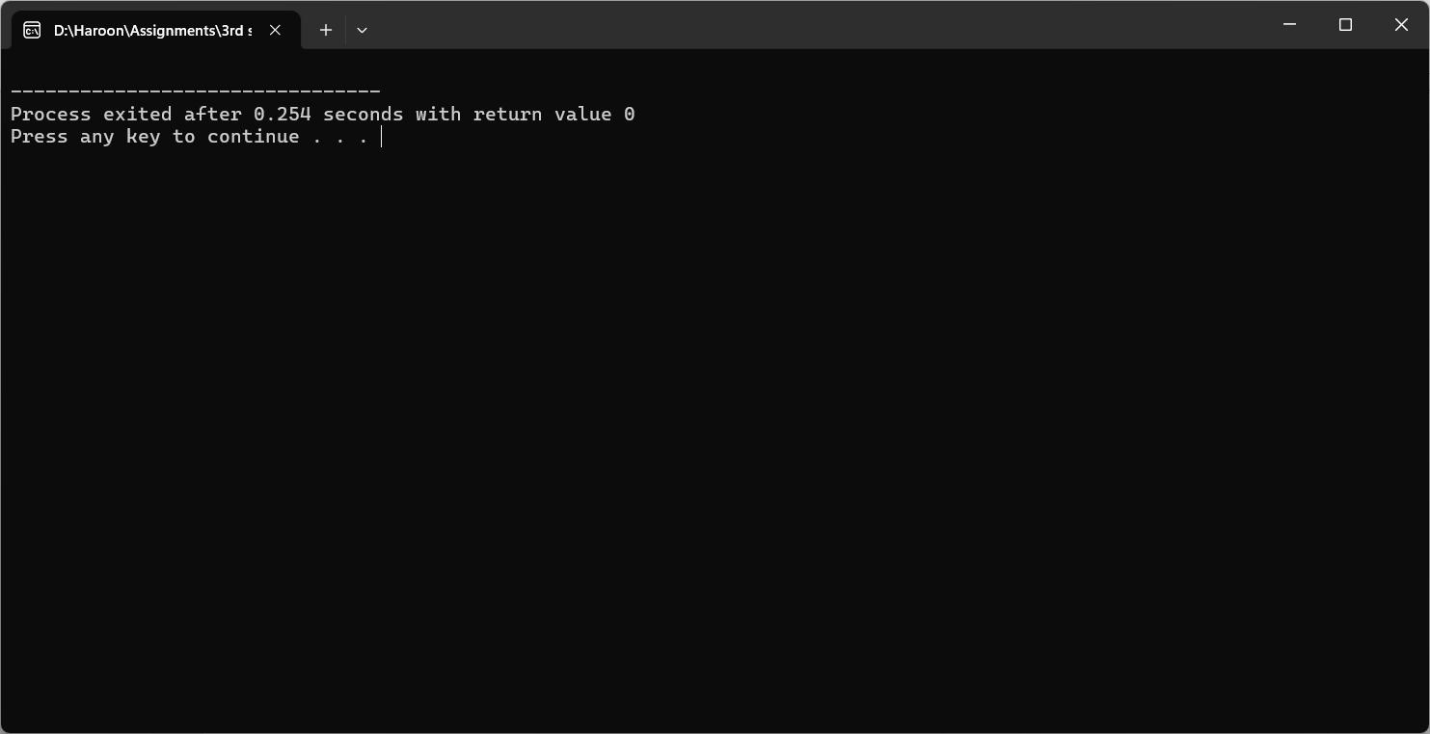

PS. doesnt print anything because we didnt write code for it.