**Merging linkedlists:**

**Explanation:**

**Singly:**

* We create two separate linked lists (list1 and list2).
* Insert some nodes into both lists.
* Find the last node of list1 and make its next pointer point to the head of list2, effectively merging them.
* Display the merged list.

1. **insertLast()** → Inserts a new node at the end of the list.
2. **mergeList()** → Merges list2 into list1 by linking the last node of list1 to the head of list2.
3. **printList()** → Displays the linked list.

**Doubly:**

* Similar to SLL, but since DLL has prev and next pointers, we update both:
* The last node of list1 should point to the first node of list2.
* The first node of list2 should have its prev pointing to the last node of list1.

1. **insertLast()** → Adds nodes at the end of the list.
2. **mergeList()** → Connects the tail of list1 with the head of list2 and updates the prev pointer of list2’s head.
3. **printForward()** → Displays the merged list in forward order.

**OutPut:**

**Singly:**

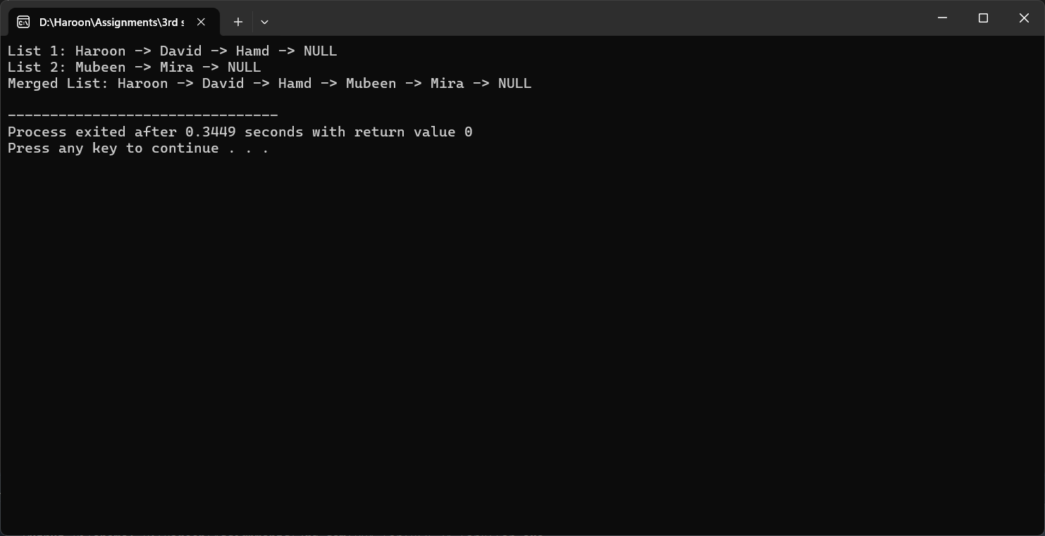

**Doubly:**

