SDN BASED FIREWALL
COMPUTER NETWORKS (ORANGE PROBLEM)
UE24CS252B
NAME : HARSH M
SRN : PES1UG24CS573
CLASS-SECTION : 4-J

CONTEXT:
Three terminals are opened :
1. Firewall.py
2. Mininet which has spawned three nodes h1, h2, h3 along with switch s1.
3. Wireshark to track the activity

H1 is treated as malicious , I.e the firewall is supposed to block it.
H2 is the receiver, the client, and h3 is the sender that is not blocked.

SCREENSHOTS:

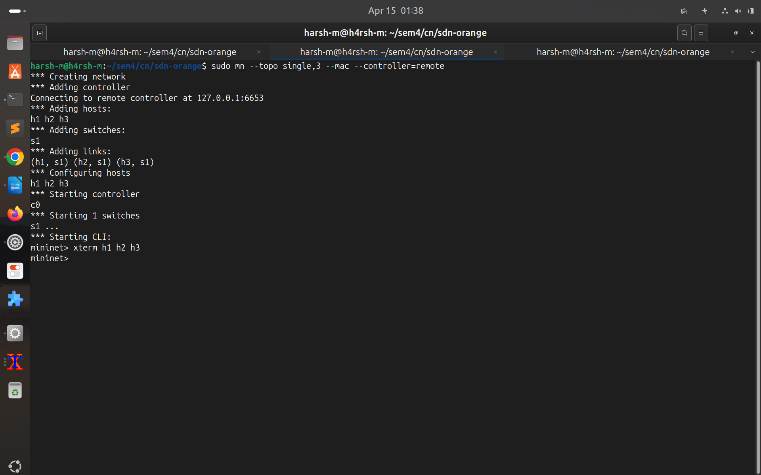

Node : h2:
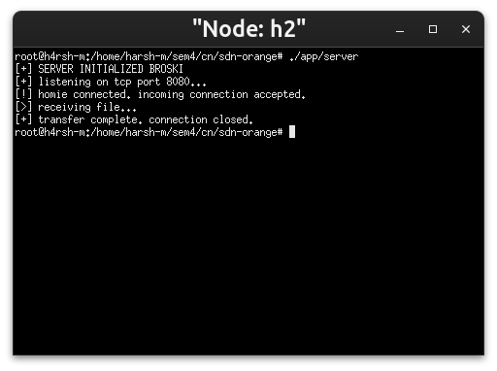
Node h3 :
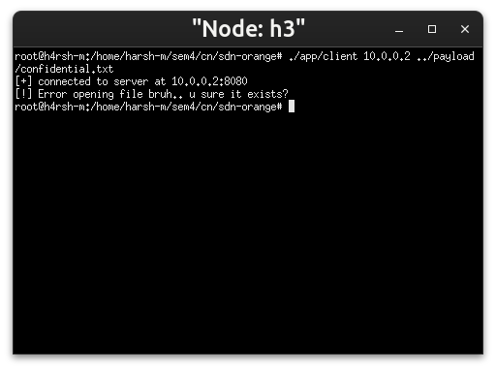

Node h1:
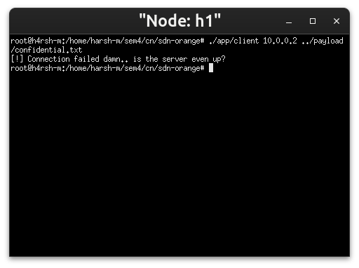
Firewall terminal :
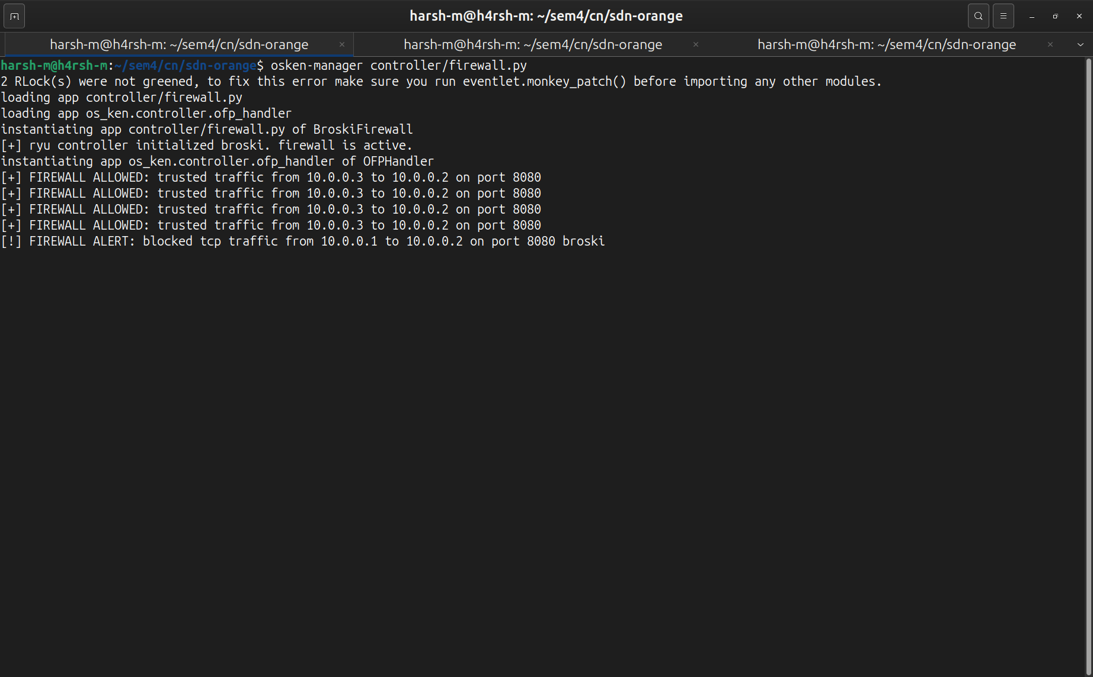
Here we can clearly see allowed vs blocked traffic , from h3 and h1 respectively.
Wireshark capture:
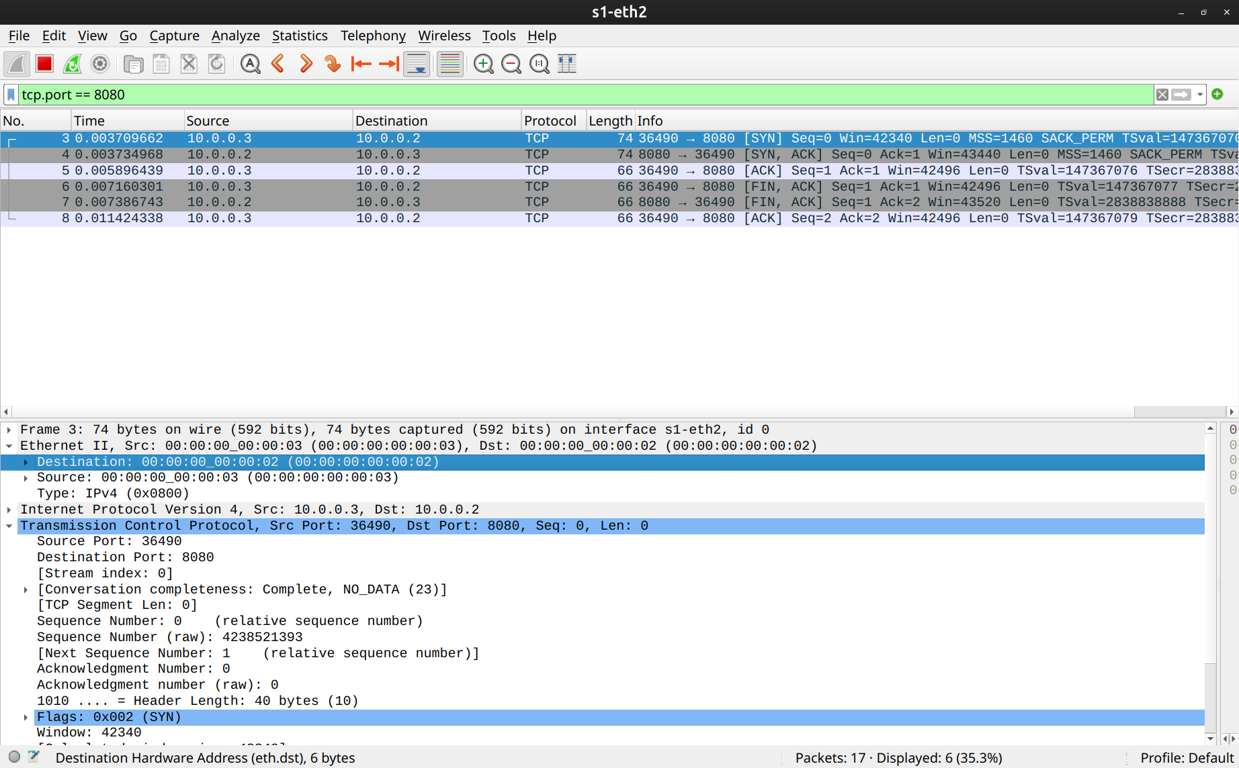
Here we can see the handshake attempt, and responses between h3 (10.0.0.3) and h2 (10.0.0.2) in the form of syn synack ack, and then the text file payload delivery tracked as it is.
What we can’t see is the requests from h1(10.0.0.1) since the firewall has blocked them , so they are dropped somewhere into Madhya Pradesh (which nobody cares about).

Ping tests:
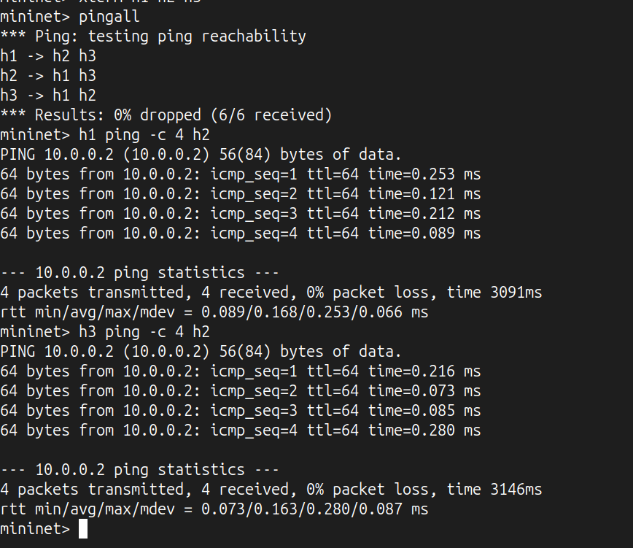

Iperf test:
h3 to h2: Result 33.8 Gb/s bandwidth
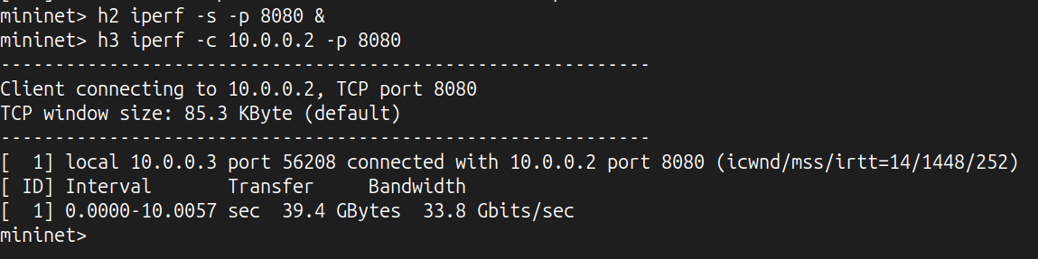
h1 to h2 : Since it is bloacked by the firewall it will hang forever
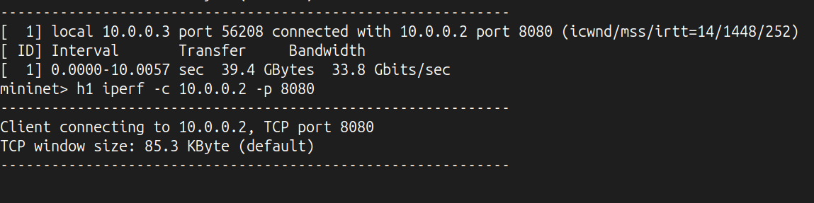
Flow tables:
