Hyperparameter tuning

Nennenswerte Test Resultate:
27_randomizationStrength_01:
-GAMESPERROUND 20
-GHOSTGAMESPERROUND 7
-SNAPSHOT_PROBABILITY 2000
-randomizationAmount 0.04
-randomizationStrengthWeights 0.01
-randomizationStrengthBiases 0.01
-ROUND_COUNT 2000
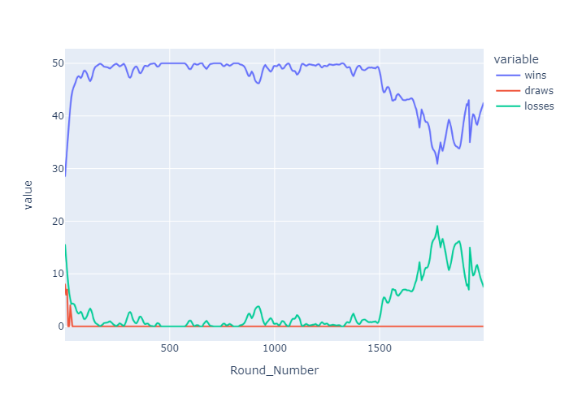Figure 1: Generation 1
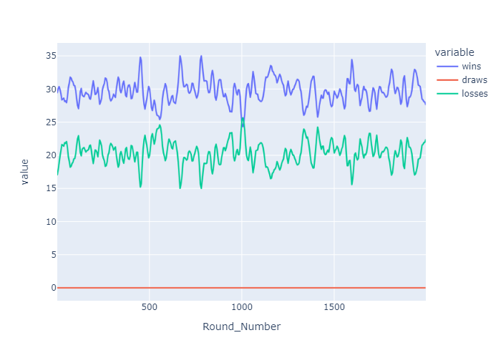Figure 2: Generation 2

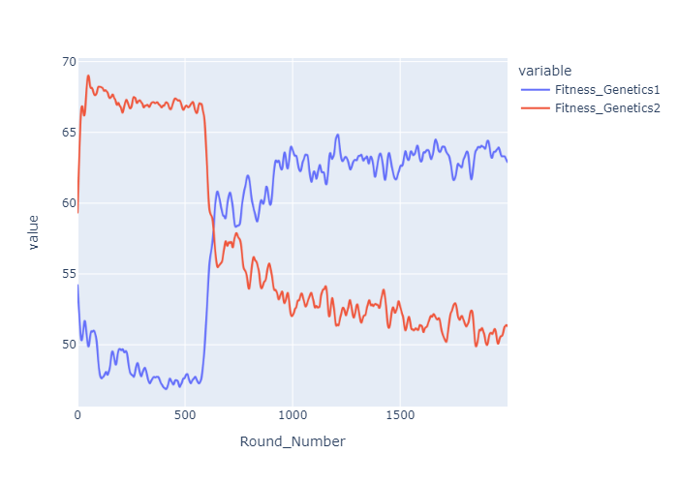Figure 3: Relative fitness

