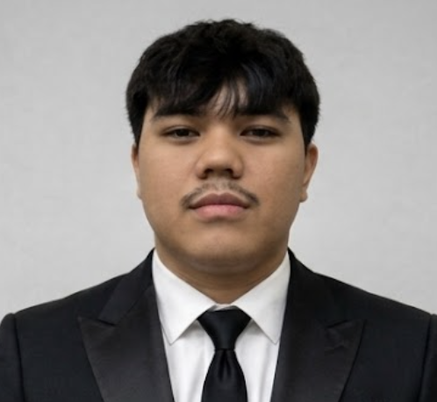
Jess Patrick R. Paguel
Information Technology Student — Web Development & Cybersecurity
0976 529 8516 | jess102904@gmail.com | linkedin.com/in/jess-patrick-paguel | github.com/H4te-r | jesspaguel.vercel.app
PROFILE
Information Technology student from the Philippines who would rather build things than just study them. I work across the stack — React, Next.js, and Tailwind CSS on the frontend, PHP, MySQL, and REST APIs on the backend — and I hold Certiport certifications in Networking and Cybersecurity, with Network Security currently in progress. My goal is to combine both sides of my background: shipping real, working software while building it with security best practices in mind. I am currently seeking an On-the-Job Training placement for the 2nd Semester of SY 2026–2027 where I can contribute, keep learning, and grow as a developer.
EDUCATION
University of the East, Manila Expected Graduation: 2027
Bachelor of Science in Information Technology
On-the-Job Training scheduled for 2nd Semester, SY 2026–2027
CERTIFICATIONS
- Networking — Certiport (April 2026) — covers core networking concepts, infrastructure, and protocols.
- Cybersecurity — Certiport (November 2025) — covers foundational security principles, threat identification, and protection practices.
Currently pursuing: Network Security (Certiport), exam around October 2026 — Cloud Computing to follow
TECHNICAL SKILLS
Frontend Development: HTML, CSS, JavaScript, Tailwind CSS, React, Next.js
Backend Development: PHP, MySQL, REST APIs
Networking & Security: Core networking fundamentals, network security practices, secure authentication, input validation
Tools & Platforms: Git, GitHub, VS Code, Figma, Vercel
PROJECTS
Barangay Central — Thesis Project PHP · JavaScript · Tailwind CSS · MySQL
- Designed and developed a full e-government web system for an actual local government unit (barangay).
- Built modules for resident management, document requests, and community services, serving real users in local government.
- Handled database architecture and deployment of a system that real residents and staff depend on.
- Applied security-conscious development practices, including input validation and secure authentication, to protect resident data.
- Source code is kept private due to real resident data involved; available upon request.
Live Demo: barangaycentral.com/public
KARMÉ — Luxury That Lingers React · Next.js · Tailwind CSS
- Independently built a full e-commerce website for KARMÉ, a fragrance startup founded by my sister, currently in its early launch phase.
- Developed a product catalog, individual product detail pages, shopping cart functionality, and brand storytelling pages.
- Handled the complete build and deployment pipeline, from design to a live, functioning production site.
Live Demo: karmefragrance.vercel.app
Personal Portfolio React · Next.js · Tailwind CSS
- Designed, built, and deployed a personal portfolio site showcasing projects, skills, and certifications (jesspaguel.vercel.app).

