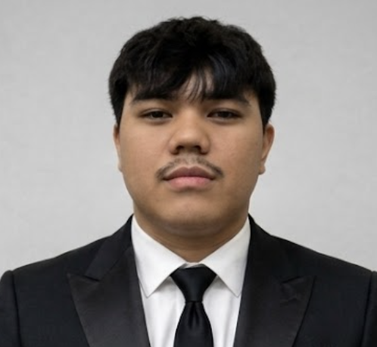
Jess Patrick R. Paguel
Information Technology Student — Web Development & Cybersecurity
0976 529 8516 | jess102904@gmail.com | linkedin.com/in/jess-patrick-paguel | github.com/H4te-r | jesspaguel.vercel.app
PROFILE
IT student who builds and ships real-world web systems, backed by Certiport certifications in networking and cybersecurity (with network security in progress). Comfortable across the stack — from React/Next.js interfaces to PHP/MySQL backends — with a growing focus on building software with security best practices in mind.
EDUCATION
University of the East, Manila Expected Graduation: 2027
Bachelor of Science in Information Technology
On-the-Job Training scheduled for 2nd Semester, SY 2026–2027
CERTIFICATIONS
- Networking — Certiport (April 2026)
- Cybersecurity — Certiport (November 2025)
Currently pursuing: Network Security (Certiport), exam around October — Cloud Computing to follow
SKILLS
Frontend: HTML, CSS, JavaScript, Tailwind CSS, React, Next.js
Backend: PHP, MySQL, REST APIs
Tools: Git, GitHub, VS Code, Figma, Vercel
PROJECTS
Barangay Central PHP · JavaScript · Tailwind CSS · MySQL
- Thesis project: a full e-government web system for an actual local government unit.
- Handles resident management, document requests, and community services for real users.
- Built with attention to security practices, including input validation and secure authentication.
KARMÉ — Luxury That Lingers React · Next.js · Tailwind CSS
- Full e-commerce website built for a real fragrance startup (my sister's business), currently in its early launch phase.
- Features a product catalog, individual product pages, shopping cart, and brand storytelling.
- Independently designed, developed, and deployed the site end-to-end.

