Adrian Mortensen & Kamil Sosna

DAT151 – Oblig8

Security and virtualization

Innhold

**Fant ingen oppføringer i innholdsfortegnelsen.**

# Task1: Firewall

## Setup explanation

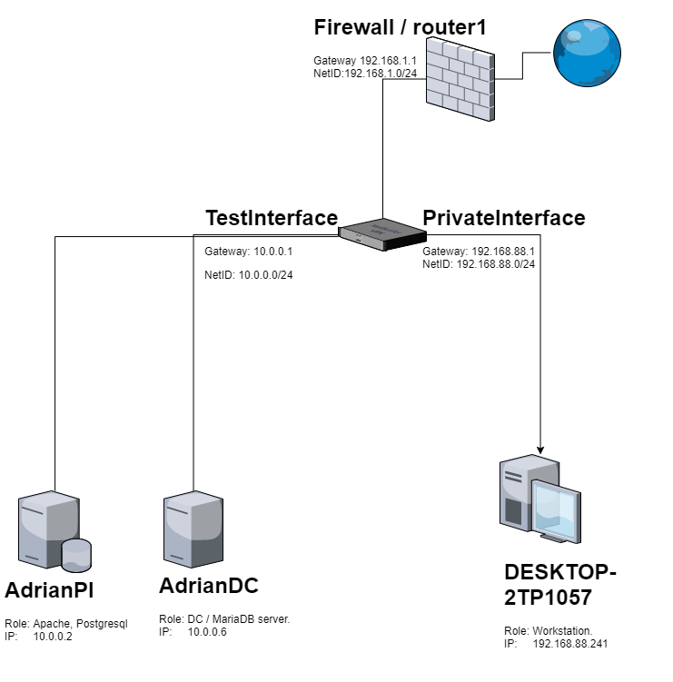

The desktop / workstation is where most of the work will be done from. AdrianPI has a mounted display so this will be the one we work on the most in terms of security since its easier to fix mistakes.

## Blocking everything.

## Rule:

pi**@**adrianpi**:~** **$ sudo** iptables -A INPUT **-**j DROP

Small explanation; -A is what direction. I chose to do input since this will block all connections to the client. This will also stop it from receiving any packet from the internet. Meaning even if it asks for instance a website the answer will be blocked. Using -j DROP makes the rule silently drop the package not giving back a response at all. This could make a potential attacker think that they have the wrong IP address or that there is some other network issue.

## Testing:

C**:**\Users\adria**>**ping 10**.**0**.**0**.**2

Pinging 10**.**0**.**0**.**2 with 32 bytes of data**:**

Request timed out.

Request timed out.

Request timed out.

Request timed out.

Ping statistics for 10**.**0**.**0**.**2**:**

Packets**:** Sent **=** 4**,** Received **=** 0**,** Lost **=** 4 **(**100**%** loss**),**

## Blocking all SSH except Workstation

## Rule:

**iptables** -A INPUT -p tcp -s 192**.**168**.**88**.**241 **--**dport 22 **-**j ACCEPT

**iptables** -A INPUT -p tcp **-**m tcp **--**dport 22 **-**j DROP

Small explanation; -p is what type of protocol used (here TCP) -s is source address or mask, --dport is destination port and -j is Jump to target. (Here accept, letting the connection through)

The 2nd rule is pretty similar to the previous one just that don’t specify a source address and drops all incoming on the port.

## Testing:

adrian**@**DESKTOP-2TP1O57**:~$ ssh** pi**@**10**.**0**.**0**.**2

pi**@**10**.**0**.**0**.**2s password**:**

Linux adrianpi.adrian.local 4**.**14**.**79**-**v7+ #1159 SMP Sun Nov 4 17:50:20 GMT 2018 armv7l

The programs included with the Debian GNU**/**Linux system are free software**;**

the exact distribution terms for each program are described in the

individual files in **/**usr**/**share**/**doc**/*/**copyright.

Debian GNU**/**Linux comes with ABSOLUTELY NO WARRANTY**,** to the extent

permitted by applicable law.

Last login**:** Fri Feb 28 00**:**46**:**45 2020 from 192**.**168**.**88**.**241

pi**@**adrianpi**:~** **$**

pi**@**AdrianDC**:~** **$ ssh** pi**@**10**.**0**.**0**.**2

ssh**:** connect to host 10**.**0**.**0**.**2 port 22**:** Connection timed out

## Making sure b) persists through restart.

This can be done multiple ways. One is to just add these rules to crontab as root.

But one can also make a small script for ease of edit that is ran by crontab so that you don’t fill up your crontab page with iptables rules.

## Script:

#!/bin/bash

**iptables** -A INPUT -p tcp -s 192**.**168**.**88**.**241 **--**dport 22 **-**j ACCEPT

**iptables** -A INPUT -p tcp **-**m tcp **--**dport 22 **-**j DROP

Making a folder on /FirewallRules (Not ideal location but this is temporary)

pi**@**adrianpi**:/**FirewallRules **$ sudo** chmod 755 Firewall.sh

pi**@**adrianpi**:/**FirewallRules **$ sudo** crontab -e

crontab**:** installing new crontab

In the sudo crontab:

**@**reboot sudo **/**FirewallRules**/**Firewall.sh

## Testing:

pi@adrianpi:/FirewallRules $ sudo shutdown -r now

After restart:

Last login**:** Fri Feb 28 01**:**30**:**26 2020 from 192**.**168**.**88**.**241

pi**@**adrianpi**:**sudo iptables -S

**-**P INPUT ACCEPT

**-**P FORWARD ACCEPT

**-**P OUTPUT ACCEPT

-A INPUT -s 192**.**168**.**88**.**241**/**32 -p tcp **-**m tcp **--**dport 22 **-**j ACCEPT

-A INPUT -p tcp **-**m tcp **--**dport 22 **-**j DROP

pi**@**adrianpi**:~** **$**

(Here we can see the rules being there and that I did connect through SSH. Still testing through AdrianDC:

pi**@**AdrianDC**:~** **$ ssh** pi**@**10**.**0**.**0**.**2

ssh**:** connect to host 10**.**0**.**0**.**2 port 22**:** Connection timed out

# Task2: SELinux

Task done on a CentOs 8 virtual machine.

## Checking if SELinux is enabled or not

**[**admo**@**EXAMPLE **~]$ getenforce**

Enforcing

**[**admo**@**EXAMPLE **~]$ sestatus**

SELinux status**:** enabled

SELinuxfs mount**:** **/**sys**/**fs**/**selinux

SELinux root directory**:** **/**etc**/**selinux

Loaded policy name**:** targeted

Current mode**:** enforcing

Mode from config file**:** enforcing

Policy MLS status**:** enabled

Policy deny_unknown status**:** allowed

Memory protection checking**:** actual **(**secure**)**

Max kernel policy version**:** 31

You can turn it off by going to the configuration file.

**[**admo**@**EXAMPLE **~]$ sudo** nano **/**etc**/**selinux**/**config

# This file controls the state of SELinux on the system.

# SELINUX= can take one of these three values:

# enforcing - SELinux security policy is enforced.

# permissive - SELinux prints warnings instead of enforcing.

# disabled - No SELinux policy is loaded.

SELINUX**=**enforcing

# SELINUXTYPE= can take one of these three values:

# targeted - Targeted processes are protected,

# minimum - Modification of targeted policy. Only selected processes $

# mls - Multi Level Security protection.

SELINUXTYPE**=**targeted

Changing from “enforcing” to disabled would turn it off.

However here it is on.

## Running semanage login

**[**admo**@**EXAMPLE **~]$ sudo** semanage login -l

Login Name SELinux User MLS**/**MCS Range Service

__default__ unconfined_u s0-s0**:**c0.c1023 **\***

root unconfined_u s0-s0**:**c0.c1023 **\***

semanage login controls the mapping between a Linux User and the SELinux User. It can be used to turn on confined users. For example you could define that a particular user or group of users will login to a system as the user_u user. You can also see the SELinux users in this list (default, root)

while with the option “-l” it lists the objects.

## Context

### Create a file setest

**[**admo**@**EXAMPLE **~]$ touch** **/**tmp**/**setest

### Check the context of setest

**[**admo**@**EXAMPLE **~]$ ls** **-**Z **/**tmp**/**setest

unconfined_u**:**object_r**:**user_tmp_t**:**s0 **/**tmp**/**setest

Output just gives the default context that is given to a new file. It is not configured yet.

### Change the context of setest to user_home_t

**[**admo**@**EXAMPLE **~]$ chcon** -t user_home_t **/**tmp**/**setest

### Show the context of setest.

**[**admo**@**EXAMPLE **~]$ ls** **-**Z **/**tmp**/**setest

unconfined_u**:**object_r**:**user_home_t**:**s0 **/**tmp**/**setest

### Show the context of the current user

**[**admo**@**EXAMPLE **~]$ id** **-**Z

unconfined_u**:**unconfined_r**:**unconfined_t**:**s0-s0**:**c0.c1023

### How to check if httpd has privilege to read the file /etc/passwd

First have a look at the httpd context

**[**admo**@**EXAMPLE **~]$ ps** axZ **|** **grep** httpd

unconfined_u**:**unconfined_r**:**unconfined_t**:**s0-s0**:**c0.c1023 14436 pts**/**2 R+ 0**:**0

Here we can see the type is unconfined_t. While /etc/passwd has:

**[**admo**@**EXAMPLE **~]$ ls** **-**Z **/**etc**/**passwd

system_u**:**object_r**:**passwd_file_t**:**s0 **/**etc**/**passwd

For httpd to have access to passwd it would have to be a similar type to passwd_file_t and it is not.

# Task3: Virtualisation

KVM is known as Kernel based Virtual Machine because when we install KVM package then KVM module is loaded into the current kernel and turns our Linux machine into a hypervisor. Install a non-graphical Virtual machine using KVM kickstart file located at

<https://eple.hib.no/dat151/kvm_centos8.ks>

Use the following address to download the Centos8

<http://centos.uib.no/8-stream/BaseOS/x86_64/>

**[**admo**@**EXAMPLE **~]$ sudo** virt-install -n CentOsNoGraph -f **/**vm**/**CentNG.img**,**size**=**10 -l http://centos.uib.no/8-stream/BaseOS/x86_64/os -r 512 **--**nographics -x "ks=http://eple.hib.no/dat151/kvm_centos8.ks

"

WARNING KVM acceleration not available**,** using 'qemu'

WARNING No operating system detected**,** VM performance may suffer. Specify an OS with **--**os-variant for optimal results.

Starting install...

Retrieving file vmlinuz... **|** 7**.**8 MB 00**:**00**:**01

Retrieving file initrd.img... **|** 59 MB 00**:**00**:**10

Allocating 'CentNG.img' **|** 10 GB 00**:**00**:**00

Connected to domain CentOsNoGraph