Name: - Dixit D Solanki

Enrollment No.: - 200410107103

Subject: - Object-oriented Programming in

Java

PRACTICAL 1

Q-1 Write a Program that displays Welcome to Java, Learning Java Now and Programming is fun.

class Practical_1 {

public static void main(String[] args) {

System.out.println("Enrollment No.: 200410107103");

System.out.println("Welcome to Java");

System.out.println("Welcome to Computer Science");

System.out.println("Programming is fun");

}

}

Output

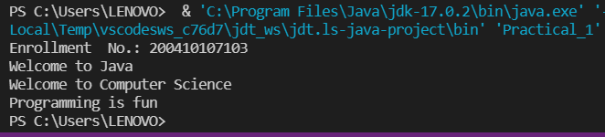

Q.2 Write a program that solves the following equation and

displays the value x and y:

1) 3.4x+50.2y=44.5

2) 2.1x+.55y=5.9

(Assume Cramer’s rule to solve equation

ax+by=e x=ed-bf/ad-bc

cx+dy=f y=af-ec/ad-bc )

import java.util.Scanner;

class Practical_1_2

{

public static void main(String[] args)

{

System.out.println("Enrollment No.: 200410107103");

Scanner input = new Scanner(System.in);

System.out.println("Values from Equestion:- 1 :");

System.out.print("Enter value of a : ");

double a = input.nextDouble();

System.out.print("Enter value of b : ");

double b = input.nextDouble();

System.out.print("Enter value of e : ");

double e = input.nextDouble();

System.out.println("Values from Equestion:- 2 :");

System.out.print("Enter value of c : ");

double c = input.nextDouble();

System.out.print("Enter value of d : ");

double d = input.nextDouble();

System.out.print("Enter value of f : ");

double f = input.nextDouble();

double x = ((e*d)-(b*f))/((a*d)-(b*c));

double y = ((a*f)-(e*c))/((a*d)-(b*c));

System.out.print(" X = "+ x + " Y = " + y);

}

}

Output

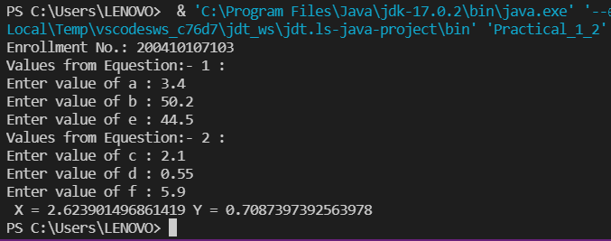

Q.3 Write a program that reads a number in meters, converts it to feet, and displays the result.

import java.util.Scanner;

class Practical_1_3

{

public static void main(String[] args)

{

System.out.println("Enrollment No.: 200410107103");

Scanner input = new Scanner(System.in);

System.out.print("Enter Value in Meters :");

double meter = input.nextDouble();

double feet = meter * 3.28084;

System.out.print(meter + " Meters = "+ feet + " Feets");

}

}

Output

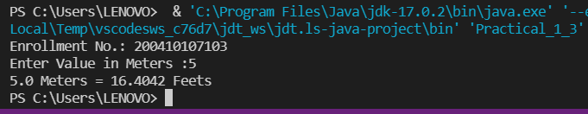

Q.4 Body Mass Index (BMI) is a measure of health on weight. It can be calculated by taking your weight in kilograms and dividing by the square of your height in meters. Write a program that prompts the user to enter a weight in pounds and height in inches and displays the BMI.

Note: - 1 pound=.45359237 Kg and 1 inch=.0254 meters.

import java.util.Scanner;

class Practical_1_4

{

public static void main(String[] args)

{

System.out.println("Enrollment No.: 200410107103");

Scanner input = new Scanner(System.in);

System.out.print("Enter Your weight in Pound :");

double pound = input.nextDouble();

System.out.print("Enter Your Height in Inch :");

double inch = input.nextDouble();

double BMI = (pound * 0.45359237) / ((inch * 0.0254)*(inch * 0.0254));

System.out.print("BMI = "+BMI);

}

}

Output

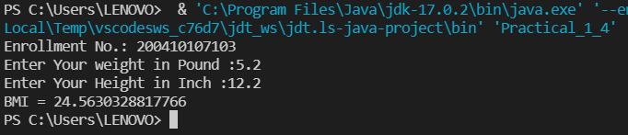

PRACTICAL 2

Q.1 Write a program that prompts the user to enter three integers and display the integers in decreasing order.

import java.util.Scanner;

class Practical_2_1

{

public static void main(String[] args)

{

System.out.println("Enrollment No.: 200410107103");

int temp;

Scanner input = new Scanner(System.in);

System.out.print("Enter 1st Integer :");

int a = input.nextInt();

System.out.print("Enter 2nd Integer :");

int b = input.nextInt();

if(a<b)

{

temp=a;

a=b;

b=temp;

}

System.out.print("Enter 3rd Integer :");

int c = input.nextInt();

if(c>b)

{

if(c>a)

{

temp=c;

c=b;

b=a;

a=temp;

}

else

{

temp=c;

c=b;

b=temp;

}

}

System.out.print("Decreasing Order :"+a+" "+b+" "+c);

}

}

Output

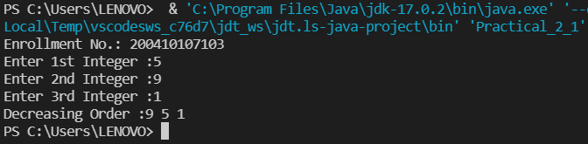

Q.2 Write a program that prompts the user to enter a letter and check whether a letter is a vowel or constant.

import java.util.Scanner;

class Practical_2_2

{

public static void main(String[] args)

{

System.out.println("Enrollment No.: 200410107103");

Scanner input = new Scanner(System.in);

System.out.print("Enter Character : ");

char ch = input.next().charAt(0);

switch(Character.toLowerCase(ch))

{

case 'a':

case 'e':

case 'i':

case 'o':

case 'u':

System.out.print(ch + " is vowel");

break;

default:

System.out.print(ch + " is constant");

}

}

}

Output

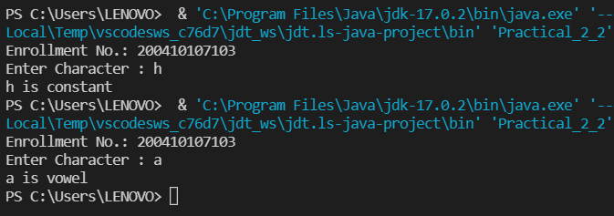

Q.3 Assume a vehicle plate number consists of three uppercase letters followed by four digits. Write a program to generate a plate number.

public class Practical_2_3 {

public static void main(String[] args) {

System.out.println("200410107103");

System.out.println("Time for Practical 2_3");

System.out.println("The Number plate is : "+letterOfPlate()+numberOfPlate());

}

public static String numberOfPlate(){

String number = "";

for (int i = 0; i<4;i++){

number = number + (char)('0' + Math.random() * ('9' - '0' + 1));

}

return number;

}

public static String letterOfPlate() {

String Letter = "";

for (int i =0; i<3;i++){

Letter = Letter + (char)('A' + Math.random() * ('Z' - 'A' + 1));

}

return Letter;

}

}

Output

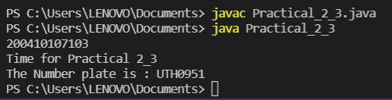Q.4 Write a program that reads an integer and displays all its smallest factors in increasing order. For example, if input number is 120, the output should be as follows:2,2,2,3,5.

import java.util.Scanner;

public class Practical_2_4 {

public static void main(String[] args) {

System.out.println("200401017103");

System.out.println("Hello");

Scanner sc = new Scanner(System.in);

System.out.print("Enter the number : ");

int k = sc.nextInt();

while (k != 1) {

for (int i = 2; i <= k ; i++) {

if (k % i == 0) {

System.out.println(i);

k = k/i;

break;

}

}

Output

