SimPy

event based simulation toolkit for Python programming language

pros:
- natural model based on coroutines (generators)
- support of basic simulation objects and mechanisms
- waiting queues, shared resources, signals
- plenty of Python libraries (including support of scientific )

cons:
- behavior of simulated object is modeled by one single routine (distribution of code to hierarchical system subroutines is almost impossible)
- complicated declarative parametrization of model

ETOS (our project)

declarative extension of SimPy

models are specified by mixture of procedural and declarative code

Procedural code
elementary actions including processing of data
represented in Python (by using of wrapped SimPy simulation primitives)

Declarative code
flow of elementary actions (including loops, branching)
parameters of action (including random values)
logging and statistics
XML representation (structured hierarchical code)

Etos – basic objects
Entity = basic actions (parking, charging) and its states
Transaction = process defined as by chains of entities which simulates part of limetime of actors (e.
Shared Objects = shared resource used in several transactions by several actors (shared objects are represented by common data of all instances of the entity)
Actors = active object, which changes its state by processing of transactions (e.g. car, man, product)
Simulations = define simulation time and collect common data (statistics)

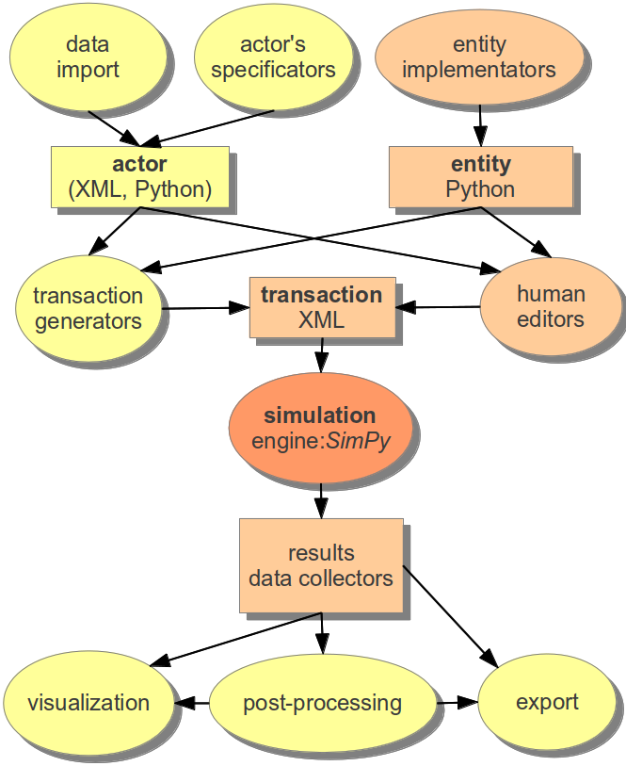
ETOS
main goal = separations of roles in process of design and implementations of simulation model

Innovative contributions

Context model
values in model have configurable context, which support random and time based values

Subtransaction
The subtransactions are implemented as almost independent SimPy processes (cooperative threads), i.e. without re-invocation of generators. This implementation improves scalability of simulations.

Data collectors
The simulated data outputs (main results of simulations) are collected by specialized objects – collectors. Collectors support counting, basic statistics (mean, standard deviations) and logging.

Sample model

actor: e-car (battery powered)
transaction: repetition of daily route from home to work and back (sometimes including some shopping in shopping centres) with two type of charging:
home charging
fast charging in shopping center (number of charging sockets limited)

expected results:
frequency of out-of -battery event
fast charging / home charging ratio
utilization of fast-charging stations
etc.

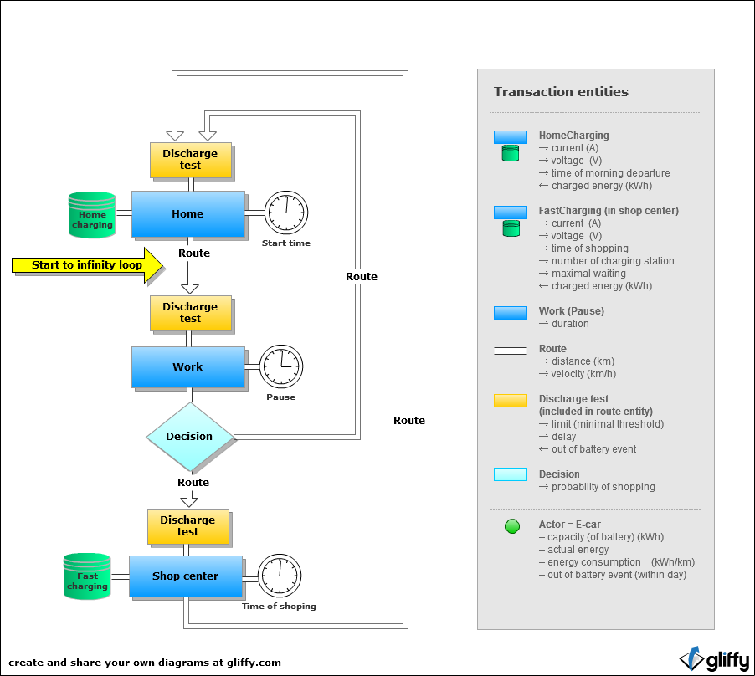

Submodels
e-car:
battery capacity and consumption (simple model based on fixed kWh/km ratio) [-discharge during pauses isn't taken in account]
charging: more sophisticated model (two state charging procedure, CC – constant charging current, CV – current gradually declines asymptotically towards 0, based on ....)
out-of-battery event: energy of battery drops bellow the limit – delaying (duration is configurable) and exceptional charging (the event is registered inside actor)

exceptional situation are not easily representable in current ETOS model

