**CISC 3141 Final Project Documentation**

**Inspiration**

For my project the website that I decided to create is called Musings of the Doctor. It is a blog website for the fictional character Dr. Watson of Sherlock Holmes fame.

The idea was to create a website that would somewhat emulate how Dr. Watson would catalogue his adventures with Sherlock in the modern day. This draws inspiration from the letters and journal entries he writes in the original books. Another idea I had for the website is that it would also serve as a bit of an advertisement page for the Sherlock Holmes books. I framed this by making it seem that the books were written by ghost writers on the real-life person Sherlock Holmes.

The idea for this website just came to me as I was brainstorming topics that I could make a website around. I was interested in the idea as creative writing is a bit of a passion of mine so I could mold the website to how I might write a modern-day fictional detective. Also, I thought that the concept was deep enough that I could find ways to use the various different tags and features in order to meet the requirements.

This idea is what gave shape to the different pages on the website like the lists of open and closed cases as well as a page for people to submit what they think is evidence.

I also thought it would be interesting to have other pages that reference other characters like the recipe pages which mentions a recipe for tea received my Mrs. Hudson the owner of 221B Baker Street where Holmes resides.

When creating the website, I drew on my memory of the different Sherlock Holmes books that I have read. The user base for the website would be anyone interested in Sherlock Holmes.

This project is an improved version of my project 1.

**Outline**

**Home page**

This is the landing page for the website. At the top of the page is the navbar. The background of this page is a picture of the real-life Scotland Yard which is the police force Sherlock Holmes works with. It has a picture of a magnifying glass to represent detective work. The name of the website is mentioned. The famous quote “The game is afoot” is on the page as well as a link to a website for reporting crimes and another link to an email asking people to send their thoughts on the website.

**About Page**

This page explains the purpose of the website, the different pages of the website, and the people involved with the website. The page has an ordered list of the main 4 sections of this page. The links on the list take you to that specific section. The first 3 sections are for Dr. Watson, Det. Holmes and Arthur Conan Doyle. Each section gives a brief summary of the person and has a table that lists their address, email, phone number and available times. The last section is the area of operations page which says that Watson and Holmes mostly work in London and accompanied is a map of London.

**Crime Stats**

This page calls an API maintained by the London Police. From it the page gets the different categories of crime documented. As I found it hard to find a good API with monthly averages of the crimes, I randomly generated numbers.

**Closed Cases Page**

This page is a record of the current successfully completed cases of Watson and Holmes. Each case has a brief description and a link to where the book can be purchased. The color of the different cases was sort of chosen to reflect the case. The ordered list that holds the different closed cases has links to each section of the page but since the page is so short, they are not really needed.

**Open Cases Page**

This page is a list of the cases that are currently being investigated. It is very similar in format to the Closed Cases page. Each case has a brief description of how the case came to them. I added some functionality so that you can add some tentative cases to the page.

**Recipes**

The idea for this page was to add a light hearted element to the website and so I chose to have Dr. Watson share recipes with the people visiting his website. The page has a picture of a cup of tea, an unordered list of the ingredients and an ordered list of the steps. It also has a short description of the tea. I got this recipe after looking up a tea recipe.

**Log In Page**

This page asks for your username and password so that you can sign into your account on the website. This page is strictly aesthetic as the log in function does not work. Has a link to a signup page if the user does not have an account.

**Sign Up Page**

This is a page so that people can sign up to receive updates from the website. It asks for a username, password, frequency of updates, what the person is interested in, and if any particular crimes interest them. It also asks what made them want to subscribe. There are some jokes on this page. This page is purely aesthetic as you cannot actually sign up.

**Clues Page**

This is a page so that people can upload stuff about open cases. This is purely aesthetic as it does not work. Clicking on upload file will open your file explorer though.

**Hunt Page**

This page has a simple detective game. The game is where you go into rooms in a warehouse and notice different things about the rooms. You navigate with the goal of guessing which room the criminal is hiding in.

**Diagram**

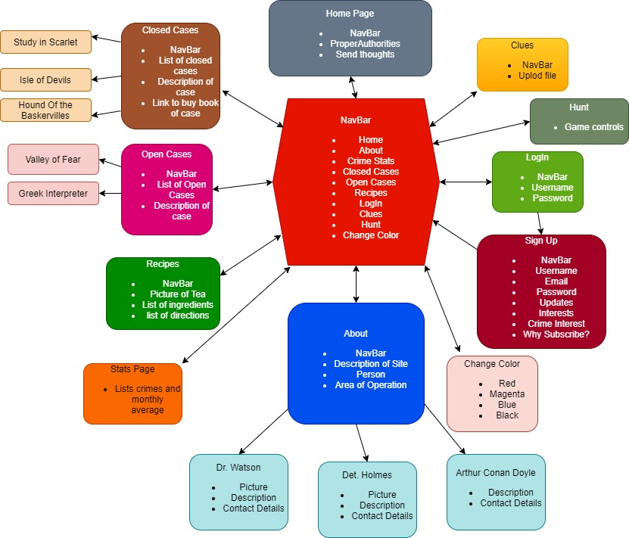

**Instruction Manual**

Version 2.0

The website for the most part functions like an ordinary blog website.

You navigate the website using the navbar.

Most of the website is non-interactable as it is meant for reading.

On the homepage there is a magnification lens so the user can look at a smaller version of the homepage background.

The about page has link you can click on to go to different sections of the about page.

The crime stats page has a list of the types of crime.

The closed cases page has a list of closed cases and a search bar so you can search for specific cases and then click on the result to go to that section.

The open cases page lets you add content to the page temporarily be entering a case name and case description and hitting submit.

The open cases page also has a list of leads that you can add, remove and cross out items from.

The recipes page has an accordion button you can press to get the ingredients and directions for the recipe.

The login, clues and signin page are purely aesthetic

The hunt page lets the user play a simple deduction game.

The change color option lets the user change some of the text color on a page.

Browser: It should work with any browser. Was tested on Chrome and Mozilla.

**Project Update**

**Week 1**

|  |  |  |  |
| --- | --- | --- | --- |
| **Feature** | **Completion%** | **Comment** | **Estimated Completion Week** |
| **API** | **20%** | **Found a police API for London but is hard to get statistics from** | **Week 2** |
| **Accounts** | **0%** | **Not sure how to add this functionality** | **Week 3?** |
| **Add Posts Temporarily** | **100%** | **Based this functionality after the homework tracker from class** | **Done** |
| **Add posts Permanently** | **0%** | **Not Sure how to do this?** | **Week 3?** |
| **Design** | **20%** | **Changed the background of some pages to a gradient from plain white to make them look nice** | **Week 5** |
| **Database** | **0%** | **Not sure how to do this** | **Week 3?** |
| **FrontEnd** | **0%** | **Not sure how to do this** | **Week 3?** |
| **BackEnd** | **0%** | **Not sure how to do this** | **Week 3?** |
| **Clue Game** | **5%** | **Looked up different articles on creating games using only HTML and JavaScript** | **Week5?** |

**Week 2**

|  |  |  |  |
| --- | --- | --- | --- |
| **Feature** | **Completion%** | **Comment** | **Estimated Completion Week** |
| **API** | **50%** | **Figured out how to call from the API. It does not offer the statistics I want though.** | **Week 3** |
| **Accounts** | **0%** | **Not sure how to add this functionality** | **Week 4?** |
| **Add Posts Temporarily** | **100%** |  | **Done** |
| **Add posts Permanently** | **0%** | **Not Sure how to do this?** | **Week 4?** |
| **Design** | **40%** | **Added a feature to the navbar that lets you change the color of most of the text on the page.** | **Week5** |
| **Database** | **0%** | **Not sure how to do this** | **Week 3?** |
| **FrontEnd** | **0%** | **Not sure how to do this** | **Week 3?** |
| **BackEnd** | **0%** | **Not sure how to do this** | **Week 3?** |
| **Clue Game** | **15%** | **Created the basic outline of how I want the game to work** | **Week5?** |

**Week 3**

|  |  |  |  |
| --- | --- | --- | --- |
| **Feature** | **Completion%** | **Comment** | **Estimated Completion Week** |
| **API** | **100%** | **Used the API to get crime categories and used random number generation to make up statistics** | **Done** |
| **Accounts** | **0%** | **Not sure how to add this functionality** | **Week 4?** |
| **Add Posts Temporarily** | **100%** |  | **Done** |
| **Add posts Permanently** | **0%** | **Not Sure how to do this?** | **Week 4?** |
| **Design** | **60%** | **Added a magnifying feature to the home page** | **Week5** |
| **Database** | **0%** | **Not sure how to do this** | **Week 3?** |
| **FrontEnd** | **0%** | **Not sure how to do this** | **Week 3?** |
| **BackEnd** | **0%** | **Not sure how to do this** | **Week 3?** |
| **Clue Game** | **25%** | **Created the board outline on the website by creating a table** | **Week5?** |

**Week 4**

|  |  |  |  |
| --- | --- | --- | --- |
| **Feature** | **Completion%** | **Comment** | **Estimated Completion Week** |
| **API** | **100%** | **Used the API to get crime categories and used random number generation to make up statistics** | **Done** |
| **Accounts** | **0%** | **Not sure how to add this functionality** | **Week 4?** |
| **Add Posts Temporarily** | **100%** |  | **Done** |
| **Add posts Permanently** | **0%** | **Not Sure how to do this?** | **Week 4?** |
| **Design** | **80%** | **Added a search feature to closed cases and a leads list to open cases** | **Week5** |
| **Database** | **0%** | **Not sure how to do this** | **Week 3?** |
| **FrontEnd** | **0%** | **Not sure how to do this** | **Week 3?** |
| **BackEnd** | **0%** | **Not sure how to do this** | **Week 3?** |
| **Clue Game** | **50%** | **Made player movement and a way to show where the player has been. There are bugs when guessing which room the criminal is in though.** | **Week5?** |

**Week 5**

|  |  |  |  |
| --- | --- | --- | --- |
| **Feature** | **Completion%** | **Comment** | **Estimated Completion Week** |
| **API** | **100%** | **Used the API to get crime categories and used random number generation to make up statistics** | **Done** |
| **Accounts** | **0%** | **Not sure how to add this functionality** | **Week 4?** |
| **Add Posts Temporarily** | **100%** |  | **Done** |
| **Add posts Permanently** | **0%** | **Not Sure how to do this?** | **Week 4?** |
| **Design** | **100%** | **Added some extra features like an accordion button to make the website look nicer.** | **Done** |
| **Database** | **0%** | **Not sure how to do this** | **Week 3?** |
| **FrontEnd** | **0%** | **Not sure how to do this** | **Week 3?** |
| **BackEnd** | **0%** | **Not sure how to do this** | **Week 3?** |
| **Clue Game** | **100%** | **Game seems to work as intended now** | **Done** |

**Week 6**

**Week 6 was used for final touches.**

**I added some more images and things to the frontend to make it look better.**