**CISC 3141 Project1**

**1st page: Project proposal/problem statement**

For my project the website that I decided to create is called Musings of the Doctor. It is a blog website for the fictional character Dr. Watson of Sherlock Holmes fame.

The idea was to create a website that would somewhat emulate how Dr. Watson would catalogue his adventures with Sherlock in the modern day. This draws inspiration from the letters and journal entries he writes in the original books. Another idea I had for the website is that it would also serve as a bit of an advertisement page for the Sherlock Holmes books. I framed this by making it seem that the books were written by ghost writers on the real-life person Sherlock Holmes.

The idea for this website just came to me as I was brainstorming topics that I could make a website around. I was interested in the idea as creative writing is a bit of a passion of mine so I could mold the website to how I might write a modern-day fictional detective. Also, I thought that the concept was deep enough that I could find ways to use the various different tags and features in order to meet the requirements.

This idea is what gave shape to the different pages on the website like the lists of open and closed cases as well as a page for people to submit what they think is evidence.

I also thought it would be interesting to have other pages that reference other characters like the recipe pages which mentions a recipe for tea received my Mrs. Hudson the owner of 221B Baker Street where Holmes resides.

When creating the website, I drew on my memory of the different Sherlock Holmes books that I have read.

**2nd page: Outline**

**Home page**

Description: This is the landing page for the website. At the top of the page is the navbar. The background of this page is a picture of the real-life Scotland Yard which is the police force Sherlock Holmes works with. It has a picture of a magnifying glass to represent detective work. The name of the website is mentioned. The famous quote “The game is afoot” is on the page as well as a link to a website for reporting crimes and another link to an email asking people to send their thoughts on the website.

More info used to be on this page but I thought it was hard to read because of the background picture and so moved that info to the about page.

Content:

**NavBar**

**Musings of the Doctor**

**Home Page**

**Picture of Magnifying Glass**

**The game is afoot!**

**Dr. Watson**

**If in immediate danger please reach out to the proper authorities.**

**Send your thoughts**

s afoot!

About Page

Description: This page explains the purpose of the website, the different pages of the website, and the people involved with the website. The page has an ordered list of the main 4 sections of this page. The links on the list take you to that specific section. The first 3 sections are for Dr. Watson, Det. Holmes and Arthur Conan Doyle. Each section gives a brief summary of the person and has a table that lists their address, email, phone number and available times. Where appropriate I also added an image that represents the character. The last section is the area of operations page which says that Watson and Holmes mostly work in London and accompanied is a map of London. The different colors for the description of each character were chosen to display individuality.

Content:

NavBar

Welcome to "Musings of the Doctor" the website that I created to share the details of the various cases me and my partner Sherlock Holmes have worked on or are currently working on.  
Here I endeavor to share various news about our undertakings to stop the criminal element as well as some more light hearted content.  
On this website you will find an about page to inform you about me and my partner.  
A page on the various solved cases we have completed.  
A page on the ongoing cases we are currently investigating.  
A page on recipes mostly curated by the marvelous Mrs. Hudson.  
A sign up page where you can enter in your information in order to stay up to date with our intrepid adventures.  
A log in page so you can sign in after you have signed up.  
A contact page informing you of the best times and places to reach us if you require our services.  
And lastly a clue page where concerned citizens who believe they have relevant info regarding an ongoing case can submit evidence. **Please** keep in mind that the clues page is only for currently *ongoing and open* cases.

221B Baker Street London

1. Dr John H. Watson (link to section)
2. Det. Sherlock Holmes
3. Arthur Conan Doyle
4. Area of Operation

Dr. Watson

Picture of cane

Former army doctor turned asset to the Constabulary of London Dr. Watson is the liaison for Scotland Yard to the rather eccentric detective Sherlock Holmes.

|  |  |  |  |
| --- | --- | --- | --- |
| **Address** | **Email** | **Phone Number** | **Available Times** |
| 221B Baker Street | [drwatson@scotyard.org](mailto:drwatson@scotyard.org) | 1-111-111-1111 | 10:00am~12:00pm Mon~Fri |

Det. Sherlock Holmes

Picture of Sherlock hat

Invaluable asset for the police and bane of the criminal underbelly of London Detective Holmes while often enigmatic works are using his powers of deduction to right wrongs.

|  |  |  |  |
| --- | --- | --- | --- |
| **Address** | **Email** | **Phone Number** | **Available Times** |
| 221B Baker Street | Unavailable | Unavailable | Unavailable |

Arthur Conan Doyle

Mr. Doyle is a ghost writer who has been working with Dr. Watson to better catalogue the various cases of Det. Holmes into books for the enjoyment of many

|  |  |  |  |
| --- | --- | --- | --- |
| **Address** | **Email** | **Phone Number** | **Available Times** |
| 243 Main Street | [acd@gmail.com](mailto:acd@gmail.com) | 2-222-222-2222 | 10:00am~12:00pm Mon~Fri |

Area of Operation

For the most part Det. Holmes and Dr. Watson serve the greater London area but in the event of particularly important cases will venture beyond the capital.

Map of London

Closed Cases Page

Description: This page is a record of the current successfully completed cases of Watson and Holmes. Each case has a brief description and a link to where the book can be purchased. The color of the different cases was sort of chosen to reflect the case. The ordered list that holds the different closed cases has links to each section of the page but since the page is so short, they are not really needed.

Content:

NavBar

1. A study in Scarlet (link to section)
2. Hound of the Baskervilles
3. The Isle of Devils

A study in Scarlet

A study in Scarlet marks my first case with Det. Holmes. This adventure includes my first confrontation with Holmes' signature brand of deduction.

Available here (link to but the book)

Hound of the Baskervilles

This is a tale of a hell hound roused whose thirst for blood knows no bounds.

Available here

The Isle of Devils

One of the rare times I happen upon a mystery without my partner Holmes to help.

Available here

Open Cases Page

Description: This page is a list of the cases that are currently being investigated. It is very similar in format to the Closed Cases page. Each case has a brief description of how the case came to them.

Content:

NavBar

* The Greek Interpreter (link to section)
* The Valley of Fear

The Greek Interpreter

Me and Holmes are currently looking into an abduction case. A man came to us claiming he was compensated handsomely for translating Greek in order to communicate with a chained up masked man. While it sounds incredibly odd we shall make every endeavor to get to the bottom of it.

The Valley of Fear

Two murder cases 20 years apart. I cannot see any connection between them but Holmes insists that the key to solving this new murder depends on an old crime lodge that used to rule the valley.

Recipes

Description: The idea for this page was to add a light hearted element to the website and so I chose to have Dr. Watson share recipes with the people visiting his website. The page has a picture of a cup of tea, an unordered list of the ingredients and an ordered list of the steps. It also has a short description of the tea. I got this recipe after looking up a tea recipe.

Content:

NavBar

Picture of tea

Here is the recipe for Mrs. Hudson's famous afternoon tea. Sometimes the simple things are best.

**Ingredients**

* 1 Twining's english breakfast tea bag
* Boiling Water
* 1 teaspoon low-fat milk
* 1 teaspoon sugar

1. First, you have to boil the water - don't just heat it, boil it.
2. Second, add the boiling water to the tea bag, not the other way round. - putting the water in the cup and adding the bag to it - is a recipe for disaster. Unless the water is at boiling point when it makes contact with the tea, the tea will never properly brew.
3. Make sure the cup or pot is nice and hot before you start. If necessary, rinse it out with near-boiling water. And keep it covered while the tea is brewing.
4. Leave the bag in the water for at least two minutes - longer if you like your tea strong. And for goodness sake, resist the temptation to dunk. Just leave the bag alone until the drink is ready!
5. Add milk and sugar to taste.

Sign Up Page

Description: This is a page so that people can sign up to receive updates from the website. It asks for a username, password, frequency of updates, what the person is interested in, and if any particular crimes interest them. It also asks what made them want to subscribe. There are some jokes on this page. This page is purely aesthetic as you cannot actually sign up.

Content:

NavBar

Don't worry. Most of it is optional.

Username:

Email:   
Password:

How often do you want to receive updates?

Daily Weekly Monthly Never

(radio box so can only select one)

What are you interested in?:  
 Open Cases Closed Cases Recipes

(check box so can select multiple)

Which crimes interest you most?

Murder

Theft

Missing Persons

None

(Drop down menu. Can only select one)

What made you want to subscribe?

(text box)

Subscribe button

Log In Page

Description: This page asks for your username and password so that you can sign into your account on the website. This page is strictly aesthetic as the log in function does not work.

Content:

NavBar

Username:   
  
Password:

Log in button

Clues Page

Description: This is a page so that people can upload stuff about open cases. This is purely aesthetic as it does not work. Clicking on upload file will open your file explorer though.

Content:

NavBar

Feel free to anonymously upload anything you might consider relevant to open cases.

Choose File button

Upload button

**3rd page: Diagram**

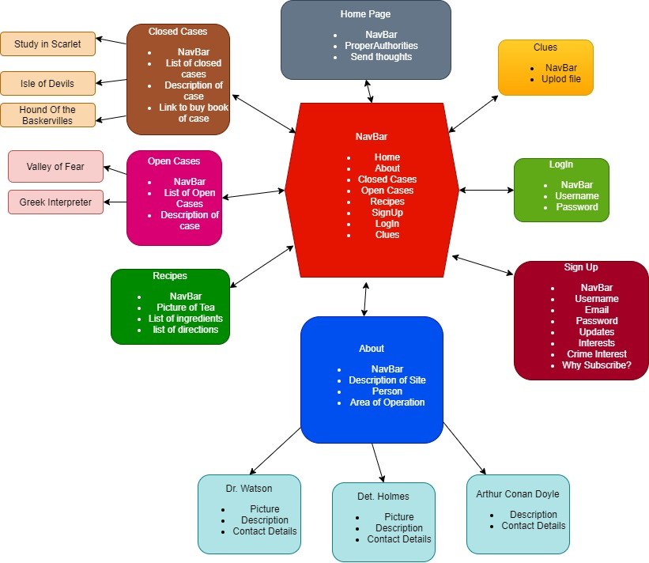

**4th page: Screenshot of your website/webpage**

