Clinical trials failures due to undetected off-targets

Off-targets were in blind spot of the drug development assays

* Need the clinical trials info
* How many known off-targets
* Key limitations

Solution: EpiTox

Technical validation

Experimental data validation

**Abstract**

**Introduction**:

Drug X failed in clinical trials due to undetected off-target Y

Current tools missed this critical off-target

We developed a comprehensive workflow-kit that catches these missed off-targets

Knew already of it in the patent it has low risk

but in clinic MAGEA12 paper 1

then another group used bioinformatic EPS2L8 as the real reason rather than MAGEA12

this was then patented, and the reference came from; the reference still recognized magea12

entire MAGEA family (kick off slides)

none MAGEA members (patent or published)

**Results:**

**Experimental validation**:

(1)

show catching the known off-targets

Ein Bild, das Kreis, Diagramm, Screenshot enthält.

KVADLIHFL: found in melanoma, TVAELVQFV: synthetic & FLWGPRALV is a different sequence (edit distance =9); all are considered true negative since they are not in healthy tissues and one surpasses the edit distance threshold of EpiTox for this target.

(2)

Enrichment analysis:

-rate of validated OT in top ranked predictions vs. random selection, e.g. top 100 contain x% validated OT vs Y% expected by chance -> fisher’s exact test or chi-square test

(3) ranking quality metrics:

- precision-recall curve

- area under the precision-recall curve

- enrichment at top-k: % of known OT in top 50, 100, 200 predictions

Enrichment analysis and ranking score:

N = total number of OT

K = number of known OT (truth set)

n = number of top predictions (bi-features score)

k = number of known OT in n

enrichment = (k/n)/(K/N) >1 great, = 1 same as random, <1 doing worse

Ein Bild, das Text, Reihe, Diagramm, Schrift enthält.

Top 10% (136 predictions): 16/17 (94.1%) known off-targets

Top 20% (272 predictions): 16/17 (94.1%) known off-targets

Top 30% (408 predictions): 16/17 (94.1%) known off-targets

Top 50% (680 predictions): 17/17 (100.0%) known off-targets

Show case: SNPs can lead to discovering highly risked off-target

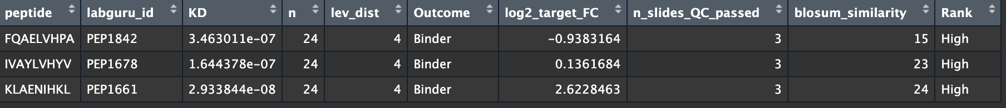

Ein Bild, das Reihe, Diagramm, parallel, Screenshot enthält.

log2(gxp off target +1) - log2(gxp target +1)

mutated off-targets were ranked as high, bind to the antibody and on top highly expressed compared to the target in these normal tissues

the KLA… happens to have a mutation on genomic level that on protein level produces the same peptide sequence. Making the individual carrying the mutation still at risk of side effect

**Compare performance**

Ein Bild, das Kreis, Diagramm, Screenshot, Darstellung enthält.
Ein Bild, das Diagramm, Text, Screenshot, Reihe enthält.
Ein Bild, das Text, Screenshot, Diagramm, Reihe enthält.

The one peptide that CrossDome identifies has 9 mismatches! So nothing to do with the target!

SCORE measurements

**Materials and methods:**

Technical implementation details

Computational methodology – algorithms, DBs, parameters

Experimental protocols for validation

Statistical analysis methods

**Discussion**:

asfsa