Peptide-Centric Off-Target Risk Assessment for TCR-Mimic Antibodies Using Integrated Sequence and Expression Analysis

EpiTox: A Multi-Modal Computational Platform for Population-Aware Off-Target Risk Assessment in TCR-mimic therapeutics and Beyond
Hoor Al-Hasaniª, Other authors^{a,b}
ªBioCopy GmbH, Emmendingen, Germany; ^{b}BioCopy AG, Basel, Switzerland

*Corresponding author:

Abstract
- Problem: Off-target Toxicity from peptide mimicry in TCRm therapies (MAGE-A3 case)
- Gap: No integrated peptide-centric screening
- Solution: EpiTox workflow
- Results: Workflow detects proven MAGE-A3 off-targets
- Impact: Safer drug discovery

Key words
HLA, pHLA, pMHC, TCR-like antibody, peptide-MHC complex, off-target toxicity, preclinical de-risking,…

Acknowledgements

Conflict of interest
All authors are current employees of BioCopy AG or BioCopy GmbH. They may hold shares or stock options in BioCopy AG. BioCopy has patent applications relating to certain research areas described in this article.

Code availability

Data availability

Author contributions

Introduction
- Promise of TCRm/HLA therapies
- Unique risk: mimic peptides --> fatal toxicities
- Existing methods fragmented
Objective: present EpiTox, a peptide centric integrative approach

Related work / State of the art
- Existing peptide-HLA predictors
- Mimicry assessments
- Identified Gap

Current off-target prediction methods have multiple limitations. Most of state-of-the-art tools fail to account for population specific genetic variation (sCRAP, CrossDome) while those who integrates it either they integrate known disease associated mutations or only common SNPs (ARDiTox). Additionally, some would restrict the similarity search with a fixed threshold for similar amino acids (ARDiTox, at least 5 amino acids shared with the target), search space (CrossDome, experimentally validated peptides only), or peptide length (CrossDome is limited to 9-mer peptides). Moreover, some tools would only search specific pool of peptides or their own set (CrossDome, sCRAP), making them good on ranking known off-targets but not novel ones.
To address these limitations collectively, we developed EpiTox (Epitope Toxicity), a multi-modal computational platform that systematically integrates different features including population genetics with comprehensive off-target assessment. EpiTox comprises seven integrated modules: FindTopes uses both BLASTp and PEPMatch algorithm for comprehensive peptide search with customized cutoffs; MutaTopes integrates SNPs from gnomAD to integrate population-specific variation; PrediTopes combines HLA binding predictions with experimental database validation using public resources, IEDB, and inhouse PEPREP. The experimental information is then used to assess the peptide confidence or worth using Bayesian probability; AnnoTopes provide multi-modal risk scoring incorporating binding affinity, sequence similarity, tissue expression, physiochemical properties, and optionally the experimental weight; ViralTopes screens human-hosted pathogen proteomes and XScan module performs systematic binding motif analysis. The last module is the DBfetch which is reposnisble for aggregating, processing and QC all requirements.

Methods
EpiTox is implemented and developed as multiple modules to perform two functions, off-targets identification and peptides annotation. The core was implemented using BioCopy’s High throughput clustering system on Linux platform and slurm for resource management [CITE].

1- EpiTox architecture

EpiTox workflows-kit consists of multiple individual workflows, each is designed to perform specific tasks. The module’s name reflects what the main task or the dominant task of the module. Figure XX shows the different modules, expected input and different routes to perform these tasks.

Figure 1: Flowchart illustrates EpiTox’s different modes and modules interaction. EpiTox has two modes, human and non-human. The human mode has in return two functiones: off-target identification (solid line) and peptides annotation (dotted line). Currently, the non-human mode consists of off-target identification only.

Data acquiring and integration

DBfetch is the dedicated model to acquiring data and standardizing them for EpiTox. DBfetch makes all required materials available, insures error-free cross-referencing and data sanity. This includes different workflows, individual processing for each resource, and periodic updating.
while the whole process is standardized, each resource is investigated to assess that, the compatibility is maintained between all different resources, only then update takes place.

Finally, all input resources are standardized into the format that each module requires.

Databases and inhouse propriety
Along with public resources, EpiTox uses inhouse established resource for experimentally validated peptide-HLA complexes, peptides repertoire (PEPREP). PEPREP is mostly used in PrediTopes module and is used in the two main functionality, off-target identification and peptides annotation.

FindTopes: off-targets identification module
As the name indicates, FindTopes finds peptides that share sequence similarity with the target sequence. The similarity threshold is by default 40%, meaning that all found peptides will share at least that level of sequence similarity with the target. However, for all our targets we generate off-targets sets using different thresholds, 20-70% similarity range to proceed further.

Off-targets peptides are identified using dual-algorithmic approach to maximize the coverage of potential off-targets, all based on sequence similarity to the target.
BLASTp was used in two modes: short with BLOSUM62 substitution matrix and long with PAM250 as substitution matrix. The choice of substitution matrix is heavily driven by the substitution penalties and logic. PAM matrices are generally considered lenient as they are more permissive to substitutions (mismatches are less penalized) and therefore more suitable for distance homologs. By switching to PAM250, BLASTp can retrieve long distanced peptides that could be missed by BLOSUME matrices. PEPMatch is also used with the similarity cutoff to generate one additional list. One list is then constructed from the unique joined results of BLASTp both modes and PEPMatch.
We use the following cutoffs in searching for similar peptides:
- Mismatch cutoff: 3,4, and 5
- Length cutoff: all off-targets must have the same length as the target, 9
- No gaps are allowed
The peptide list generated in this module has the complete mapping of genomic and proteomic location coordinates.

MutaTopes: SNPs integration
Using the genomic coordinates that were extracted in FindTopes, SNPs that were reported in these regions are extracted [CITE] and annotated [CITE]. The SNPs are filtered according to the chosen population of the study, quality and allele frequency that can be specified (default > 0.1). SNPs are then integrated into the peptides (Figure XX) using inhouse developed tools resulting into increasing the final peptides list. Finally, the edit distance of the newly added peptides is calculated, keeping only those within the determined dissimilarity rate while excluding duplicates (same protein, same isoform, same peptide sequence and same position) and other peptides that exceed the dissimilarity threshold.

At this point, the identified peptides/off-targets has the basic information: sequence, gene-protein mapping, transcript-isoform mapping, edit distance, wildtype/mutated annotation and the position on the protein. The size of the list will not change after this module; the resulted peptides list is isoform specific.

Figure 4: same genomic SNPs map to different protein coordinates across isoforms, enabling differential peptide overlap patterns. The resulted peptides have the same sequence if the SNPs alternative allele was identical across isoforms, yet the final peptides list is isoform specific making the peptide unique for its isoform.

PrediTopes: everything HLA important!
Affinity and presentation score are predicted using NetMHCpan [CITE] and MHCflurry [CITE] followed by pulling all experimental information found on IEDB [CITE] and BioCopy’s propriety database for experimentally validated peptide-HLA complexes, PEPREP. Presentation score and affinity were obtained using NETMHCpan and used to classify the off targets [Figure XX].
Figure 5: affinity vs. presentation; pie chart showing peptides categories by binding affinity

PrediTopes provides EDA as well from all experimental information which were retrieved. Information such as the experimentally identified hla-allele, tissue the complex was found in and the binding strength plus other relevant information [Figure XX]. This further information is obtained on two levels, the off-target sequence and the protein id and later used in derisking the off-target.
Figure XX: different annotation obtained by PrediTopes

Bayesian Assessment of Experimental Evidence
To systematically evaluate the relevance of the experimental evidence of each peptide in the predicted list, we developed a Bayesian probabilistic framework. This approach quantifies confidence in peptide being an off-target based on the cumulative strength of available experimental data. Experimental data were first aggregated per peptide, maintaining allele-binding relationships. A neutral prior probability was selected (50%) and was updated using likelihood ratios for: evidence level (number of studies), HLA allele match, binding affinity reported by the reference study (categorical) and tissue match. The posterior probability classified peptides as high (≥80%), medium (50-79%), low (30-49%) or very low confidence (<30%).

The posterior probability for each peptide was calculated using Bayes’ theorem with likelihood ratios as follow:
$$Posterior odds=prior odds × ⊓_{i}{LR}_{i}$$
Where:
$$Prior odds=P\left(H\right)/P(¬H)$$

With P(H) = 0.5 (neutral) and ${LR}_{i}$ represents the likelihood ratio for evidence type i:

$${LR}_{i}=P\left(E_{i }\right|H)/P(E_{i}|¬H)$$
The posterior probability was then calculated as follow:
$$P\left(H | E\right)=posterior odds/(1+posterior odds)$$

AnnoTopes: off-targets annotation and ranking
all annotations are integrated in this module along with gene expression (both on gene and transcript levels) allowing scientists to make further decisions and adding more selection criteria. On top of the annotation peptide ranking/risk scores are integrated. EpiTox offers, in addition to the experimental weight, two different ranking scores:

bi-features score
The score prioritizes off-targets based on similarity to the target, using BLOSUM62 substitution matrix, and its affinity to HLA-allele, IC50 [Figure 7]. The higher the score is the higher the risk is, i.e., highly ranked peptides are more likely to be relevant off-targets and therefore should be included in downstream analysis.
The score function (S) is defined as $S\left(a,b\right)= \frac{f\left(a\right)+g\left(b\right)}{2}$ , where:
$$f\left(a\right)= \left\{1, 0.66, 0.33, 0\right\}for a ∈ \left\{\left[0,50\right), \left[50,500\right), \left[500,5000\right), \left[5000,∞\right)\right\}$$
$g\left(b\right)= \frac{b- b_{min}}{b_{max}-b_{min}}$
The final peptide classification is then estimated using supervised machine learning method, k-means with 3 clusters (EpiTox’s default clustering mode):
$${peptide}_{rank}= {kmeans}_{3}\left(S\right)→\left\{Low, Moderate, High\right\}$$

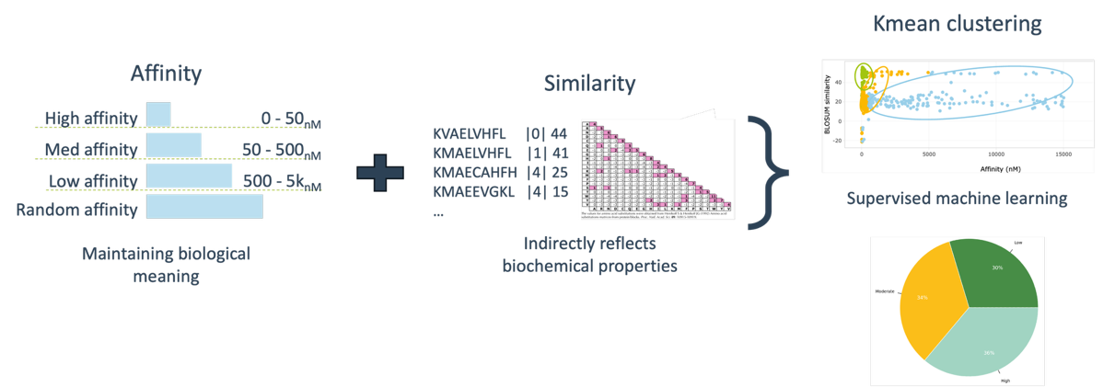
Figure 7: bi-features clustering

multi-features score
The multi-features score is a more sophisticated version that handles high-dimensional feature spaces allowing for a better integration of the peptide’s physiochemical features and other features that contribute to their biological context thus their relevance as off-targets [Figure 8]. First, the feature matrix is constructed $X = \left[x^{1}, x^{2}, …, xₙ\right]∈ Rᵐˣⁿ$, where $m$ m is total number of peptides, $n$ total number of features (affinity, BLOSUM, stability, expression, etc.) and $x_{i}$ represents features vector.
The features are first normalized:
$X_norm = (X - μ) / σ or X_norm = (X - X_min) / (X_max - X_min)$
A dimension reduction technique is used
$Z = DR(X_norm) ∈ Rᵐˣᵏ$ where $k<n$ and $DR ∈\{PCA, t-SNE, UMAP\}$
Followed by unsupervised clustering
$C = Clustering\left(Z, k_{clusters}\right) | C∈\{K-means, hierarchical, DBSCAN\}$
Finally, the ranking is defined as $Rank({peptide}_{i}) = f({cluster}_{i}, {distance_to_centroid}_{i})$

Figure 8: multi features score

XScan: binding motif module
sdafa

ViralTopes: off-targets identification in pathogens module
sdafsd

2- Data sources and computational methods
EpiTox integrates multiple public databases at different points into its different pipelines (Table XX). All datasets were accessed between [2022-2025] and first filtered according to their compatibility with each other, more key parameters for each dataset are provided in (table XX).

Data sources and datasets
Dataset | Purpose | Access date | Filtering | source
Uniprot | Human Protein sequences + protein annotation | Feb 2025 | Reviewed sequences + proteins with valid uniprot ids | https://www.uniprot.org/
gnomAD v2.1.1 leftover to GRCh 38 | SNPs | 2025 | SNPs in exon regions; coding SNPs; AF >0.1; Filter = PASS; population = EUR* | https://gnomad.broadinstitute.org/
Ensembl v110 | VEP indexed cache | 2025 | https://ftp.ensembl.org/pub/release-110/variation/indexed_vep_cache/homo_sapiens_vep_110_GRCh38.tar.gz
HPA v24 | HPA RNA dataset | 2025 | Valid cross-reference with Uniprot | https://www.proteinatlas.org/download/rna_tissue_hpa.tsv.zip
GTEx v8 | Transcript level gxp | 2025 | Valid cross-reference with Uniprot | https://storage.googleapis.com/adult-gtex/bulk-gex/v8/rna-seq/GTEx_Analysis_2017-06-05_v8_RSEMv1.3.0_transcript_tpm.gct.gz
IEDB | Peptide annotation | 2025 | Human; linear peptide; peptide sequence | https://www.iedb.org/
PEPREP | Peptide annotation | 2025 | Human; peptide sequence | BioCopy

Tools and packages
Data processing and analysis employed both established bioinformatics tools, modules and packages, and custom modules within EpiTox (Table XX). Key parameters for each analytical step are provided where applicable.

Tools/package | Purpose | Reference
snakemake 7.24.2
BLASTp
PEPMatch
tabix 1.9
Bcftools
vep
NetMHCpan
MHCflurry
R packages
ggplot2 |  | H. Wickham. ggplot2: Elegant Graphics for Data Analysis. Springer-Verlag New York, 2016.
lessR |  | Gerbing D (2025). lessR: Less Code, More Results. R package version 4.4.5, <https://CRAN.R-project.org/package=lessR>.  Gerbing DW (2021). “Enhancement of the Command-Line Environment for use in the Introductory Statistics Course and Beyond.”  Journal of Statistics and Data Science Education, 29(3), 251-256. doi:10.1080/26939169.2021.1999871  <https://doi.org/10.1080/26939169.2021.1999871>.
biomaRt |  | Mapping identifiers for the integration of genomic datasets with the R/Bioconductor package biomaRt. Steffen Durinck, Paul  T. Spellman, Ewan Birney and Wolfgang Huber, Nature Protocols 4, 1184-1191 (2009).  BioMart and Bioconductor: a powerful link between biological databases and microarray data analysis. Steffen Durinck, Yves  Moreau, Arek Kasprzyk, Sean Davis, Bart De Moor, Alvis Brazma and Wolfgang Huber, Bioinformatics 21, 3439-3440 (2005).
rmarkdown |  | Allaire J, Xie Y, Dervieux C, McPherson J, Luraschi J, Ushey K, Atkins A, Wickham H, Cheng J, Chang W, Iannone R (2024).  rmarkdown: Dynamic Documents for R. R package version 2.29, <https://github.com/rstudio/rmarkdown>.
tidyr |  | Wickham H, Vaughan D, Girlich M (2024). tidyr: Tidy Messy Data. R package version 1.3.1,  <https://CRAN.R-project.org/package=tidyr>.
Python module
Panda
sklearn
Numpy
Bio.SeqUtils
Scipy
peptides
CrossDome | An R package to measure cross-reactivity risk in the sequence-space | Fonseca A (2025). crossdome: An R package to measure cross-reactivity risk in the sequence-space. R package version <https://github.com/antuneslab/crossdome>.
R 4.4.1
Python 3.9.16
*: we followed gnomAD population’s description for selection (see https://gnomad.broadinstitute.org/news/2017-02-the-genome-aggregation-database/)

- EpiTox Workflow
  - Input data
  - Workflow overview
  - Module description
  - Short output description (will be in more detail in results)
  - Technical implementation: databases, models, …
- Experimental setup for the case study
  - Prediction and panel design
    - EpiTox produced a ranked list of candidate off-target peptides for the MAGE-A3 index epitope.
    - Top-ranked peptides, including Titin and EPS8L2, were selected for experimental testing.
    - Peptides were synthesized and printed on a peptide microarray.
  - Binding measured
    - Binding was measured with SCORE
    - Multiple AB screened, here we show one representative candidate with a broad off-target profile (not a lead candidate)
  - Controls and Hit calling
    - Description of negative controls, replicate handling, definition of a “hit”

Figures:
- Epitox Workflow Overview with modules
- Case Study experimental workflow diagram

Results
We used EpiTox to predict off-targets for MAGEA3- KVAELVHFL

EpiTox Output Analysis
Goal: in-silico analysis of the output
- Exploratory data analysis: SNPs, mismatch distributions, annotation layers, expression comparison,…
- Ranking and Enrichment: PR curves, enrichment tests,…
- Comparison to other tools
- Integration of external data (PEPREP)

Figures:
- Examples of EpiTox output
- In silico analysis: risk distribution, enrichment plot, PR curve.
- Performance comparison plots
- …

Case Study: MAGE-A3
Goal: wet-lab grounding; measurement on selected AB candidate
- Known clinical context
- The microarray confirmed binding to critical known targets peptides predicted by EpiTox. (did it?)
- Additional off-target peptides in high EpiTox risk bins also showed measurable binding.
- Expression annotation further underscored critical off-targets high abundance in cardiac tissue, linking directly to observed clinical toxicity

Figures:
- Visualization of kinetic data for the array. (Heatmap/ Bar plot for binding)
- Expression and prog. P-HLA binding for selected OT peptides

Lessons learned:
- Binding-only predictors would not have prioritized critical OT (Titin/EPS8L2 ?).
- EpiTox’s integration of similarity + binding + expression correctly placed these among top risk candidates.
- Demonstrates how a peptide-centric workflow can preemptively flag clinically dangerous off-targets.

Discussion
- Key finding: EpiTox reliably highlight toxic off-target peptides
- Peptide centric paradigm: Enable durable “off-target watchlist” independent of AB candidate identity
- MAGE-A3 lessons: illustrates value of peptide-first screening
- Limitations
- Future work

Conclusions

Clinical trials failures due to undetected off-targets
Off-targets were in blind spot of the drug development assays
- Need the clinical trials info
- How many known off-targets
- Key limitations
Solution: EpiTox
Technical validation
Experimental data validation

Abstract

Introduction:

Drug X failed in clinical trials due to undetected off-target Y
Current tools missed this critical off-target
We developed a comprehensive workflow-kit that catches these missed off-targets

Knew already of it in the patent it has low risk
but in clinic MAGEA12 paper 1
then another group used bioinformatic EPS2L8 as the real reason rather than MAGEA12
this was then patented, and the reference came from; the reference still recognized magea12
entire MAGEA family (kick off slides)
none MAGEA members (patent or published)
anchor positions and their probability to bind to HLA and how this effect the results -> should be discussed

Results:

EDA:

Show case: SNPs can lead to discovering highly risked off-target

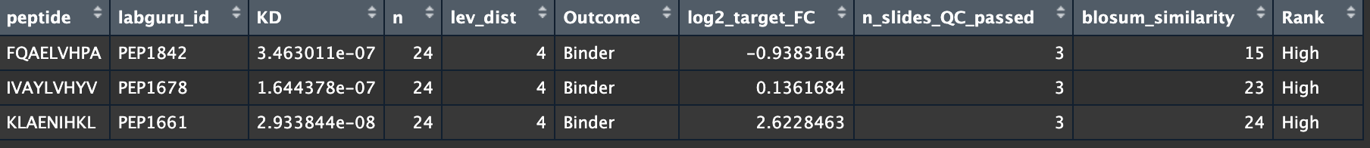

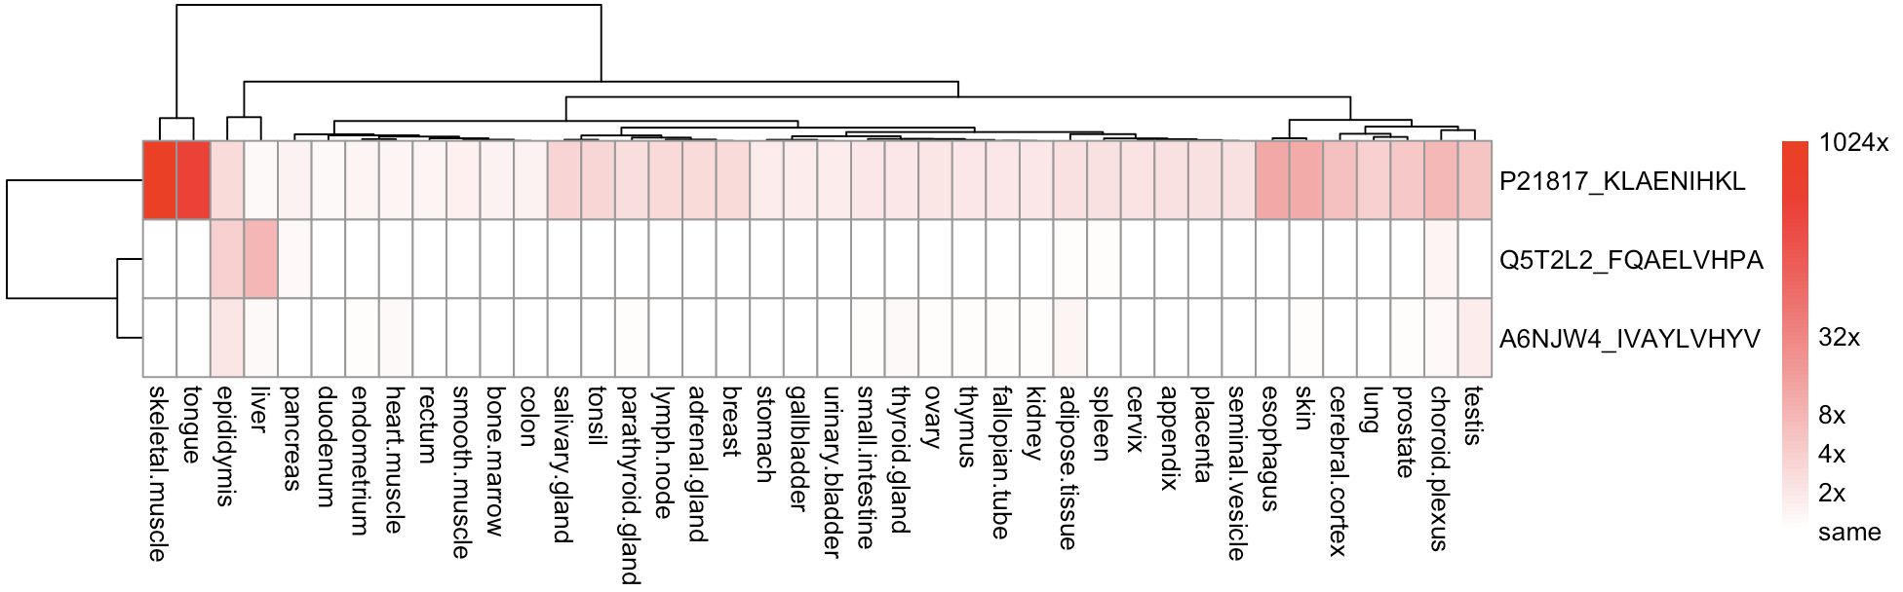
log2(gxp off target +1) - log2(gxp target +1)
mutated off-targets were ranked as high, bind to the antibody and on top highly expressed compared to the target in these normal tissues
the KLA… happens to have a mutation on genomic level that on protein level produces the same peptide sequence. Making the individual carrying the mutation still at risk of side effect

Detailed analysis:
- Safety score or experimental weight score -> show how we are using experimental info from PEPREP and IEDB

Experimental validation:
(1)
show catching the known off-targets

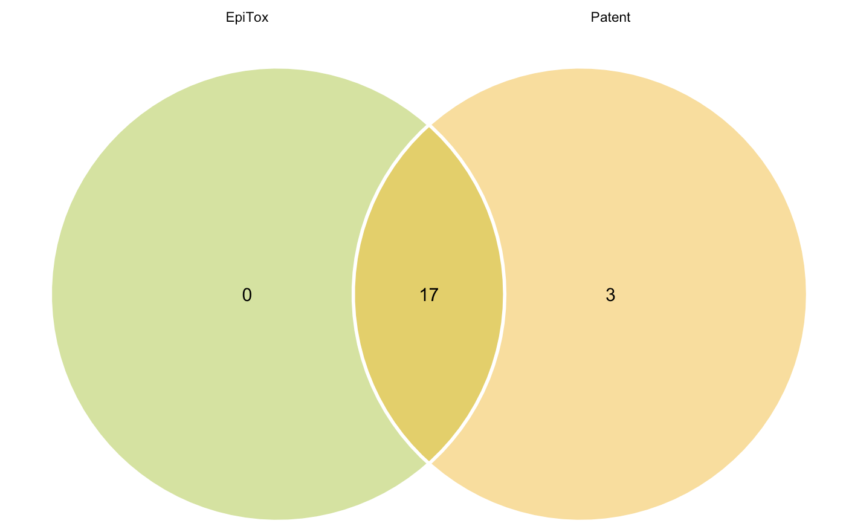

KVADLIHFL: found in melanoma, TVAELVQFV: synthetic & FLWGPRALV is a different sequence (edit distance =9); all are considered true negative since they are not in healthy tissues and one surpasses the edit distance threshold of EpiTox for this target.

(2)
Enrichment analysis:
-rate of validated OT in top ranked predictions vs. random selection, e.g. top 100 contain x% validated OT vs Y% expected by chance -> fisher’s exact test or chi-square test

(3) ranking quality metrics:
- precision-recall curve
- area under the precision-recall curve
- enrichment at top-k: % of known OT in top 50, 100, 200 predictions

Enrichment analysis and ranking score:
N = total number of OT
K = number of known OT (truth set)
n = number of top predictions (bi-features score)
k = number of known OT in n
enrichment = (k/n)/(K/N) >1 great, = 1 same as random, <1 doing worse

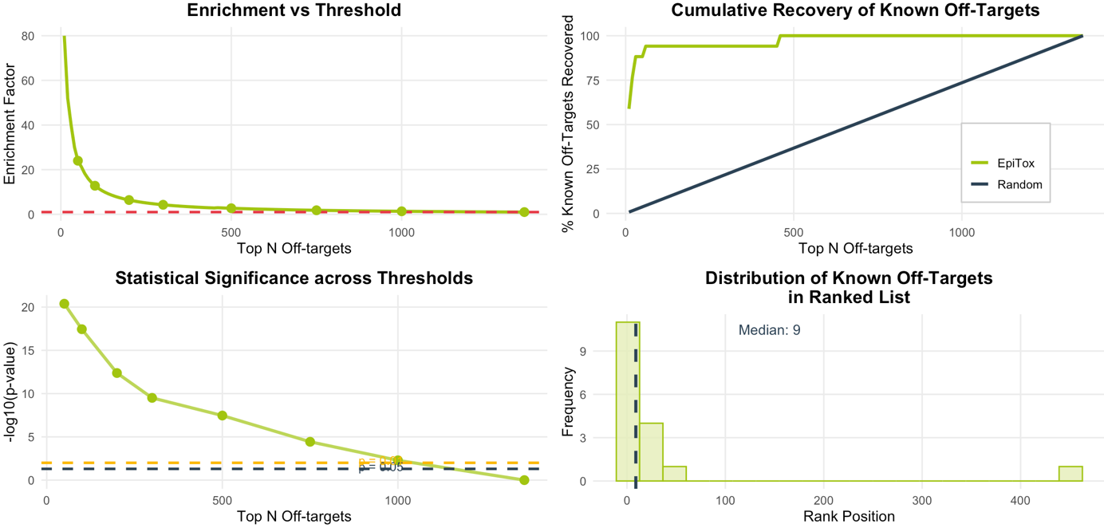

Top 10% (136 predictions): 16/17 (94.1%) known peptides
Top 20% (272 predictions): 16/17 (94.1%) known off-targets
Top 30% (408 predictions): 16/17 (94.1%) known off-targets
Top 50% (680 predictions): 17/17 (100.0%) known off-targets

Differentiation between relevant and not revelant

Compare performance

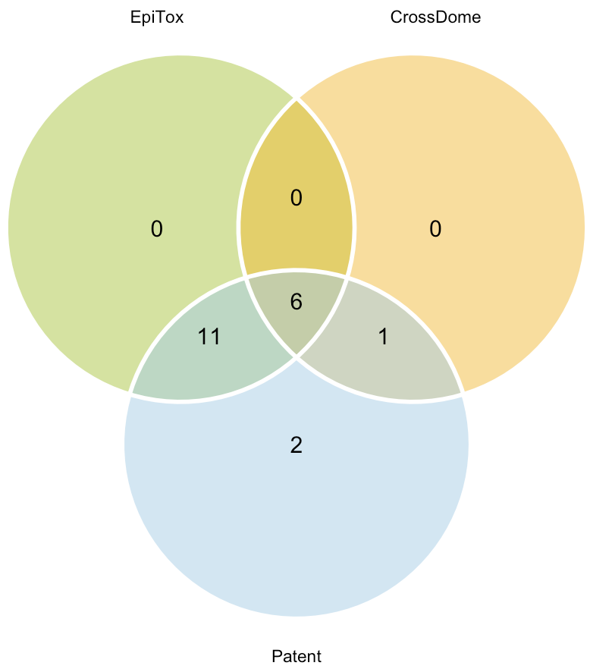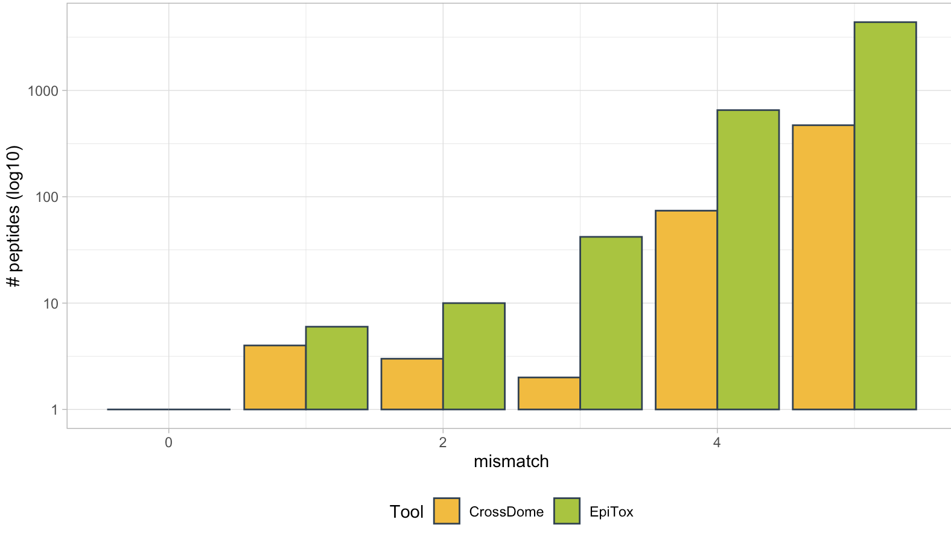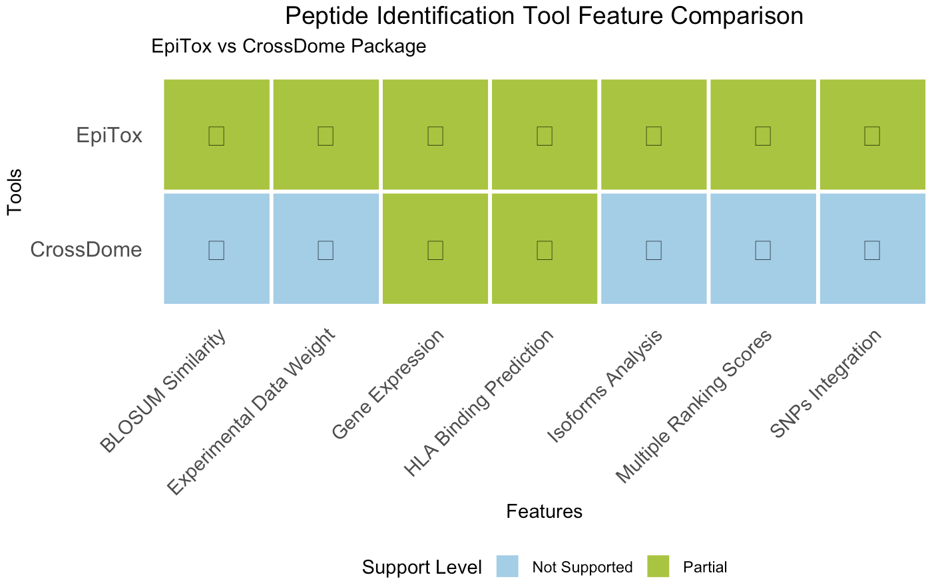

Check if these tools do retrieve the risky off-target
The one peptide that CrossDome identifies has 9 mismatches! So nothing to do with the target!

Crossdome:
- only 9-mer from experimental peptides pool only (hla-ligand atlas, IEDB, systeMHC, HLAthena & two datasets)
- similarity model from biochemical profiles
- used MHFlury and DeepImmuno for annotation
- basically, the created a profile for each known peptide (BP), 9-mer, and used a look-up table for any off-target that might have profile-similarity with the target, regardless of their sequence similarity
- they showed example of known off-targets and that they predicted them correctly!
- Contact map (CM)??

SCORE measurements and validation

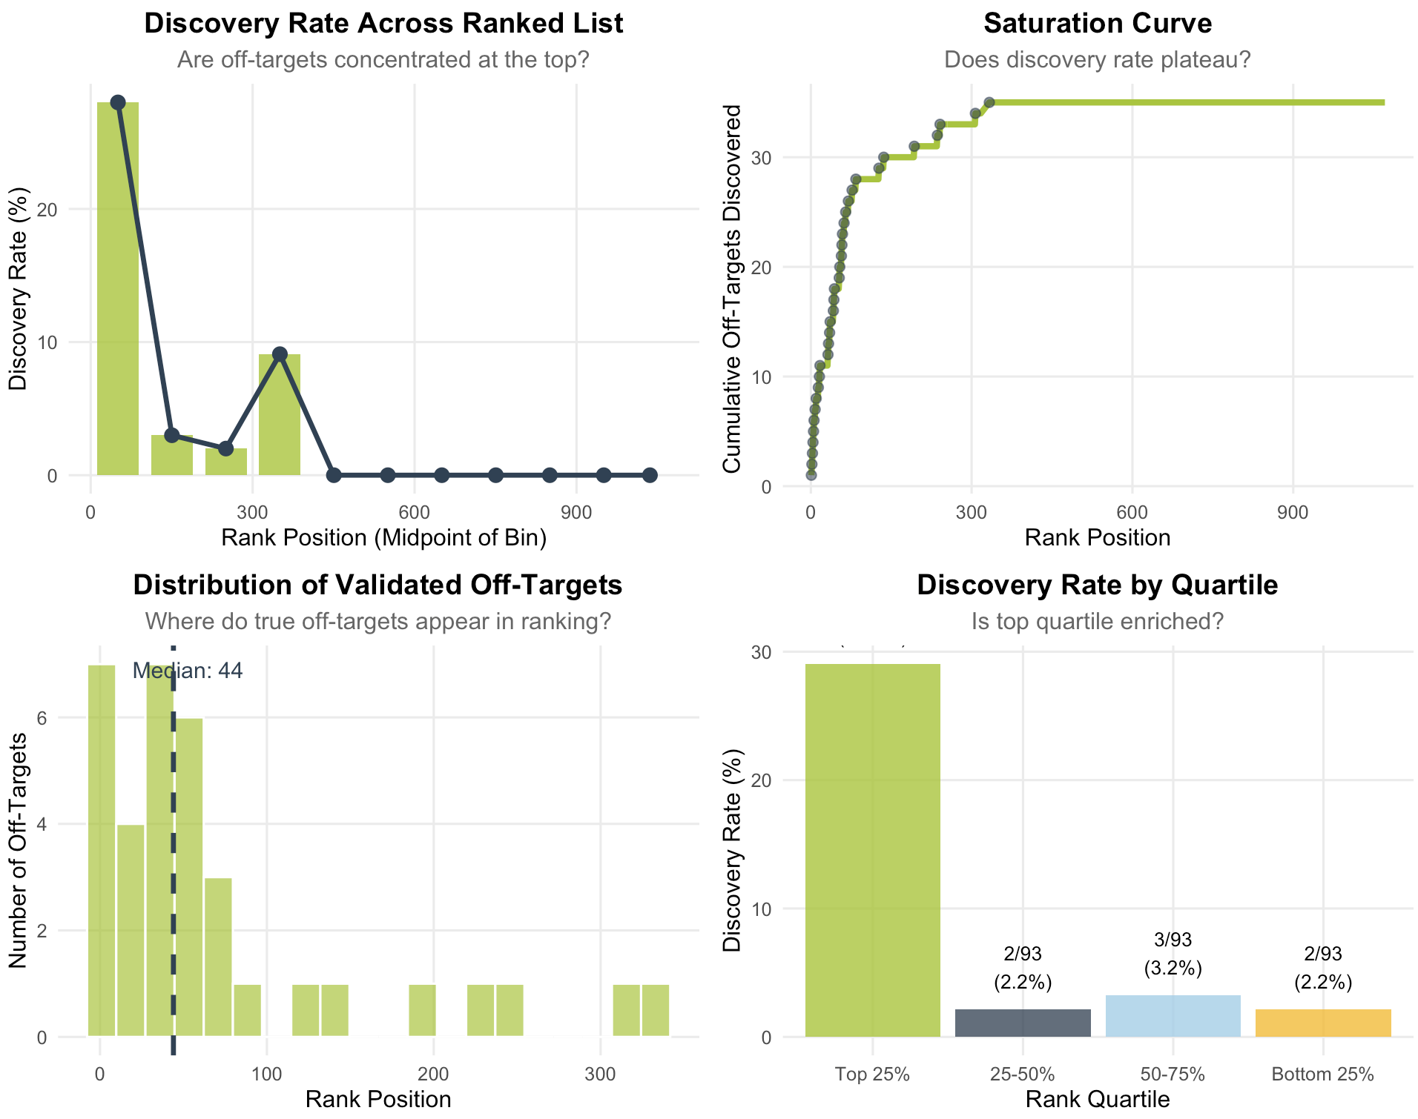

Materials and methods:
Technical implementation details
Computational methodology – algorithms, DBs, parameters
Experimental protocols for validation
Statistical analysis methods

Discussion:
asfsa

