EpiTox: A Multi-Modal Computational Platform for Population-Aware Off-Target Risk Assessment in TCR-mimic therapeutics and Beyond

Hoor Al-Hasani^{a*}, Simon Schusterª, Mazar Aliª, Stefan Krämerª, Alexander Sinclairª, Kirsten Heissª, Tobias Herzª, Pranav Hamdeª, Günter Roth^{b}, Joerg Birkenfeld^{b}, Oliver Selingerª
ªBioCopy GmbH, Emmendingen, Germany; ^{b}BioCopy AG, Basel, Switzerland

*Corresponding author,

Abstract

Targeting intracellular tumor antigens presented by peptide human leukocyte antigen (pHLA) complexes offers a promising immunotherapeutic strategy for patients with limited treatment options. However, development of pHLA-targeted drugs such as T-cell receptor (TCR) mimic antibodies (TCRm) and other TCR-based therapeutics remains challenging due to severe off-tumor and off-target toxicities arising from incomplete pHLA off-target profiling. The fatal neurological toxicities in the MAGE-A3 TCR-T cell trial, caused by unanticipated cross-reactivity with peptides from EPS82L and MAGEA12, highlight the urgent need for improved safety assessment. Current preclinical de-risking methods rely on peptide-centric similarity searches performed in isolation, failing to capture the complex landscape of peptide cross-reactivity and leaving safety gaps unaddressed.
To address these limitations, we developed EpiTox, a computational multi-modular platform that systematically identifies and evaluates pHLA off-targets. EpiTox integrates proteome-wide sequence similarity, genetic context, HLA binding profiles, and layered risk assessment to provide a holistic evaluation of potential cross-reactive peptides. Using MAGE-A3 as a model, EpiTox identified known toxic off-targets and predicted novel epitopes. Notably, an anti-MAGE-A3 therapeutic TCRm antibody bound several newly predicted off-targets, confirming the physiological relevance of these predictions.
By enabling comprehensive and predictive preclinical safety screening, EpiTox supports safer TCRm drug development and may help prevent future clinical failures.

Introduction

The immune system relies on sophisticated surveillance mechanisms to detect intracellular abnormalities that signal infection or malignant transformation. Central to this process is the presentation of intracellular protein fragments on the cell surface by human leukocyte anti-gen (HLA) molecules. Within cells, proteins are continuously degraded into short peptides that are loaded onto HLA molecules and displayed as peptide–HLA (pHLA) complexes. These complexes provide the immune system with a molecular snapshot of the cell’s internal state. When the presented repertoire deviates from normal, such as during viral infection or onco-genic transformation, cytotoxic T lymphocytes (CTLs) recognize these altered pHLA complexes through their T-cell receptors (TCRs), leading to the targeted elimination of affected cells.

Because approximately 75% of human proteins are localized intracellularly, including many oncogenic drivers and tumor-associated antigens, the HLA immunopeptidome represents a vast reservoir of potential targets for cancer immunotherapy. Accessing these intracellular epitopes through HLA presentation expands the druggable proteome beyond the reach of small molecules or conventional antibodies, which are typically restricted to extracellular or cell-surface targets.nAn emerging therapeutic approach that exploits this principle is the development of T-cell receptor mimic antibodies (TCRms). These antibodies share the structural framework of con-ventional monoclonal antibodies but differ fundamentally in antigen recognition: whereas classical antibodies bind conformational epitopes on native surface proteins, TCRms recog-nize linear peptide epitopes presented by HLA molecules. HLA Class I molecules primarily pre-sent 8–10 amino acid peptides, most commonly 9-mers, with occasional longer (11–15) peptides that bulge out of the groove. The resulting pHLA complex forms a composite antigen composed of a variable peptide and a largely invariant HLA scaffold. This architecture imposes unique design constraints and introduces a key safety consideration - cross-reactivity. Similar to TCRs, engineered TCRm antibodies can recognize multiple distinct pHLA complexes with similar surface topologies, potentially engaging self-derived peptides and triggering off-target toxicity.

Clinical experience with TCR-based therapies has highlighted this risk. Several trials were halt-ed due to fatal off-target effects, most notably MAGE-A3-specific TCRs that cross-reacted with a Titin-derived HLA-A*01-restricted peptide (ESDPIVAQY), resulting in lethal cardiotoxici-ty, or with EPS8L2 and MAGE-A12-derived peptides (SAAELVHFL & KMAELVHFL respectively), leading to fatal neurotoxicity. Although such events have not yet been reported for TCRms, the underlying molecular challenge of cross-reactivity is shared between both modalities, underscoring the need for robust preclinical safety assessment.i

A major challenge in developing safe and effective TCR and TCRm therapeutics lies in the pro-spective identification of off-tumor, off-target pHLA complexes. Existing preclinical assays, such as alanine or X-scanning mutagenesis, can reveal critical peptide residues and guide pro-teome-wide similarity searches but cannot directly pinpoint specific off-targets. Over the past decade, several computational tools have been developed to predict TCR cross-reactivity based on sequence or biochemical similarity. Sequence-based methods, including Expitope and iCrossR, rely on peptide identity and HLA-binding predictions to identify related epitopes, whereas biochemical-similarity frameworks such as dGraph and sCRAP leverage physico-chemical descriptors to detect structurally related peptides. These predictions can be refined using biological context, such as mRNA expression, HLA presentation, and peptide processing data, but often lack comprehensive integration. Structure-based approaches attempt to in-corporate three-dimensional TCR–pHLA interaction data, yet their utility remains constrained by limited structural information and the high computational cost of proteome-scale model-ing.eTo overcome some of these limitations, CrossDome was introduced as a next-generation framework for predicting T-cell cross-reactivity and off-target toxicity. Unlike traditional se-quence-based tools, CrossDome leverages experimentally derived immunopeptidomics data from healthy tissues, thereby reducing reliance on in silico peptide predictions. It integrates peptide biochemical properties, structural features, and functional annotations including tissue expression, HLA restriction, and immunogenicity to identify biochemically similar tar-gets independent of strict sequence identity thresholds. This integrative approach enables systematic prioritization of candidate off-targets for experimental validation within TCR dis-covery pipelines. However, CrossDome is optimized for annotating known off-targets and peptides rather than discovering novel ones, as its search space is constrained to the experi-mental dataset, i.e., a fixed predefined pool of candidates. Despite these advances, current prediction frameworks still exhibit key limitations. Most state-of-the-art tools fail to account for population-specific genetic variation (e.g., sCRAP, CrossDome), while those that do either focus on disease-associated mutations or only in-clude common SNPs (e.g., ARDiTox). Others impose restrictive similarity thresholds (e.g., ARDiTox requires ≥5 shared amino acids), limited search spaces (e.g., CrossDome includes only experimentally validated peptides), or fixed peptide lengths (e.g., restriction to 9-mers). Additionally, some tools operate within constrained peptide pools derived from proprietary or pre-validated datasets, which enhances known off-target ranking but limits the discovery of novel cross-reactivities. Consequently, a comprehensive, proteome-wide interrogation of potential off-target pHLA complexes remains elusive.eTo address these challenges, we developed EpiTox (Epitope Toxicity), a multimodal computa-tional platform for systematic off-target assessment in TCR and particularly TCRm develop-ment. EpiTox integrates multiple layers of biological and computational information, includ-ing peptide sequence similarity with customizable thresholds, biophysical descriptors, pre-dicted HLA processing and binding, experimental evidence, and tissue-specific expression, to generate ranked lists of physiologically relevant candidate off-targets.

The framework broadens the search space by incorporating population-specific single-nucleotide polymorphisms (SNPs), non-human viral peptides, and patent-derived sequenc-es, ensuring comprehensive proteomic coverage. Each identified peptide is automatically annotated with gene identity, tissue expression, HLA affinity, and experimental validation status, including available mass spectrometric (MS) evidence.

To quantitatively evaluate the strength of supporting data, we apply a Bayesian statistical model combined with machine learning (ML) to integrate evidence sources such as the num-ber of supporting studies, HLA allele match, reported binding affinity, and tissue relevance. The resulting confidence estimates are incorporated into a multi-feature ranking model that integrates predicted HLA presentation, biophysical similarity, and complex stability to priori-tize high-confidence off-target candidates.mWe demonstrate that EpiTox accurately predicts and prioritizes physiologically meaningful candidate peptides for kinetic off-target screening of TCRms. In an anti-MAGE-A3 TCRm dis-covery campaign, EpiTox successfully identified previously known lethal off-targets and nov-el, unrecognized ones, validating its predictive power and practical utility in preclinical safety assessment. Furthermore, kinetic datasets derived from EpiTox-prioritized off-targets pro-vide physiologically relevant information that can be used to train ML models for proteome-wide prediction of off-target interactions, enabling identification of sequence-divergent yet biophysically similar pHLA complexes. In conclusion, EpiTox offers a comprehensive, data-driven framework for identifying and prioritizing physiologically relevant off-targets for any given pHLA target. The resulting off-target sets enable high-throughput kinetic screening, while the derived kinetic landscapes support the training of neural networks for proteome-wide prediction of sequence-unrelated off-targets, advancing both the safety and precision of TCRm therapeutic discovery.

Methods

1- Data sources and computational methods
EpiTox integrates multiple public databases at different points into its different pipelines (supplementary Table 1). All datasets were accessed between [2022-2025] and first filtered according to their compatibility with each other, more key parameters for each dataset are provided in (supplementary table 1).

Tools and packages
Data processing and analysis employed both established bioinformatics tools, modules and packages, and custom modules within EpiTox (supplementary Table 2). Key parameters for each analytical step are provided where applicable.

2- EpiTox architecture

EpiTox workflows-kit consists of multiple individual workflows implemented with Snakemake [CITE], each is designed to perform specific tasks. The module’s name reflects what the main task or the dominant task of the module. The different modules serve two functions, off-targets identification and peptides annotation. The core was implemented using BioCopy’s High throughput clustering system on Linux platform and slurm for resources management [CITE].

Data acquiring and integration

DBfetch is a model dedicated to acquiring data and standardizing it for EpiTox. DBfetch makes all required materials available, insures error-free cross-referencing and data sanity. This includes different workflows, individual processing for each resource, and periodic updating. While the whole process is standardized, each resource is investigated to assess that compatibility is maintained between all different resources, only then update takes place.

Finally, all input resources are standardized into the format that each module requires. (see supplementary tables 1 & 2)

Databases and inhouse propriety
Along with public resources, EpiTox uses in-house established resource for experimentally validated pHLA complexes, peptides repertoire (PEPREP). PEPREP provides different information for each peptide, for example HLA-allele, disease, tissue, being an epitope. This information is later leveraged to estimate the peptide experimental weight in module three, PrediTopes.

X-Scan: binding motif module
To identify the binding motif the target sequence is modified one amino acid at the time. The total modified version of the target sequence would be $L×19$. The affinity to the hla-allele is then predicted using NetMHCpan with every variation. Four different scores are calculated to estimate pHLA binding motif.

Given a target of length L; for every Position [1..L],
the estimated mean value for every position i is calculated as $\overline{{Pos}_{{KD}_{i}}} = \frac{1}{19}\sum_{1}^{19}{{KD}_{i}}$

Mean fold change score = $\overline{{Pos}_{{KD}_{i}^{mutated}}} /{KD}^{WT}$
Sensitivity score = $(max{({Pos}_{{KD}_{i}^{mutated}})}-\min{{(Pos}_{{KD}_{i}^{mutated}}))}/ {KD}^{WT}$
% better than WT = $\operatorname{count}\left({Pos}_{{KD}_{i}^{mutated}} ≤ {KD}^{WT}\right)/ n × 100$
Best than WT = ${KD}^{WT} / \min{{(Pos}_{{KD}_{i}^{mutated}})}$
Relative variability via coefficient of variant (CV) = $\operatorname{sd}{{(Pos}_{{KD}_{i}^{mutated}})} / \overline{{Pos}_{{KD}_{i}^{mutated}}}$
The position can be classified into four main categories:
- Classical: mean FC and sensitivity are true
- Permissive: if % better than WT is true
- Flexible: if the position met the criteria of both classical and permissive
- Neutral: if none of the above

Sensitivity and CV reflect variability; we provide CV (a scale-free metric) as an additional option to be use instead of the sensitivity for classification or in a different setup.

Note on Method Generalizability: While this study uses computational binding predictions from NetMHCpan, our functional profiling framework is agnostic to the source of HLA binding data. Position-specific sensitivity analysis requires only comparative binding affinities across substitutions at each position, which can be derived from either computational predictions (as used here) or experimental binding measurements. This flexibility enables application to rare or poorly- characterized HLA alleles where prediction algorithms may have limited training data, by substituting experimental HLA binding assays (e.g., competitive binding, T2 stabilization, or pHLA microarrays) for the X-Scan module. The topology classification framework remains unchanged regardless of data source.

FindTopes: off-targets identification module
As the name indicates, FindTopes finds peptides that share sequence similarity with the target sequence. The similarity threshold is by default 40%, meaning that all found peptides will share at least that level of sequence similarity with the target. We typically generate multiple off-targets sets using different thresholds, 20-70% similarity range to proceed further.

Off-targets peptides are identified using dual-algorithmic approach to maximize the coverage of potential off-targets, all based on sequence similarity to the target.
BLASTp [CITE] was used in two modes: short with BLOSUM62 substitution matrix and long with PAM250 as substitution matrix. PEPMatch [CITE] is also used with the similarity cutoff to generate one additional list. One list is then constructed from the unique joined results of BLASTp both modes and PEPMatch.
We use the following cutoffs in searching for similar peptides:
- Mismatch cutoff
- Length cutoff: all off-targets must have the same length as the target
- No gaps are allowed
The peptide list generated in this module has the complete mapping of genomic and proteomic location coordinates.

MutaTopes: SNPs integration
Using the genomic coordinates that were extracted in FindTopes, SNPs that were reported in these regions are extracted [CITE] and annotated [CITE]. The SNPs are filtered according to the chosen population of the study, quality and allele frequency that can be specified (default > 1%). SNPs are then integrated into the peptides (supplementary figure?) using in-house developed tools resulting in increasing the final peptides list. Finally, the edit distance of the newly added peptides is calculated, keeping only those within the determined dissimilarity rate while excluding duplicates (same protein, same isoform, same peptide sequence and same position) and other peptides that exceed the dissimilarity threshold.

Off-Target Dissimilarity Analysis
We then proceeded to characterized sequence dissimilarities between the target peptide and off-target candidates based on the position-specific binding profile established above (X-Scan). Off-target peptides were classified using target as a sequence template, i.e., according to the sequence mismatches pattern relative to the target. For each off-target peptide, we performed position-by-position sequence comparison with the target peptide and quantified mismatches within each position category. Off-target peptides were characterized by number of mismatches at anchor positions, exposed positions, flexible anchor positions, and finally overall sequence identity (%).
Off-targets were then categorized into groups based on their mismatch patterns:
- Anchor-only: One or more mismatches at anchor positions, potentially altering peptide-MHC complex structure
- Backbone-only/Intact: Anchor positions conserved but exposed positions differ, maintaining presentation but potentially avoiding antibody recognition
- Both: mismatches are everywhere
Peptide backbone is defined as all positions between anchor positions that found above. This approach ensures handling rare alleles with unknown binding motif.

At this point, the identified peptides/off-targets have the characteristic information: sequence, gene-protein mapping, transcript-isoform mapping, edit distance, mismatch profile, wildtype/mutated annotation, and the position on the protein. The size of the list will not change after this module; the resulted peptides list is isoform specific.

PrediTopes: HLA binding prediction and pHLA assessment
Affinity and presentation score are predicted using NetMHCpan [CITE] and MHCflurry [CITE] followed by pulling all experimental information found on IEDB [CITE] and PEPREP. The predicted presentation score and affinity were used to classify the off targets [Figure 2b].
PrediTopes provides EDA as well from all experimental information which was retrieved. Information such as the experimentally identified hla-allele, tissue the complex was found in and the binding strength plus other relevant information [Figure 2d]. This further information is obtained on two levels, the off-target sequence and the protein id and later used in off-targets contextual analysis.

Bayesian Assessment of Experimental Evidence
To systematically evaluate the experimental evidence supporting each predicted peptide-HLA interaction, we developed a Bayesian probabilistic framework that quantifies confidence based on cumulative strength and contextual relevance of available data.

Data preparation
Experimental data were aggregated for each protein-peptide pair (uniprot ID – peptide sequence), preserving allele-binding relationships and associated metadata including tissue/disease context, binding affinity measurements, and study quality indicators. This protein-specific aggregation ensures that evidence assessments reflect the exact biological context of each peptide's source, rather than conflating data across homologous proteins with identical subsequences

Bayesian framework

We implemented a multiplicative Bayesian update using likelihood ratios (LRs) to integrate evidence from multiple sources. Each protein-peptide pair began with a prior probability of 0.5.

The posterior odds for each pair were calculated as
$$Posterior odds=prior odds × ⊓_{i}{LR}_{i}$$
Where $Prior odds=\frac{P\left(H\right)}{P\left(¬H\right)}=\frac{0.5}{0.5}=1$, and ${LR}_{i}$ represents the likelihood ratio for evidence type i.
the posterior probability was then derived as:
$P\left(H | E\right)=posterior odds/(1+posterior odds)$
Likelihood ratio assignments
LRs were assigned based on biological relevance and evidence strength:
Evidence quality:
- Multiple high-relevance studies: target allele + tissue context, LR = 12
- Single high-relevance study: LR = 8
- Multiple/single medium-relevance studies: LR = 6/4
- Multiple/single low-relevance studies: LR = 3/2
- No experimental evidence: LR = 0.3
HLA allele specificity:
- Target allele match: LR = 10
- Different allele: LR = 2
- HLA class match (when allele is unknown):
  - Same: LR = 2
  - Different: 0.5
Binding affinity
- Base LR: strong = 5, intermediate = 3, weak = 2, non-binder = 1
- Target-specific multipliers: strong = 2.5x, intermediate = 1.5x, weak = 1x, negative = 0.2x
Tissue/disease context
- Normal tissue: LR = 10
- Same disease (optional): LR = 6
- Similar tissue: LR = 3
Protein-peptide pair were classified into four evidence groups based on the probabilities: High (≥80%), medium (50-79%), low (30-49%), and very low (<30%)

AnnoTopes: off-targets annotation and ranking
All annotations are integrated in this module along with gene expressions (both on gene and transcript levels) allowing scientists to make further decisions and adding more selection criteria.
On top of the annotation, peptide ranking/risk scores are integrated. EpiTox offers, in addition to the experimental weight, two complementary ranking scores:

Bi-features score:
The score prioritizes off-targets based on similarity to the target, using BLOSUM62 substitution matrix (b), and its affinity to HLA-allele (a), [Figure 1]. The score is bounded [0-1], the higher the score is, the higher the risk is, i.e., highly ranked peptides are more likely to be relevant off-targets and therefore should be included in downstream analysis.
The score function (S) is defined as $S\left(a,b\right)= \frac{f\left(a\right)+g\left(b\right)}{2}$ , where:
$$f(a)= \{1, 0.66, 0.33, 0\}for a ∈ \{[0,50), [50,500), [500,5000), [5000,∞)\}$$
$g\left(b\right)= \frac{b- b_{min}}{b_{max}-b_{min}}$
The final peptide classification is then estimated using supervised machine learning method, k-means with 3 clusters (EpiTox’s default clustering mode):
$${peptide}_{rank}= {kmeans}_{3}\left(S\right)→\left\{Low, Moderate, High\right\}$$

Multi-Biophysical Feature Scoring:
To complement the Bi_features ranking, we computed eight biophysical properties: five global features (GRAVY, pI, net charge at pH 7.4, aromaticity, aliphatic index) and three position-specific features for TCR-facing backbone residues at previously estimated positions (backbone GRAVY, backbone charge, backbone aromaticity). All features were computed and z-score normalized. Target anchor & backbone positions were determined in the X-Scan module, and the associated off-target positions classification was determined after obtaining the final list from MutaTopes.
Features were weighted based on mismatch location relative to HLA anchors, these weights within each category were normalized to sum to 1. When anchors are intact, HLA presentation is maintained and TCR recognition of exposed backbone residues dominates; when anchors are disrupted, global properties affecting presentation become more relevant. Therefore, the weights are Anchor intact (backbone mismatches only): Backbone features weighted 3.0×, global features 1.0×; Anchor mismatch (backbone intact): Global features weighted 2.0×, backbone features 1.0×; Both (mismatches everywhere): Global features 1.0×, backbone features 1.5×
Multi-biophysical distance from the target peptide was computed as weighted Euclidean distance:
$$d= \sqrt{\sum{w_{i}{(X_{i}- X_{0i})}^{2} }}$$
where `xᵢ` and `x₀ᵢ` are normalized feature values for off-target and target peptides, and `wᵢ` is the conditional weight for feature `i`. Peptides were ranked by ascending distance (rank 1 = most similar).

Disagreement Analysis:

Bi_features score combined normalized BLOSUM62 similarity (min-max scaled to 0-1) with categorized binding affinity (KD binned into biologically relevant ranges: <50nM, 50-500nM, 500-5000nM, >5000nM). The two components were averaged to create a composite score ranging from 0 to 1, where higher values indicate greater predicted cross-reactivity risk. Multi-biophysical distance was computed as weighted Euclidean distance from the target peptide. Given the bounded nature of Bi_features (0-1) versus the unbounded Euclidean distance metric, both were converted to ranks for comparison. This identifies which specific biophysical properties drive divergence from Bi_features ranking.

ViralTopes: off-targets identification in pathogens module
The module focuses on non-human genomes by identifying off-targets in human hosted species, e.g., HIV. The off-targets identification process follows the same approach used in FindTopes and applying the same cutoffs and criteria (length, edit distance, etc.). The current version of EpiTox offers these results as optional metric with the potential of adding more comprehensive analysis when it is needed.

3- Experimental validation

Goal | Approach | rationale
Known risk only | Bayesian evidence + one  ranking score | Prioritizing empirical knowledge
Pragmatic | Bi-feature score | Intuitive + good sensitivity
Mechanistic characterization | Multi-feature score | Feature contribution
Novel peptides only | Bi-feature + multi-feature | Comprehensive prediction
High-confidence set | Consensus (2+ scores) | Multiple orthogonal information

Validation Candidate Selection

Peptides for initial experimental validation (Cohort 1, n=XX) were selected based on Bi_features ranking prior to development of the multi-biophysical scoring approach. Following retrospective analysis comparing both methods, we designed a second validation cohort (Cohort 2, n=XX) using a stratified selection strategy to test predictions from both approaches: (1) consensus high-priority peptides (high scores by both methods), (2) Bi_features-specific predictions (high Bi_features, low multi-biophysical similarity), (3) multi-biophysical-specific predictions (low Bi_features, high multi-biophysical similarity), and (4) maximum disagreement cases. Candidates were selected using three strategies: top 15 by Bi_features, top 15 by multi-biophysical distance, and top 10 by disagreement score. Duplicates were removed, yielding ~40 unique candidates spanning both consensus predictions and method-divergent cases.
Sample Distribution: Testing Status and Outcomes
Peptides were selected for experimental validation based on different prediction strategies aligned with specific drug development goals:
- Anchor Status: Baseline assessment of peptide binding potential
- Bi-features Rank: Sequence similarity and HLA affinity (n=XXX tested)
- Experimental Evidence: Bayesian empirical risk (n=XXX tested)
- Multi-features Rank: Physicochemical features with anchor weighting (n=XXX tested)
- SNPs-derived peptides: Reference sequences (n=XXX tested)

Peptide–HLA array production and SCORE measurements
Peptide–HLA array production and SCORE measurements were performed essentially as described previously [31]. Peptides were purchased from Peptides & Elephants GmbH (Hennigsdorf, Germany), and biotinylated, stabilized HLA-A*02:01 variant was used [32]. The antibody was measured in its fab format to avoid avidity effects. The binding curves were fitted and analyzed using an internal version of anabel and a 1:1 Langmuir binding model [33].

Results

1 – EpiTox integrates biological knowledge with statistical frameworks
To address critical gaps in current off-target prediction methods, specifically the lack of proper usage of experimental data, integration of population genetics and limited peptide context coverage, we developed EpiTox, a multi-modular platform for comprehensive drug safety assessment. EpiTox integrates six modules: X-Scan performs a systematic target-HLA binding motif analysis through single-residue substitution to identify critical positions and potential antibody-exposed residues; FindTopes applies dual-algorithm search for peptides in human proteome sequences with user defined dissimilarity penalty; ViralTopes screens pathogen proteomes; MutaTopes incorporates population-specific variants with customized AF threshold (default >1% of the population) and population selection (see methods); PrediTopes focuses on HLA binding prediction then leverages pre reported experimental data through Bayesian probability framework to employ the experimental knowledge and finally, AnnoTopes provides multi-modal risk scoring to proceed with off-target validation. We demonstrate EpiTox’s capabilities through experimental validation using our inhouse technology (SCORE) and systematic benchmarking.

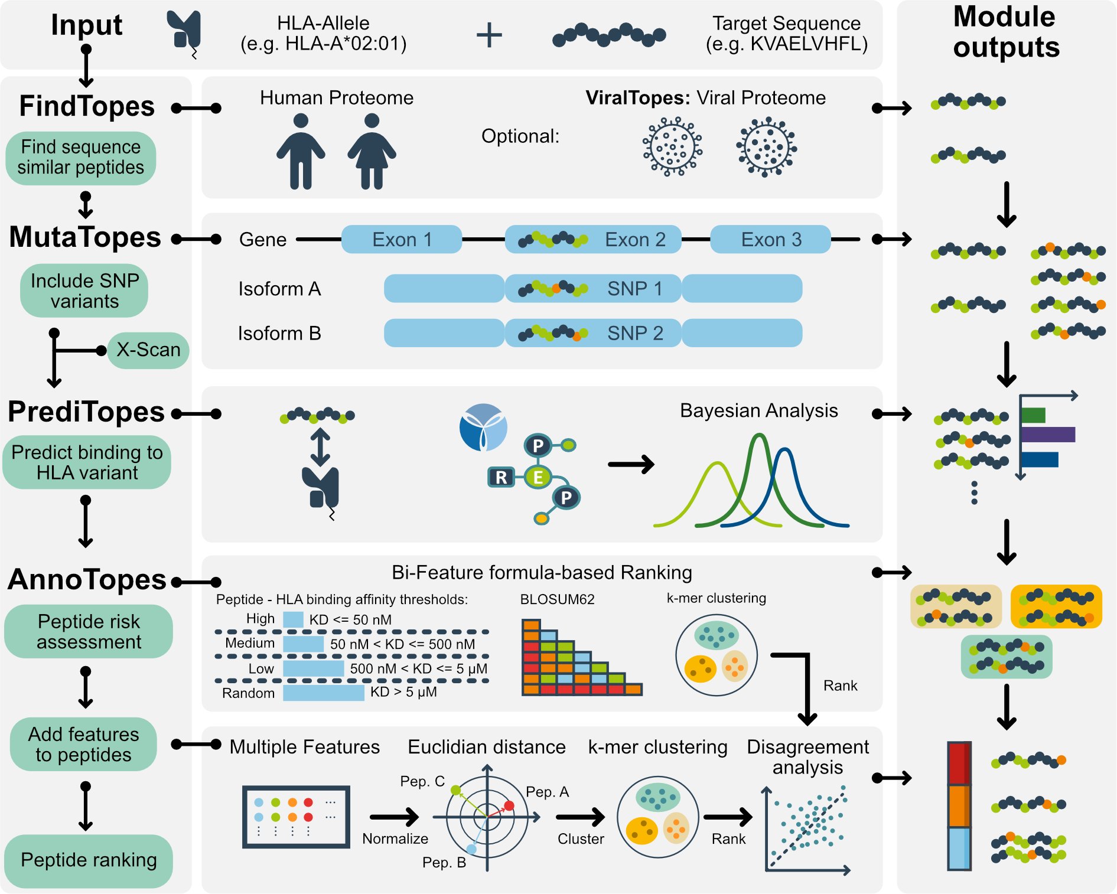

Figure 1: EpiTox integrates six computational modules for comprehensive off-target risk assessment. FindTopes or ViralTopes) perform dual-algorithm sequence similarity search with dissimilarity penalty in human genome or in non-human genomes. X-Scan) generates synthetic peptide list based on 19*L substitutions and characterizes target based on in-silico motif characterization. MutaTopes) population-specific variant analysis to integrate SNPs and generate SNPs-derived peptides. SNP can map to different protein coordinates across isoforms, enabling differential peptide overlap patterns. The final peptides list is isoform specific making the peptide unique for its isoform. PrediTopes) HLA predictions: processing, affinity and presentation using NetMHCpan followed by peptide contextual assessment: experimental evidence is determined with Bayesian analysis by leveraging public and propriety experimental data (PEPREP & IEDB). AnnoTopes) two different ranking scores are used to classify the peptides, Bi-feature score incorporates sequence similarity and binding affinity to the HLA-allele. Multi-feature score integrates eight global and local physiochemical features while applying binding profile weights, finally a decision matrix presents a roadmap on using different ranking.

2 - Comprehensive off-target identification for MAGE-A3

We applied EpiTox to predict and prioritize off-targets for MAGEA3- KVAELVHFL with focus on European population [CITE], the primary target demographic for clinical development (Figure 2). Our analysis integrated population-specific variant analysis, Bayesian evidence weighting, binding motif characterization, and direct experimental testing to provide comprehensive risk assessment.

Position-specific analysis shows binding residues landscape

We performed HLA-A*02:01 binding profile characterization of the target peptide (KVAELVHFL) to identify positions critical for presentation and assess their tolerance for sequence alteration/variation (see methods: X-Scan). The analysis (Table 1) confirmed positions P2 and P9 as classical anchor positions, consistent with the established HLA-A*02:01binding motif [CITE:1], and P1 as a third possible anchor position, with >80% of substitutions at these positions resulting in weakend binding (mean fold-change >5.96). Sequence variation or mutations at anchor positions are known to alter peptide backbone conformation within the MHC groove [CITE 2,3], potentially disrupting both MHC presentation and consequently antibody recognition. Therefore, off-targets with maintained anchor positions are more likely to adopt similar backbone conformations and warrant further investigation for cross-reactivity assessment, even though sequence differences in backbone positions, may ultimately prevent antibody recognition.
In contrast, positions P3 & P5 were classified as permissive, with 60-70% of amino acids substitution and maintained the binding affinity within 2-fold of wildtype. These permissive positions not only tolerate diverse amino acids without disrupting MHC presentation, but they are indicative of, when mutated/varied are less likely to alter the overall pHLA complex structure. However, positions forming the backbone are surface-exposed ones and may serve as antibody epitope, therefore, off-targets with sequence variation at permissive positions may still require experimental validation for cross-reactivity assessment.

Table 1: position classification summary
Position | WT AA | Classification | FC_mean | Sensitivity | % Better than WT
P1 | K | Classical | 5.96 | 39 | 15.79
P2 | V | Classical | 24.41 | 108.67 | 15.79
P3 | A | Permissive | 1.63 | 3.9 | 31.58
P4 | E | Neutral | 1.91 | 2.8 | 5.26
P5 | L | Permissive | 1.12 | 0.6 | 31.58
P6 | V | Neutral | 1.43 | 1.46 | 15.79
P7 | H | Neutral | 1.62 | 2.65 | 0
P8 | F | Neutral | 1.5 | 1.8 | 5.27
P9 | L | Classical | 305.99 | 1135.26 | 10.53
Table 1: position-specific binding metrics and classification for MAGE-A3 peptide, KVAELVHFL. FC_mean: mean fold change in KD upon substitution. Sensitivity: normalized range of KD change. % better than WT: percentage of substitutions with better KD than target.

Off-targets prediction
We then predicted off-targets with an edit distance <5 from the target (see methods: FindTopes & MutaTopes). The analysis identified 1454 putative off-targets for MAGEA3- KVAELVHFL, of which 1304 were wildtype sequences and 150 were European-specific variant-derived sequences (Figure 2a). No SNPs-derived peptides were found among highly similar off-targets, edit distance <3,
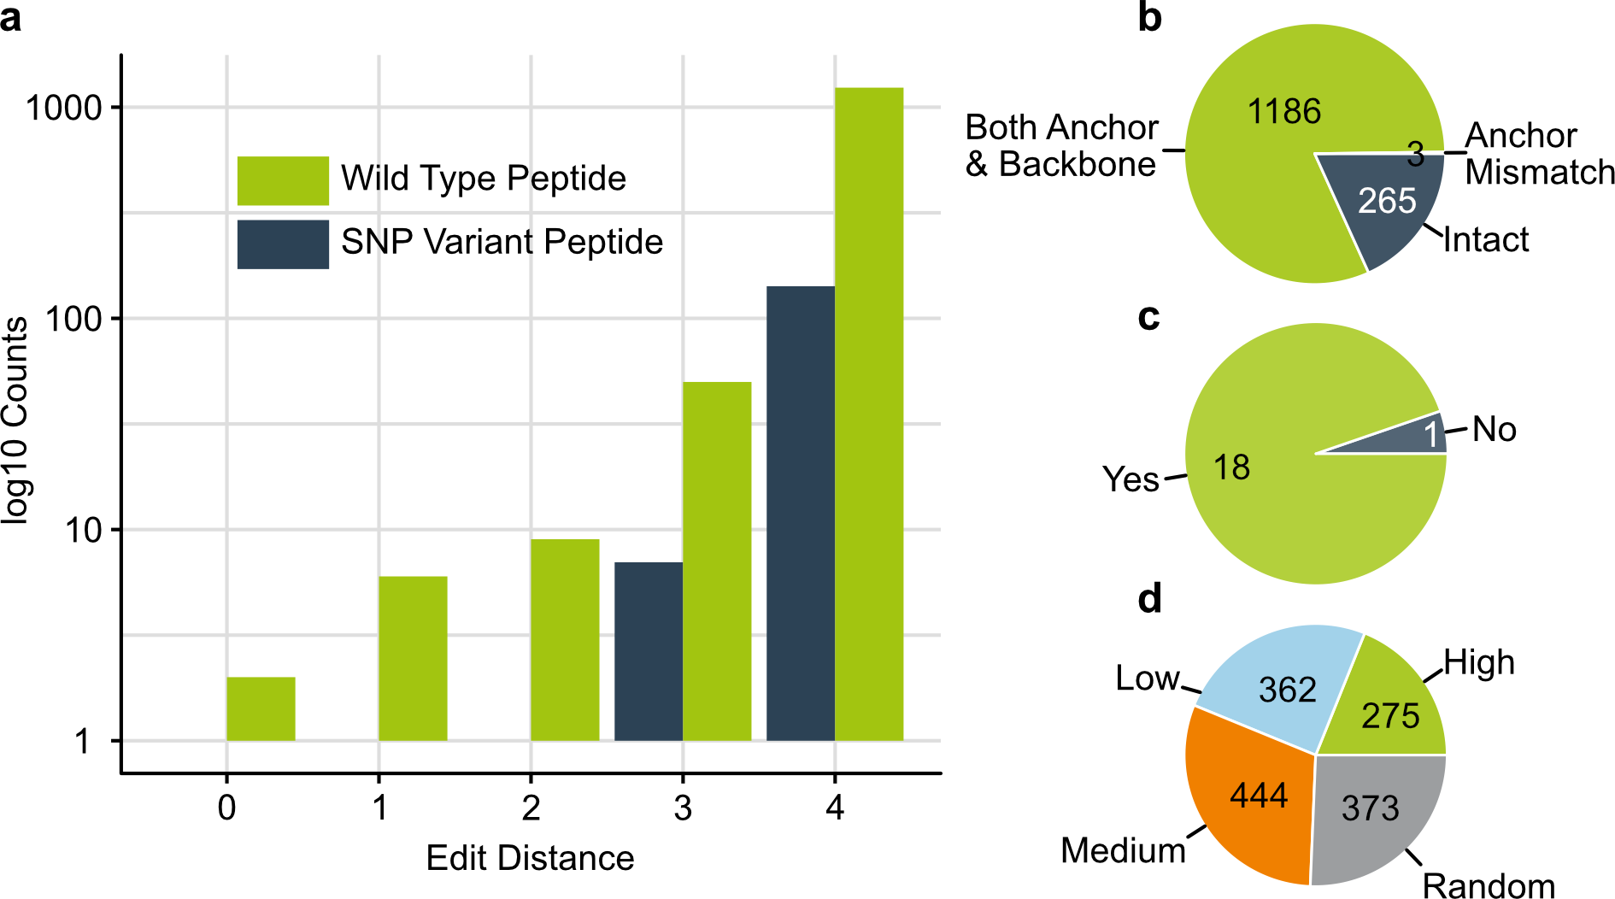
Figure 2: selected output from EpiTox using MAGEA3-KVAELVHFL. a) bar chart of identified peptides in human proteome distributed according to their edit distance to the target. The plot shows two categories, the wildtype peptides and the SNPs-derived peptides. (b) position mismatch classification of the predicted peptides according to the target binding profile (c) number of disclosed peptides in previous patents and studies that were identified by EpiTox, only one peptide was missed by EpiTox due to quality checks during data aggregation. (d) peptides are categorized by their binding affinity to HLA-A*02:01 according to NetMHCpan; ~50% of the peptide have moderate to high binding affinity.

According to the classification we obtained from the target (table 1), around 19% of off-targets have sequence mismatches within the backbone positions only (Figure 2b), indicating that their anchor positions remained intact and therefore, pHLA complex is likely to form. Furthermore almost 81% of the predicted off-targets have their sequence variation both in anchor and permissive positions, making the safety assessment in needs for further and in-depth inevitable. Only three peptides have mismatches exactly at the anchor positions, MAGEA12- KMAELVHFL with one mismatch at P2, EPS8L2- SAAELVHFL with two mismatches at P1 & P2 and PPP2R1B-GIAELVHFS with three mismatches at all classified positions P1, P2 & P9.
Interestingly, in total six predicted off-target have exactly one mismatch to the target, of which only one had its mismatch at the anchor position, a known off-target the MAGEA12- KMAELVHFL [CITE 4, 5], the rest five had their single mismatch in the backbone only. Following on, EpiTox identified 18/19 peptides that were previously disclosed in patents and studies (Figure 2c, supplementary table 3). The missing off-target was MAGEA5-KVADLIHFL due to quality controls we applied during data aggregation. We also retrieved MAGEA9 as a perfect match to the target. Several of the top peptides with the lowest edit distance were, as expected, from the MAGE family.

The binding metrics to HLA were then predicted for every peptide in the list (Figure 2d). Accordingly, 277 peptides were highly binders (mean KD = 28.3 nM), 444 medium binders (mean KD = 179 nM), low binders (mean KD = 1999 nM), and 373 random binders (mean KD = 14960 nM). As expected, the predicted affinity exposed the largest variation in peptides with mismatches at both anchor positions and backbone (Supplementary figure XX). Interestingly, the three peptides with mismatches at anchor positions showed also different binding, while MAGEA12- KMAELVHFL and EPS8L2- SAAELVHFL both showed high affinity (KD = 10.8, 29.5 nM respectively) showing a similar level to those who have intact anchor positions; on the other hand, PPP2R1B-GIAELVHFS was predicted to have moderate affinity (KD = 1313.3nM) suggesting that the binding to HLA was compromised due to the mismatch at all classified anchor positions.

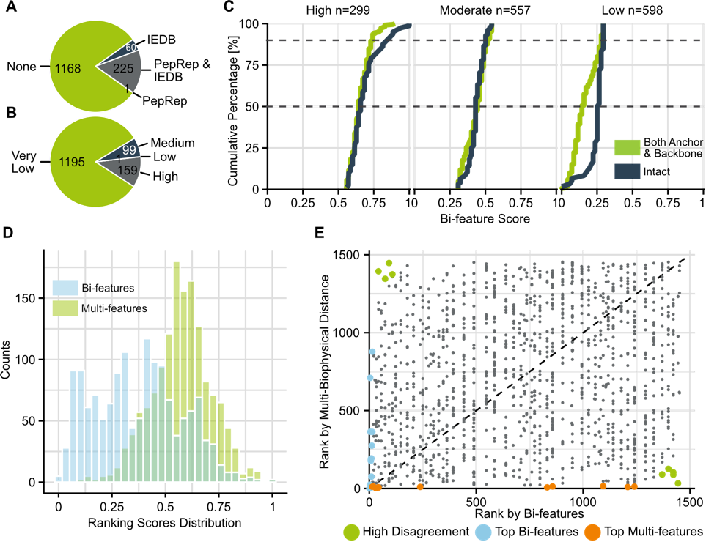
Figure 3: A) peptides with available experimental data according to PEPREP (inhouse source for pHLAs) and IEDB. Accordingly, 80% of the predicted peptides have no previous record, indicating their potential for being novel off-targets. B) peptides classification according to experimental evidence: once the experimental data obtained from IEDB and PEPREP is leveraged, peptides were classified by their context relevance to this study, ~11% were of high relevance, as their relevance is being observed in normal tissues and with strong binding evidence to HLA-A*02:01. C) CDFs of Bi_features score stratified by risk rank (High, Moderate, Low) according to k-mer method, and anchor status (Intact, Both Anchor & Backbone). Peptides with mismatches at anchor positions (n=3) were excluded due to small sample size. Dashed lines indicate 50th and 90th percentiles. D) histograms of Bi_features score, and Multi_features score across all off-target peptides. Low correlation (ρ = 0.19) demonstrates orthogonal risk dimensions: Bi_features score quantifies immunological cross-reactivity (sequence similarity and MHC affinity), while Multi_features score integrates physicochemical properties (hydrophobicity, charge, aromaticity, aliphatic index, pI) influencing peptide-MHC stability and TCR recognition, weighted by anchor status. E) Scatter plot comparing the ranked Bi_features and Multi_features scores. High Disagreement (upper-left and bottom-right corners), Top Bi_features (lie on the y-axis with x value = 0), and Top Multi_features (lie on the x-axis with y-value = 0) categories highlight peptides prioritized differently by each method. Dashed line indicates perfect rank agreement.

Bayesian integration of experimental evidence extends risk assessment

In total, 286 peptides were previously reported in MHC and t-cell assays (PEPREP + IEDB), none of them was a SNP-derived (Figure 3a). Moreover, 141 peptides were found in normal or healthy tissues according to both PEPREP and IEDB, 70 of which were found binding to HLA-A*02:01.

We recognize that peptides reported in previous studies may lack allele specificity, and sometime having been observed binding to multiple alleles. Moreover, experimental evidence for binding to the allele of interest is extremely context-dependent. Therefore, we developed a contextual risk intelligence approach using Bayesian algorithm (See methods: PrediTopes) to distinguish peptides with strong experimental evidence from novel peptides not previously reported in experimental studies or MHC databases.

While experimentally validated peptides are valuable, novel peptides may still pose safety risks. We therefore set our prior probability at 50%, indicating that novel peptide has an equal chance of being a legitimate off-target and should be considered for safety testing. Admittedly, this assumption is rather a conservative approach for safety screening.

Our model classifies peptides into four evidence levels based on posterior probabilities (Figure 3b). High evidence (posterior probability ~99.7%) is assigned when peptide was reported with same allele of interest and found exclusively in normal tissues. The evidence chain accumulates with additional supporting information such as multiple independent studies, reports from related HLA superfamily or class, and relevant tissue or disease context.
Medium evidence (~64.3%) indicates moderate relevance, such as when the peptide was reported with different but related allele (e.g., same HLA class) or showed intermediate affinity with other alleles. Low evidence (~31.0%) applies when the peptide was observed with generally intermediate-to-low binding signals, yet neither allele nor class were given. Very low evidence (~23.1%) is assigned when the peptide was not found in any prior context.

Our model classified 159 peptides (11%) as high evidence (mean = 99.7%, SD = 0.19), 99 peptides (7%) as medium evidence (64.3), 1 peptide (<1%) as low (31.0%), and 1195 (82%) as very low evidence (23.1%) (Figure 2d. III). These posterior probabilities reflect the multiplicative integration of evidence across allele specificity, binding affinity, tissue context, and study quality (see methods, PrediTopes)
Protein-context specificity in evidence assessment
Current epitope prediction tools and some databases typically aggregate experimental data by peptide sequence alone [CITE], potentially conflating evidence across distinct protein sources. To assess whether this approach is appropriate, we examined 94 peptide sequences appearing in multiple proteins within our dataset.
Most sequence-identical peptides (84/94, 89%) lacked experimental validation for any protein source. Among the 10 with available data, 4 showed differential confidence classifications depending on protein context (Supplementary Table X). For example, KVDEAVAVL received High evidence for PABP1/PABP4 but Very Low for PABP3, while AVHELGHAL showed Medium evidence for MMP14 but Very Low for MMP15/16/24 demonstrating that experimental validation is protein-specific and non-transferable across homologs.
These findings highlight that sequence-based evidence aggregation, as commonly implemented risks inappropriate confidence inflation for unvalidated protein contexts.
Contextual evidence distinguishes sequence-identical therapeutic target from potential off-target
The therapeutic target, MAGE-A3 (P43357), shares an identical peptide sequence with MAGE-A9 (P43362), a potential cross-reactive off-target. Sequence-based methods (similarity scoring, structural prediction, physicochemical properties) cannot distinguish these peptides. However, our evidence-based framework differentiated them substantially (LR products: 10,000 vs 270) based on experimental validation contexts: MAGE-A3 showed strong binding in normal tissue studies, while MAGE-A9 demonstrated intermediate binding exclusively in cancer contexts. Both achieved High evidence classifications, but with 37-fold difference in cumulative evidence strength reflecting distinct experimental profiles. This demonstrates how context-aware evidence aggregation provides discriminatory power beyond sequence-level analysis, enabling informed prioritization even among structurally identical epitopes (Supplementary Table X).

Peptides ranking
While the Bayesian evidence captures the empirical risk, we developed two complementary approaches for off-target risk assessment, each addressing distinct biological questions:
Bi-feature binding score [0-1]: Integrates HLA binding affinity with BLOSUM62-based target similarity, providing a thermodynamic-sequence perspective on cross-reactivity potential. Multi-feature mechanistic score [0-1]: Incorporates 8 features with HLA allele-specific weighting based on binding architecture, differentiating mismatches at anchor positions, backbone residues, or both.
Bi-features Ranking
Peptides distributed across three risk categories: high risk (n=299, median score = 0.64), medium risk (n=557, median score = 0.44), and low risk (n=598, median score = 0.16) (Figure 2d). SNPs-derived peptides were also represented across all risk categories: high risk (n=26, median score = 0.67), medium risk (n=59, median score = 0.44), and low risk (n=65, median score = 0.14) (Figure 3c).
Peptides classified as high-risk exhibited both strong predicted HLA binding affinity to HLA-A*02:01 (median affinity: 30 nM) and med to high BLOSUM62 sequence similarity to MAGEA3 target (median similarity score: 21). Notably, [2/3] peptides with mismatches at the anchors demonstrated strong MHC binding affinity (KD < 30nM), comparable to intact anchor peptides. This finding underscores the limitation of relying solely on structural classifications and supports the use of integrated functional scores. Finally, GO enrichment of the origin proteins revealed enrichment for GTPase regulatory activity and Rho signaling.
We assessed whether Bi_features ranking correlated with the experimental evidence we estimated earlier. Our ranking algorithm showed significant concordance with experimental validation status (χ² test, p < 0.05, Supplementary Figure X). This concordance confirms that our ranking algorithm successfully prioritizes peptides with known immunogenic potential while maintaining comprehensive coverage of all predicted off-targets regardless of available experimental data.
We then checked whether our ranking method captures biologically relevant off-targets, we examined the scores assigned to 18 previously reported/validated off-target peptides [CITE]. Among these known peptides, 17 peptides were classified as high risk and 1 as medium risk. Specifically, the rank score of MAGEA9 was 1 as it has the exact same target sequence; the peptides previously reported and speculated to be involved in fatal neurotoxic cases EPS8L2 and MAGEA12 [CITE] (0.9 and 0.87 respectively) due to slightly different similarity and affinity. Notably, PPP2R1B was the only peptide from the known list and the only peptide that has three mismatches exclusively at the anchor positions that was assigned a moderate risk 0.47 demonstrating that the Bi-feature score was sensitive to mismatches that compromise the forming of pHLA.
Overall, this distribution demonstrates that our affinity-similarity ranking effectively prioritizes peptides with established off-target potential.
Multi-Biophysical Feature Scoring Complements Bi-features Ranking
We computed eight biophysical properties for the peptides and compared this multi-biophysical approach with our established Bi-features ranking. Feature weights were adjusted based on mismatch location. When anchor positions, P1, P2 and P9, were intact (n=265, ~18.2%), TCR-facing backbone features received 3-fold weight, as HLA presentation is maintained and TCR recognition dominates cross-reactivity risk. When only anchor positions contained mismatches (n=3, 0.2%), i.e., backbone P3-P8 remained intact, global physicochemical properties received higher weight, as altered HLA binding affects overall peptide presentation. For peptides with mismatches at both anchor and backbone positions (n=1186, ~81.6% of dataset), equal weights were applied.
The two ranking scores showed weak pairwise correlations (Spearman ρ = 0.19), confirming they capture distinct dimensions of off-target risk. This orthogonality is because the two methods capture different but complementary aspects of peptide similarity. High-priority peptides identified by Bi_features show elevated biophysical similarity (mean = 0.71) compared to the full dataset (mean = 0.57), indicating partial concordance in the high-risk region despite low overall correlation (Figure 3d).
We finally examined cases where bi-feature and multi-feature scores diverged (Figure 3E). To facilitate the comparison with Bi_features categories, we applied k-means clustering (k=3) to multi-biophysical distance values, yielding three categories: High Similarity (closest to target, n=361), Moderate Similarity (n=758), and Low Similarity (most distant from target, n=335).
- Case 1 - High Bi-feature, low Multi-feature (n=32 peptides): these are cases where physiochemical features miss good binders. Peptide Q15546- KVVELFFYL, with intact anchors but Multi-feature score of only 0.369 and backbone GRAVY of -1.007 (versus target's 0.983), exhibits binding affinity virtually identical to the target ( KD 14,8 versus 14.4 nM). The Bi-feature method correctly identifies this as a strong binder (BLOSUM62 = 23, affinity = 14,8 nM), while the Multi-feature approach would rank it poorly, over-weighting backbone physicochemical divergence relative to anchor integrity.
- Case 2 - Low Bi-feature, high Multi-feature (n=125 peptides): these are the cases where physiochemical similarity not translating to biological function. Two peptides (Q9UII4-LVAELVGYR, Q9BZ81-KVGLLEQFL) with identical sequence dissimilarity (BLOSUM62 = 18) exhibit a 5-fold difference in HLA binding affinity (2,414 vs 11,598 nM). The key distinction: anchor position integrity. The Bi-feature score cannot detect this critical difference since they both have low affinity, while Multi-feature score relying on physicochemical features correctly prioritizes anchor preservation, ranking the functionally superior peptide higher despite its worse backbone hydrophobicity profile (supplementary table XX).
These patterns suggest none of these characteristics alone is sufficient to draw a conclusion and they are all needed together to make a final derisking
Figure 4: Experimental validation of EpiTox predicted peptides. A decision matrix was generated to prioritize peptides for validation using highSCORE. A) Proportions of predicted versus tested peptides across different classification categories. The stacked bar charts show the distribution of position-specific mismatch related to the target, experimental evidence levels, multi-feature rank categories, and wildtype versus SNP-derived peptide status. B) Complex heatmap showing gene expression profiles across multiple tissues for confirmed binders according to highSCORE. Gene expression values are displayed as log2 fold-change relative to target expression in the tissue. Top annotations from outermost to heatmap: disclosed peptide (disclosed peptide versus not disclosed peptide); Anchor status (Anchor intact, mismatch, backbone and anchor); wildtype (WT) versus SNP-derived peptides; log2(KD_target) (log2-transformed KD fold-change relative to target; negative values indicate lower binding affinity compared to target, positive values indicate higher affinity); bar plot showing total gene expression (total gxp) summed across tissues per peptide. Bottom annotations indicate: Bi-feature rank, Multi-feature rank, and Experimental Evidence anchor status categories, binding feature ranks, multi-feature ranks, experimental evidence levels.

3 – Validation

We used the molecule XXX as a model molecule to validate our results, knowing that these results are antibody-specific and that a different off-target landscape can emerge from using a different antibody. Figure 4.A illustrates the schematic validation step that follows EpiTox.
In total, 538 peptides were tested using our highSCORE assay (see Methods), exceeding typical experimental validation in computational immunology studies (check selection strategy in Methods, Table XX). Of these, 171 were generated from the X-scan, of which 6 peptides were already identified as off-targets in EpiTox list with exactly one mismatch. In the following sections, we will be discussing the remaining 373 peptides that EpiTox predicted, annotated, and ranked.

Figure 4.A illustrates the experimental validation outcomes across our prediction strategies. Each category represents a different risk assessment approach aligned with our decision matrix (Table XX). The distribution of tested versus untested peptides reflects our strategic prioritization: categories with higher proportions of untested peptides represent lower-priority candidates under that particular scoring framework. In total, 37 peptides bound to the reference antibody. While 11 were previously disclosed as MAGEA3 off-targets, 26 were novel in this context. Notably, our Bayesian scoring method identifies peptides based on MHC databases (IEDB and PEPREP) evidence independent of target identity (figure 4.B), enabling detection of off-targets that may be known for related antigens but overlooked for the specific target of interest.
The binders, ~10% of tested peptides, were identified across multiple prediction strategies, validating the complementary nature of our multi-modal approach.
Notably, PPP2R1B-GIAELVHFS was the only peptide in our panel with mismatches exclusively at the anchor positions (P1, P2, and P3), and it did not achieve a consensus rank within our three-level ranking system (high, moderate, very low). Experimental validation demonstrated that it does not bind to the antibody, reinforcing our classification of binding positions and highlighting the critical role of positional context in experiment design.

Figure 4.B shows the gene expression profiles of source proteins for all 37 confirmed binders relative to the target. The gene expression revealed an instructive pattern: disclosed off-targets (n=11) predominantly showed target-like expression (7/11), while novel off-targets (n=26) were enriched for elevated expression (22/26, ≥2-fold). Critically, this distribution emerged because EpiTox applies expression as a post-prediction annotation rather than a selection criterion.

Sequence logo analysis of validated peptides, Figure 4.C, reveals conservation patterns consistent with HLA-A*02 anchor requirements (positions 1-3, hydrophobic residues) and a putative antibody recognition motif at position 4 (acidic residue, E). Variable positions (5-8) suggest antibody tolerance for substitutions at peripheral contact sites. This pattern validates that EpiTox captures peptides with shared MHC presentation and antibody cross-reactivity potential.

Population-specific variants reveal novel off-targets risks
Our initial results suggest that integrating SNPs not only modify existing off-targets, but they could result in new off-targets that wouldn’t exist in the wildtype proteome.
35 SNP-derived peptides representing different disagreement scenarios between the two scores (all were novel, so experimental evidence was identical to all = very low) were tested (Table 2), three of which emerged as binders to the antibody.

 | High | Moderate | Low
High | 9 | 15 | 2
Moderate | 1 | 4 | 1
Low | 0 | 3 | 0
Table 2: SNP-derived peptides which were selected for testing. Columns are the classification by the Multi-feature score, and rows are by Bi-features score. Peptides that both scores agreed on low were not included.
Interestingly, Q5T2L2-FRAELVHPA is the wildtype peptide has moderate affinity to HLA-A*02:01 (KD = 1584.9nM) and moderate similarity to the target (BLOSUM62 = 14); therefore, applying the different logics of our ranking scores disqualified this peptide from testing. However, the SNP-derived version of it, Q5T2L2-FQAELVHPA (SNP = rs376200113, p.Arg94Gln), increased the affinity to hla allele to very high (KD = 23.4nM) and it similarity (BLOSUM62 = 15); this elevation switched the risk of this peptide by Bi-feature score to high-risk group while its rank by Multi-feature score remained unchanged. The peptide therefore was tested and proved to be a binder with almost two-fold decreased affinity to the antibody compared to the target (log2_KD_FC = -0.9). However, the expression level of its source was at the same target’s level with elevated level in the liver and epididymis (4FC & 2FC respectively) indicating tissue-specific cross-reactivity or side toxicity.
A striking find is peptide P21817-KLAENIHKL (rs746904839, p.Glu879Lys), compared to its wildtype peptide P21817-KLAENIHEL, this peptide has very similar predicted affinity (13 nM) and exact similarity score (BLOSUM62 = 24); the two peptides were ranked as high risk according to the Bi-feature score but low by the Multi-feature score. The testing not only confirmed the SNP-derived peptide is the binder, but also at a higher level compared to the target (log2_KD_FC = 2.6 nM). Moreover, the overall gene expression in all 40 normal tissues was higher than the target, with extreme levels in the skeletal muscle and tongue (>8 log2 (FC)). This peptide highlights the need to include SNPs in the early screening, as individuals with genetic modification can suffer overall side toxicity.
Finaly, A6NJW4-IVAYLVHYV represents the opposite scenario of the previous two, as the SNP didn’t improve its initial scores (rs140521451, p.Met236Ile), affinity to HLA dropped from 16.7 to 22.5 nM, yet still affine, sequence similarity also dropped from 25 to 23. The Bi-feature score ranked this peptide as highly risky and the Multi-feature score as moderate. When tested, the peptide bounded to the antibody at least one-fold better than the target (0.14) and its overall expression level was also target-level with elevated level at epididymis, choroid plexus and pancreas (GET EXACT VALUES).
Experimental evidence and validation
We further validated our predictions against the Bayesian model we established for experimental evidence. Of the confirmed binders, 12 peptides were neither found in previously disclosed off-target lists nor in major MHC databases (IEDB, PEPREP). Three of these peptides were SNP-derived peptides as described in the previous section. Analysis of the remaining 9 peptides revealed that approximately half showed elevated expression across multiple tissues, while the other half exhibited expression levels comparable to the therapeutic target but with tissue-specific elevation patterns in placenta, esophagus, choroid plexus and other tissues. These findings demonstrate that reliance solely on existing evidence-based filtering may overlook genuine immunogenic risks, particularly for under-characterized epitopes or those with tissue-restricted expression.

Discussion

The importance of TCR mimic (TCRm) therapies has increased substantially in recent years, with the role of HLA in triggering immune responses being increasingly exploited for therapeutic benefit. However, minimizing cross-reactivity through comprehensive off-target prediction and validation remains a crucial aspect of antibody characterization and development.
Current approaches to off-target assessment rely heavily on peptide selection based on experimental evidence, whether generated from specific peptide pools or obtained from public repositories. While we acknowledge the value of experimental data, using it as a preselection criterion is shortsighted, as it creates a significant blind spot in off-target searches by overlooking potentially novel off-targets that lack prior evidence. Furthermore, public MHC databases exhibit well-documented biases toward high-affinity peptides and specific HLA alleles and are heavily context-dependent, risking the exclusion of genuinely immunogenic epitopes simply because they have not yet been experimentally characterized. Our method, EpiTox, addresses this critical limitation by avoiding binary filtering based solely on the presence or absence of experimental validation. Instead, we developed a Bayesian evidence classification system that does not rank peptide quality per se but rather provides transparent context about what is experimentally known versus unknown. This framework allows researchers to make informed decisions tailored to their specific projects, whether prioritizing well-characterized risks or exploring novel epitopes that may represent genuine immunogenic threats.
Regarding the integration of genetic variation, current approaches focus primarily on trait-associated SNPs (TAS), i.e., genetic mutations with established associations to specific diseases or cancer types and use them as filtering criteria to include or exclude peptides. In risk assessment scenarios, we argue that SNPs should be prioritized and used as peptide-inclusion criteria rather than exclusion criteria. SNPs have been widely used to explain ethnicity-specific phenotypes, many of which are not readily observable. It is surprising that despite the central role of HLA in these therapies, this important aspect has not been effectively implemented as a standard practice. We therefore integrated this logic into our standard workflows, and our data demonstrate that these SNPs can lead to unintended binding events that only individuals carrying specific SNPs will experience.
Another limitation we identified is the reliance on a single ranking metric that attempts to encapsulate all features and logic. We believe this oversimplifies the problem, as cross-reactivity is inherently complex, and the relevance of different features varies depending on the therapeutic context and target selection. Therefore, we not only incorporated empirical risk (experimental evidence) but also established two distinct scoring systems: a Bi-feature score and a Multi-feature score. Each captures different aspects of peptide similarity and ranks peptides differently, highlighting distinct facets of similarity to the target that could potentially confuse antibody recognition.

Rather than viewing these methods as competing, we propose they serve complementary roles in off-target assessment. The Bayesian evidence weighting provides contextual classification and counts for the empirical risk with Multi-feature weighted score provides comprehensive risk evaluation incorporating gravy, aromaticity, isoelectric Point, net charge at pH7.4, and aliphatic index, while the Bi-features score offers HLA binding likelihood with sequence similarity. Users can leverage the three to gain a more complete understanding of off-target landscape. Cases of strong disagreement may warrant experimental attention, as they likely represent side toxicity. We also provide a decision matrix as a practical roadmap for interpretation.

While dimension reduction techniques such as PCA are commonly employed in similar analyses, we found that Euclidean distance on the full feature set provided robust ranking performance with greater interpretability. Future work could explore whether dimensionality reduction improves computational efficiency depending on the experimental setup.

We demonstrated the capability of EpiTox via MAGEA3 as a case study. We successfully identified and validate 37 off-targets, of which 26 are new peptides in the context of MAGEA3.

Exploratory Gene Ontology analysis of the 26 novel off-targets revealed enrichment in immune-related processes, including toll-like receptor signaling and leukocyte aggregation, as well as oxidative stress response pathways. While functional validation is beyond the scope of this study, these associations suggest that comprehensive off-target profiling may reveal immunomodulatory or stress-response mechanisms not apparent from individual candidate assessment. The functional diversity among off-targets, reflected in the absence of KEGG pathway enrichment, highlights the value of unbiased sequence-based detection over hypothesis-driven approaches.

We intentionally avoid early incorporation of expression data, as this introduces tissue-context bias that can obscure relevant off-targets expressed in unexpected contexts precisely the peptides most likely to cause unanticipated toxicities. This design enables comprehensive sequence-based coverage while empowering context-appropriate risk assessment, an approach particularly valuable for novel targets or multi-indication development programs where tissue-specific biology may be incompletely characterized.

Finally, we acknowledge that even with flexible search parameters, identifying off-targets based on sequence similarity introduces a founder effect, as highly dissimilar peptides beyond established cutoffs will be missed. To address this, we developed EpiPredict (CITE), a machine learning based approach that predicts off-targets unrelated in sequence but physiologically relevant. These predictions are inferred from high-throughput kinetic landscapes derived from SCORE based TCRm-pHLA interaction screening (CITE), where sequence similar off-target pHLA targets are provided by EpiTox. By defining physiologically relevant off-target sets through EpiTox and training machine learning models, the EpiTox-SCORE-EpiPredict workflow enables comprehensive prediction of sequence unrelated yet meaningful off-targets across the proteome. This workflow provides a robust platform for holistic risk assessment of TCR-like therapeutics, with a particular focus on TCR mimetics.

Conclusions

And with this I think we are awesome :D

Acknowledgements
AI use: GPT-5 and Claude Sonnet 4 models were used solely for language refinement during manuscript preparation and to support idea generation for conceptual framework development.

Supplementary data
“Supplementary data are available at Bioinformatics Advances online.”

Conflict of interest
All authors are current employees of BioCopy AG or BioCopy GmbH. They may hold shares or stock options in BioCopy AG. BioCopy has patent applications relating to certain research areas described in this article.

Code availability

Funding
This work was supported by the German Federal Ministry of Education and Research (BMBF) under grant number 03LW0340K.

Data availability

References

Author contributions
H.A.*, S.S., and O.S. developed the conceptual design and overall architecture of the EpiTox workflow. The implementation, development, and integration of the computational pipeline were carried out by H.A., A.S., O.S., and S.K. The design and construction of the supporting PEPREP database were performed by M.A. and H.A. The MAGE-A3 study was designed by S.S., K.H., H.A., and J.B. Experimental validation and verification of computational results, including highSCORE-based measurements, were conducted by T.H., P.H., K.H., and G.R. H.A., S.K., O.S., and J.B. wrote the manuscript. All authors contributed to manuscript review and revisions.

1:

Identifying neoantigens for use in immunotherapy
December 2018
Mammalian Genome 29(11-12)
DOI:10.1007/s00335-018-9771-6
License CC BY 4.0
2: https://www.pnas.org/doi/10.1073/pnas.1000032107

3 Modification of MHC anchor residues generates heteroclitic peptides that alter TCR binding and T-cell recognition

4 PMID: 33284140

5 PMID: 23377668

6 NCBI BLASTP on High-Performance Reconfigurable Computing Systems

