Materials

1. Data sources and acquisition

Table 1: dataset, access date and other info
Dataset | Purpose | Access date | Filtering | Source
Uniprot | Human Protein sequences + protein annotation | Feb 2025 | Reviewed sequences + proteins with valid Uniprot ids | https://www.uniprot.org/
gnomAD v2.1.1 leftover to GRCh 38 | SNPs | 2025 | SNPs in exon regions; coding SNPs; AF >0.1; Filter = PASS; population = EUR* | https://gnomad.broadinstitute.org/
Ensembl v110 | VEP indexed cache | 2025 | https://ftp.ensembl.org/pub/release-110/variation/indexed_vep_cache/homo_sapiens_vep_110_GRCh38.tar.gz
HPA v24 | HPA RNA dataset | 2025 | Valid cross-reference with Uniprot-ensembl IDs | https://www.proteinatlas.org/download/rna_tissue_hpa.tsv.zip
GTEx v8 | Transcript-level expression | 2025 |  | https://storage.googleapis.com/adult-gtex/bulk-gex/v8/rna-seq/GTEx_Analysis_2017-06-05_v8_RSEMv1.3.0_transcript_tpm.gct.gz
IEDB | Peptides annotations | 2025 | Human; linear peptide; peptide sequence | https://www.iedb.org/
term = … (list of peptide sequences)
base_uri='https://query-api.iedb.org'
search_params = {'linear_sequence': term,
'structure_type': 'eq.Linear peptide',
'host_organism_iri': 'eq.NCBITaxon:9606',
'source_organism_iri': 'eq.NCBITaxon:9606',
'order': 'linear_sequence', 'offset': 0}
PEPREP | Peptides annotations | 2025 | Human; peptide sequence | BioCopy GmbH

Table 2: tools and packages that were used directly in EpiTox

Tools/package | Purpose | Reference
BLASTp | Sequence search
PEPMatch | Sequence search
tabix 1.9 | SNPs extraction*
Bcftools
vep | SNPs annotation
NetMHCpan | HLA binding predictions
MHCflurry
R packages
ggplot2 | Visualization | H. Wickham. ggplot2: Elegant Graphics for Data Analysis. Springer-Verlag New York, 2016.
lessR | Visualization | Gerbing D (2025). lessR: Less Code, More Results. R package version 4.4.5, <https://CRAN.R-project.org/package=lessR>.  Gerbing DW (2021). “Enhancement of the Command-Line Environment for use in the Introductory Statistics Course and Beyond.”  Journal of Statistics and Data Science Education, 29(3), 251-256. doi:10.1080/26939169.2021.1999871  <https://doi.org/10.1080/26939169.2021.1999871>.
biomaRt | Cross-reference and gene annotation | Mapping identifiers for the integration of genomic datasets with the R/Bioconductor package biomaRt. Steffen Durinck, Paul  T. Spellman, Ewan Birney and Wolfgang Huber, Nature Protocols 4, 1184-1191 (2009).  BioMart and Bioconductor: a powerful link between biological databases and microarray data analysis. Steffen Durinck, Yves  Moreau, Arek Kasprzyk, Sean Davis, Bart De Moor, Alvis Brazma and Wolfgang Huber, Bioinformatics 21, 3439-3440 (2005).
rmarkdown | Report generation | Allaire J, Xie Y, Dervieux C, McPherson J, Luraschi J, Ushey K, Atkins A, Wickham H, Cheng J, Chang W, Iannone R (2024).  rmarkdown: Dynamic Documents for R. R package version 2.29, <https://github.com/rstudio/rmarkdown>.
tidyr | Data manipulation | Wickham H, Vaughan D, Girlich M (2024). tidyr: Tidy Messy Data. R package version 1.3.1,  <https://CRAN.R-project.org/package=tidyr>.
Python modules
Panda
sklearn
Numpy
Bio.SeqUtils
Scipy
peptides
Framework
R 4.4.1 | R Core Team (2024). _R: A Language and Environment for Statistical Computing_. R  Foundation for Statistical Computing, Vienna, Austria.  <https://www.R-project.org/>.
Python 3.9.16 | Van Rossum, G., & Drake, F. L. (2009). Python 3 Reference Manual. Scotts Valley, CA: CreateSpace.
Conda
snakemake 7.24.2 | Mölder, F., Jablonski, K.P., Letcher, B., Hall, M.B., Tomkins-Tinch, C.H., Sochat, V., Forster, J., Lee, S., Twardziok, S.O., Kanitz, A., Wilm, A., Holtgrewe, M., Rahmann, S., Nahnsen, S., Köster, J., 2021. Sustainable data analysis with Snakemake. F1000Res 10, 33.
*we followed gnomAD population’s description for selection (see https://gnomad.broadinstitute.org/news/2017-02-the-genome-aggregation-database/)

2. PEPREP: in-house database for pHLA annotations
Along with public resources, EpiTox uses in-house established resource for experimentally validated pHLA complexes, peptides repertoire (PEPREP). PEPREP aggregates and harmonizes public and propriety data to provide different information for each pHLA, for example HLA-allele, disease, and tissue.

3. Known peptides in MAGE-A3 context
Three studies and one patent were used to create a list of 18 peptides that was used as disclosed or known off-targets for MAGE-A3 case. The peptides sequences and annotations were incorporated as they were provided by the papers.

Table 3: known peptides in MAGE-A3 context as speculated or confirmed off-targets
Gene name | peptide | mismatch | source
MAGEA9, MAGEA3 | KVAELVHFL | 0 | PMID23377668, PMID21149604, WO2021173674A1
DDX28 | KVAELVHIL | 1 | PMID23377668, WO2021173674A1, PMID27439771
MAGEA12 | KMAELVHFL | 1 | PMID23377668, PMID21149604, WO2021173674A1, PMID27439771
MAGEA6 | KVAKLVHFL | 1 | PMID21149604, WO2021173674A1
MAGEA8 | KVAELVRFL | 1 | PMID21149604, WO2021173674A1
MAGEC2 | KVAELVEFL | 1 | PMID21149604
MAGEC3 | KVAELVQFL | 1 | PMID23377668, WO2021173674A1, PMID27439771
EPS8L2 | SAAELVHFL | 2 | WO2021173674A1, PMID27439771
MAGEA1 | KVADLVGFL | 2 | PMID21149604, WO2021173674A1
MAGEA2 | KMVELVHFL | 2 | PMID21149604, WO2021173674A1
MAGEA4 | KVDELAHFL | 2 | PMID21149604, WO2021173674A1
MAGEA5 | KVADLIHFL | 2 | WO2021173674A1
MAGEB18 | KVVSLVHFL | 2 | PMID23377668, WO2021173674A1
MRV11, MRVI1 | KLEELVHFL | 2 | PMID23377668, WO2021173674A1, PMID27439771
EPS8 | SAADLVHFL | 3 | PMID23377668, WO2021173674A1, PMID27439771
MAGEA10 | KVTDLVQFL | 3 | WO2021173674A1
MAGEF1 | TVAELVQFL | 3 | PMID23377668, WO2021173674A1
PPP2R1B | GIAELVHFS | 3 | PMID23377668, WO2021173674A1
MAGEA11 | KIIDLVHLL | 4 | WO2021173674A1

4. EpiTox architecture

4.1 PrediTopes: HLA binding prediction and experimental evidence

4.1.1 Data structure
While quantitative binding measurements exist for some peptides (e.g., IC50 binding affinities, raw MS values), categorical evidence (validation: yes/no; binding: strong/intermediate/weak; class: I/II) provides more complete coverage across the dataset. We therefore utilized categorical evidence as the primary input, producing discrete posterior probabilities when evidence combinations recur. The framework accommodates future integration of quantitative data where available.
Furthermore, experimental data were aggregated for each protein-peptide pair (uniprot id – peptide sequence), preserving allele-binding relationships and associated metadata including tissue/disease context, binding affinity measurements, and study quality indicators. This protein-specific aggregation ensures that evidence assessments reflect the exact biological context of each peptide-source.

Table 4: Likelihood ratios used in Bayesian framework
Evidence quality
Multiple high-relevance studies: target allele + tissue context, | LR = 12
Single high-relevance study | LR = 8
Multiple/single  medium-relevance studies | LR = 6/4
Multiple/single  low-relevance studies | LR = 3/2
No experimental evidence | LR = 0.3 (conservative penalty)
HLA allele specificity:
Target allele match | LR = 10
Different allele | LR = 2
HLA class match (when allele is unknown): | Same: LR = 2  Different: LR =0.5
Binding affinity
Base LR: strong = 5, intermediate = 3, weak = 2, non-binder = 1
Target-specific multipliers: strong = 2.5x, intermediate = 1.5x, weak = 1x, negative = 0.2x
Tissue/disease context
Normal tissue | LR = 10
Same disease (optional) | LR = 6
Similar tissue | LR = 3

Supplementary figure 1
LR sensitivity analysis

Results and methods
Table 5: Position-specific HLA-binding of MAGEA3
Position | AA | Class | FC_mean | Sensitivity | % Better  than target
P1 | K | Classical | 5.96 | 39 | 15.79
P2 | V | Classical | 24.41 | 108.67 | 15.79
P3 | A | Permissive | 1.63 | 3.9 | 31.58
P4 | E | Neutral | 1.91 | 2.8 | 5.26
P5 | L | Permissive | 1.12 | 0.6 | 31.58
P6 | V | Neutral | 1.43 | 1.46 | 15.79
P7 | H | Neutral | 1.62 | 2.65 | 0
P8 | F | Neutral | 1.5 | 1.8 | 5.27
P9 | L | Classical | 305.99 | 1135.26 | 10.53
AA: Target sequence amino acid wise.
FC_mean: mean fold change in KD upon substitution.
Sensitivity: normalized range of KD change.
% Better than WT: percentage of substitutions with better KD than target.

Supplementary figure 2
Target positional template (TPT)

Table 6: Identified off-target candidates from different MAGE families (A, B, C, F & E)
uniprot | Gene Name | Peptide | Blosum62 similarity | Edit distance | Wildtype | HLA-A*2:01 Affinity
MAGEA family
P43357 | MAGEA3 | KVAELVHFL | 44 | 0 | Yes | 14,3961329
P43362 | MAGEA9 | KVAELVHFL | 44 | 0 | Yes | 14,3961329
P43365 | MAGEA12 | KMAELVHFL | 41 | 1 | Yes | 10,8250373
P43361 | MAGEA8 | KVAELVRFL | 36 | 1 | Yes | 52,6518232
P43360 | MAGEA6 | KVAKLVHFL | 40 | 1 | Yes | 23,7568242
P43356 | MAGEA2 | KMVELVHFL | 37 | 2 | Yes | 10,885883
P43355 | MAGEA1 | KVADLVGFL | 31 | 2 | Yes | 36,2984481
P43358 | MAGEA4 | KVDELAHFL | 34 | 2 | Yes | 29,9630256
P43363 | MAGEA10 | KVTDLVQFL | 29 | 3 | Yes | 30,3629588
P43364 | MAGEA11 | KIIDLVHLL | 29 | 4 | Yes | 15,3669415
Q7L5Y9 | MAEA (PIG5) | VVAELEKTL | 14 | 4 | Yes | 1046,11964
Q7L5Y9 | MAEA (PIG5) | VVAELQKTL | 14 | 4 | No | 967,514188
MAGEB family
Q96M61 | MAGEB18 | KVVSLVHFL | 35 | 2 | Yes | 19,2521481
A8MXT2 | MAGEB17 | KTGELVQFL | 28 | 3 | Yes | 104,838719
A2A368 | MAGEB16 | KVAFLVNFM | 27 | 3 | Yes | 1158,76239
Q96LZ2 | MAGEB10 | KVIILVHYL | 28 | 3 | Yes | 38,8062522
O15479 | MAGEB2 | KSGSLVQFL | 21 | 4 | Yes | 1673,43194
O15481 | MAGEB4 | KTKMLVQFL | 20 | 4 | Yes | 7170,88466
O15480 | MAGEB3 | KTNMLVQFL | 19 | 4 | Yes | 1665,05912
Q9BZ81 | MAGEB5 | KVGLLEQFL | 18 | 4 | Yes | 2413,8697
A8MXT2 | MAGEB17 | KVLEFVAKL | 16 | 4 | Yes | 20,0630444
MAGEC family
Q9UBF1 | MAGEC2 | KVAELVEFL | 36 | 1 | Yes | 19,868702
Q8TD91 | MAGEC3 | KVAELVQFL | 36 | 1 | Yes | 20,4910337
O60732 | MAGEC1 | KVDELARFL | 26 | 3 | Yes | 111,874657
Q8TD91 | MAGEC3 | KVDKLVQFL | 26 | 3 | Yes | 69,3400635
MAGEF family
Q9HAY2 | MAGEF1 | TVAELVQFL | 30 | 2 | Yes | 40,0224415
MAGEE family
Q9HCI5 | MAGEE1 | NVAELLQFL | 28 | 3 | Yes | 57,7469841

Supplementary figure 3

Position-specific mismatches vs. predicted binding affinity

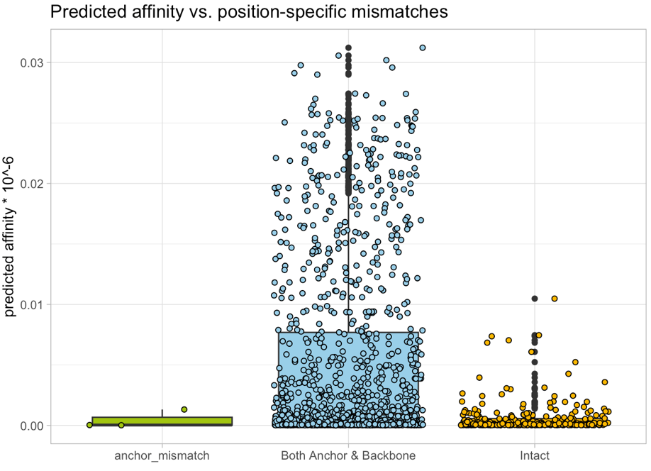

Table 7: protein-sequence pair evidence aggregation

Figure 4
Multi-features ranking score

Figure 5
Bi-features vs. multi-features assessment

Figure 6
Bi-features score validation (using 18 disclosed peptides)

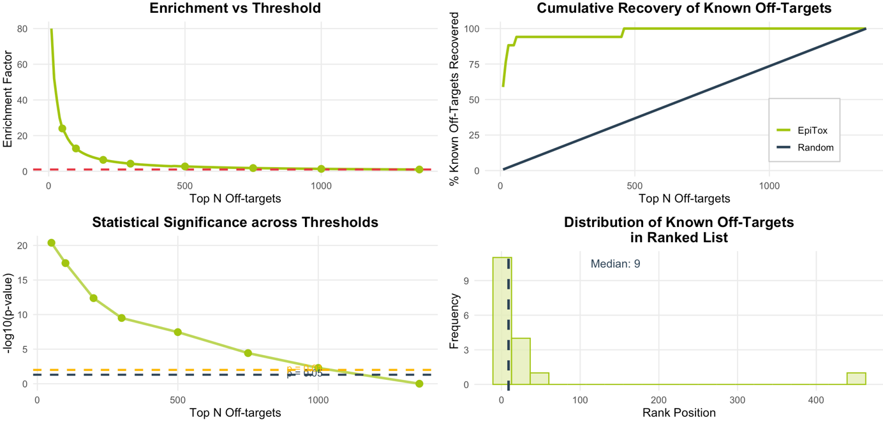

Figure 7
Bi-features score validation (using reference antibody binding results)

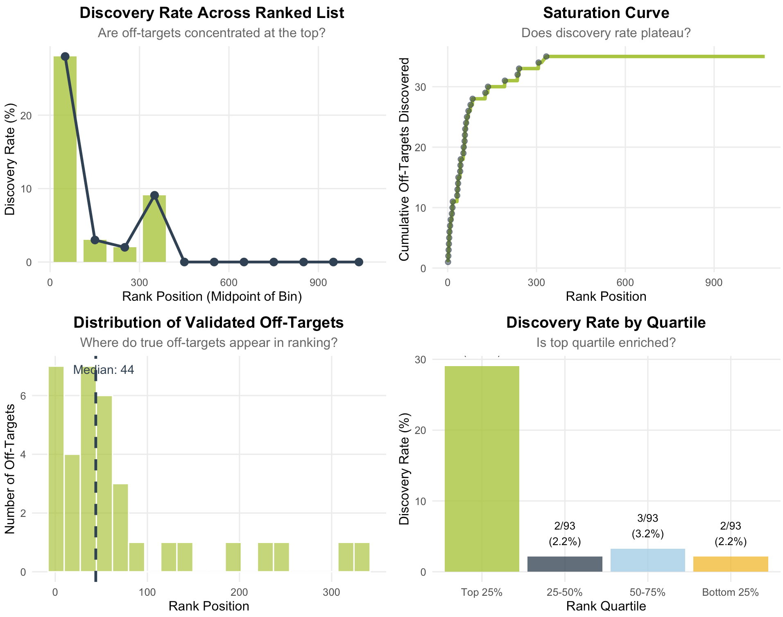

Validation

Table 5: SNP-derived peptide ranked by different scores
Multi-features | Bi-features
2-4 | High | Moderate | Low
High | 9 | 15 | 2
Moderate | 1 | 4 | 1
Low | 0 | 3 | 0

