OSPF

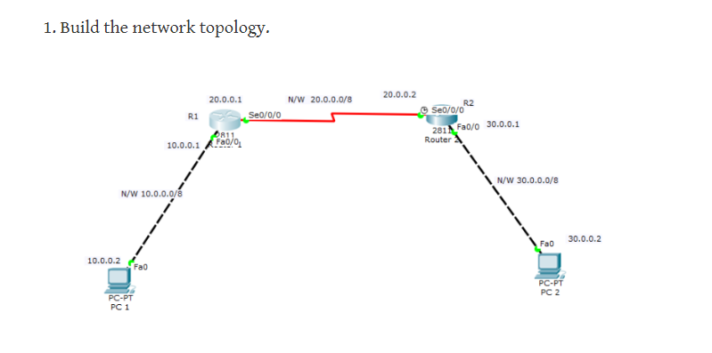

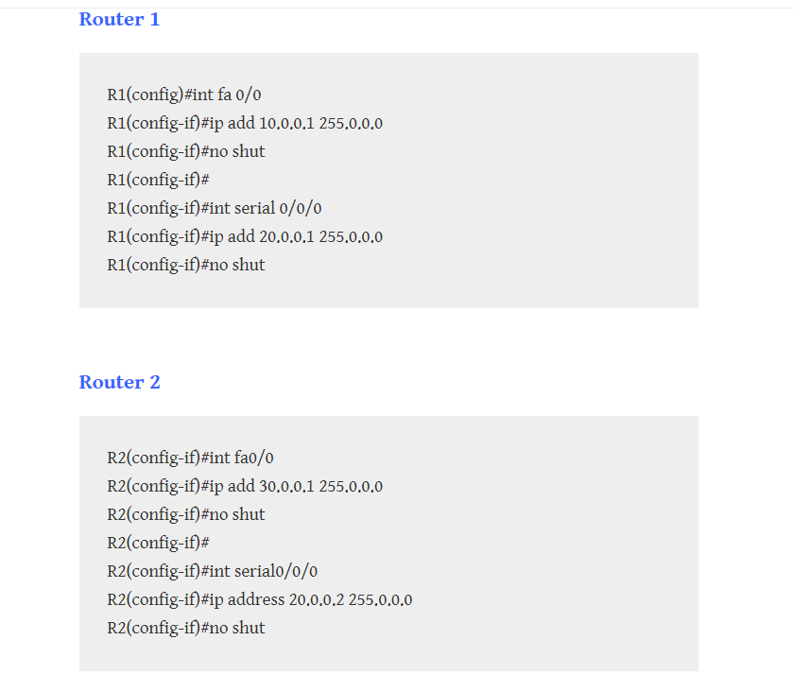

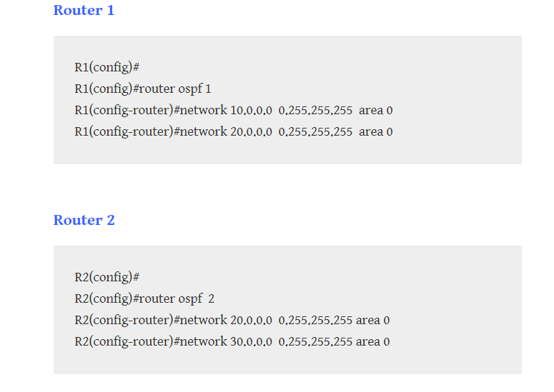

ACL

ACL from a picture in class:

enable

config t

access-list 1 deny 192.168.2.2 0.0.0.0

access-list 1 permit any

exit

Int fa0/0

Ip access-group 1 out

exit

NAT

enable config t

int fa0/0

ip nat inside

int fa0/1

ip nat outside

exit

ip nat inside source static 192.168.1.10 100.100.100.10

Exit

