Software Requirement Specification

Habil Iman Personal Project
TrainerWrite2Send Mobile Application
  - Version 1 Revision Date: 7 April 2026

Table Of Content

Introduction

Introduction
Living in modern world’s today, everyone is expected to be comfortable with technology in daily’s life. Though the number of people that knows their way around technology especially mobile phone is staggering, one cannot assume that everyone knows how to use technology. The application TrainerWrite2Send is built to cater that problem.
My mother works as a production trainer in a manufacturing company. One of the job descriptions is to write 2 reports using phone by giving names and employee numbers of the trainee as well as other inputs. With the modernization and digitalization of many companies specifically manufacturing company she’s now expected to write the report digitally. Though she has basics of using mobile phone but to type each trainee’s name is incredibly inefficient Therefore this app aims to change the way she input the name and other relevant data. Instead of digitally typing, this app changes the input style from digital typing to manual typing which then converted into the required report format.

Requirements

Introduction
This chapter outlines all the requirement for TrainerWrite2Send, starting from tools to non-functional requirement

Functional Requirement
First requirement gathering phase concluded into 2 simples’ functional requirement.

The system must allow user to capture image
As the first flow of the system, this system has to allow user to use the scan button to capture image

The system must extract text using OCR
The system, after the user capture the image must be able to accurately scan the image

The system must be able to format the extracted data
Once the system has extracted the data, the system must be able to format the output as per user choice and give it as the output

The system must allow user to copy the output using one click
The system after returning the output must allow user to copy the output just with one click

Non-Functional requirement
The nonfunctional requirement is listed below

User Interface must be less than 3 steps
The target is to simplify the process for no tech-savvy person. So it must consist of least possible step to achieve the result.

Processing time should be less than 3 seconds
Since the target is to make the report process more efficient the system must take the least amount of time.

Development environment

Frontend Development
- Flutter - Cross Platform mobile app development framewrok
- Dart – Primary language used in flutter

OCR and Image Processing
- Google ML kit

State Management
- RiverPod – Manages application state efficiently

Local Storage
- Hive / SharedPreferences – Stores temporary or persistent data

Development tools
- Visual Studio Code – Main IDE for development
- Android Studio – Emulator and debugging tools
- Git – Version control system
- GitHub – Repository hosting and collaboration

Testing tools
- Flutter Test – Unit and widget testing
- Mockito – Mocking dependencies for testing

UI/UX Design
- Figma – Used for designing app interface

Use Case

Use Case diagram
The diagram below shows the interaction of user within the system.
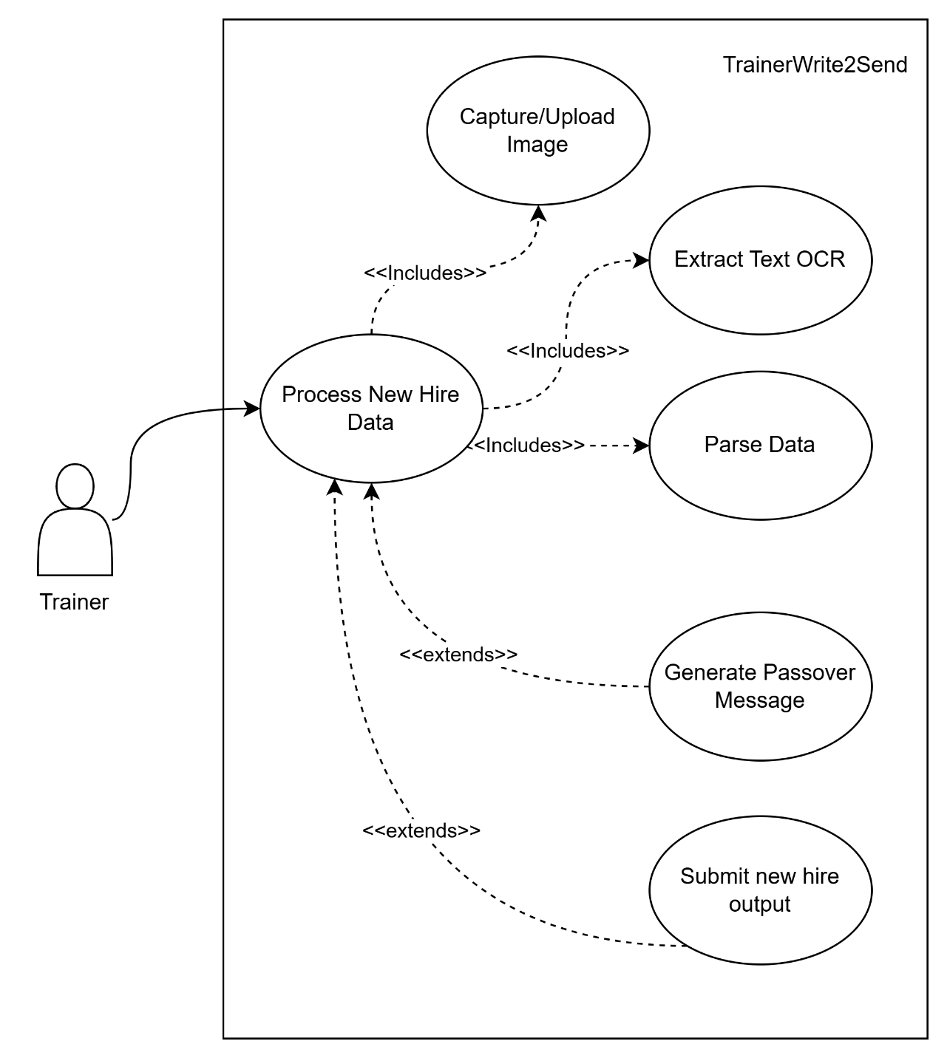

Activity Diagram
Diagram below shows the activity diagram of the app
