Surfer Table Logic breakdown

1. Retrieve user inputs from form, “2. EAL Surfer - Tier 1 EALs”

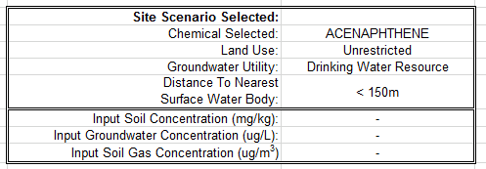

1. Create look up logic to use which table based on groundwater utility and surface water body inputs, for soil and groundwater analysis

Table A. part1

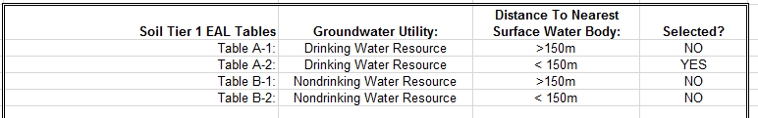

Table B. part1

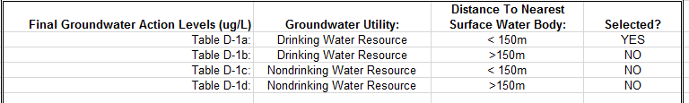

For example, the above “table A. part1” shows “Drinking Water Resource” and “> 150m” were selected as inputs, therefore use “Table A-1”

1. Soil Action Logic breakdown part 1:

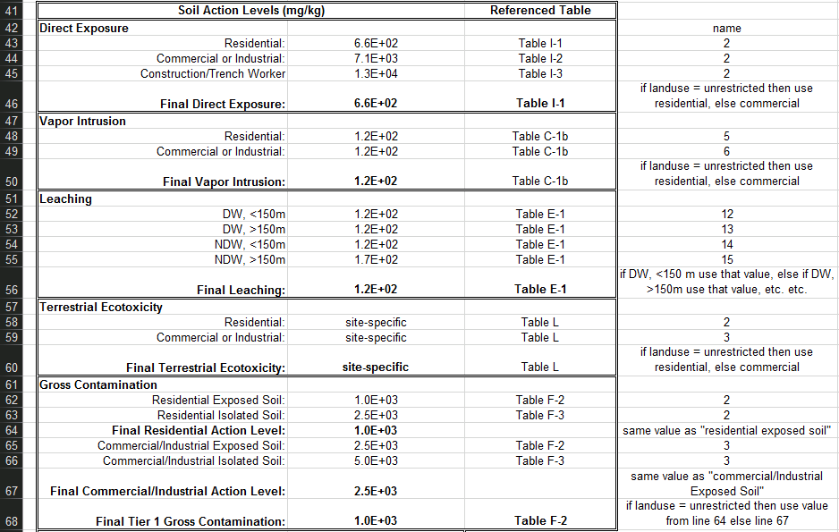

Part 2:

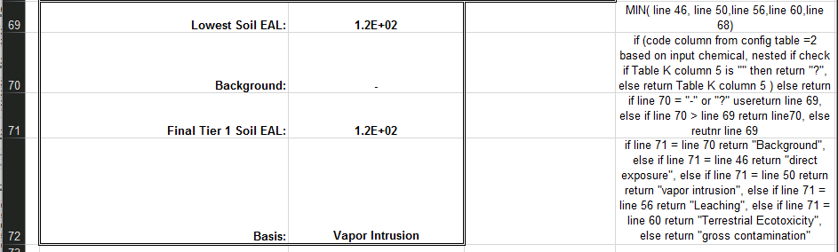

1. Groundwater Action Logic breakdown:

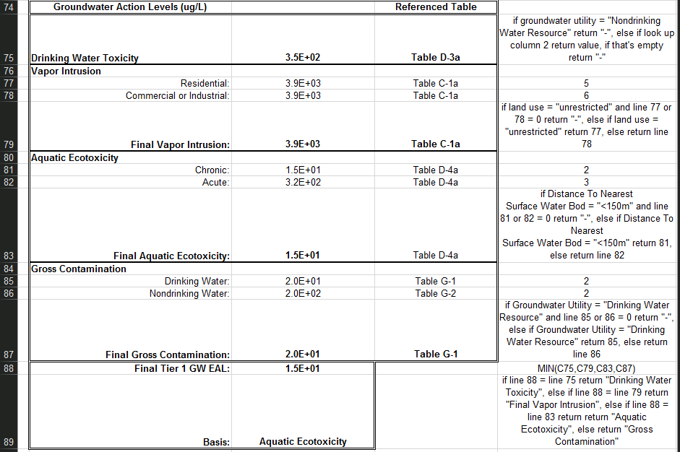

1. Indoor Air and Soil Gas Action logic breakdown:

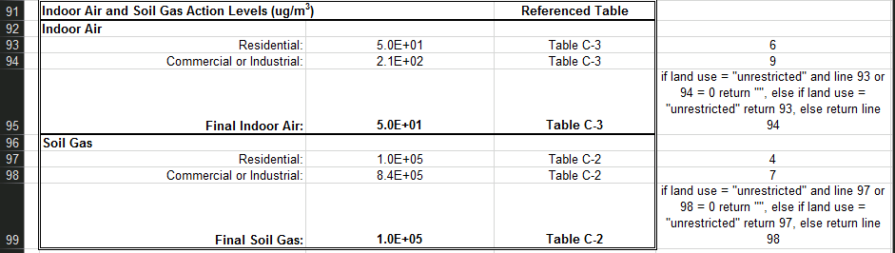

1. Fill in remainder of Table A. part2 and Table B. part3. All these values from both these Tables are looked up based on other tables. (See step 3-5.) Technically this is step is piecing together all the lookup logics into one table.

Table A. part2

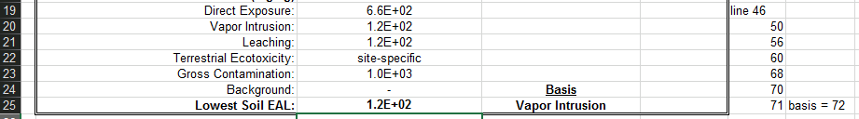

Table B. part2



1. Finally output return back to user input form:

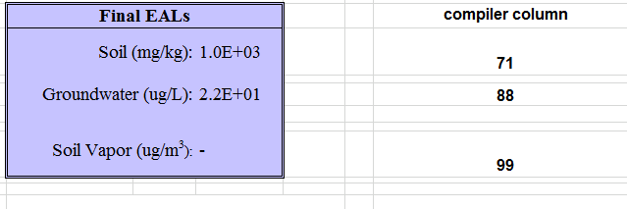

Surfer Summary Table breakdown:

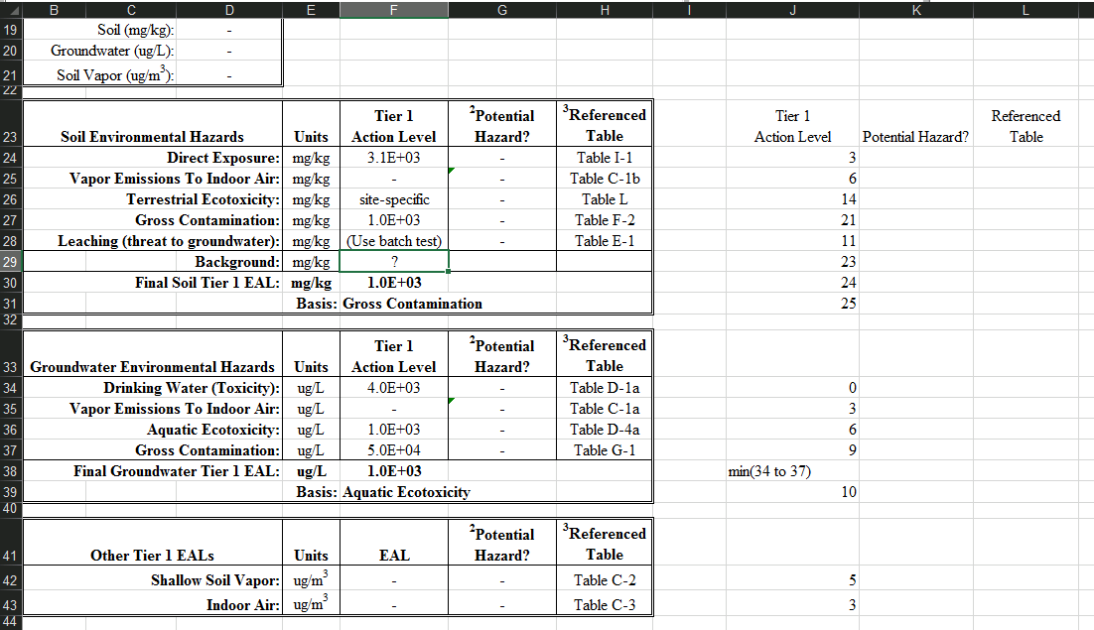

Chemical Summary Table breakdown:

