**Overview**

This is an application created in two parts. A mobile/hybrid web application and an Aurdiuno created Internet of things (Iot) device.

The application piece was created mostly as a mobile app but can also be used as a web tool using Ionic’s dev server. Not all features are available in the web version, such as talk to text.

**SET UP AND INSTALLATION**

**Installation and setup Mobile/Web application. (https://ionicframework.com/docs/intro/installation/)**

1. Install Node and NPM. The quickest way is through the NodeJS installer(<https://nodejs.org/en/>).
   1. Once installed close and relaunch a new terminal window.
2. Next install Ionic CLI

npm install -g ionic cordova

1. Clone the repository from git

clone <https://github.com/HACC2018/Paperless.git>

**Running the application**

The application can be run as a web application or a mobile app. There are features that are specific to both platforms.

**Running the application as a web application**

1. CD into the client folder
   1. This should be something like \paperless\client
2. Run the ionic server.

ionic serve

1. Currently the web version is only working in the Chrome browser. The application might ask you for permissions to geolocation and speech please accept to get full functionality.

**Running the application on mobile (https://ionicframework.com/docs/intro/deploying/)**

1. Download and install the Java JDK
2. Download and install the Android studio
3. Make sure that USB debugging and Developer Mode is enabled on your android device.
4. An update to the build.gradles needs to be made to properly deploy. Please ensure that google() is added to the top of the repositories list for the following files.
   1. \Paperless\client\platforms\android\build.gradle

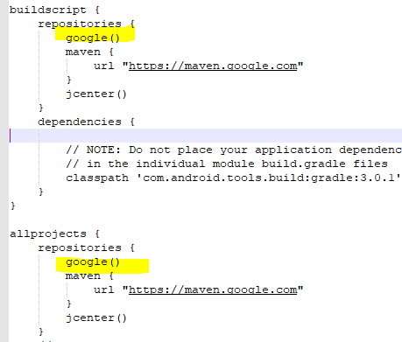

* 1. C:\CodeProjects\Paperless\client\platforms\android\CordovaLib\build.gradle

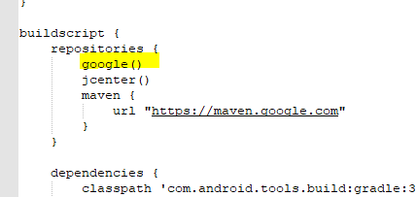

1. Plug in your android device into a USB port.
2. Run the Ionic deployment code and specify android.

ionic cordova run android –device

**Installation of the IoT device**

The IoT code is contained in the following git hub location

<https://github.com/HACC2018/Paperless.git>

**File name**: sketch_nov04a.ino

To run the application, you need the physical button which we can demo. But if you want to view the code in the ARDUINO IDE you can download the IDE here

<https://www.arduino.cc/en/Main/Software>

**USER GUIDE**

**What is it?**

This application and Internet of Things (IoT) device have the simple goal of taking the effort out of data entry and collection for the waste audit. With simplified data entry the volunteers can focus on increasing waste awareness and create more consistent and accurate data as well as just creating more data in general for analysis. We tried to focus on the pain points communicated to us as well as to show future improvements that could be made in the waste audit process using IoT devices.

**Running the application.**

Once the application is started you are dropped into the main waste auditing page.

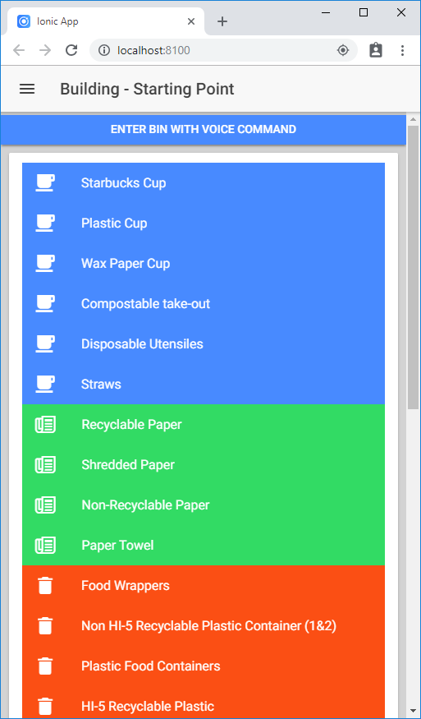

The auditing tool automatically picks up your location using the GPS on your phone and will label the location on the top menu, in this example (Starting Point). This corresponds to a location created in the database before a waste audit. If the application is unable to sense your location you can still audit, but it will need to be associated with a location later. You will get a loading location error, but this can be ignored for now.

The easiest way to add a new audit is to simply click the “ENTER BIN WITH VOICE COMMAND” button. On the mobile platform it will bring up a talk to text feature on your phone to capture your audit. Simply say something like “Starbucks cups 10 pounds bag was 30% full” and you will be presented with the following.

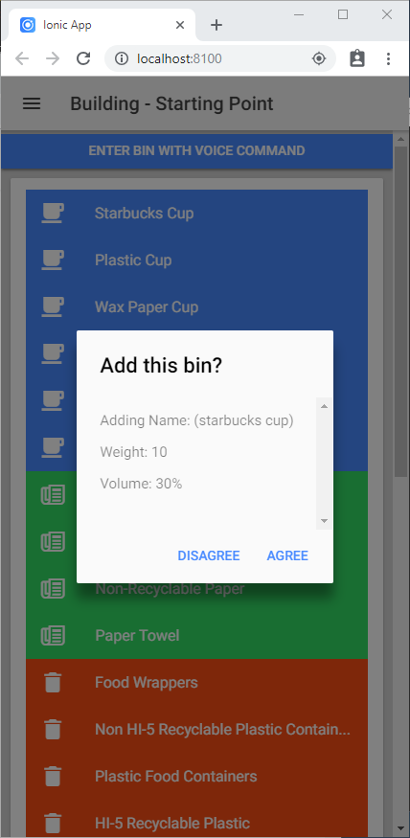

If you are running this on a website, it will put in a test talk item for you. Feel free to try that or hit cancel. If the application captures your numbers correctly just click “Agree” and the audit is imported live to the google firebase database. This data is now available for whoever is using the application!

If you do not wish to use the Talk to Text feature, no problem. The main screen lists all the categories which are created by the audit administrative staff and stored in the database. This allows for consistent data to be entered into the system. Each category is a button that will take you to the corresponding audit page.

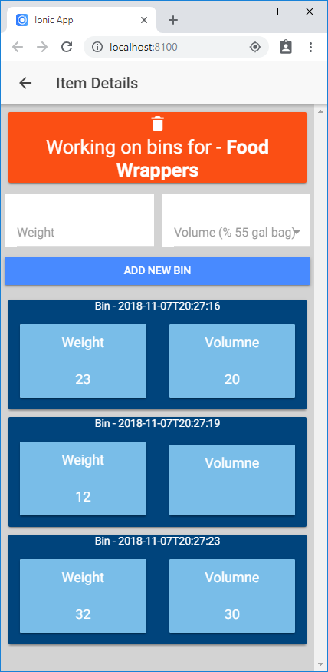

Once you click on a category you will be taken to the Item Details page where you can enter you audit. On the screen you will see only audits that were taken at this location (based on your current gps) and on this day. Simply enter in a weight and/or volume % and click “ADD NEW BIN” and you are done!

Click the back button or the arrow in the top left corner to return.

Once you are done with your audit you can go to the reports. Just click on the menu button on the top left corner and click “Waste Audit Reports”

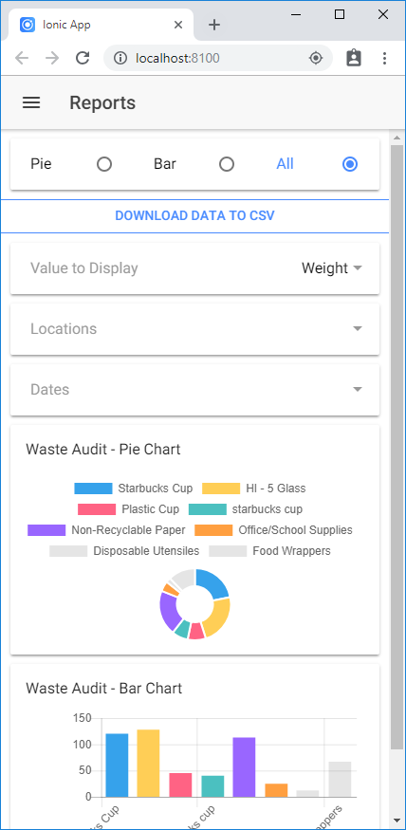

In this report you can change from Weight or Volume. You can also filter by locations or dates. The reports are connected to the database and will update immediately as new data comes in. Finally, you can click the “DOWNLOAD DATA TO CSV” button, but this only works in the web version for now.

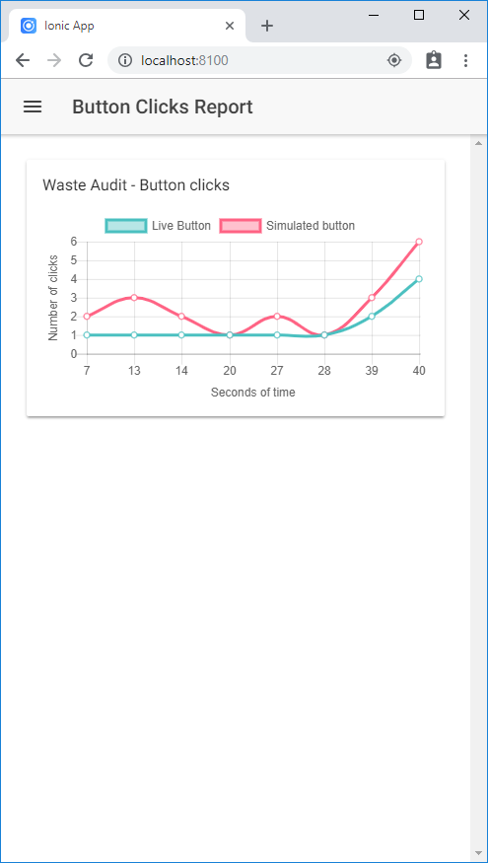

The last report is the “Button Clicks Report.” This report shows you the number of button clicks that have happened per second from our IoT. We only have one device collecting pushes, so the other line in the report is simulated. But more buttons are to come!

**Things to come**

Finally, we have even more features in the works, including an IoT scale that automatically sends the weight of trash bags to the cloud, and software that tracks waste by gathering point-of-sale data. This really is just the beginning.