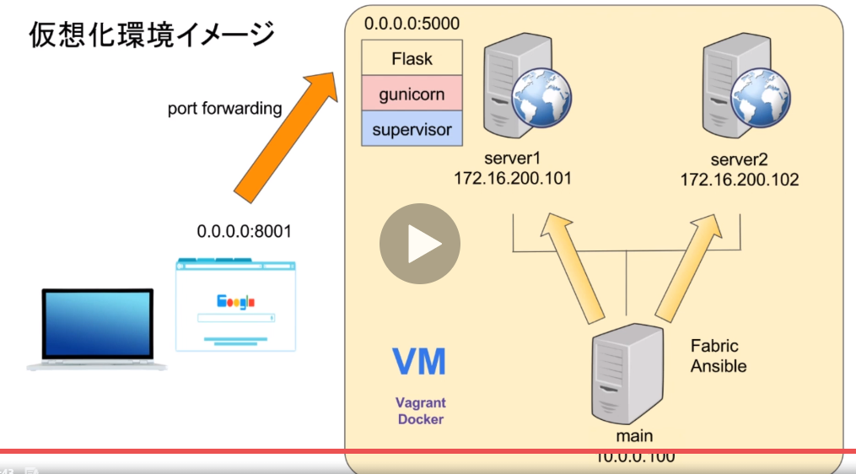

https://qiita.com/xKxAxKx/items/da9dcc8caa36e1c303c7