**Government College of Engineering, Jalgaon**

**(An Autonomous Institute of Government of Maharashtra)**

**Name :** Janhavi Ramesh Wankhede **Semester :** V **PRN :** 2141027

**Class :** T. Y. B.Tech Computer **Academic Year :** 2023-24 **Subject :** CO307U

**Course Teacher : Mr. Vinit Kakde**

**Date of Performance : Date of Completion :**

**Practical no. 5**

**Aim :** Design queries to demonstrate different types of joins.

**Requirements:**

1. Computer System with Open Source Operating System.

2. Mysql

**Theory:**

**SQL Join** statement is used to combine data or rows from two or more tables based on a common field between them. Different types of Joins are as follows:

* INNER JOIN
* LEFT JOIN
* RIGHT JOIN
* FULL JOIN
* NATURAL JOIN

1. **INNER JOIN**

The INNER JOIN keyword selects all rows from both the tables as long as the condition is satisfied. This keyword will create the result-set by combining all rows from both the tables where the condition satisfies i.e value of the common field will be the same.

**Syntax:**

SELECT *table1.column1,table1.column2,table2.column1,....*  
FROM table1   
INNER JOIN table2  
ON table1.matching_column = table2.matching_column;  
table1: First table.  
table2: Second table  
matching_column: Column common to both the tables.

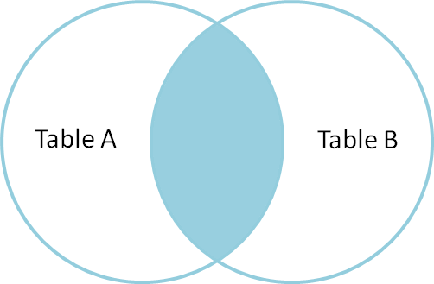

1. **LEFT JOIN**

This join returns all the rows of the table on the left side of the join and matches rows for the table on the right side of the join. For the rows for which there is no matching row on the right side, the result-set will contain *null*. LEFT JOIN is also known as LEFT OUTER JOIN.

**Syntax:**

SELECT *table1.column1,table1.column2,table2.column1,....*FROM table1   
LEFT JOIN table2  
ON table1.matching_column = table2.matching_column;  
  
  
table1: First table.  
table2: Second table  
matching_column: Column common to both the tables.

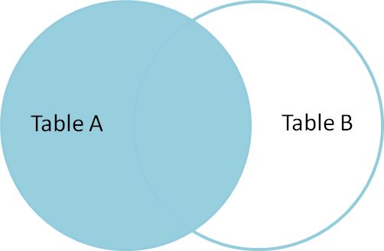

1. **RIGHT JOIN**

RIGHT JOIN is similar to LEFT JOIN. This join returns all the rows of the table on the right side of the join and matching rows for the table on the left side of the join. For the rows for which there is no matching row on the left side, the result-set will contain *null*. RIGHT JOIN is also known as RIGHT OUTER JOIN**.**

**Syntax:**

SELECT *table1.column1,table1.column2,table2.column1,....*FROM table1   
RIGHT JOIN table2  
ON table1.matching_column = table2.matching_column;  
  
  
table1: First table.  
table2: Second table  
matching_column: Column common to both the tables.

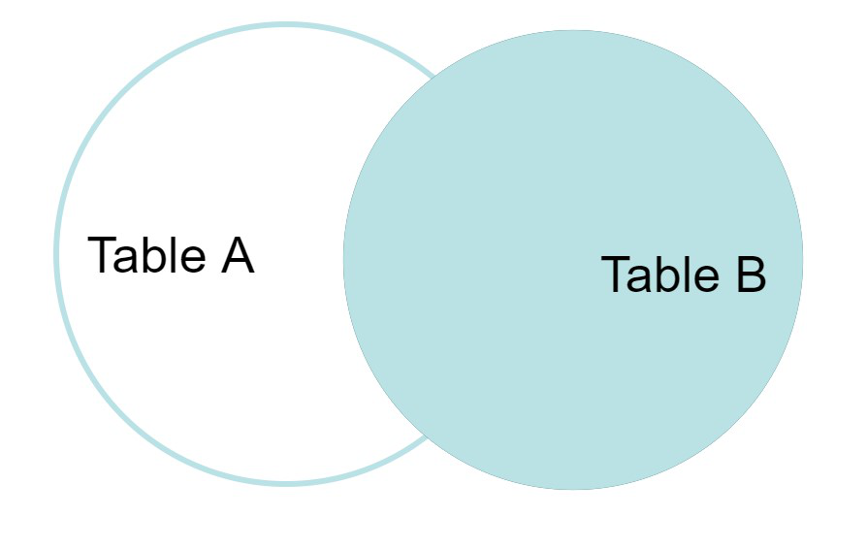

1. **FULL JOIN**

FULL JOIN creates the result-set by combining results of both LEFT JOIN and RIGHT JOIN. The result-set will contain all the rows from both tables. For the rows for which there is no matching, the result-set will contain *NULL* values.

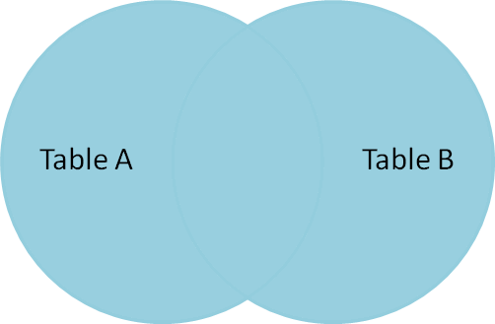

**Syntax:**

SELECT *table1.column1,table1.column2,table2.column1,....*FROM table1   
FULL JOIN table2  
ON table1.matching_column = table2.matching_column;  
  
  
table1: First table.  
table2: Second table  
matching_column: Column common to both the tables.

**Conclusion:**

Design queries to demonstrate different types of joins.

**Questions:**

**1) What is the purpose of an INNER JOIN in MySQL?**

An **INNER JOIN** in MySQL is used to combine rows from two or more tables based on a related column between them. It retrieves only the rows where there is a match in the specified columns in both tables.

**2) How can you perform a LEFT JOIN in MySQL, and what does it return?**

**LEFT JOIN** in MySQL returns all rows from the left table (the first table mentioned) and the matched rows from the right table (the second table mentioned). If there is no match in the right table, NULL values are returned for columns from the right table.

SELECT column1, column2, ...

FROM table1

LEFT JOIN table2 ON table1.common_column = table2.common_column;

**3) Explain the purpose of a RIGHT JOIN in MySQL.**

**RIGHT JOIN** in MySQL returns all rows from the right table and the matched rows from the left table. If there is no match in the left table, NULL values are returned for columns from the left table.

SELECT column1, column2, ...

FROM table1

RIGHT JOIN table2 ON table1.common_column = table2.common_column;

**4) How do you combine the results of two tables and include all rows, even if they don't have matches in the other table in MySQL?**

MySQL doesn't have a direct **FULL OUTER JOIN**. However, you can simulate it using a combination of **LEFT JOIN**, **RIGHT JOIN**, and **UNION**. For example:

SELECT column1, column2, ...

FROM table1

LEFT JOIN table2 ON table1.common_column = table2.common_column

UNION

SELECT column1, column2, ...

FROM table1

RIGHT JOIN table2 ON table1.common_column = table2.common_column

WHERE table1.common_column IS NULL;

**5)How do you retrieve rows from one table that have no corresponding matches in another table in MySQL?**

You can use a **LEFT JOIN** and check for **NULL** values in columns from the right table or use the **NOT EXISTS** clause. For example:

-- Using LEFT JOIN and IS NULL

SELECT table1.*

FROM table1

LEFT JOIN table2 ON table1.common_column = table2.common_column

WHERE table2.common_column IS NULL;

-- Using NOT EXISTS

SELECT column1, column2, ...

FROM table1

WHERE NOT EXISTS (SELECT 1 FROM table2 WHERE table1.common_column = table2.common_column);

**Course Teacher**

**Mr. Vinit Kakde**