PRACTICAL NO. 2

1. **Create a table called Employee with following structure.**

Create Table:

SQL> create table employee(empno int,ename varchar(10),job varchar(10),mgr int,sal int);

SQL> desc employee;

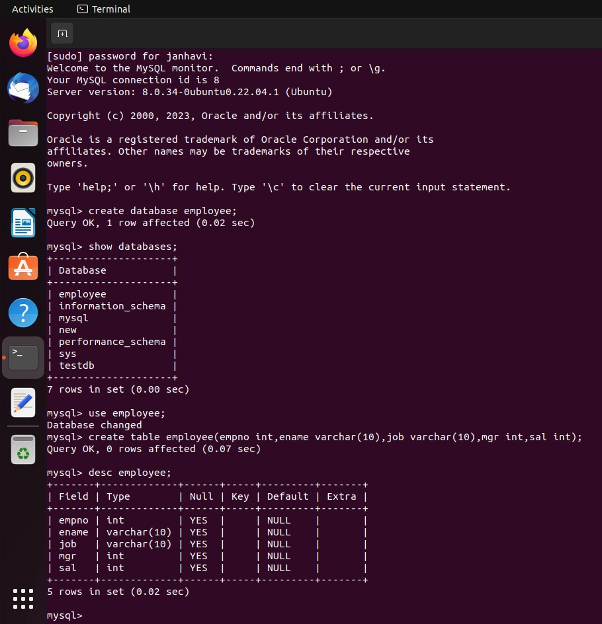

1. **Add a column commission with domain to the Employee table.**

SQL> alter table employee add(commission int);

SQL> desc employee;

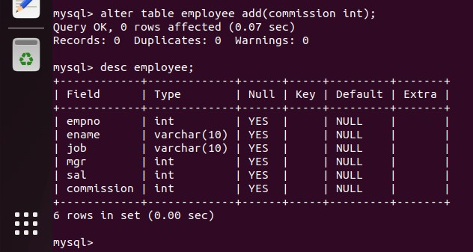

1. **Insert any Five records into the table.**

SQL> insert into employee values(101,’Janhavi’,’CEO’,1234,100000,’70’);

SQL> insert into employee values(102,’Siddharth’,’Vice-CEO’,2345,90000,’65’);

SQL> insert into employee values(103,’Jayesh,’Manager’, 3456,85000,’65’);

SQL> insert into employee values(104,’Ramesh’,’Co-Manager’, 4567,87000,’55’);

SQL> insert into employee values(105,’Abhishek’,’Jr-Manager’, 5678,83000,’50’);

SQL> select *from employee;

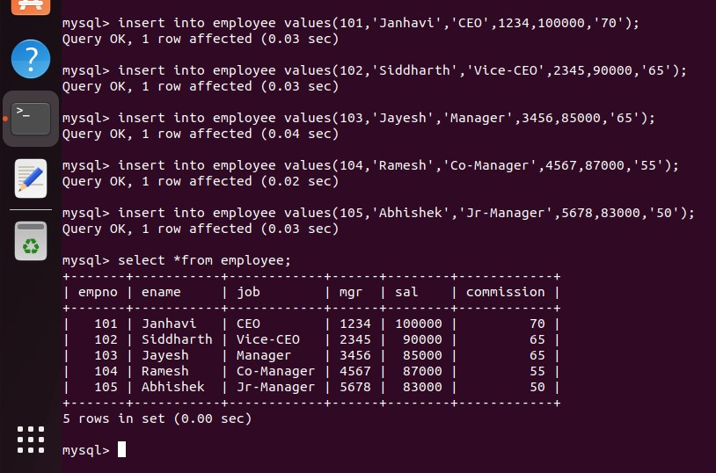

1. **Update the column details of job.**

SQL> update employee set job=’trainee’ where empno=103;

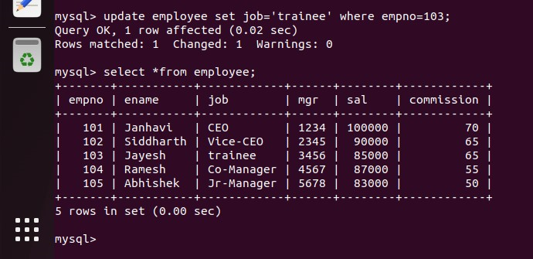SQL> select *from employee;

1. **Rename the column of Employee table using alter command.**

SQL> alter table employee rename column mgr to manager_no;

SQL> desc employee;

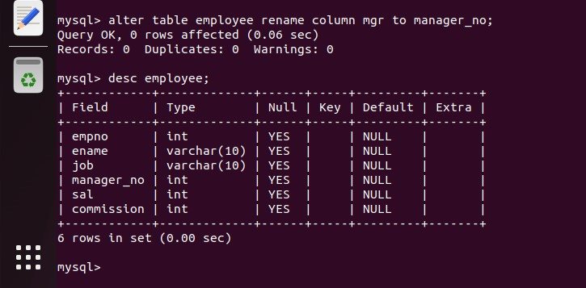

1. **Delete the employee whose Empno is 105.**

SQL> delete from employee where empno=105;

SQL> select *from employee;

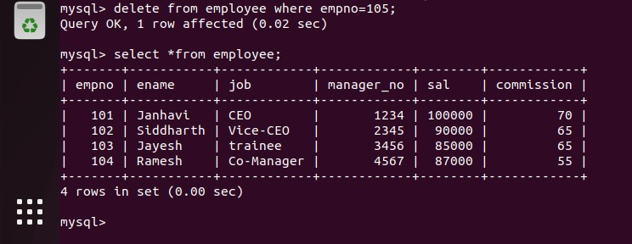

1. **Create department table with following structure.**

SQL> create table department(deptno int,deptname varchar(10),location varchar(10));

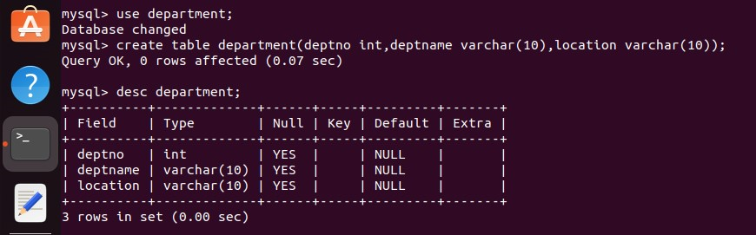SQL> desc department;

1. **Add a column designation to the Department table.**

SQL> alter table department add(designation varchar(10));

SQL> desc employee;

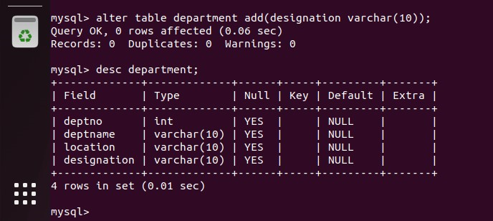

1. **Insert values into the table.**

SQL> insert into department values(9,’Accounting’,’Mumbai’,’Manager’);

SQL> insert into department values(10,’Research’,’Pune’,’Professor’);

SQL> insert into department values(11,’Sales’,’Banglore’,’Salesman’);

SQL> insert into department values(12,’Operations’,’Hyderabad’,’Operator’);

SQL> insert into department values(13,’Accounting’,’Chennai’,’Manager’);

SQL> select *from department;

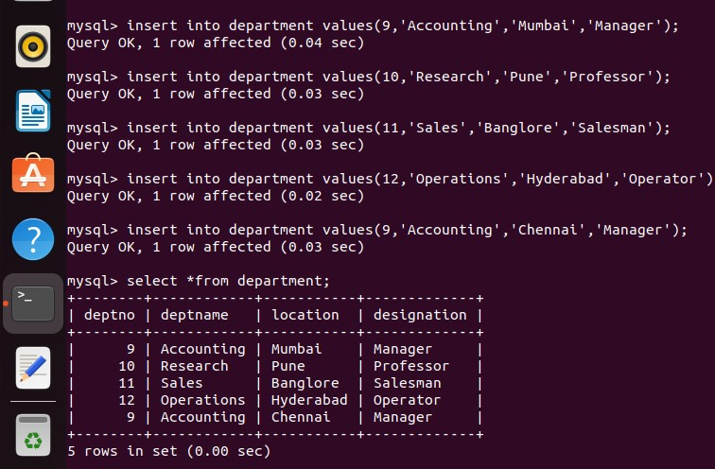

1. **List the records of dept table grouped by deptno.**

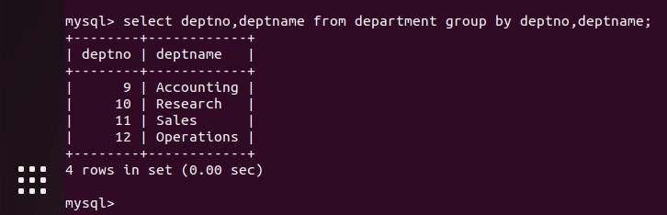 SQL> select deptno,deptname from department group by deptno,deptname;

1. **Update the record where deptno is 9.**

SQL> update department set designation=’Accountant’ where deptno=9;

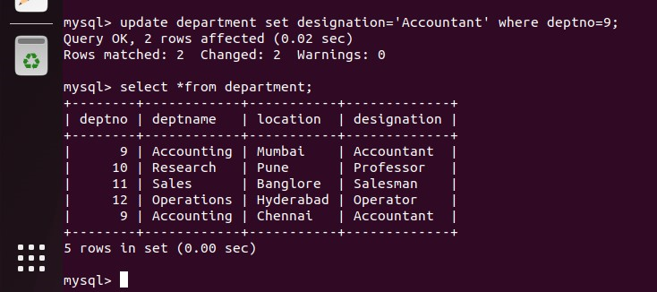SQL> select *from department;

1. **Delete any column data from the table.**

SQL> alter table department drop(designation);

SQL> select *from department; 