PRACTICAL NO. 3

1. **Display all the fields of employee table.**

SQL> create table employee(EMPNO varchar(10),EMP_NAME varchar(10),DEPT varchar(20),SALARY int,DOJ DATE,BRANCH varchar(10));

SQL>insert into employee values(‘E101’,’Amit’,’Production’,45000,’2000-03-12’,’Bangalore);

SQL>insert into employee values(‘E102’,’Amit’,’HR’,70000,’2002-07-03’,’Bangalore);

SQL>insert into employee values(‘E103’,’Sunita’,’Management’,120000,’2001-01-11’,’Mysore);

SQL>insert into employee values(‘E104’,’Sunita’,’IT’,67000,’2001-08-01’,’Mysore);

SQL>insert into employee values(‘E105’,’Mahesh’,’Civil’,145000,’2003-09-20’,’Mumbai);

SQL>select *from employee;

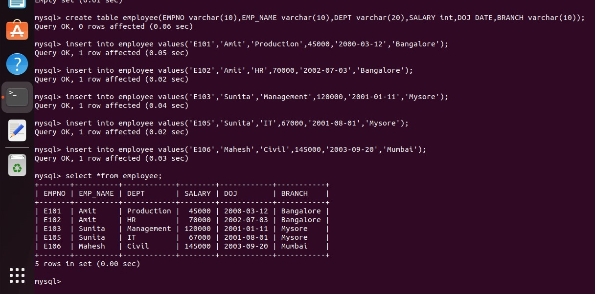

1. **Retrieve employee number and their salary.**

SQL>select EMPNO, SALARY from employee;

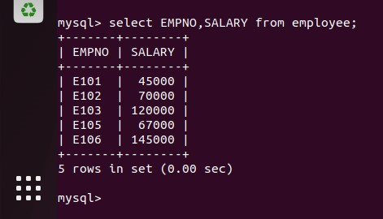

1. **Retrieve average salary of all employee.**

SQL>select AVG(SALARY) from employee;

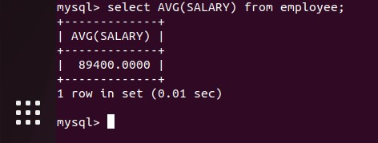

1. **Retrieve number of employee.**

SQL>select COUNT(*) from employee;

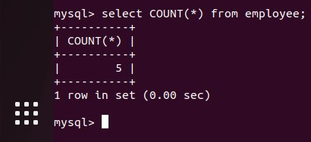

1. **Retrieve distinct number of employee.**

SQL>select COUNT(DISTINCT EMP_NAME) from employee;

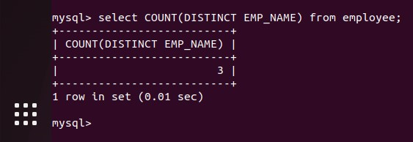

1. **Retrieve total salary of employee group by employee name and count similar names.**

SQL>select EMP_NAME , SUM(SALARY), COUNT(*) from employee

>GROUP BY(EMP_NAME);

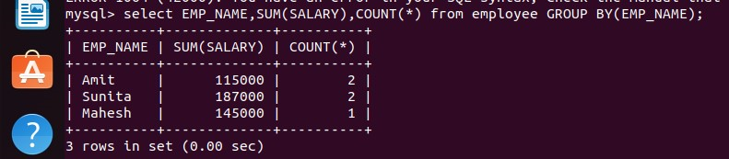

1. **Retrieve total salary of employee which is greater than > 120000.**

SQL>select EMP_NAME , SUM(SALARY), COUNT(*) from employee

>GROUP BY(EMP_NAME)

>HAVING SUM(SALARY)>120000;

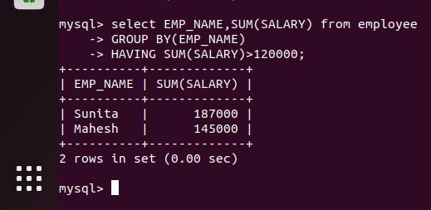

1. **Display name of employee in descending order.**

SQL>select EMP_NAME from employee

>ORDER BY EMP_NAME desc;

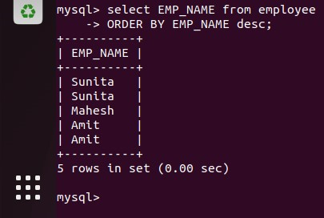

1. **Display details of employee whose name is AMIT and salary greater than 50000.**

SQL>select *from employee

>WHERE EMP_NAME = ‘Amit’ and SALARY>50000;

