PRACTICAL NO. 4

**TABLE COLLEGE.**

SQL> create table college(NAME varchar(10),Id int(5),DEPT_NAME varchar(10));

SQL>insert into college values(‘JANHAVI’,1,’COMPUTER’);

SQL>insert into college values(‘JAYESH’,2,’CIVIL’);

SQL>insert into college values(‘PRIETY,3,’COMPUTER’);

SQL>select *from college;

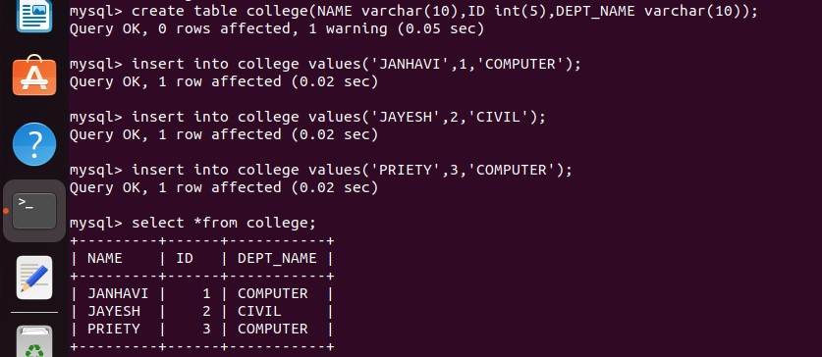

**TABLE UNIVERISTY.**

SQL>create table university(NAME varchar(10),Id int(5),DEPT_NAME varchar(10),CITY varchar(10));

SQL>insert into university values(‘PRIETY,3,’COMPUTER’,’AHMEDNAGAR’);

SQL>insert into university values(‘JAYESH’,2,’CIVIL’,NAGPUR’);

SQL>insert into university values(‘SIDDHARTH’,3,’ACTOR’,’MUMBAI’);

SQL>select *from university;

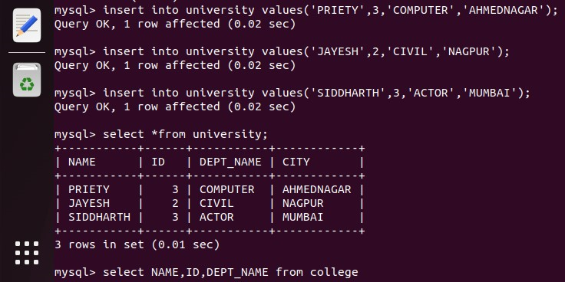

1. **UNION.**

SQL>select NAME,ID,DEPT_NAME from college

UNION

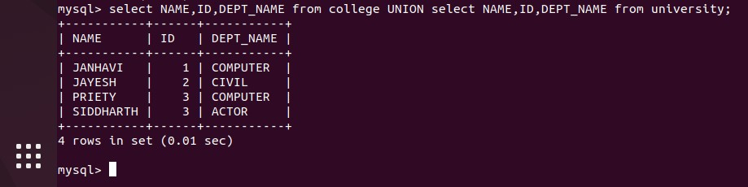 select NAME,ID,DEPT_NAME from university;

1. **INTERSECT.**

SQL>select ID from college

INTERSECT

select ID from university;

