PRACTICAL NO. 5

**TABLE ORDERS.**

SQL> create table orders(O_Id int(5),Orderno int(5),P_Id int(3));

SQL>insert into orders values(1,77895,3);

SQL>insert into orders values(2,44678,3);

SQL>insert into orders values(3,22456,1);

SQL>insert into orders values(4,24562,1);

SQL>insert into orders values(5,34764,15);

SQL>select *from orders;

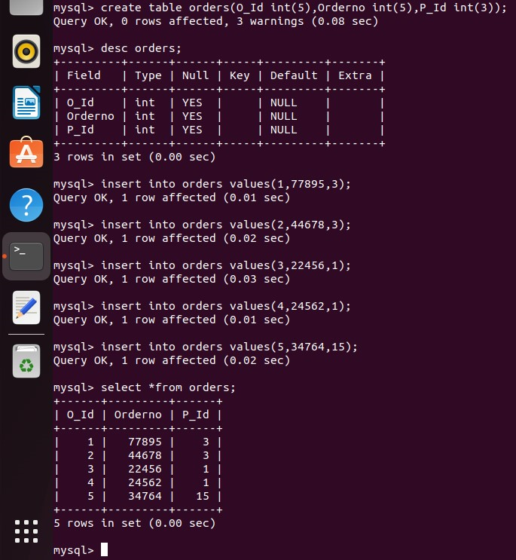

**TABLE PERSONS.**

SQL> create table persons(P_Id int(5),LASTNAME varchar(10), FIRSTNAME varchar(10),Address varchar(10),City varchar(10));

SQL>insert into persons values(1,’Hansen’,’Ola’,’Timotcivn 10’,’Sadnes’);

SQL>insert into persons values(2,’Svendson’,’Tove’,’Borgn 23’,’Sandnes’);

SQL>insert into persons values(3,’Petterson’,’Kari’,’Storgt 20’,’Stavanger’);

SQL>select *from persons;

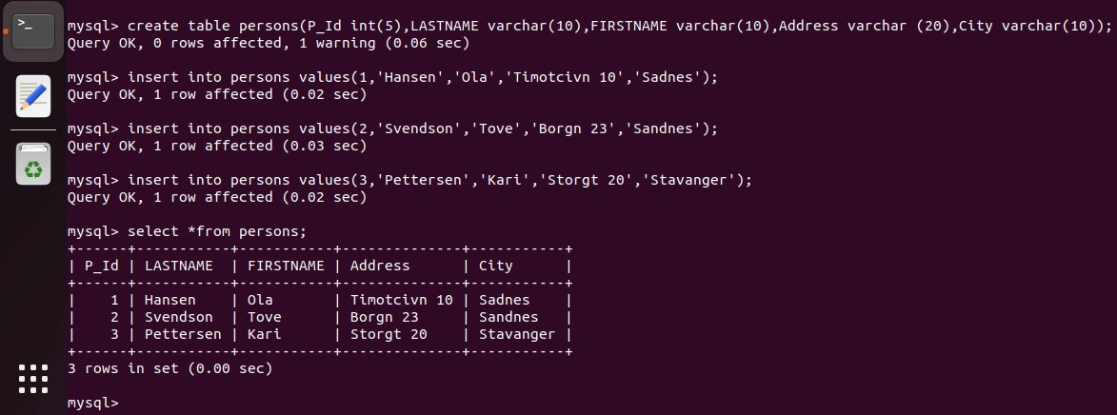

1. **LEFT JOIN.**

SQL>select persons.LASTNAME,persons.FIRSTNAME,orders.Orderno

from persons

left join orders

on persons.P_Id = orders.P_Id

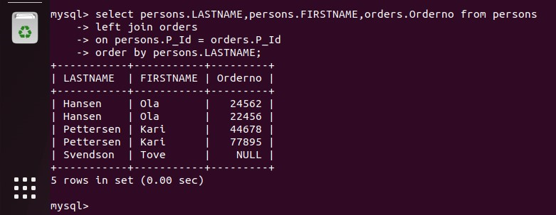 order by persons.LASTNAME;

1. **RIGHT JOIN.**

SQL>select persons.LASTNAME,persons.FIRSTNAME,orders.Orderno

from persons

RIGHT OUTER JOIN orders

on persons.P_Id = orders.P_Id

order by persons.LASTNAME;

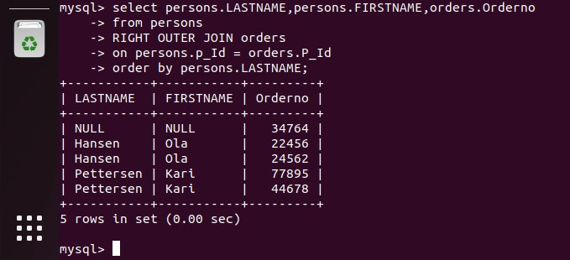

1. **INNER JOIN.**

SQL>select persons.LASTNAME,persons.FIRSTNAME,orders.Orderno

from persons

INNER JOIN orders

on persons.P_Id = orders.P_Id

order by persons.LASTNAME;

