PRACTICAL NO. 6

1. **CREATION OF VIEW.**

SQL> create view EMPVIEW as select EMPLOYEE_NAME,EMPLOYEE_NO,DEPT_NAME,DEPT_NO,DATE_OF_JOIN from EMPLOYEE;

SQL> desc EMPVIEW ;

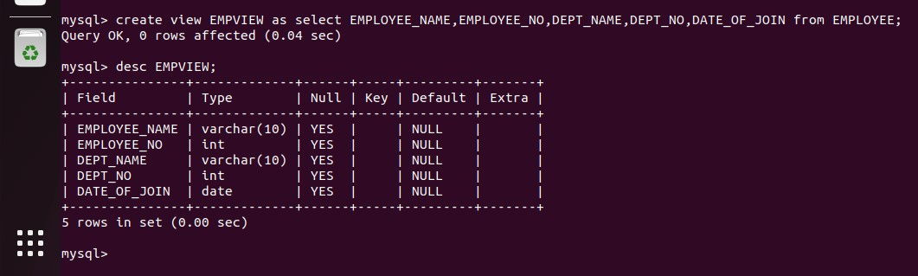

1. **DISPLAY VIEW.**

SQL> select *from EMPVIEW;

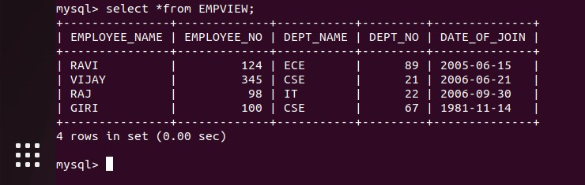

1. **INSERTION INTO VIEW.**

SQL> insert into EMPVIEW values(‘SRI’,120,’CSE’,67,’1981-11-16’);

SQL> select *from EMPVIEW;

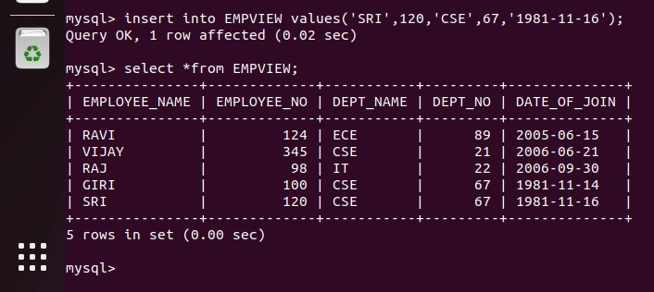

1. **DELETION OF VIEW.**

SQL> delete from EMPVIEW where EMPLOYEE_NAME = ‘SRI’;

SQL> select *from EMPVIEW;

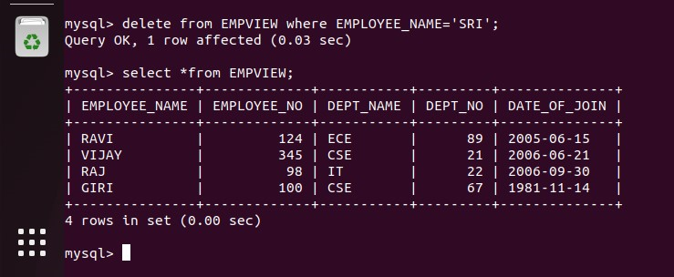

1. **UPDATE STATEMENT.**

SQL> update EMPVIEW set EMPLOYEE_NAME = ‘KAVI’ where EMPLOYEE_NAME = ‘RAVI’ ;

SQL> select *from EMPVIEW;

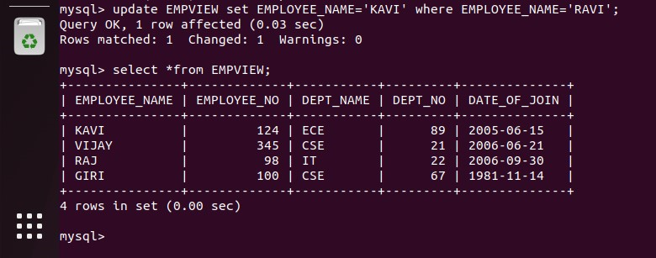

1. **DROP A VIEW.**

SQL>drop view EMPVIEW;

