A

Project Report on

Social Media Database Management System

Developed by

### KASHYAP GORASIYA(IT-037)

### GAUTAM GANDHI(IT-033)

**Guided By**

**Internal Guide: Prof. Archana N Vyas**

**Department of Information Technology Faculty of Technology**

**DD University**



**Department of Information Technology Faculty of Technology, Dharmsinh Desai University**

**College Road, Nadiad-387001 October-2019**

**ACKNOWLEDGEMENT**

We would like to give our sincere acknowledgement to everybody responsible for the successful completion of our project “SOCIAL MEDIA DATABASE MANAGEMENT SYSTEM”.

The success and final outcome of this project required a lot of guidance and assistance from many people and we are extremely privileged to have got this all along the completion of this project.

We owe our deep gratitude to our project guide Prof. Archana Vyas, who took been interest on our project work and guided us all along till the completion of our project work by providing all the necessary help for developing a good Database System.

We would also like to thank all our lecturers.

Finally we convoy our acknowledgement to all our friends and family members who directly or indirectly associated with us in the successful completion of the project. We thank one and all.

TABLE OF CONTENTS

1. Certificate I
2. Acknowledgement II

1. SYSTEM OVERVIEW .........................................................................................

* 1. Current system 1
  2. Objectives of the Proposed System 1
  3. Advantages of the Proposed system (over current) 1

1. E-R DIAGRAM 6
2. DATA DICTIONARY 7
3. SCHEMA DIAGRAM 10

5. DATABASE IMPLEMENTION...........................................................................

* 1. Create Schema 11
  2. Insert Data values 14
  3. Queries (Based on group by, having, constrain) 24
  4. Queries (joins, self joins, sub query)…………………………………………........28
  5. PL/SQL 34
  6. Functions 35
  7. Triggers 36
  8. Cursors 40

1. FUTURE ENHANCEMENTS OF THE SYSTEM 41
2. BIBLIOGRAPHY 42

**DHARMSINH DESAI UNIVERSITY**

## NADIAD-387001, GUJARAT



**CERTIFICATE**

This is to certify that the project entitled “**Social Media Database Management System**” is a bonafide report of the work carried out by

1. **Mr. GANDHI GAUTAM ,** Student ID No : **19ITUOF015**
2. **Mr. GORASIYA KASHYAP** , Student ID No : **19ITUEF014**

of Department of Information Technology, semester V, under the guidance and supervision for the subject Database Management System. They were involved in Project training during academic year 2020-2021.

### Prof. Archana N Vyas.

(Project Guide)

Department of Information Technology, Faculty of Technology,

Dharmsinh Desai University, Nadiad Date:

### Prof. Vipul Dabhi

Head , Department of Information Technology, Faculty of Technology,

Dharmsinh Desai University, Nadiad Date:

# SYSTEM OVERVIEW

1)Social Media Database System keeps track of almost everything a real life social media deals with. (eg: Facebook).

2)It keeps the track of users, their friends ,stories, posts and much more.

3)All the basic queries as well as complex pl/sql , cursors and triggers have been implemented in order to prove the effectiveness of the database Management system.

# 2.E-R DIAGRAM

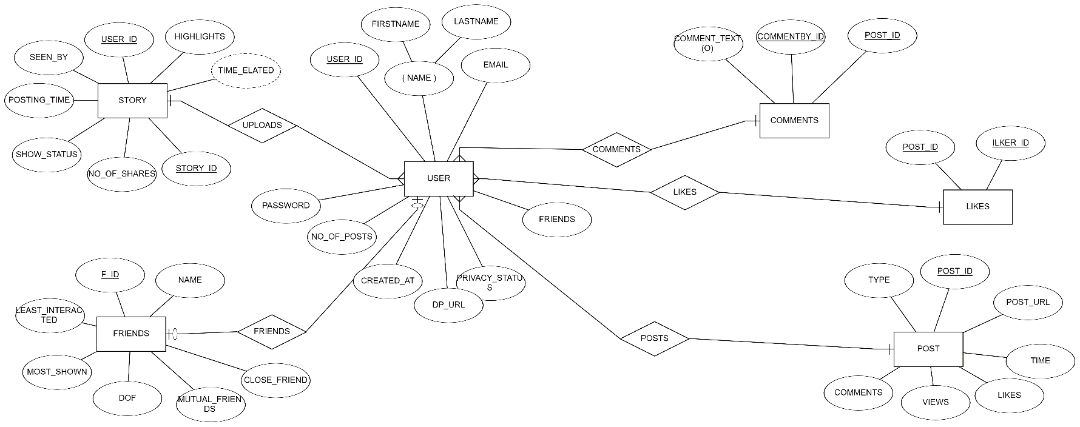

# DATA DICTIONARY

## USERS

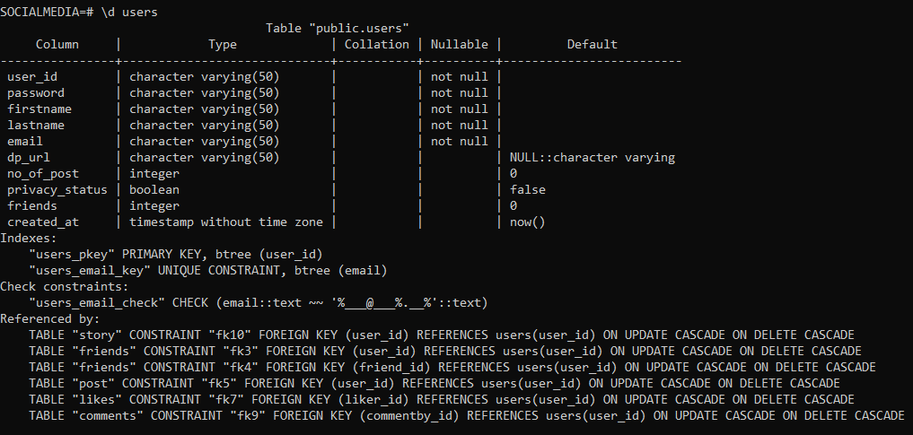

* 1. **FRIENDS**

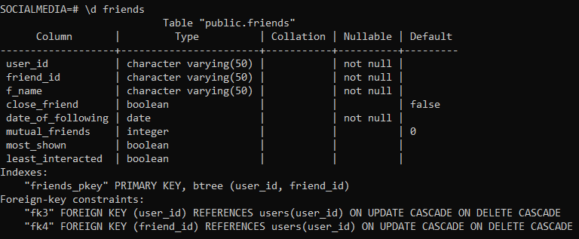

* 1. **POST**

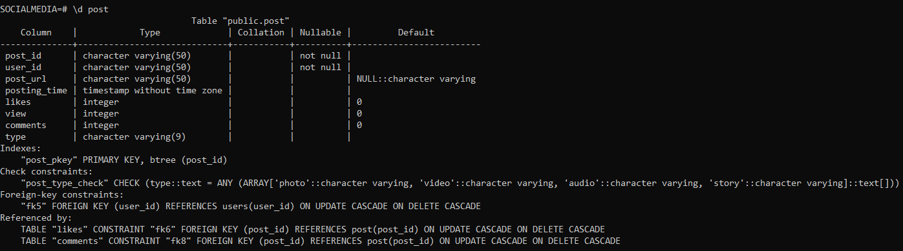

* 1. **LIKES**

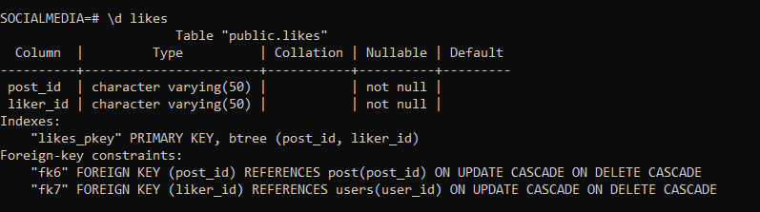

* 1. **COMMENT**

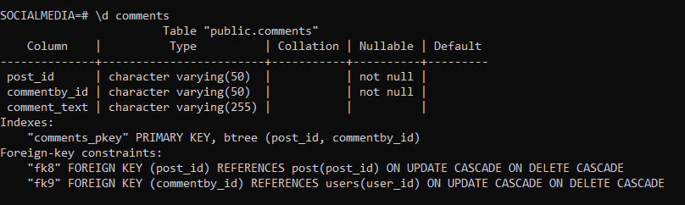

* 1. **STORY**

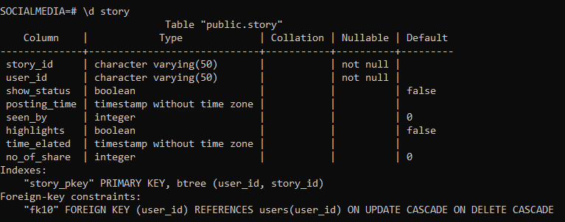

# SCHEMA DIAGRAM

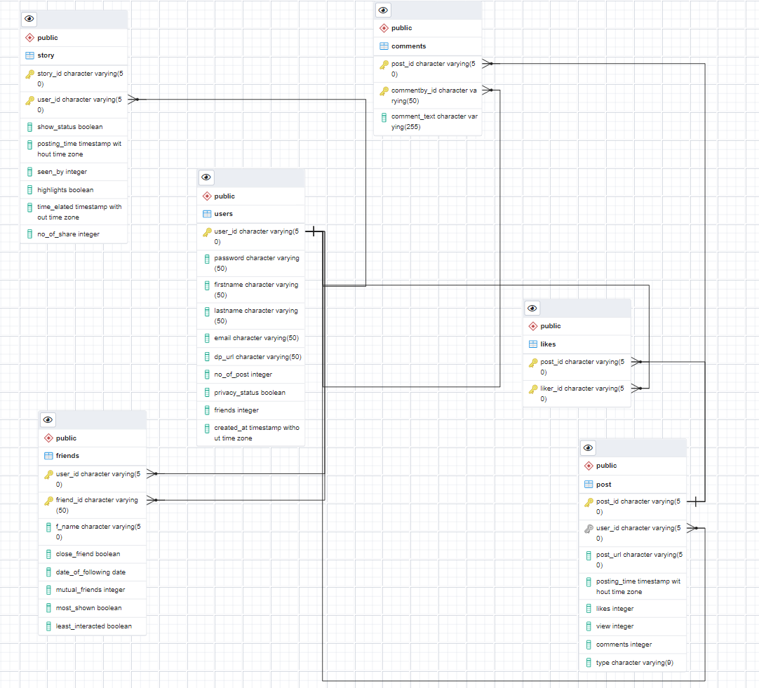

1. **DATABASE IMPLEMENTATION**

## CREATE SCHEMA

### USERS

CREATE TABLE users (

user_id VARCHAR(50) NOT NULL,

password VARCHAR(50) NOT NULL,

firstname VARCHAR(50) NOT NULL,

lastname VARCHAR(50) NOT NULL,

email VARCHAR(50) CHECK(email LIKE '%___@___%.__%') UNIQUE NOT NULL,

dp_url VARCHAR(50) DEFAULT NULL,

no_of_post INT DEFAULT 0,

privacy_status BOOLEAN DEFAULT FALSE,

friends INT DEFAULT 0,

created_at TIMESTAMP DEFAULT NOW(),

PRIMARY KEY(user_id)

);

### FRIENDS

### CREATE TABLE friends(

### user_id VARCHAR(50) NOT NULL,

### friend_id VARCHAR(50) NOT NULL,

### f_name VARCHAR(50)NOT NULL,

### close_friend BOOLEAN DEFAULT FALSE,

### date_of_following DATE NOT NULL,

### mutual_friends INT DEFAULT 0,

### most_shown BOOLEAN,

### least_interacted BOOLEAN,

### 

### PRIMARY KEY(user_id,friend_id),

### CONSTRAINT fk3 FOREIGN KEY(user_id) REFERENCES users(user_id) ON DELETE CASCADE ON UPDATE CASCADE,

### CONSTRAINT fk4 FOREIGN KEY(friend_id) REFERENCES users(user_id) ON DELETE CASCADE ON UPDATE CASCADE

### );

### POST

CREATE TABLE post(

post_id VARCHAR(50) NOT NULL ,

user_id VARCHAR(50) NOT NULL,

post_url VARCHAR(50) NULL DEFAULT NULL ,

posting_time TIMESTAMP ,

likes INT DEFAULT 0,

view INT DEFAULT 0,

comments INT DEFAULT 0,

type VARCHAR(9) check(type IN ('photo', 'video','audio','story')),

PRIMARY KEY(post_id),

CONSTRAINT fk5 FOREIGN KEY(user_id) REFERENCES users(user_id) ON DELETE CASCADE ON UPDATE CASCADE

);

### LIKES

CREATE TABLE likes(

post_id VARCHAR(50) NOT NULL,

liker_id VARCHAR(50) NOT NULL,

PRIMARY KEY(post_id,liker_id),

CONSTRAINT fk6 FOREIGN KEY(post_id) REFERENCES post(post_id) ON DELETE CASCADE ON UPDATE CASCADE,

CONSTRAINT fk7 FOREIGN KEY(liker_id) REFERENCES users(user_id) ON DELETE CASCADE ON UPDATE CASCADE

);

### COMMENTS

CREATE TABLE comments(

post_id VARCHAR(50) NOT NULL,

commentby_id VARCHAR(50) NOT NULL,

comment_text VARCHAR(255) ,

PRIMARY KEY(post_id,commentby_id),

CONSTRAINT fk8 FOREIGN KEY(post_id) REFERENCES post(post_id) ON DELETE CASCADE ON UPDATE CASCADE,

CONSTRAINT fk9 FOREIGN KEY(commentby_id) REFERENCES users(user_id) ON DELETE CASCADE ON UPDATE CASCADE

);

### STORY

CREATE TABLE story(

story_id VARCHAR(50) NOT NULL,

user_id VARCHAR(50) NOT NULL,

show_status BOOLEAN DEFAULT FALSE,

posting_time TIMESTAMP ,

seen_by INT DEFAULT 0,

highlights BOOLEAN DEFAULT FALSE,

time_elated TIMESTAMP ,

no_of_share INT DEFAULT 0,

PRIMARY KEY(user_id,story_id),

CONSTRAINT fk10 FOREIGN KEY(user_id) REFERENCES users(user_id) ON DELETE CASCADE ON UPDATE CASCADE

);

## INSERT DATA VALUE

### USERS

INSERT INTO users(user_id , password , firstname , lastname , email , dp_url , no_of_post , privacy_status , friends , created_at )VALUES

('USR01','Pass@USR1','Raj','Sharma','rajsharma@gmail.com','IC/DP/USRDP01.png',2,FALSE,4,'2010-06-02 01:10:25-03'),

('USR02','Pass@USR2','Yash','Varma','yashvarma@gmail.com','IC/DP/USRDP02.png',1,TRUE,4,'2019-07-22 05:05:25-02'),

('USR03','Pass@USR3','Pooja','Maheta','poojamaheta@gmail.com','IC/DP/USRDP03.png',null,FALSE,null,'2020-08-08 09:10:25-07'),

('USR04','Pass@USR4','Riya','Kotak','riyakotak@gmail.com','IC/DP/USRDP04.png',3,TRUE,4,'2011-05-22 10:02:25-01'),

('USR05','Pass@USR5','Parth','Bhatt','parthbhatt@gmail.com','IC/DP/USRDP05.png',null,FALSE,3,'2016-06-15 02:06:25-06'),

('USR06','Pass@USR6','Alice','Shah','aliceshah@gmail.com','IC/DP/USRDP06.png',null,TRUE,2,'2018-06-16 08:13:25-04'),

('USR07','Pass@USR7','Akash','Benarji','akashbenarji@gmail.com','IC/DP/USRDP07.png',1,FALSE,5,'2017-04-06 19:15:25-07'),

('USR08','Pass@USR8','Juli','Kapoor','julikapoor@gmail.com','IC/DP/USRDP08.png',1,FALSE,3,'2018-09-12 03:56:25-05'),

('USR09','Pass@USR9','Rahul','Agrawal','rahulagrawal@gmail.com','IC/DP/USRDP09.png',1,TRUE,2,'2017-06-07 04:10:25-09'),

('USR010','Pass@USR10','Kajal','Adani','kajaladani@gmail.com','IC/DP/USRDP010.png',null,FALSE,1,'2018-06-22 17:20:25-08'),

('USR011','Pass@USR11','Pratik','Gandhi','pratikgandhi@gmail.com','IC/DP/USRDP011.png',1,TRUE,null,'2019-06-04 19:57:25-07'),

('USR012','Pass@USR12','Jitu','Kumar','jitukumar@gmail.com','IC/DP/USRDP012.png',null,FALSE,1,'2019-12-25 16:27:25-07'),

('USR013','Pass@USR13','Vaibhav','Roshan','vaibhavroshan@gmail.com','IC/DP/USRDP013.png',null,TRUE,null,'2019-10-31 18:40:25-05'),

('USR014','Pass@USR14','Minal','Gada','minalgada@gmail.com','IC/DP/USRDP014.png',2,FALSE,null,'2017-06-22 06:51:25-04'),

('USR015','Pass@USR15','Vartika','Hathi','vartikahathi@gmail.com','IC/DP/USRDP015.png',null,TRUE,2,'2016-04-30 12:10:25-04'),

('USR016','Pass@USR16','Meena','Aiyar','meenaaiyar@gmail.com','IC/DP/USRDP016.png',null,FALSE,null,'2016-03-14 21:37:25-06'),

('USR017','Pass@USR17','Shivangi','Joshi','shivangijoshi@gmail.com','IC/DP/USRDP017.png',2,FALSE,1,'2019-11-13 07:49:25-07'),

('USR018','Pass@USR18','Harsh','Patel','harshpatel@gmail.com','IC/DP/USRDP018.png',1,FALSE,null,'2015-06-17 22:28:25-01'),

('USR019','Pass@USR19','Deep','Chavda','deepchavda@gmail.com','IC/DP/USRDP019.png',null,TRUE,null,'2016-02-20 11:48:25-08'),

('USR020','Pass@USR20','Ashtha','Modi','ashthamodi@gmail.com','IC/DP/USRDP020.png',1,FALSE,1,'2017-01-10 23:30:25-09')

;

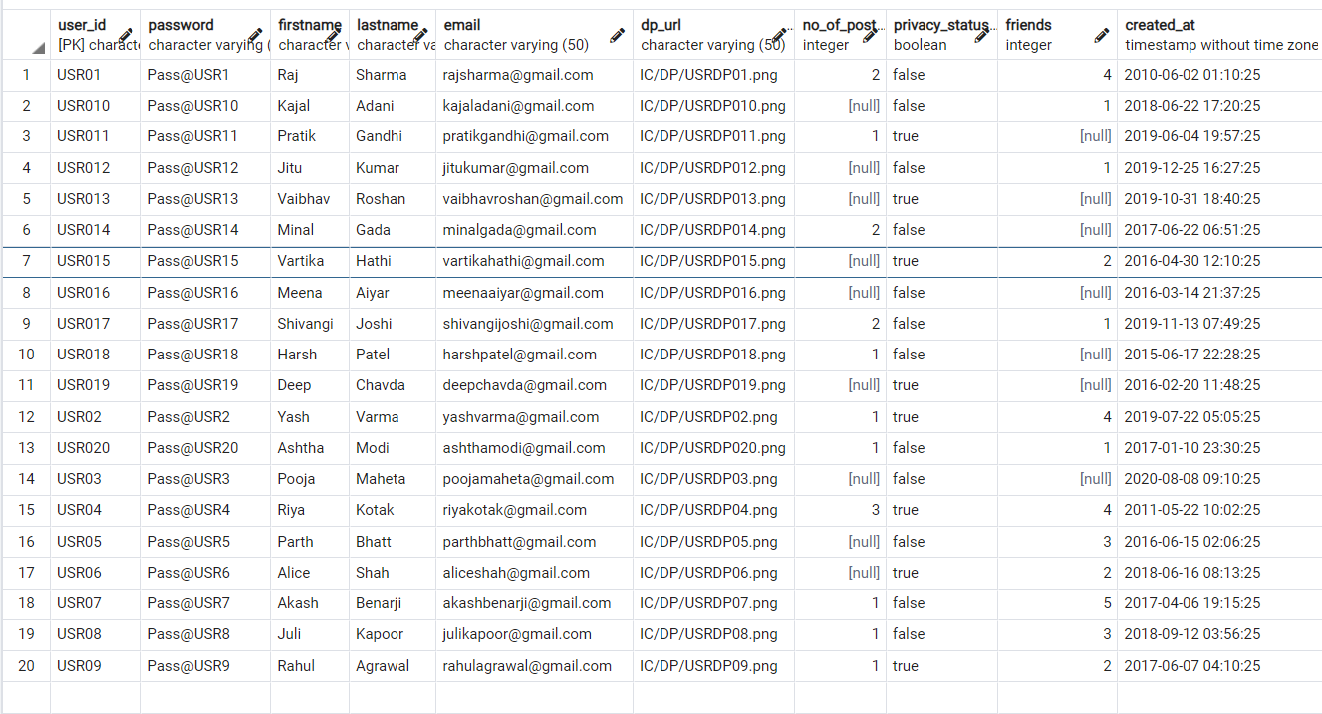

### FRIENDS

INSERT INTO friends( user_id , friend_id , f_name , close_friend , date_of_following , mutual_friends , most_shown , least_interacted)VALUES

('USR01','USR02','Yash Varma',TRUE,'2019-08-23',1,FALSE,TRUE),

('USR01','USR020','Ashtha Modi',FALSE,'2018-09-02',0,FALSE,TRUE),

('USR01','USR012','Jitu Kumar',FALSE,'2020-01-02',1,TRUE,FALSE),

('USR01','USR04','Riya Kotak',TRUE,'2012-03-15',1,TRUE,FALSE),

('USR02','USR01','Raj Sharma',TRUE,'2019-10-30',1,TRUE,FALSE),

('USR02','USR03','Pooja Maheta',FALSE,'2020-12-16',0,FALSE,TRUE),

('USR02','USR04','Riya Kotak',TRUE,'2020-06-07',0,FALSE,TRUE),

('USR02','USR010','Kajal Adani',FALSE,'2021-04-05',0,FALSE,TRUE),

('USR04','USR02','Yash Varma',FALSE,'2020-06-07',0,FALSE,TRUE),

('USR04','USR05','Parth Bhatt',FALSE,'2017-07-17',0,FALSE,TRUE),

('USR04','USR08','Parth Bhatt',FALSE,'2019-09-19',0,TRUE,FALSE),

('USR04','USR07','Akash Benarji',TRUE,'2018-12-02',1,TRUE,FALSE),

('USR05','USR01','Raj Sharma',FALSE,'2016-06-22',1,FALSE,TRUE),

('USR05','USR04','Riya Kotak',FALSE,'2016-06-22',0,FALSE,TRUE),

('USR05','USR010','Kajal Adani',TRUE,'2019-01-30',0,TRUE,FALSE),

('USR06','USR09','Rahul Agrawal',FALSE,'2018-09-19',0,TRUE,FALSE),

('USR06','USR011','Pratik Gandhi',FALSE,'2020-10-20',0,FALSE,TRUE),

('USR07','USR02','Yash Varma',TRUE,'2019-10-10',0,TRUE,FALSE),

('USR07','USR012','Jitu Kumar',TRUE,'2020-04-06',1,FALSE,TRUE),

('USR07','USR013','Vaibhav Roshan',FALSE,'2021-08-12',0,TRUE,FALSE),

('USR07','USR018','Kajal Adani',FALSE,'2017-04-06',1,FALSE,TRUE),

('USR07','USR020','Ashtha Modi',TRUE,'2017-11-02',0,FALSE,TRUE),

('USR08','USR01','Raj Sharma',FALSE,'2018-06-22',1,TRUE,FALSE),

('USR08','USR04','Riya Kotak',FALSE,'2019-09-09',0,FALSE,TRUE),

('USR08','USR016','Meena Aiyar',TRUE,'2020-06-20',0,FALSE,TRUE),

('USR09','USR05','Parth Bhatt',TRUE,'2016-06-06',0,TRUE,FALSE),

('USR09','USR014','Mina Gada',TRUE,'2018-06-16',0,TRUE,FALSE),

('USR010','USR06','Alice Shah',TRUE,'2020-01-01',0,TRUE,FALSE),

('USR012','USR02','Yash Varma',TRUE,'2019-12-25',0,FALSE,TRUE),

('USR015','USR010','Kajal Adani',TRUE,'2019-05-22',0,TRUE,FALSE),

('USR015','USR09','Rahul Agrawal',FALSE,'2019-05-25',0,TRUE,FALSE),

('USR017','USR05','Parth Bhatt',TRUE,'2019-10-19',0,TRUE,FALSE),

('USR020','USR018','Harsh Patel',TRUE,'2017-02-20',0,FALSE,TRUE)

;

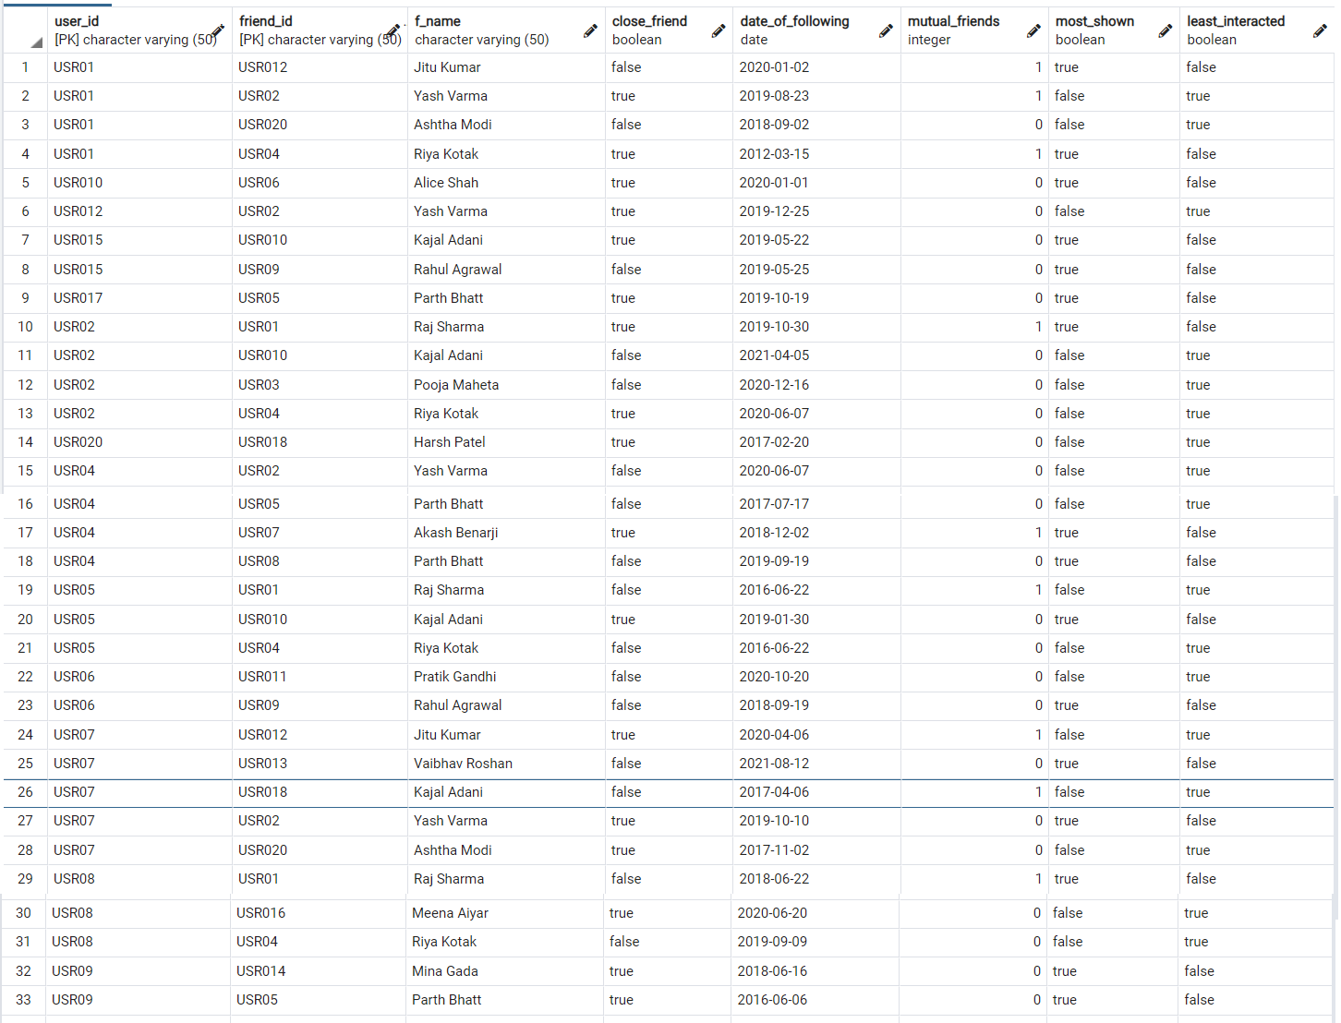

### POST

INSERT INTO post( post_id , user_id , post_url , posting_time , likes , view , comments , type )VALUES

('USR01PST01','USR01','IC/POST/POSTUSR01/POST01USR01.png','2011-05-02 01:10:25-03',1,8,1,'photo'),

('USR01PST02','USR01','IC/POST/POSTUSR01/POST02USR01.png','2020-03-20 10:00:25-03',2,7,0,'video'),

('USR02PST01','USR02','IC/POST/POSTUSR02/POST01USR01.png','2019-07-23 05:01:03-02',1,6,1,'photo'),

('USR04PST01','USR04','IC/POST/POSTUSR04/POST01USR04.png','2012-05-22 11:059:20-01',1,5,0,'photo'),

('USR04PST02','USR04','IC/POST/POSTUSR04/POST02USR04.png','2015-11-02 12:010:05-01',2,4,1,'audio'),

('USR04PST03','USR04','IC/POST/POSTUSR04/POST03USR04.png','2019-12-20 13:02:00-01',1,3,0,'video'),

('USR07PST01','USR07','IC/POST/POSTUSR07/POST01USR07.png','2017-09-01 23:50:25-07',2,2,2,'photo'),

('USR08PST01','USR08','IC/POST/POSTUSR08/POST01USR08.png','2019-09-12 03:06:00-05',1,1,0,'photo'),

('USR09PST01','USR09','IC/POST/POSTUSR09/POST01USR09.png','2018-09-04 02:10:56-09',2,8,1,'photo'),

('USR11PST01','USR011','IC/POST/POSTUSR11/POST01USR11.png','2019-12-25 10:52:25-07',1,4,0,'video'),

('USR14PST01','USR014','IC/POST/POSTUSR14/POST01USR14.png','2018-06-22 06:52:26-04',2,7,1,'audio'),

('USR14PST02','USR014','IC/POST/POSTUSR14/POST02USR14.png','2020-06-22 06:50:27-04',1,8,0,'photo'),

('USR17PST01','USR017','IC/POST/POSTUSR17/POST01USR17.png','2019-12-25 10:52:45-07',1,9,1,'video'),

('USR17PST02','USR017','IC/POST/POSTUSR17/POST02USR17.png','2021-08-22 19:10:55-07',2,2,0,'photo'),

('USR18PST01','USR018','IC/POST/POSTUSR18/POST01USR18.png','2016-03-04 18:30:15-08',1,1,1,'video'),

('USR20PST01','USR020','IC/POST/POSTUSR20/POST01USR20.png','2017-09-10 07:30:25-09',3,1,0,'audio')

;

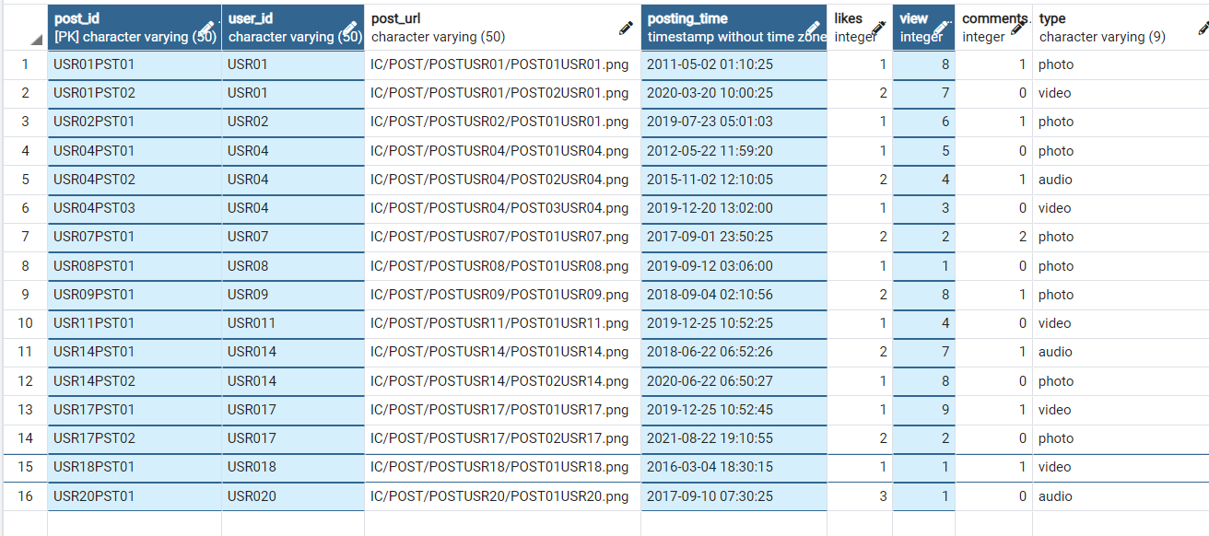

### LIKES

INSERT INTO likes( post_id , liker_id )VALUES

('USR01PST01','USR01'),

('USR01PST02','USR011'),

('USR01PST02','USR014'),

('USR02PST01','USR01'),

('USR04PST01','USR02'),

('USR04PST02','USR07'),

('USR04PST02','USR08'),

('USR04PST03','USR05'),

('USR07PST01','USR011'),

('USR07PST01','USR012'),

('USR08PST01','USR013'),

('USR09PST01','USR014'),

('USR09PST01','USR05'),

('USR11PST01','USR016'),

('USR14PST01','USR017'),

('USR14PST01','USR018'),

('USR14PST02','USR015'),

('USR17PST01','USR016'),

('USR17PST02','USR01'),

('USR17PST02','USR017'),

('USR18PST01','USR017'),

('USR20PST01','USR019'),

('USR20PST01','USR09'),

('USR20PST01','USR015')

;

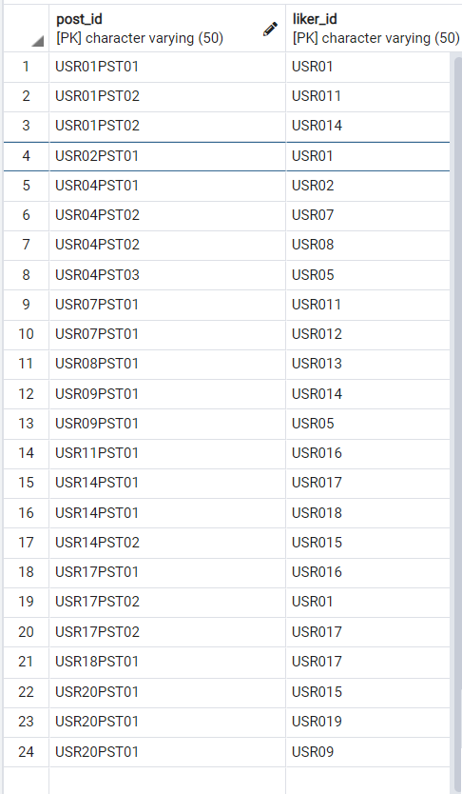

### COMMENT

### INSERT INTO comments( post_id, commentby_id , comment_text ) VALUES

### ('USR01PST01','USR020','WOWWWWWW'),

### ('USR02PST01','USR04','Awesome'),

### ('USR04PST02','USR08','Great'),

### ('USR07PST01','USR09','Good'),

### ('USR07PST01','USR020','Superb'),

### ('USR09PST01','USR05','Nice'),

### ('USR14PST01','USR011','Alas'),

### ('USR17PST01','USR012','Best wishes'),

### ('USR18PST01','USR019','Happy Birthday')

### ;

### 

### STORY

INSERT INTO story( story_id , user_id , show_status , posting_time , seen_by , highlights, no_of_share )VALUES

('STORYUSR01','USR020',TRUE,'2021-06-22 04:10:25-07',3,TRUE,1),

('STORYUSR03','USR01',TRUE,'2021-06-22 06:10:34-07',9,TRUE,0),

('STORYUSR04','USR07',TRUE,'2021-06-22 23:10:10-07',7,FALSE,3),

('STORYUSR02','USR018',TRUE,'2021-06-22 05:10:50-07',3,FALSE,5),

('STORYUSR011','USR019',TRUE,'2021-06-22 01:10:43-07',6,TRUE,7),

('STORYUSR019','USR016',TRUE,'2021-06-22 13:10:58-07',9,TRUE,2),

('STORYUSR013','USR013',TRUE,'2021-06-22 00:00:40-07',3,FALSE,1)

;

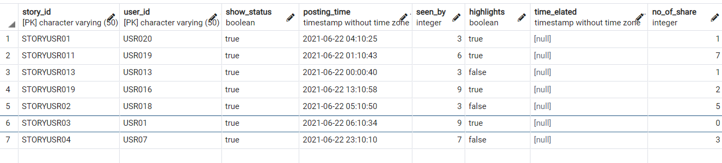

## BASIC QUERIES

**1) Display information of posts between 2019 and 2021.**

select * from post where posting_time between '2019-01-01' AND '2021-12-31';

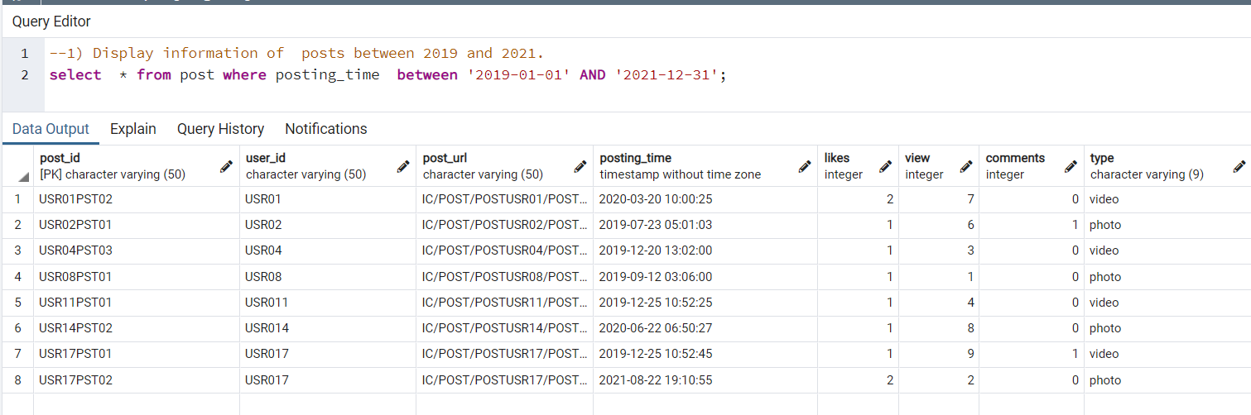

**2)Display sum of likes from post table.**

select sum(likes) as likes from post;

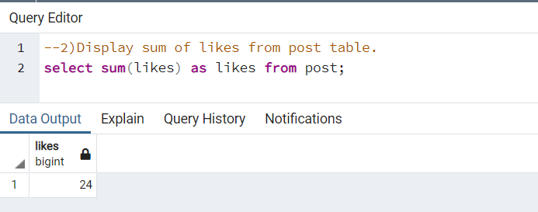

**3)Display average of likes from post table.**

select avg(likes) as likes from post;

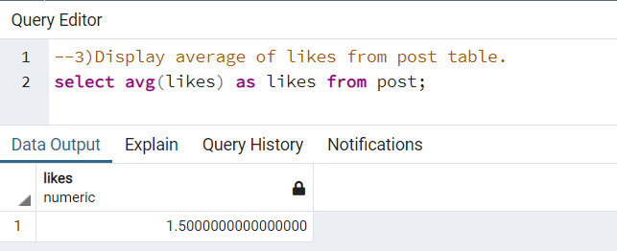

**4)Display average posts and email id of users.**

select email,avg(no_of_post) from users group by email;

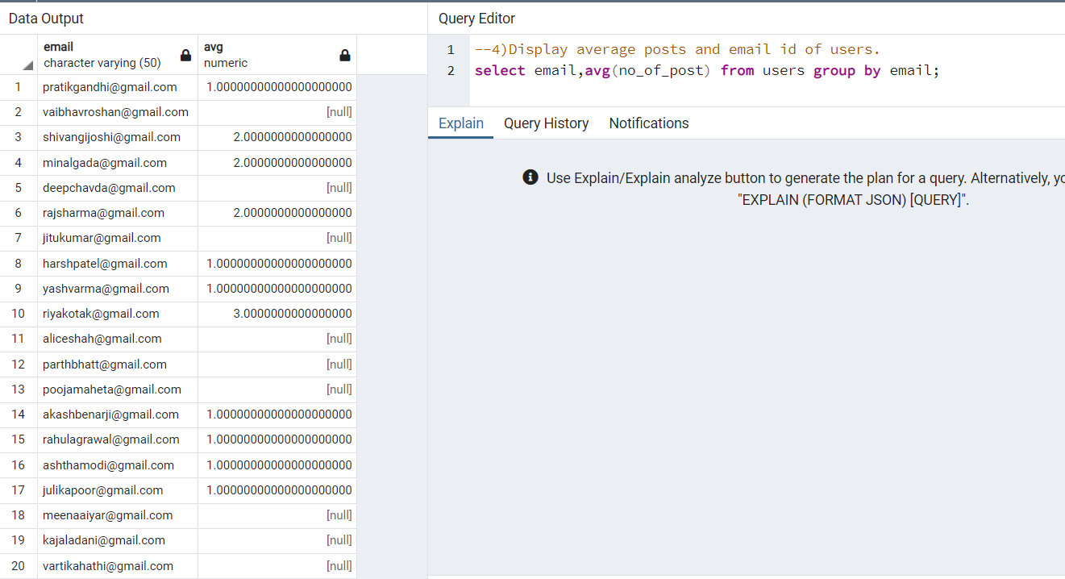

**5)Display user id and date of following from followers table where user id should not be USR01 or USR02.**

select user_id,date_of_following from friends where user_id not in('USR01','USR02') order by user_id;

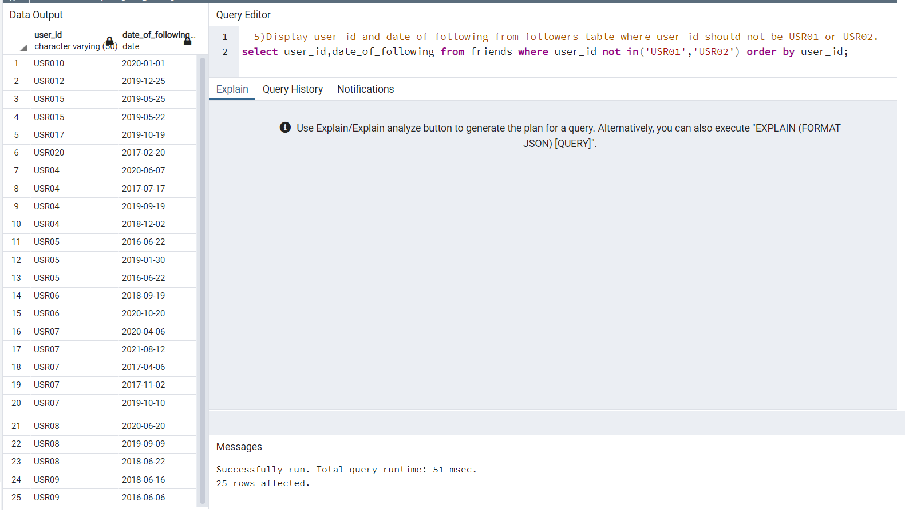

**6)No. of friend of a particular user. user_id= USR08**

select COUNT(friends.friend_id) from friends WHERE friends.user_id = 'USR08';

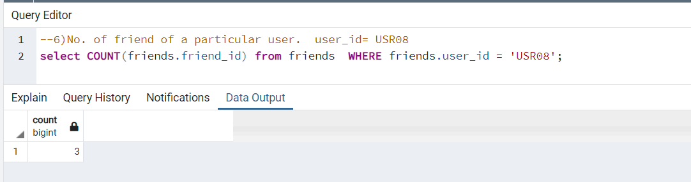

**7) Most liked post of a particular user.**

SELECT post_id, count(liker_id) as count FROM likes GROUP BY post_id ORDER BY count desc LIMIT 1;

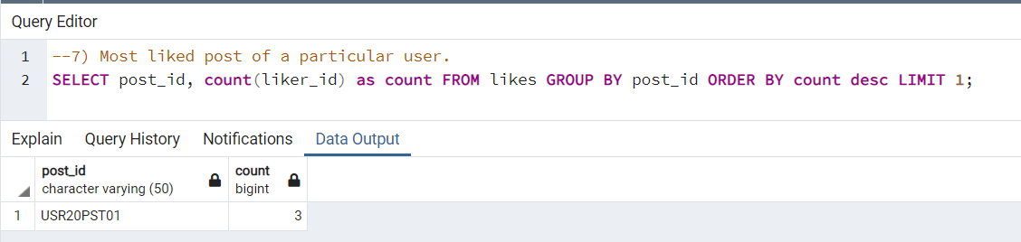

**5.4 Queries (self join & join & subqueries)**

**1)liker_id of post id = USR07PST01.**

SELECT post.post_id,post.likes,likes.liker_id FROM post inner join likes on post.post_id = likes.post_id;

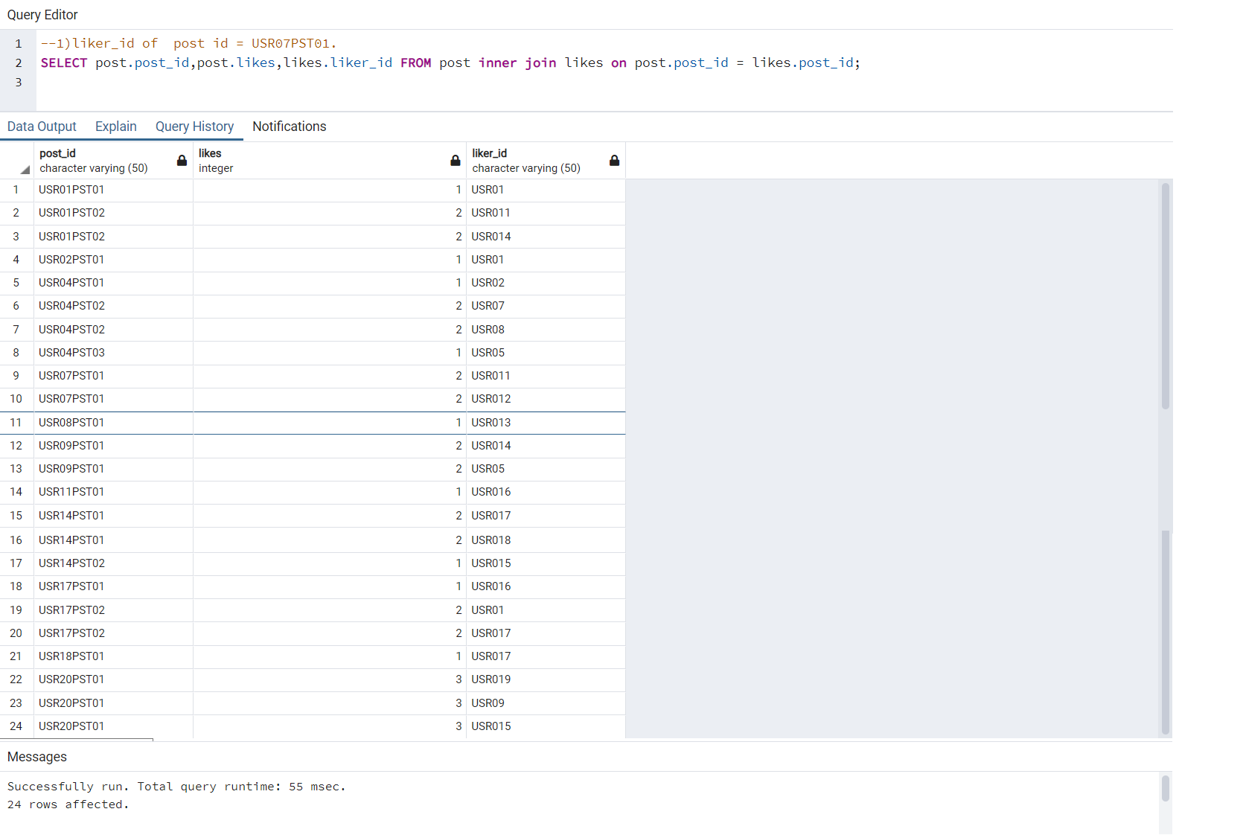

**2)Display name of friends of user='USR07' who had posted story?**

select friends.friend_id from friends inner join story on friends.user_id = story.user_id WHERE story.user_id in (select friends.friend_id from friends where friends.user_id= 'USR07');

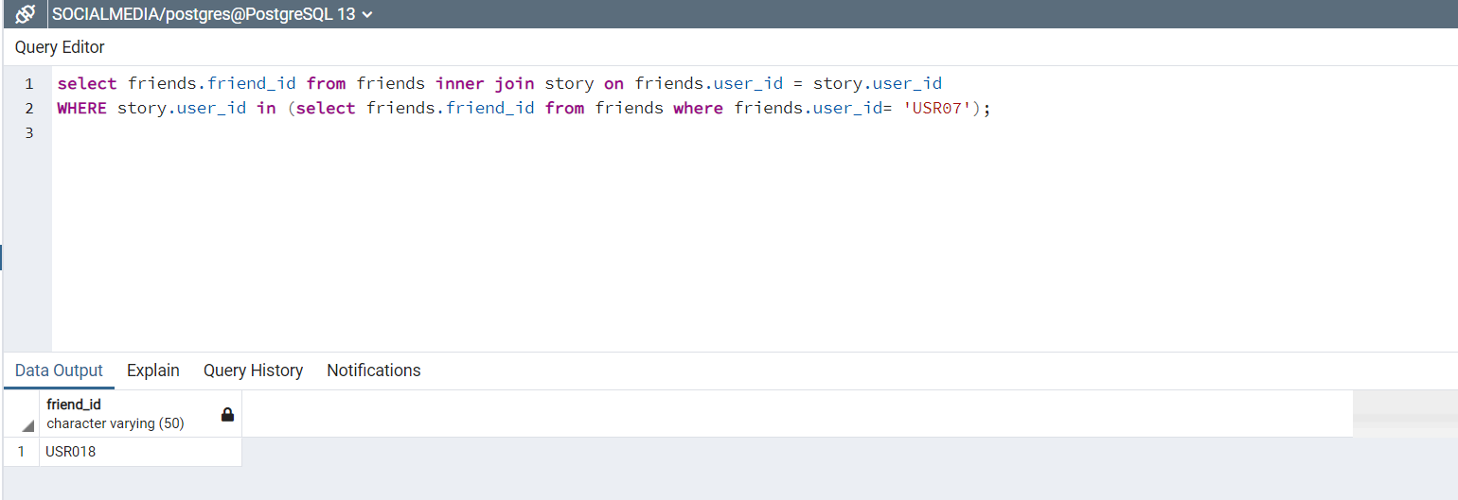

**3)Display story information of story which has been posted at the earliest.**

select * from story where posting_time=(select posting_time from story order by posting_time limit 1);

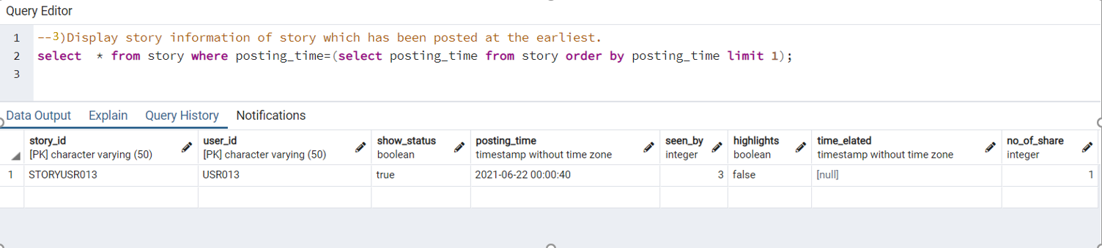

**4)Display post_id ,likes from post table where no. of likes of one is greater than another.**

select a.post_id,a.likes,b.post_id,b.likes from post a, post b where a.likes>b.likes;

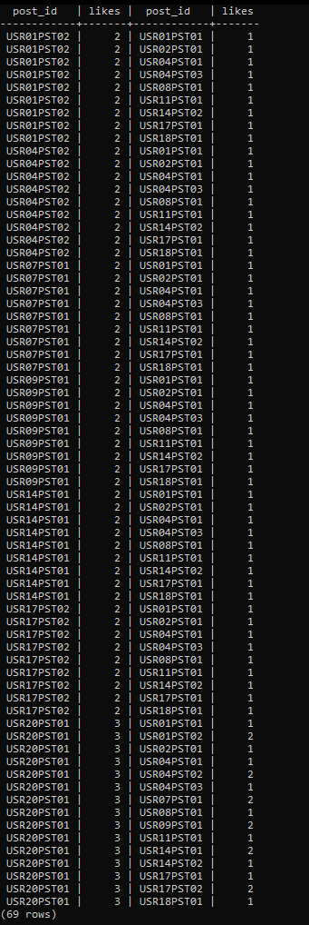

**5)Display first_name of user who has commented on any Post .**

select users.firstname from (post inner join comments on comments.post_id=post.post_id) inner join users on users.user_id=comments.commentby_id;

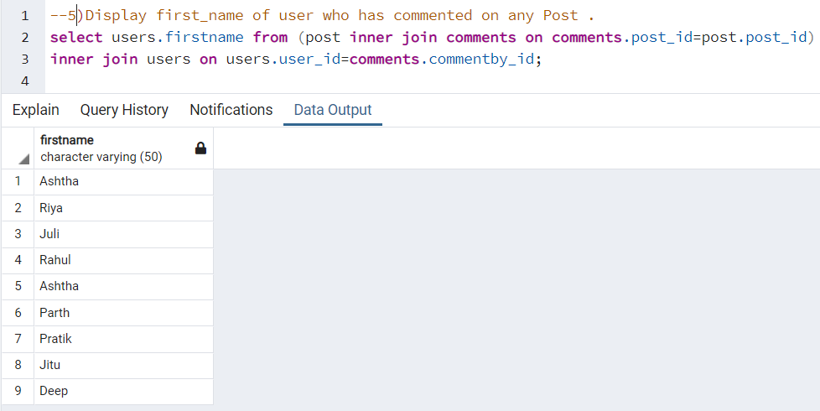

**6)Most liked post .**

SELECT post_id, COUNT(DISTINCT liker_id) FROM likes GROUP BY post_id ORDER BY COUNT DESC LIMIT 1 ;

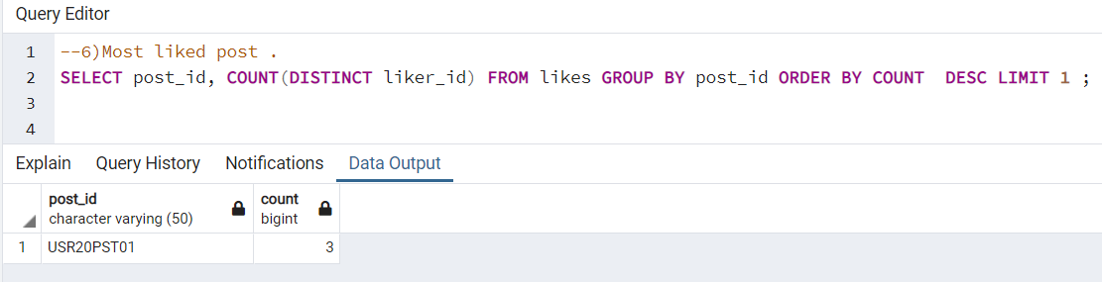

**7) Display mutual_friends of USR01 and USR02.**

SELECT f1.friend_id as Mutual_friend,f1.f_name FROM friends f1 INNER JOIN friends f2 ON f1.friend_id = f2.friend_id WHERE f1.user_id ='USR01' AND f2.user_id = 'USR02';

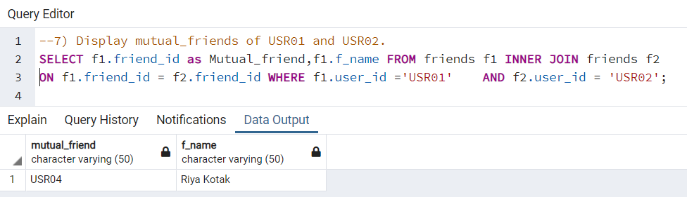

**8) Display friends of each other from friends table .**

SELECT f1.user_id , f2.user_id FROM friends f1 INNER JOIN friends f2 ON f1.user_id =f2.friend_id WHERE f1.friend_id =f2.user_id ;

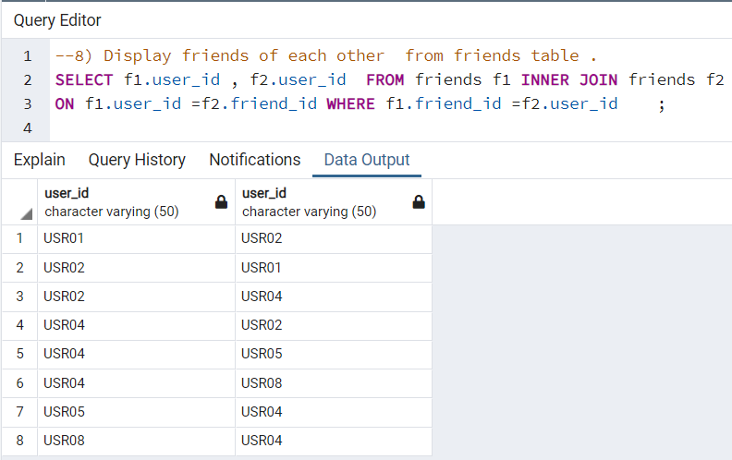

**9)searching for users that aren't already friends.**

SELECT f2.user_id ,COUNT(*) as friends_in_common FROM friends f1 LEFT JOIN friends f2 ON f1.friend_id = f2.friend_id

WHERE f1.user_id = 'USR07' GROUP BY f2.user_id ORDER BY friends_in_common DESC ;

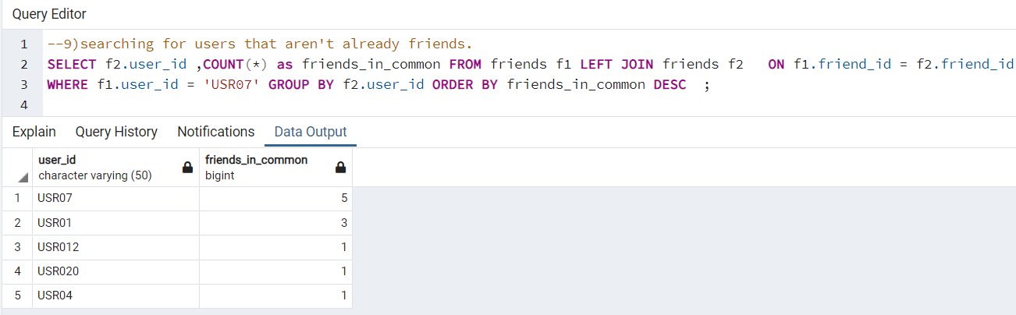

**5.5 PL/SQL**

**1)Create a view that displays story_id and the no. of times it is shared.**

create view newstory as

select story_id,no_of_share from story;

select * from newstory;

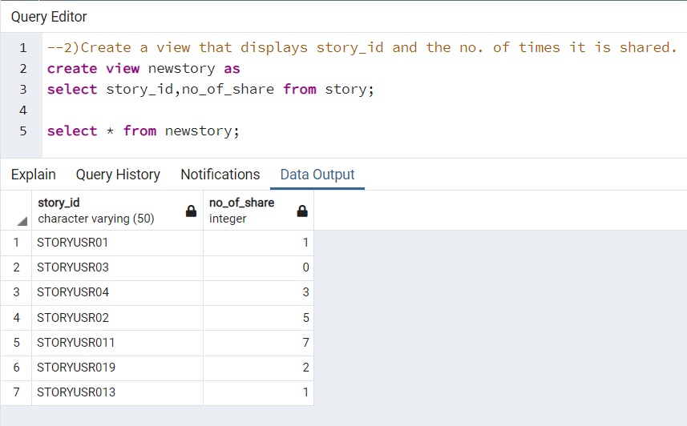

**5.6 Functions**

**1)Create a function gives the total number of private accounts.**

create function get_privacy_status()

returns int

language plpgsql

as

$$

Declare

user_count integer;

Begin

select count(*)

into user_count

from users

where privacy_status='true';

return user_count;

End;

$$;

select get_privacy_status();

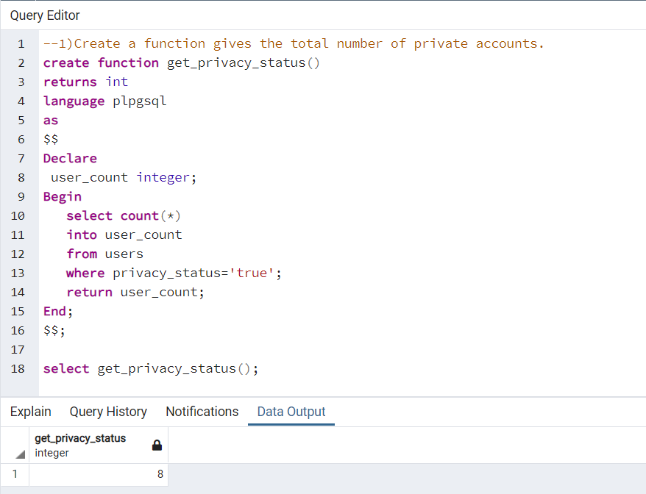

**5.7 Triggers**

**1)Create a trigger which displays an error message if someone tries to enter invalid E-mail.**

create function check_email() returns trigger as $$

BEGIN

if NEW.email LIKE '%___@___%.__%' then

return NEW;

end if;

raise exception 'Your E-mail format must be like '**@**.**';

END;

$$

LANGUAGE plpgsql;

create trigger email_check

BEFORE INSERT OR UPDATE

ON users

FOR EACH ROW

EXECUTE PROCEDURE check_email();

INSERT INTO users(user_id , password , firstname , lastname , email , dp_url ,no_of_post , privacy_status , friends ,created_at )VALUES('USR021','Pass@USR21','Shyam','Sharma','shyamsharmagmail.com','IC/DP/USRDP021.png',2,FALSE,4,'2010-06-02 01:10:25-03');

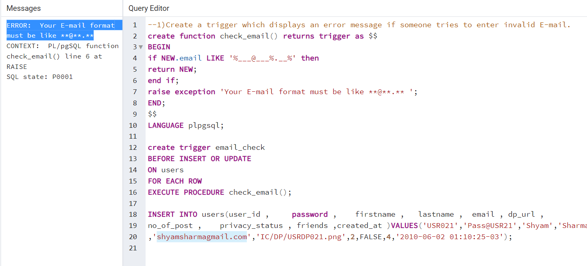

**2)Create a trigger which inserts the new tuples on insertion and old tuples on deletion into a new table called friend_audit.**

create or replace function do_friend_audit()

returns trigger as $$

begin

if(TG_OP='DELETE') then insert into friend_audit

select 'D',now(),OLD.user_id,OLD.f_name;

return OLD;

elseif(TG_OP='UPDATE') then insert into friend_audit

select 'U',now(),NEW.user_id,NEW.f_name;

return NEW;

elseif(TG_OP='INSERT') then insert into friend_audit

select 'I',now(),NEW.user_id,NEW.f_name;

return NEW;

end if;

end;

$$

language plpgsql;

create trigger friend_audit

after insert or update or delete on friends

for each row

execute procedure do_friend_audit();

create table friend_audit(OP varchar(10) not null,

stamp timestamp not null,

user_id varchar(10) not null,

friend_name varchar(10) not null);

INSERT INTO users(user_id , password , firstname , lastname , email , dp_url , no_of_post , privacy_status , friends , created_at )VALUES

('USR022','Pass@USR22','Mukund','Raj','mukundraj@gmail.com','IC/DP/USRDP022.png',2,FALSE,4,'2021-06-02 01:10:25-03');

INSERT INTO friends( user_id , friend_id , f_name , close_friend , date_of_following , mutual_friends , most_shown , least_interacted)VALUES

('USR022','USR02','Yash Varma',TRUE,'2021-08-23',1,FALSE,TRUE);

UPDATE friends set most_shown = 'TRUE' where user_id = 'USR022';

SELECT * from friend_audit;

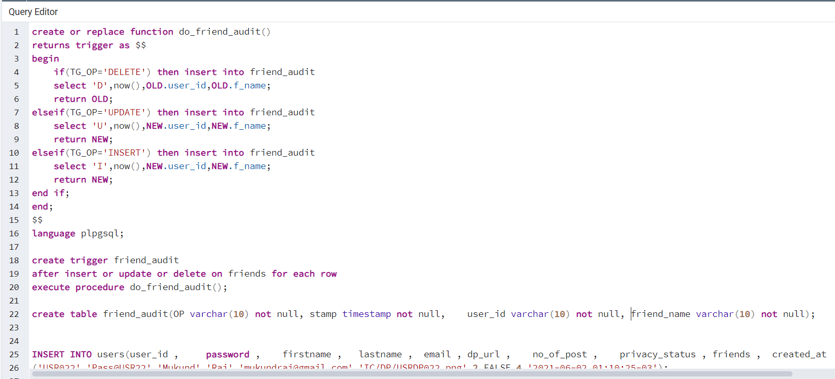

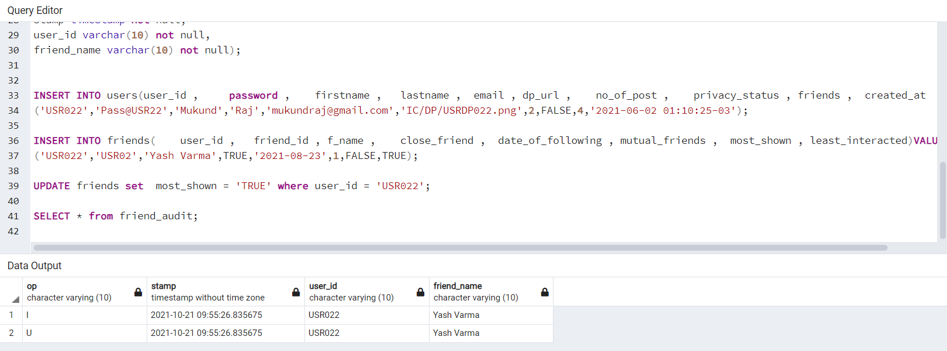

**5.8 Cursor**

**1)Create a cursor which displays the the respective story’s information iff it is included in highlights. Otherwise it should not display anything.**

create or replace function get_story_info(str_id varchar(50)) returns text as $$

declare name text default '';

storyrec record;

cur_str cursor(str_id varchar(50))

for select user_id,story_id

from story

where story.highlights='TRUE' and str_id=story_id;

begin

open cur_str(str_id);

fetch cur_str into storyrec;

exit when not found;

name := storyrec.user_id || ' , ' || storyrec.story_id;

close cur_str;

return name;

end; $$

language plpgsql;

SELECT get_story_info(‘STORYUSR01’);

SELECT get_story_info(‘STORYUSR02’);

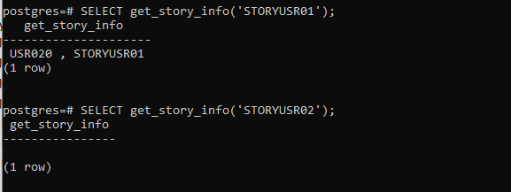

# FUTURE ENHANCEMENTS OF THE SYSTEM

* + - * We will design Front-end Design in HTML , CSS , JavaScript and Develop Bank- end in Python.
      * For security purpose New Registration is done using OTP.
      * We will make database more consistent and We are making this database efficient and easy to implement with huge data capacity.
      * Methods and user data input will be lot easy after the implement of GUI.
      * We will also add some extra features so that the users can get answer for their complaints as fast as possible.

# BIBLIOGRAPHY

* + - * For the successful implementation of this project we referred to many websites and books.
      * We created the ER Diagram and Schema Diagram on “erdplus.com”.
      * Mostly we referred the online material for syntax of procedures, triggers, Exception and cursors.

### Reference book:

**Data Base System Concepts**

**-Henry F. Korth & A. Silberschatz 2nd Ed. McGraw-Hill 1991**

**Reference Websites:**

* + - * <https://www.stackoverflow.com/>
      * <https://erdplus.com>