**COMPUTER SYSTEM SERVICING NC II**

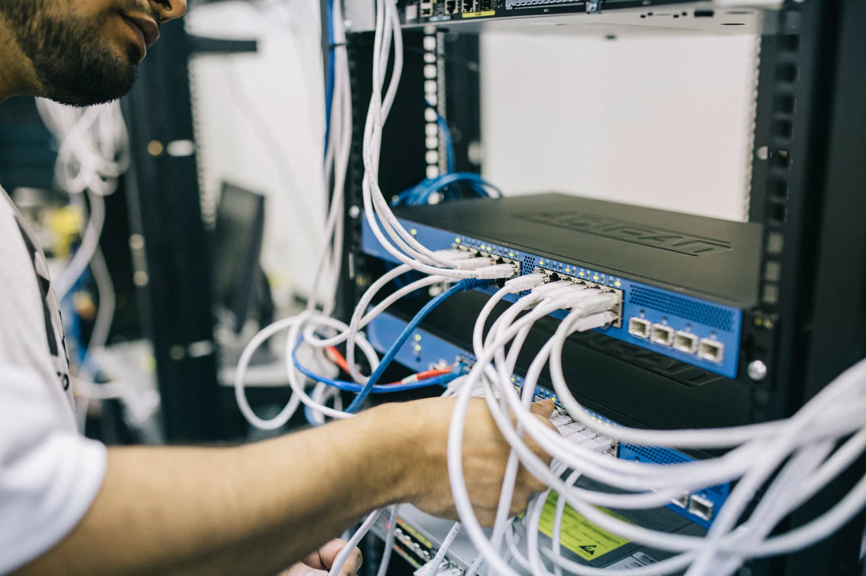*)*

**PREPARED BY:**

*Talipan National High School*

Table of Content

**Contents**

**COC 2 SETUP COMPUTER NETWORKS**  3

**SERVER COMPUTER USING BOOTABLE USB** 3

**CREATE AN IP ADDRESS IN WORKSTATION TO ACCESS INTERNET USING ROUTER AND HUB** 4

Go to computer workstation 4

Go to computer server 5

**CREATE AN IP ADDRESS IN WORKSTATION TO ACCESS INTERNET USING ACCESS POINT AND HUB** 6

Go to computer workstation 6

Go to computer server 7

Connecting Workstation to Server 8

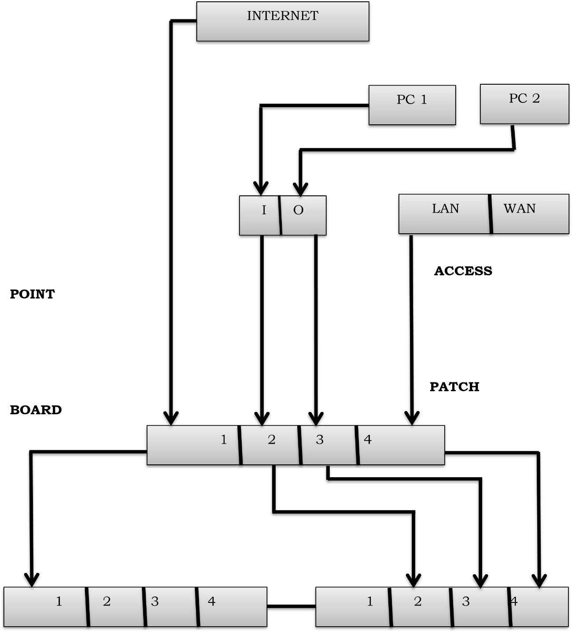**

**ROUTER** **SWITCH HUB • FORMATTING**

**SERVER COMPUTER USING BOOTABLE USB**

1. Insert USB
2. Turn on computer
3. Press F12
4. Click USB device
5. Press any key to boot from USB
6. Click next
7. Click install now
8. Click windows 2008 R2 server standard x64
9. Click next
10. Check I accept the license terms
11. Click next
12. Click custom: Install windows only (advanced)
13. Click drive 0 partition 1: system reserved
14. Click delete
15. Click ok
16. Click drive 0 partition 2
17. Click delete
18. Click ok
19. Click drive 0 partition 3
20. Click delete
21. Click ok
22. Click new
23. Click backspace to delete
24. Enter the desired number 75000
25. Click apply
26. Click drive 0 unallocated space
27. Click new
28. Click apply
29. Click drive 0 partition 2
30. Click next then wait
31. Computer will restart
32. Wait to complete installation
33. Computer will restart again
34. Click begin install
35. Click ok
36. Create new password, P@SSWORD12345
37. Click ok

## **CREATE AN IP ADDRESS IN WORKSTATION TO ACCESS INTERNET USING ROUTER AND HUB**

**Go to computer workstation**

1. Click start
2. Type cmd
3. Type ipconfig
4. Click Google chrome
5. Type the IP address in the Google for example 192.168.100.101
6. Click enter
7. Write admin in the username
8. Write admin in the password
9. Click log in
10. Change the Wireless Network Name (SSID) to your surname
11. Click apply then wait
12. Write admin in the username again
13. Write admin in the username again
14. Click network setting
15. Click LAN/DHCP server
16. Change LAN IP in your desired IP address for example 192.168.50.51
17. Click apply then wait
18. Click internet icon
19. Click open network and sharing center
20. Click change adapter setting
21. Click local area connection
22. Right click disable then enable
23. Go to cmd then type ipconfig for checking
24. Click internet icon
25. Click open network and sharing center
26. Click change adapter setting
27. Click local area connection
28. Right click then click properties
29. Click Internet Protocol Version 4 (TCP/IPv4)
30. Click properties
31. Click use the following IP address
32. Type your desire IP for example 192.168.50.6 for workstation
33. Click subnet mask 255.255.255.0
34. Click default gateway then type 192.168.50.51
35. Click preferred DNS server then type 192.168.50.51
36. Click ok then click close
37. Right click local area connection
38. Click disable and enable
39. Go to cmd and type ipconfig for checking
40. Go to Google chrome then type for example youtube

**Go to computer server**

1. Click start
2. Type cmd
3. Type ipconfig
4. Click internet icon
5. Click open network and sharing center
6. Click change adapter settings
7. Click local area connection
8. Right click properties
9. Click Internet Protocol Version 4 (TCP/IPv4)
10. Click properties
11. Click use the following IP address
12. Click IP address then type for example 192.168.50.7 for server
13. Click subnet mask 255.255.255.0
14. Click default gateway then type for example 192.168.50.51
15. Click preferred DNS server then type for example 192.168.50.51
16. Click ok then click close
17. Right click local area connection
18. Click disable then enable
19. Go to cmd and type ipconfig for checking
20. Go to internet explorer then type for example youtube

## 

## **CREATE AN IP ADDRESS IN WORKSTATION TO ACCESS INTERNET USING ACCESS POINT AND HUB**

**Go to computer workstation**

1. Click internet icon
2. Click open network and sharing center
3. Click change adapter settings
4. Right click local area connection
5. Click properties
6. Click Internet Protocol Version 4 (TCP/IPv4)
7. Click properties
8. Click obtain and IP address automatically
9. Click obtain DNS server address automatically
10. Click ok
11. Right click local area connection
12. Click disable then enable
13. Click start
14. Type cmd
15. Type ipconfig
16. Go to goggle chrome
17. Type the default gateway of access point for example 192.168.20.21
18. Then enter
19. Click login
20. Click wireless
21. Write your first name in the Name (SSID)
22. Click apply
23. Click setup
24. Click local network
25. Change IP address to your desired for example 192.168.35.36
26. Click apply changes
27. Click ok
28. Click please click 192.168.35.36 to continue configuration
29. Click internet icon
30. Click open network and sharing center
31. Click change adapter settings
32. Click local area connection
33. Click disable then enable
34. Go to start
35. Type cmd
36. Type ipconfig for checking
37. Click internet icon
38. Click open network and sharing center
39. Click change adapter settings
40. Click local area connection
41. Click properties
42. Click Internet Protocol Version 4 (TCP/IPv4)
43. Click properties
44. Click use the following IP address
45. Click IP address for example 192.168.35.6
46. Click subnet mask 255.255.255.0
47. Click default gateway then type 192.168.35.36
48. Click preferred DNS server then type 192.168.35.36
49. Click ok
50. Click close
51. Right click local area connection
52. Click disable then enable
53. Go to start
54. Type cmd then ipconfig for checking
55. Go to google chrome then type for example yahoo

**Go to computer server**

1. Click start
2. Type cmd
3. Type ipconfig
4. Click internet icon
5. Click open network and sharing center
6. Click change adapter settings
7. Click local area connection
8. Click disable then enable
9. Click properties
10. Click Internet Protocol Version 4 (TCP/IPv4)
11. Click properties
12. Click obtain an IP address automatically
13. Click obtain DNS server address automatically
14. Click ok
15. Click close
16. Click local area connection
17. Click properties
18. Click Internet Protocol Version 4 (TCP/IPv4)
19. Click properties
20. Click use the following IP adress
21. Click IP address for example 192.168.60.7
22. Click subnet mask 255.255.255.0
23. Click default gateway 192.168.60.61
24. Click preferred DNS server 192.168.60.61
25. Click ok
26. Click close
27. Right click local area connection
28. Click disable then enable
29. Go to cmd
30. Type ipconfig for checking
31. Go to internet explorer browse application

**Connecting Workstation to Server**

1. Click internet icon
2. Click open network and sharing
3. Click windows firewall
4. Turn off windows firewall
5. Click ok
6. Go to start
7. Type cmd
8. Type ipconfig
9. Type ping ip address of workstation 192.168.60.6
10. Type ping ip address of workstation 192.168.60.7