**COMPUTER SYSTEM SERVICING NC II**

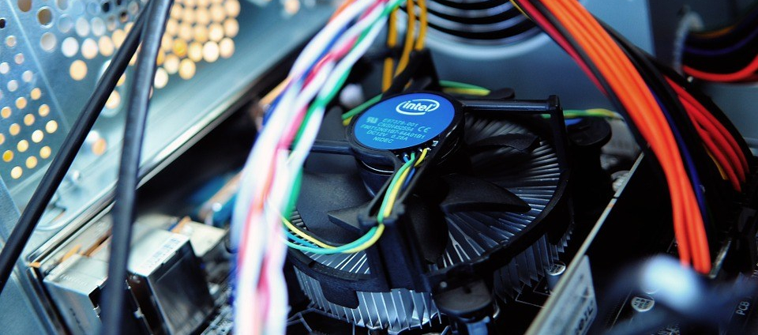*COC 1 (Install and Configure Computer System)*

**PREPARED BY:**

*Talipan National High School*

*Table of Contents*

Computer parts and its functions 3

1. System case 3

2. Motherboard 4

3. Power Supply 4

4. Central Processing Unit (CPU) 4

5. Random Access Memory (RAM) 5

6. Hard Disk Drive (HDD) or Solid-State Drive 5

Solid State Drive 5

7. The CPU Cooler 6

8. Graphics Card or Video Card 6

9. Peripheral Hardware. 6

10. Wireless Network Card 6

DISASSEMBLY & ASSEMBLY SYSTEM UNIT 7

**Certificate of Competency (COC) 1**

Before getting really into Computer System Servicing it is essential that you know and understand the parts and components of a computer.

Educating yourself with the basic functions of the computer parts could help you better understand how the computer works and it could really help you in diagnosing some problems of your computer that you could have in the future, we will talk about this on COC 4 (Maintain and Repair Computer System and Network), let continue in Core Competency 1 (Install and configure computer system).

Upon completing this series of lectures in COC 1 your expected to:

1. Identify computer parts and its function
2. Assemble and Disassemble computer system

**Computer parts and its functions**

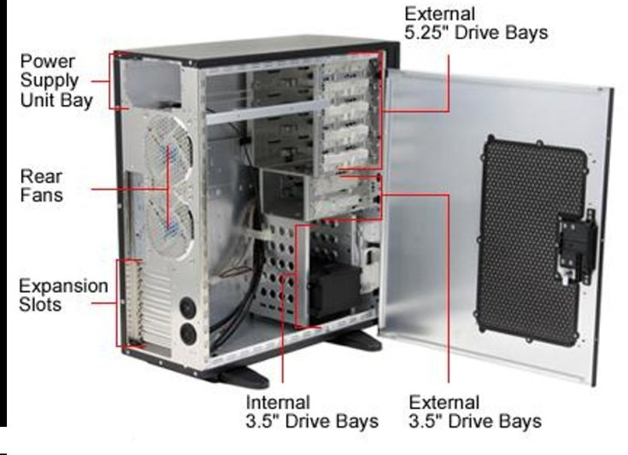**1. System case**

The **system case**, sometimes called the *chassis* or *enclosure*, is the metal and plastic box that houses the main components of the computer. Most people don’t consider it a very important part of the computer (perhaps in the same way they wouldn’t consider their *own* skin a very important body organ). While the case isn’t as critical to the system as some other computer components (like the processor or hard disk), it has several important roles to play in the functioning of a properly designed and well-built computer.

The case has a role to play in several important areas:

* **Structure –** The case must provide a solid structural framework for these components to ensure that everything fits together and works well.
* **Protection –** The case protects the inside of your system from the outside world, and vice-versa.
* **Cooling –** Components that run [cool](http://www.pcguide.com/care/care/gen/cool.htm) last longer and give much less trouble to their owner.

**2. Motherboard**

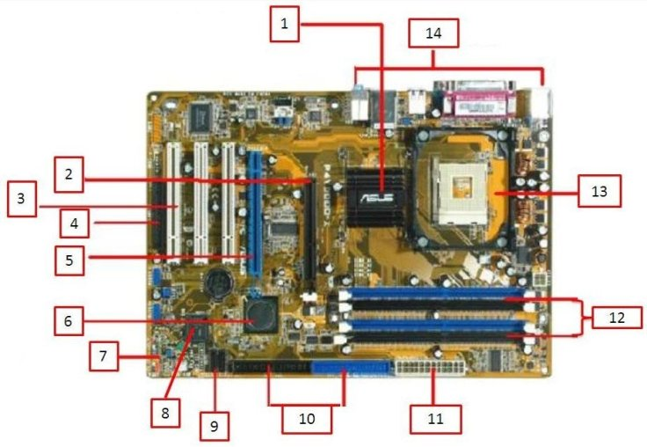

The **motherboard** is an important computer component because it’s what everything else connects to! The motherboard is a decently sized circuit board that lets other components communicate. A motherboard has ports that face outside a PC’s case, so you can charge your computer, plug in a monitor, or connect a mouse. A computer’s motherboard also contains slots for expansions, so you can add additional accessory ports if you wish. The motherboard also stores low-level information like the system time even when the computer is turned off.

**3. Power Supply**

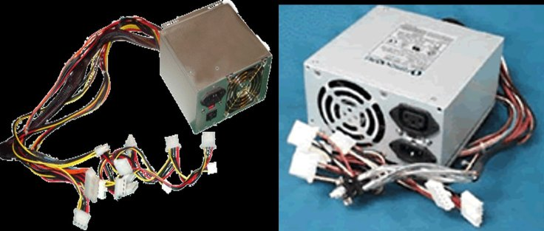True to its name, the **power supply**powers all other components of the machine. It usually plugs into the motherboard to power the other parts. The power supply connects to either an internal battery (on a laptop) or a plug for an outlet (on a desktop).

**4. Central Processing Unit (CPU)**

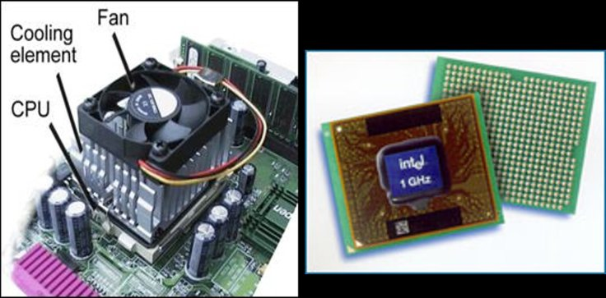A **CPU**, sometimes referred to as a computer’s brain, is the workhorse of the machine. It performs the calculations needed by a system and can vary in speed. The work that a CPU does generates heat, which is why your computer has a fan inside. A more powerful CPU is necessary for intense computer work like editing high-definition video or programming complex software.

**5. Random Access Memory (RAM)**

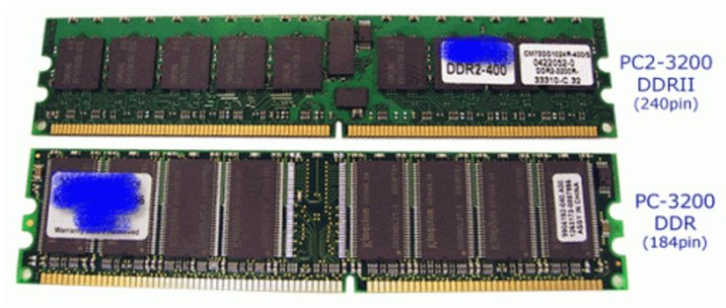**RAM** is temporary memory. Whenever you open a Microsoft Word window, your computer places it in RAM, and when you close the window, that RAM is freed. Since RAM is volatile, its contents are lost if the machine loses power. Therefore, you lose a Word document when the power goes out if you didn’t save it.

The more RAM you have, the more programs you can run at once. A common cause of slow computers is a lack of sufficient RAM.

**6. Hard Disk Drive (HDD) or Solid-State Drive**

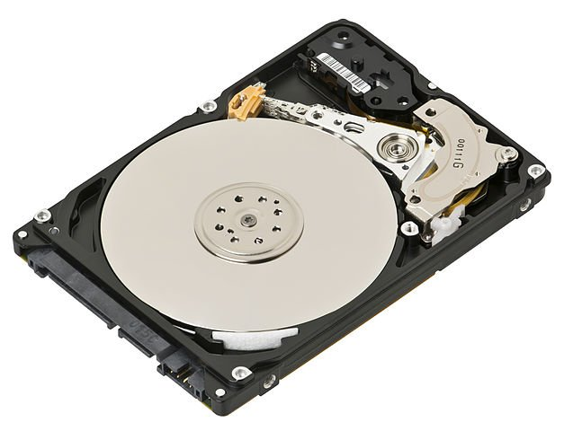

Since RAM is temporary, your computer needs a place to store data permanently. That’s where the hard drive comes in. The traditional hard drive consists of several spinning platters with an arm that physically writes data to the disk. However, these drives are slow and are starting to be replaced by the faster solid-state drives.

**Solid State Drive**

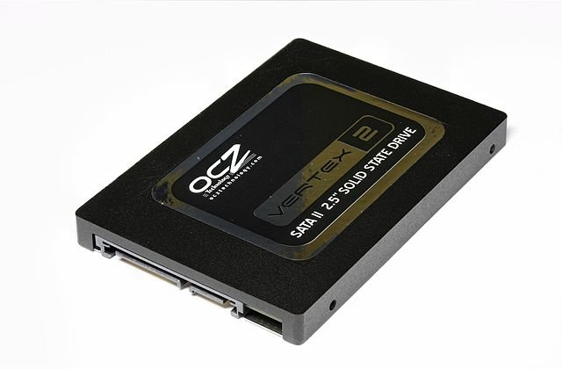A **solid-state drive** (**SSD**) is solid-state storage device that uses integrated circuits assemblies’ memory to store data persistently. It is also sometimes called a **solid-state disk**, although SSDs do not have physical disks. Best option when upgrading your hard drive, the performance accelerates.

**7. The CPU Cooler**

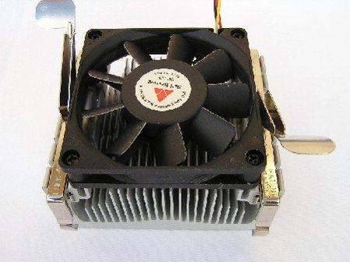

This is usually a **heatsink** with a **fan** on it, however it can also sometimes be a watercooling system. Its role is to dissipate heat from the CPU into the air.

**8. Graphics Card or Video Card**

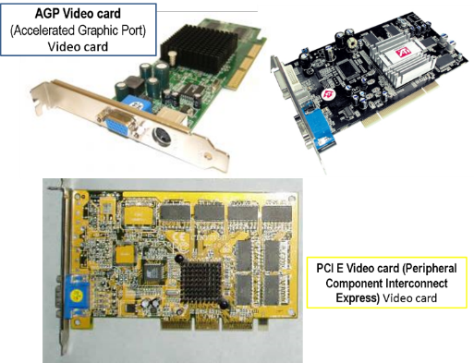This is different from a GPU. The GPU (Graphics Processing Unit) is the chip that handles graphics processing in a particular computer. The GPU is surface mounted to the Graphics Card, but the graphics card also has power delivery circuitry, cooling, and video output ports.

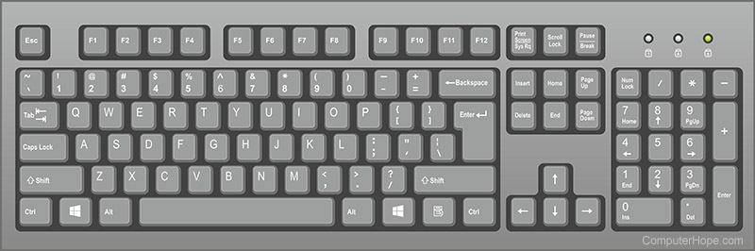**9. Peripheral Hardware.**

* **Keyboard, Mouse, Microphone, Camera –**usually external devices that allow input to the computer.
  + **Screen, Speakers** – device for converting electrical energy into acoustical signal energy that is radiated into a room or open air.

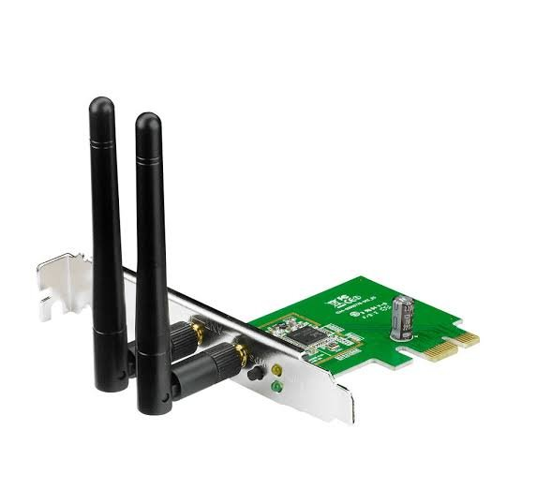

**10. Wireless Network Card**

Allow the computer to connect to Wi-Fi.

*https://ilearncss.wordpress.com/coc-1-install-and-configure-computer-system/*

## **DISASSEMBLY & ASSEMBLY SYSTEM UNIT**

Computer assembly is a process in which all the internal components of the computer system are fitted to make the computer functional. The main component involves CPU, motherboard, memory, disk drives, etc. There is a proper process of attachment and installation of each component. An installation technician should be competent to disassemble and reassemble the computer system. In this Unit, we will understand the step-by-step process of computer assembly and disassembly. The assembly and disassembly of the desktop as well as of a laptop computer is demonstrated. Tools are an essential part of computer assembly and maintenance. It is also important to handle the tools carefully and safely. While installation a computer and its peripherals, you should follow the basic safety guidelines to prevent cuts, burns, electrical shock, and damage to eyesight. The technician must take care of the tools as well as personal safety. Safe working practice helps to prevent injury to people and damage to computer equipment. In this Unit, we will learn to use various tools required for installation of a computer and peripherals. We will also understand and follow the basic safety precautions while handling tools and equipment during the installation process.

As we know, computer assembly is a systematic process. First, arrange the computer parts. The sequence for assembly and working of the computer listed below is as:

• Open the case.

• Install the power supply.

• Attach the components to the motherboard.

• Install the motherboard.

• Install internal drives.

• Connect all internal cables.

• Install motherboard power connections

• Connect external cables to the computer.

• Boot the computer for the first time.

Prepare the workspace before starting installation of the computer. There should be adequate lighting, good ventilation, and a comfortable room temperature. The

workbench or table should be accessible from all sides. Avoid cluttering the surface of the workbench or table with tools and computer components. An anti‑static mat on the table will help to prevent physical and electrostatic discharge (ESD) damage to equipment. Small containers can be used to hold small screws and other parts as they are being removed.

**Material Required**

• Computer case, with power supply installed

• Motherboard

• CPU

• Heat sink/fan assembly

• Thermal compound

• RAM module(s)

• Motherboard standoffs and screws

• Anti‑static wrist strap and anti-static mat

• Tool kit

**Procedure**

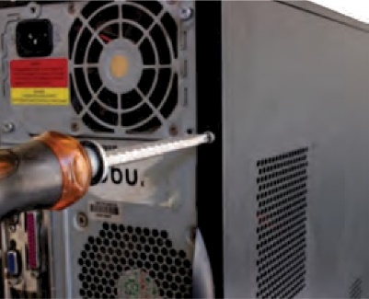Step 1: **Open the case**

• The first step in assembling a computer is to open the computer case. There are different methods for opening cases.

• The computer comes with various types of cabinets. The method for opening the case is different based on the manufacturer.

• To open the case, first remove the screws of the left side cover and slide the side cover.

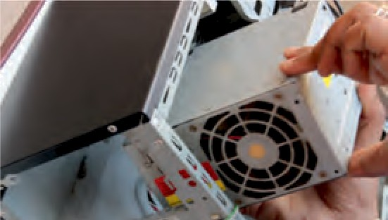Step 2: **Install the power supply**

The next step is to install a power supply (see Figure

12.4). There are usually four screws that attach the

power supply to the case. Power supplies have fans that

can vibrate and loosen screws that are not secured.

When installing a power supply, make sure that all the

screws are used and that they are properly tightened.

Step 3: **Attach the components to motherboard**

The motherboard must be prepared before its installation.

To prepare the motherboard, you first need to install the

CPU, then the heat sink on the CPU and CPU fan.

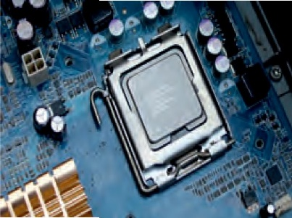

**CPU** The CPU and motherboard are sensitive to electrostatic

discharge. So, place them on a grounded anti-static

mat and wear an anti-static wrist strap while handling

the CPU. When handling a CPU, do not touch the CPU

contacts at any point. The CPU is secured to the socket

on the motherboard with a locking assembly.

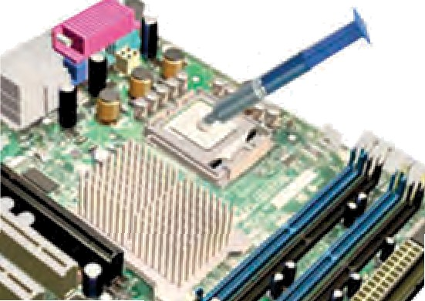**Thermal compound** which is used to conduct heat away

from the CPU is applied on the top of CPU. In case of an

old CPU, first clean the top of the CPU, and then apply the

thermal compound. Clean the top of the CPU and the base

of the heat sink with isopropyl alcohol and a lint‑free cloth.

This removes the old thermal compound. Then apply a new

layer of thermal compound.

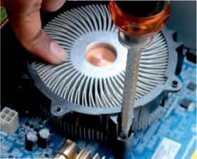

**Heat sink and fan assembly**

Heat sink and fan assembly is a two-part cooling device.

The heat sink draws heat away from the CPU. The fan

moves the heat away from the heat sink. The assembly

has a 3-pin power connector.

To install a CPU and heat sink and fan assembly,

follow these steps:

* First, open the CPU load plate. Align the CPU
* orientation so that the notches on the CPU are
* aligned with the orientation keys on CPU socket.
* Place the CPU gently into the socket.
* Close the CPU load plate.
* Close the load lever.
* Apply a small amount of thermal compound to
* top of the CPU.
* Screw the CPU fan on the heat sink.
* Align the heat sink and fan assembly with the holes on the motherboard.
* Place the assembly onto the CPU socket carefully.
* Screw the assembly on the motherboard.
* Connect the assembly power cable to the CPU fan connector on the motherboard.

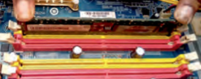It is better to install the RAM first on the motherboard and then fix the motherboard in the case. To install RAM, first ensure its compatibility with the motherboard. If DDR3 is mentioned on the motherboard, then DDR3 RAM may be fixed in the memory slot. To install RAM, follow these steps.

• Press down the side locks of the memory slot. Align the notches on the RAM module to the keys in the slot and press down on both ends of RAM module until the side lock gets locked.

• Make sure that the side tabs have locked the RAM module.

• Repeat the above steps to install additional RAM modules.

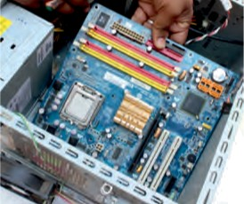

Step 4: **Install motherboard**

After preparing the motherboard, you can install the computer case. Plastic and metal standoffs are used to mount the motherboard and to prevent it from touching the metal portions of the case.

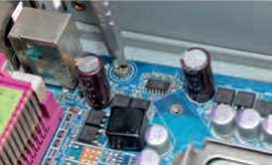To install the motherboard, follow these steps:

• Lay the motherboard over the standoffs to mount it on the holes.

• Align the screw holes of the motherboard with the standoffs.

• Then screw the board using a standard screwdriver.

• Tighten all the motherboard screws.

• Connect the 4-pin ATX power connector from the power supply to the motherboard.

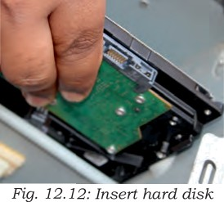Step 5: **Install internal drives**

The hard drive is the device which stores all the data. It is 3.5 inch wide and needs to be mounted so that access to the cable connections on the back is gained. Drives that are installed in internal bays are called internal drives. A hard disk drive (HDD) is an example of an internal drive. To install HDD, follow these steps:

* Position the HDD so that it aligns with the 3.5-inch drive bay.
* Insert the HDD into the drive bay so that the screw holes in the drive line up with the screw holes in the case
* 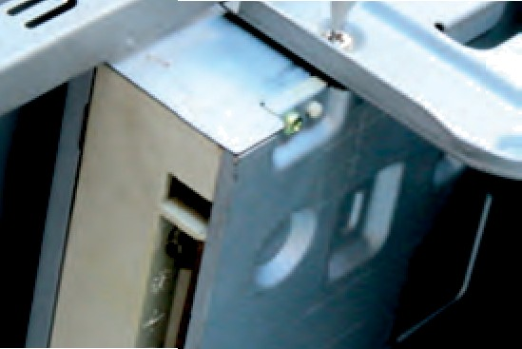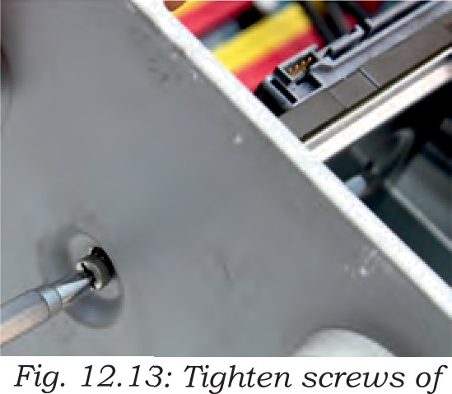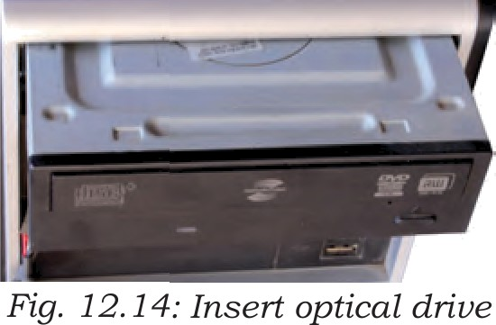Secure the HDD to the case using proper screws
* Position the optical drive so that it aligns with the 5.25-inch drive bay.
* Insert the optical drive into the drive bay so that the optical drive screw holes align with the screw holes in the case).
* Secure the optical drive to the case using the proper screws
* Connect the power cable coming from the SMPS to the power socket of optical drive.
* Connect SATA data cable from optical drive socket to the motherboard socket.

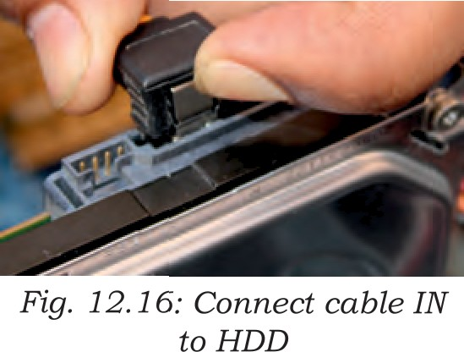

Step 6: **Connect all internal cables**

Power cables are used to distribute electricity from the power supply to the motherboard and other components. Data cables transmit data between the motherboard and storage devices, such as hard drives.

Step 7: **Install motherboard power connections**

Just like other components, motherboards require power to operate. The Advanced Technology eXtended (ATX) main power connector will have either 20 or

24 pins. The power supply may also have a 4-pin or 6-pin auxiliary (AUX) power connector that connects to the motherboard. A 20-pin connector will work in a motherboard with a 24-pin socket. Follow these steps for motherboard power cable installation:

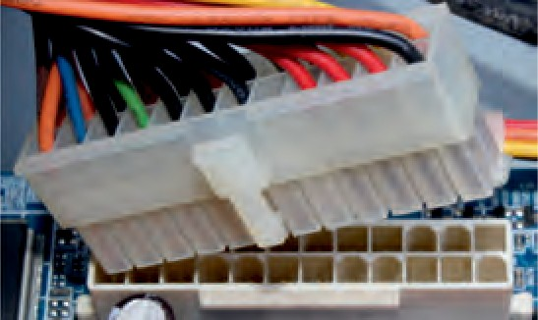• Align the 20-pin ATX power connector with the socket on the motherboard.

• Gently press down on the connector until the clip clicks into place

• Align the 4-pin AUX power connector with the

socket on the motherboard.

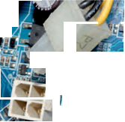• Gently press down on the connector until the clip clicks into place

SITE power connectors

SATA power connectors use a 15-pin connector. Serial advanced technology attachment

{SATA) power connectors are used to correct to hard disk drives, optical drives, or any devices that have a SATA power socket.

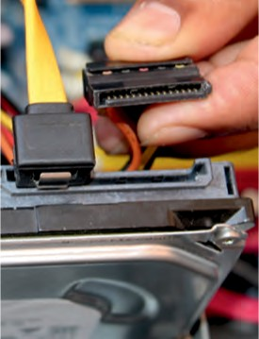

Step 8: **Connect external** cables to the computer Setting up the computer system involves the complete process of establishing the proper connectivity of various parts of the computer system—input and output devices, connectivity of computer with the surge power supply. Reattach the side panels to the case. The process of connecting the external cables

Step 9: **Starting the computer**

To start the computer, it is necessary to follow the correct sequence to start up. Now push the power button on the CPU to start the computer. Practically when we start our vehicle, we always check that the light or air conditioner (AC) is off. Otherwise, it will consume more power compared to normal start up.

Always remember that the first step is to push power button of the CPU than the monitor’s. Because the monitor consumes more electricity when powered. An operating system or system software like Window



**COMPUTER DISASSEMBLY**

Disassembly is the process of breaking down a device into separate parts. Disassembly of any device is required to determine a problem, to replace a part, or take the parts and use them in another device. A computer is also an electronic device which requires disassembly for such issues. For example, if a RAM gets dysfunctional in a computer, then it requires disassembling the computer to take out the dysfunctional RAM and replace it with new RAM chips. As we know, computers have standard internal components, but the way of placement may vary as per the PC tower case and different brands of computer. The best way is to refer to the manufacturer instructions manual. But in general, there is a standard process of computer disassembly, which is demonstrated in this session. Just like computer assembly, the disassembly is a standard process. The process involves unplugging of all the cords and cables connecting a component to other components, then removing the part from the case or frame. Components can be attached to the case with special clips, screws, or by insertion into a holder. A small amount of force is required to remove each part of the computer system.

Material Required

• One working PC

• An anti-static wrist strap

• An anti-static mat

• Anti-static bags of various sizes

• Technician’s toolkit

• A plastic cup or box to organize screws, nuts, and bolts

**Procedure**

The disassembly procedure of computer is demonstrated as below.

Step 1: **Unplugging**

• Unplug the power cord from the PC and from the wall socket to prevent any injuries and damage of the PC from electrostatic discharge (ESD).

• Unplug all the peripherals attached to the computer, such as the keyboard, mouse, monitor, headphones, and any external drives.

• Wear a grounding strap to discharge any static electricity.

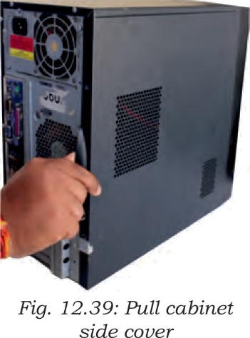Step 2: **Open the case**

The computer comes with various types of cabinets. The methods of opening the case are different based on the manufacturer.

• To open the case, first remove the screws of the

left side cover and slide the side cover.

• Pull the latch to release the side panel. Then lift

the side cover out from the chassis.

To remember connectivity of internal cables, take the photographs of internal circuitry. It will help to assemble back the system.

Step 3: **Disconnect all the connectors**

Disconnect all the connectors connected to the motherboard. These include SATA power cable and data cable of HDD as well as SATA cable of optical drive.

Step 4: **Remove the fan**

Remove the fan now. Most computers have two fans —the system fan and CPU fan. The system fan is located at the back side of the computer to blow air into the computer. The CPU fan is located on top of the CPU heat sink. The fans and its connectors are labelled with their names.

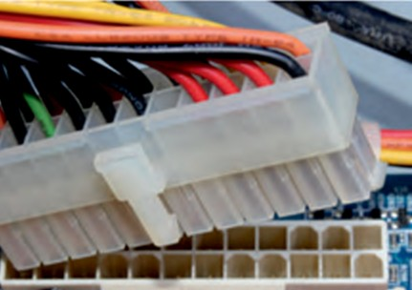

Step 5: **Remove the power supply**

The power supply is connected to the motherboard by a 20-pin connector and 4-pin connector. It is also connected to hard disk drive and the optical drive. Firstly, disconnect hard disk drive and the optical drive connectors from the motherboard

Step 6: **Removing HDD and optical drive**

• Remove the SATA cable connecting to the HDD and motherboard.

Unscrewed the SMP!3 and remove it from cabinet

• Then unscrew the four screws securing it in place and pull out the HDD

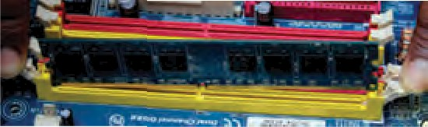

Step 7: **Remove RAM (random access memory) modules**

RAM allows for the transfer of information to and from the CPU. Computer runs fast with more RAM. Most computers have four RAM slots, and two RAM chips.

To remove the RAM, push down on both tabs holding the RAM in place, which are located at both ends of the RAM. It will cause the module to pop up

removal.

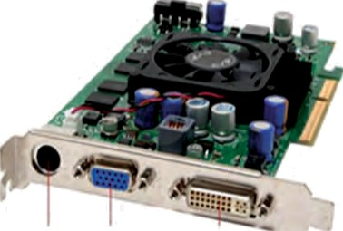Step 8: **Remove expansion cards**

The modern motherboards are integrated with the audio, video, and network cards. However, if your computer has the expansion card insert into the expansions slot to increase the functionality. The expansion card is screwed with a single screw on top of expansion card slot.

• To remove the expansion cards, disconnect the cables attached to it.

• Remove the screws securing the card in

the slot.

• Carefully take out the card from the slot

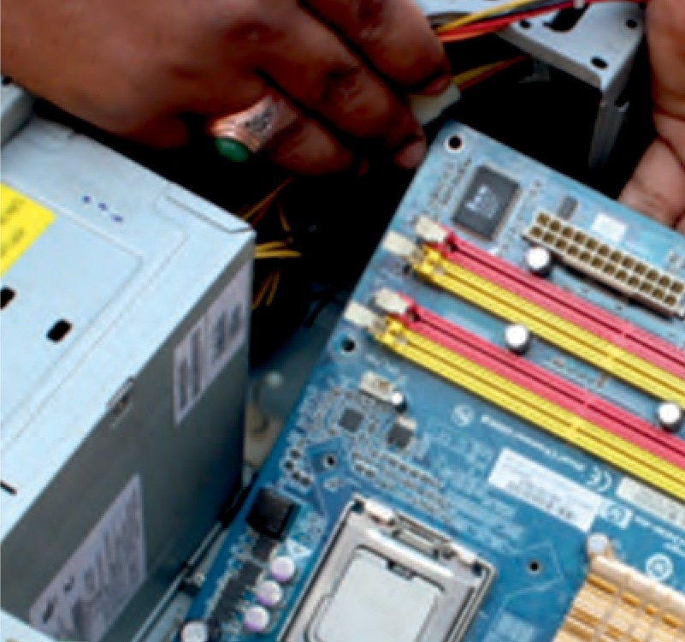

Step 9: **Remove motherboard**

Every part of the computer is attached to the motherboard. The CPU, RAM, and expansion cards are directly attached to the motherboard. To remove the motherboard, disconnect all the cables from the motherboard. It has seven screws holding it to the frame. Remove these screws and then lift the motherboard out of

the frame.

Step 10: **Reassemble the components**

• Identify every component and take its photograph.

• After identification of each component, put all the components back in their place and ensure that all cables and wires are connected at the right place to avoid further troubleshooting.

• Close the case and put the screws back in their place.

• Lastly, connect every external device such as the keyboard, mouse, monitor, etc., and turn on the computer to see everything is working fine after assembled.