# Physical Machine

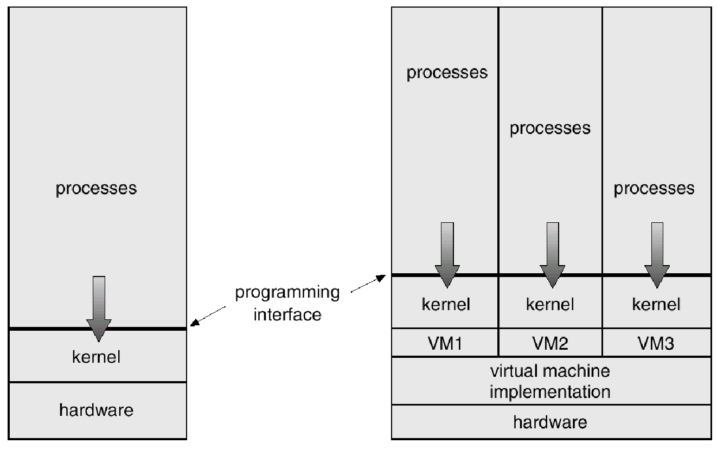

**Example of MS-DOS on top of Windows XP**

**DOS APPLICATION**

**BIOS DRIVERSWindows XP Physical**

**UserPhysical**

**Machine**

Information Sheet No. 1.1-4

## Familiarization with the various computer systems’ components and peripherals system configuration/ settings of computer systems and devices

A peripheral device connects to a computer system to add functionality. Examples are a mouse, keyboard, monitor, printer and scanner. Learn about the different types of peripheral devices and how they allow you to do more with your computer.

A computer peripheral is a device that is connected to a computer but is not part of the core computer architecture. The core elements of a computer are the central processing unit, power supply, motherboard and the computer case that contains those three components. Technically speaking, everything else is considered a peripheral device. However, this is a somewhat narrow view, since various other elements are required for a computer to actually function, such as a hard drive and random-access memory (or RAM).

Most people use the term peripheral more loosely to refer to a device external to the computer case. You connect the device to the computer to expand the functionality of the system. For example, consider a printer. Once the printer is connected to a computer, you can print out documents. Another way to look at peripheral devices is that they are dependent on the computer system. For example, most printers can't do much on their own, and they only become functional when connected to a computer system.

**Types of Peripheral Devices**

There are many different peripheral devices, but they fall into three general categories:

 **Input devices**, such as a mouse and a keyboard

 **Output devices**, such as a monitor and a printer

 **Storage devices**, such as a hard drive or flash drive

Some devices fall into more than one category. Consider a CD-ROM drive; you can use it to read data or music (input), and you can use it to write data to a CD (output).

Peripheral devices can be external or internal. For example, a printer is an external device that you connect using a cable, while an optical disc drive is typically located inside the computer case. Internal peripheral devices are also referred to as integrated peripherals. When most people refer to peripherals, they typically mean external ones.

**Install**

**Equipment**

**Device**

**System**

**Information Sheet No. 1.2-1**

**Basic computer configuration set up**

You have a new computer and are ready to set it up. While this may seem like an overwhelming and difficult task, it is actually quite simple. It doesn't matter what brand of computer you have because most computers are set up in a similar way.

If you're setting up a newly purchased computer that's still in the box, you'll probably find a how-to guide in the packaging that includes step-by-step details. However, even if it didn't include instructions you can still set up the computer in a few easy steps. In this lesson, we'll go through the different steps needed to set up a typical computer.

**Setting up a desktop computer**

Step 1

Unpack the **monitor** and **computer case** from the box. Remove any plastic covering or protective tape. Place the monitor and computer case where you want on a desk or work area.

Think about where you want your desk or work area to be located, and where you want your monitor, computer case, and other hardware to be. Be sure to place your computer case in an area that is **well ventilated** and that

has good air flow. This will help to prevent overheating.

Step 2

There are several types of monitor cables, so computer may not look like the one in the you're having trouble finding your monitor to the instruction manual for your computer. (If

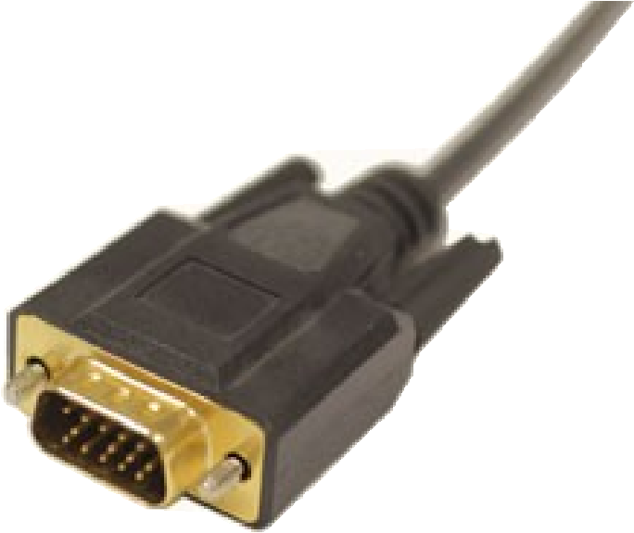

Locate the

**monitor cable**

.

the one on your

image at the left. If

cable, refer

you have an **all-in-one** computer that's built into the

monitor, you can skip to **Step 4**).

Step 3

Connect one end of the cable to the **monitor port** on the back of the**computer case** and the other end to the **monitor**. Hand tighten the plasticscrews on the monitor cable to secure

it.

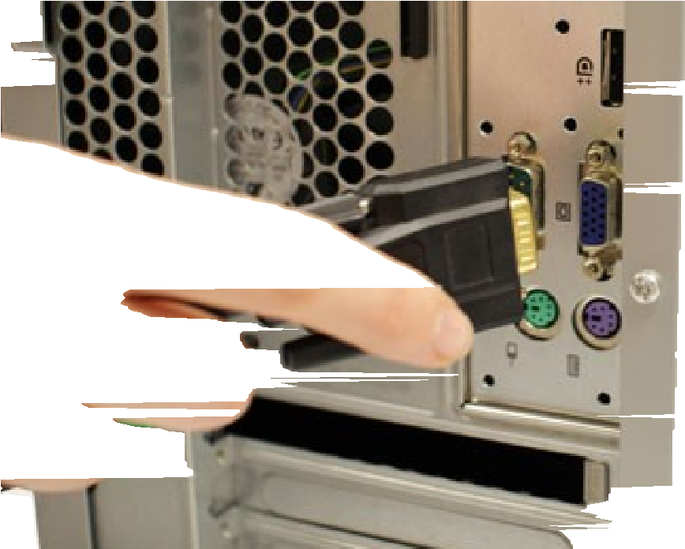

covered

Many

way.

you

computer cables will only fit a specific If the cable doesn't fit, don't force it or might damage the connectors. Make sure the plug aligns with the port, then

connect it.

To figure out which cables belong in which ports, try our **Connecting Cables** interactive.

Step 4

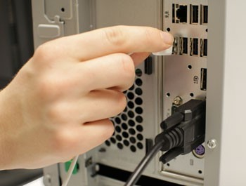Unpack the **keyboard** and determine whether it uses a **USB**(rectangular) connector or a **PS/2** (round) connector. If it uses a USB connector, plug it into any of the USB ports on the back of the computer. If it uses a

PS/2 connector, plug it into the **purple** keyboard port on the back of the computer.

Step 5

Unpack the **mouse** and determine whether it uses a **USB** (rectangular) connector or a **PS/2** (round) connector. If it uses a USB connector, plug it into any of the USB ports on the back of the computer. If it uses a PS/2 connector, plug it into the **green** mouse port on the back of the computer.

If your keyboard has a **USB port**, you can connect your mouse to the keyboard instead of connecting it directly to your computer.

If you have a **wireless** mouse or keyboard, you may need to connect a Bluetooth **dongle** (USB adapter) to your computer. However, many computers have built-in Bluetooth, so a dongle may not be necessary.

Step 6

If you have **external speakers** or **headphones**, you can connect them to your computer's **audio port** (either on the front or the back of the computer case).

Many computers have color-coded ports.

**Speakers** or **headphones** connect to

the **green** port, and a **microphone** connects to the **pink** port. The **blue** port is the **line in**, which can be used with other types of devices.

Some speakers, headphones, and microphones have **USB connectors** instead of the usual audio plug. These can be connected to any USB port. In

addition, many computers have speakers or microphones built into the monitor.

Step 7

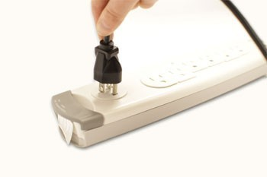Locate the two **power supply cables** that came with your computer. Plug the first power supply cable into the back of the **computer case**, and then into a **surge protector**. Then, using the other cable, connect the **monitor** to the **surge protector**.

Step 8

Finally, plug the **surge protector** into a wall outlet. You may also need to turn on the **surge protector** if it has a power switch.

If you don't have a surge protector, you can plug the computer directly into the wall. However, this is **not recommended** because electrical surges can damage your computer.

Setup complete

Your basic computer hardware is now set up. Before you start it up, spend some time arranging your workspace. A workspace that is arranged well can **improve your productivity** and **promote health**.

**Challenge!**

* If you have a desktop computer that is already set up at home, take a look at it.
  + Look at the **monitor cable**, and see where it connects to the computer case and monitor.
  + Locate the **power cords** for the monitor and computer case.
  + Locate the **audio ports**.
* Does your computer have a **VGA** **monitor port**, or another kind?
* Do you have a **USB** or **PS/2** mouse?
* Do you have a **USB** or **PS/2** keyboard?
* Is your computer plugged into a **surge protector**?

**Step-by-step how to set the computer, boot sequence to boot from installation media.**

BIOS ROM (Basic Input Output System) has a built in Setup program that allows users to modify the basic system configuration. The Setup program store the computer information in CMOS RAM that is powered by a little battery that is located on the computer motherboard so that it will retain the computer information even if the computer is turned off.

To make computer to start or to boot from the CD-ROM, we need to configure the Bios Setup or CMOS Setup program and set the first boot sequence to CD-ROM drive.

**How to enter the BIOS / CMOS Setup Program Utility.**

1. When the computer power on, black screen appear on you monitor, waituntil the message appears briefly at the bottom of the screen.

example of the massage at the bottom of the computer boot up screen:

1. From the boot up screen message above, we know that the key need topress to enter the BIOS setup is [F2] key. Now press [F2] key to enter the setup program. This key may be vary from one machine to other machine, because this is key base on the manufacture of the BIOS Setup program.

Note: Other key that commonly used to enter the CMOS setup (BIOS setup)

**Delete** key.

**Esc** key.

**F1** key.

**F2** key.

**F3** and **F2** key.

**F10** key.

**Ctrl** **+** **Alt** **+** **Esc** key.

**Ctrl** **+** **Alt** **+** **S** key.

**How to change the boot sequence.**

1. Press [F2] key until you see the BIOS Setup Utility screen, then go to the **Boot Option** tab then change the **Boot sequence** to **CD-ROM drive** as the first boot device.

NOTE: Use the < + > key to move the CD-ROM Drive up. Make sure that you read help menu on or blow the window screen

**Item Specific Help**

Key used to view or configure devices:

**< Enter >** expends or collapses devices with a + or -

**< Ctrl + Enter >** expands all

**< Shift + 1 >** enables or disables a device.

**< + >** and **< - >** moves the device up or down.

**< n >** May move removable device between Hard Disk or Removable Disk **< d >** Remove a device that is not installed.

3. Save the configurations changes and exit the BIOS Setup / CMOS Setup Utility by pressing the [F10] and then hit [ENTER] key to '**Save configuration changes and exit now?**'.

**Item Specific Help**

Exit System Setup and save your changes to CMOS.

**NOTE**: Press **[ F10 ]** key to **Save all the CMOS changes and Exit** the BIOS / CMOS Setup Utility.

Keyword: set computer boot sequence, change boot sequence, boot cd, boot from cdrom, boot sequence, boot from installation media, boot from cd, boot from cd rom, set boot sequence, bios setting, cmos setting, change cmos setting, change bios setting, computer boot sequence, boot installation media, boot CD-Rom.

**Three Basics Kind of Computer**

**Analogue Computer**

* Analog computers are used to process analog data. Analog data is ofcontinuous nature and which is not discrete or separate.
* Such type of data includes temperature, pressure, speed weight, voltage,depth etc.
* These quantities are continuous and having an infinite variety of values.

**Digital Computer**

* A Digital Computer works with digits to represent numerals, letters or otherspecial symbols.
* Digital Computers operate on inputs which are ONOFF type and its output isalso in the form of ONOFF signal.
* Normally, an ON is represented by a 1 and an OFF is represented by a 0.
* A digital computer can be used to process numeric as well as non-numericdata.

**Hybrid Computer**

* A hybrid is a combination of digital and analog computers.
* It combines the best features of both types of computers, i-e. It has the speedof analog computer and the memory and accuracy of digital computer.
* Hybrid computers are used mainly in specialized applications where bothkinds of data need to be processed. Therefore, they help the user, to process both continuous and discrete data.

Computer Operations

**A. Input**

* It is the process of capturing or acquiring the information, or it is theprocess of accepting data or information, by using input the computer can do any process.
* Information or data that is entered into a computer or computer device usingan input device. • Data is gathered – Manually
  + Automatically
  + Both

**Types of Computer Input**

* Data – the raw facts given to the computer.
* Programs – the sets of instructions that direct the computer.
* Commands – special codes or key words that the user inputs to perform atask.
* User response – the user's answer to the computer's question.

**B. Processing**

* It is the transformation process to convert the input into output.
* A process is an instance of running a program.
* It cause the computer to follow instructions from the Memory.
* Perform by Central Processing Unit (CPU).
* The CPU has three parts:
  + Arithmetic / Logic Unit (ALU)
  + Control Unit
  + Input / Output Unit (I/O)

**Arithmetic / Logic Unit (ALU)**

* The part of a computer that performs all arithmetic computations, such asaddition and multiplication, and all comparison operations.

**Control Unit**

* The control unit is the circuitry that controls the flow of data through theprocessor, and coordinates the activities of the other units within it.

**Input / Output Unit (I/O Unit)**

* The computer components that control input and output devices.

**C. Computer Output**

* It is the result, which comes from the transformation process or it is theoutcome of the process.
* Anything that comes out of a computer.
* Example:
  + Report
  + Music
  + Graphic
  + Video clip

Types of Computer Output

* Hard copy – Printed on paper or other permanent media.
* Soft copy – A soft copy is the unprinted digital document file.

– Displayed on screen or by other non-permanent means. – It can be transported from one computer to another.

Categories of Output

* Text documents – reports, letters, memo.
* Graphics – charts, graphs, pictures
* Multimedia – combination of text, graphics, video, audio

**D. Storing**

* It is the process of storing or retaining the data or information orinstructions, so that the user can retain and retrieve it whenever required.
* Capability to store information after processing.
* Storage are used to store programs and data when they are not being used inmemory.

**E. Controlling**

* It is the process of directing the manner and sequence in which all theoperations are to be performed.

**Hardware vs. Software**

* Hardware is any part of your computer that has a physical structure, suchas the computer monitor or keyboard.
* Software is any set of instructions that tells the hardware what to do. It iswhat guides the hardware and tells it how to accomplish each task.

Information Sheet No. 1.2-2

**System’s Specifications**

The user has agreed to the project through signing off the user requirement specification. The developers know what to do through the design specification,

**A. Software Applications to be used:**

- These could be off-the-shelf application modified to suit the project or they maybe bespoke applications already available within the company.

**B. Storage Requirement:**

- This includes local storage requirements such as hard disk size or it maybe networked storage such as file servers.

1. **System Memory:**

-How much memory will be required by the system in order for to run effectively.

1. **Input Devices needed:**

-These includes OMR devices, scanners, barcode readers, keyboard, mouse, or touch screens.

1. **Output Devices to be used:**

- These may include printers, monitor or even plotter.

**F. Computing/ Processing Needed:**

- For a huge system, it may need mainframe level computing power, on the other hand it may only need a standard personal computer to run.

1. **Security and Backup Systems:**

-How the passwords are handled and controlled, authentication methods, how backups are to be handles and so on.

1. **People Required:**

-The system may need a fulltime network administrator/ manager and a team of support technicians for example.

1. **Buildings and offices required:**

-The system may need a dedicated data room or even an external data centre.

1. **Network Configuration:**

-If it is networked system then this includes topology, server, router, hubs to be used.

1. **System Feeds:**

- Many systems are inter-linked. For instance an accounting system may be connected to the production system to keep track of products being made and sold.

The main purpose of these specifications dpcumentation is to lay down exactly how the system is made up.

Information Sheet No. 1.2-3

**Identifying common symptoms and problems associated with each devices**

Windows error "Data or no disk loaded" with audio CD

**Bad or non audio CD is inserted**

Make sure the CD you have currently in the computer is not bad or being misread by the computer by inserting another known good audio CD into the computer. If another audio CD works it is likely either that the CD is dirty or may be an enhanced CD incompatible with the CD Audio player. Steps on properly cleaning a CD can be found on our [cleaning page.](http://www.computerhope.com/cleaning.htm)

MCI CD audio driver not installed or is corrupt

If no audio CD is working in the computer but other CDs work fine, it is likely that the MCI CD audio driver is not installed or is corrupt on the computer. • [CD-ROM not working in Windows 9x, 2000, or XP.](http://www.computerhope.com/issues/ch000227.htm)

To reinstall or install the MCI CD audio drivers follow the steps below:

1. Click [Start,](http://www.computerhope.com/jargon/s/start.htm) Settings, [Control Panel](http://www.computerhope.com/jargon/c/controlp.htm)
2. Double-click on Multimedia 3. Click the Advanced tab or Device tab.
3. Double-click Media Control Devices.
4. Double-click CD Audio Device (Media Control).
5. If this device is present and no audio CDs are working, click remove on the general tab in CD Audio Device (Media Control) properties. 7. Close out of all open Windows to get back to the Control panel
6. In Control panel double-click Add New Hardware.
7. Click Next, select No, click Next -- In the box listing the available hardware, select Sound Video and Game controllers and click Next.
8. In the Manufacturers box select Microsoft MCI.
9. In the Models box select CD Audio Device (Media Control).
10. Click Next and Finish.
11. Once Windows has completed the installation of the new device, reboot the computer.

**My computer is running slow, what steps can I do to fix it?**

**Tip:** This page only covers an overall slow computer and not a [computer that has a slow boot up](http://www.computerhope.com/issues/ch001131.htm) or [slow Internet.](http://www.computerhope.com/issues/ch000986.htm)

Below are steps for Microsoft Windows users that can help speed up the computer or determine why the computer is running slow.

Reboot

If your computer has not been rebooted recently, make sure to [reboot](http://www.computerhope.com/jargon/r/reboot.htm) it before following any of the steps below.

**Background programs**

One of the most common reasons for a slow computer are programs running in the[background.](http://www.computerhope.com/jargon/b/backgrou.htm) Remove or disable any [TSRs and startup programs](http://www.computerhope.com/issues/chtsr.htm) that automatically start each time the computer boots.

**Tip:** To see what programs are running in the background and how much memory and CPU they are using, open [Task Manager.](http://www.computerhope.com/jargon/t/taskmana.htm) If you are running [Windows 7](http://www.computerhope.com/windows7.htm) or higher, run [Resmon](http://www.computerhope.com/jargon/r/resmon.htm) to get a better understanding of how your computer is being used.

If you have an antivirus scanner on the computer, spyware protection program, or another security utility, make sure it is not scanning your computer in the background. If a scan is in progress, it can decrease the overall performance of your computer. If this is the case, allow the scan to complete and the computer's performance should improve afterwards.

**Delete temp files**

As a computer runs programs, accesses web pages, and is being used in general, temporary files are being stored on the hard drive. Deleting these temp files can help improve computer performance.

First, we suggest using the Windows [Disk Cleanup](http://www.computerhope.com/jargon/d/diskclea.htm) utility to delete temporary files and other files no longer needed on the computer.

Unfortunately, the Disk Cleanup may not delete all of the files in the temp directory. Therefore, we also suggest deleting temporary files manually by opening the [Start menu](http://www.computerhope.com/jargon/s/startmen.htm) and type [**%temp%**](http://www.computerhope.com/jargon/e/envivari.htm#6) in the Search field (in Windows XP and prior, click the Run option in the Start menu and enter ***%temp%*** in the Run field). Press Enter and a Temp folder should open. You can delete all files found in this folder and, if any files are in use and cannot be deleted, they can be skipped.

**Free hard drive space**

Verify that there is at least 200-500MB of free hard drive space. This available space allows the computer to have room for the [swap file](http://www.computerhope.com/jargon/s/swapfile.htm) to increase in size, as well as room for [temporary files.](http://www.computerhope.com/jargon/t/tempfile.htm)

* [Determining available hard drive space.](http://www.computerhope.com/issues/ch000369.htm) • [Regaining computer hard drive space.](http://www.computerhope.com/issues/ch000528.htm)

**Bad, corrupted or fragmented hard drive**

* [Run ScanDisk,](http://www.computerhope.com/issues/ch001118.htm) [chkdsk,](http://www.computerhope.com/chkdskh.htm) or something equivalent to verify there is nothing physically wrong with the computer's [hard drive.](http://www.computerhope.com/jargon/h/harddriv.htm)
* [Run Defrag](http://www.computerhope.com/issues/ch001126.htm) to help ensure that data is arranged in the best possible order.
* Use other software tools to [test the hard drive for any errors](http://www.computerhope.com/issues/ch001091.htm) by looking at the[SMART](http://www.computerhope.com/jargon/s/smart.htm) of the drive.

**Scan for malware**

Today, [spyware](http://www.computerhope.com/jargon/s/spyware.htm) and other [malware](http://www.computerhope.com/jargon/m/malware.htm) is a big cause of many computer problems, including a slow computer. Even if an antivirus scanner is installed on the computer, we recommend running a malware scan on the computer. Use the free version of[Malwarebytes](http://www.malwarebytes.org/) to scan your computer for malware.

**Scan for viruses**

If your computer is infected with one or more [viruses,](http://www.computerhope.com/jargon/v/virus.htm) this can cause your computer to run slow. If your computer does not have an antivirus program installed, you can run Trend Micro's free [Housecall](http://housecall.trendmicro.com/) online utility to scan for viruses on your computer, as well as remove them. It is also recommended that you install an antivirus program for active protection against viruses.

**Hardware conflicts**

* Verify that the [Device Manager has no conflicts.](http://www.computerhope.com/issues/ch001212.htm) If any exist, resolve these issues as they could be the cause of your problem.

**Update Windows**

* Make sure you have all the [latest Windows updates installed on the computer.](http://www.computerhope.com/issues/ch000545.htm)
* If you are on the Internet when your computer is slow,[make sure all browser plugins are up-to-date.](http://www.computerhope.com/cgi-bin/systeminfo.cgi) You can also try [disabling browser plugins](http://www.computerhope.com/issues/ch001411.htm) to see if one of them is causing the slowness.

**Update your drivers**

Make sure you have the [latest drivers for your computer hardware,](http://www.computerhope.com/issues/ch000546.htm) especially the [latest video drivers.](http://www.computerhope.com/drivers/video.htm) Having out-of-date drivers can cause an assortment of issues, including slow performance.

**Reboot computer again**

If you have done any of the above steps but your computer is still acting slow try rebooting the computer again at this point.

**Memory upgrade**

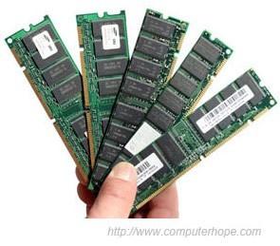If you have had your computer for more than two years, you may need more memory. Today, we suggest computers have a minimum of 1GB of[memory (RAM)](http://www.computerhope.com/jargon/r/ram.htm) for [32-bit](http://www.computerhope.com/jargon/num/32bit.htm) system and 2GB for a [64-bit](http://www.computerhope.com/jargon/num/64bit.htm) system. By having enough memory for programs to run within memory, your computer will not need to swap information stored within memory to the[swap file.](http://www.computerhope.com/jargon/s/swapfile.htm) If your computer hard drive light is constantly active, its a good indication that your computer is continuously swapping information between your memory and hard drive because of the lack of space in memory.

* Determining ho[w](http://www.computerhope.com/issues/ch000149.htm) much RAM i[s](http://www.computerhope.com/issues/ch000149.htm) installed an[d available.](http://www.computerhope.com/issues/ch000149.htm)
* [How much memory or RAM should my](http://www.computerhope.com/issues/ch001189.htm)

[computer have?](http://www.computerhope.com/issues/ch001189.htm)

* [What type of computer memory to use in a memory upgrade?](http://www.computerhope.com/issues/ch000910.htm)

**Hard drive upgrade**

One of the biggest bottlenecks of a computer is the [hard disk drive.](http://www.computerhope.com/jargon/h/harddriv.htm) For anyone with a slow computer or just looking for something to upgrade in the computer to improve overall system performance, upgrading from a traditional hard drive to a [Solid State Drive (SSD)](http://www.computerhope.com/jargon/s/ssd.htm) will significantly improve the overall system performance.

**Run Registry cleaner**

We normally do not recommend Registry cleaners. However, if you have followed all of the above steps and your computer is still slow, [try running a Registry cleaner on the computer.](http://www.computerhope.com/issues/ch001077.htm)

**Computer or processor is overheating**

Make sure your computer and processor is not overheating. Excessive heat can cause a significant decrease in computer performance because most processors automatically reduce the speed of the processor to help compensate for heat related issues.

* [What temperature should my processor be running at?](http://www.computerhope.com/issues/ch000687.htm)

Dust, dirt, and hair can also constrict proper air flow inside your computer, which can cause a computer to overheat. Make sure your computer case is clean and fans are not obstructed.

* [Steps on cleaning your computer.](http://www.computerhope.com/cleaning.htm)

**Erase computer and start over**

If none of the above solutions resolve your issues, another option is to either [reinstall Windows or erase everything and then start over.](http://www.computerhope.com/issues/ch000186.htm)

Erasing everything and starting over can increase performance by getting rid of old software or drivers that may be on the computer and causing the computer to be slow. Installing a fresh copy of Windows, software programs, and the latest drivers help verify there is no software related issues causing your computer to be slow.

**Hardware issues**

Finally, if your computer continues to be slower than normal after going over each of the above recommendations (including erasing and starting over), it's possible that your computer is experiencing a more serious hardware related issue, such as a failing component in the computer. This could be a failing or bad [hard drive,](http://www.computerhope.com/jargon/h/harddriv.htm) [CPU,](http://www.computerhope.com/jargon/c/cpu.htm) [RAM,](http://www.computerhope.com/jargon/r/ram.htm)[motherboard,](http://www.computerhope.com/jargon/m/mothboar.htm) or other component.

You can run hardware diagnostic tests using the [Ultimate Boot CD](http://www.computerhope.com/jargon/u/ubcd.htm) (UBCD) utility. This utility provides many diagnostic tests that you can run and determine if your computer has a bad piece of hardware.

**Old computer**

If your computer is older than five years, the age of the computer could be the cause of the slow performance. Computers advance in technology and capabilities and newer, more advanced software programs come out to run properly on the new computers. Older computers are not able to run the new programs as well, which can cause them to slow down. If your computer is older than five years, we suggest purchasing a new computer or accept that, if all the above options do not work to speed up your computer, it will just run slower than a newer computer.

**Missing or lost sound in Windows**

Verify software volume control settings

First, verify you see a small sound icon or in the [Windows notification area,](http://www.computerhope.com/jargon/n/notiarea.htm) also known as Systray (bottom right-hand corner of the Windows



Desktop). If this icon is missing, follow the steps below. If you see this icon,[skip to next section.](http://www.computerhope.com/issues/ch000208.htm#driver)

**Windows 8**

1. Open the [Control Panel](http://www.computerhope.com/jargon/c/controlp.htm)
2. Click the "Taskbar" icon.
3. On the "Taskbar" tab, click the "Customize" button next to

"Notification area".

1. Scroll down in the list until you see the "Volume" option and speaker icon. On the right side, in the drop-down list, make sure "Show icon and notifications" is selected. If it is not, select this option. If the drop-down list is grayed out, uncheck the box for "Always show all icons and notifications on the taskbar" to allow you to change the dropdown list selection.
2. If you changed the selection in the drop-down list, click OK in that window and the Taskbar Properties window and close out of the Control Panel.

**Windows Vista or 7**

1. Open the [Control Panel](http://www.computerhope.com/jargon/c/controlp.htm)
2. Click the "Taskbar and Start Menu" icon.
3. On the "Taskbar" tab, in the "Notification area" section, click the "Customize" button.
4. Scroll down in the list until you see the "Volume" option and speaker icon. On the right side, in the drop-down list, make sure "Show icon and notifications" is selected. If it is not, select this option. If the drop-down list is grayed out, uncheck the box for "Always show all icons and notifications on the taskbar" to allow you to change the dropdown list selection.
5. If you changed the selection in the drop-down list, click OK in that window and the "Taskbar and Start Menu Properties" window and close out of the Control Panel.

**Windows XP**

1. Open the [Control Panel](http://www.computerhope.com/jargon/c/controlp.htm)
2. Open the "Sounds and Audio Devices" icon.
3. Verify the "Place volume icon in the taskbar" [checkbox](http://www.computerhope.com/jargon/c/checkbox.htm) is checked. If this option is not available or is grayed out, skip to the [next section](http://www.computerhope.com/issues/ch000208.htm#02) of this document.
4. If you were able to check this box, click OK and close out of this window and the Control Panel.
5. Double-click the sound icon in the Systray and verify that all the sound volumes are mid-way or higher.

**Conflicts section**

If conflicts exists with your sound card or other devices installed in your computer, it is likely that either the drivers are not properly installed for that device or the sound card or other devices are conflicting. If you open the properties of the device that is conflicting and view the properties, additional details about the conflict can be found. Additional information about error codes, as well as help with Device Manager, can be found on our [Device Manager section.](http://www.computerhope.com/win95.htm)

If you are unable to locate additional information about your issue or are unable to resolve the issue, follow the steps below.

1. Under "Sound, video and game controllers", highlight each device and **press the delete key** to remove the device.
2. Reboot the computer.
3. As the computer is booting, the system will detect the sound card and any of its devices and reinstall those devices. If prompted for a location of drivers, try pointing it to your sound card CD or your Windows CD. If this does not work or is unable to locate the proper files, you need to get the [latest sound drivers](http://www.computerhope.com/drivers/sound.htm) from your sound card manufacturer.

**Other devices section**

If Other devices are listed, these could be the sound card or another conflicting device. If any other devices are listed, it is recommended you remove those devices, reboot the computer and let Windows re-detect the devices.

If this does not work, determine what device is not being detected and resolve that issue first.

**Missing sound card section.**

If you are missing the "Sound, video and game controllers" category in Device Manager, it is likely that the sound card drivers are not installed properly, sound card has been disabled, sound card is bad, or no sound card is available in the computer. First, verify no conflicts or other devices are present in the Device Manager. If these are present, it is likely they are the sound card or devices causing the sound card not to be detected. Second, verify that the computer has a sound card and that the sound card is enabled on the computer.

If this is an [on-board](http://www.computerhope.com/jargon/o/onboard.htm) sound card, you can verify that it is enabled in the [CMOS setup.](http://www.computerhope.com/issues/ch000192.htm)

If you have no adapters or cannot click the down arrow to select the correct adapter, close out of this window. In the Control Panel, double-click the System icon, click the[Device Manager](http://www.computerhope.com/win95er.htm) tab within Device Manager, and ensure there are no yellow **!** or red **X**.

If you have either of these on any of your sound devices, remove everything under "Sound, video and game controllers" and reboot the computer. If after rebooting the computer you still have the same conflicts, double-click on the conflicting device and refer to our [Device Manager error code section](http://www.computerhope.com/win95er.htm) for additional information on the error code you are experiencing.

**Verify speaker connections**

Verify the speaker settings and speakers are not at fault by running through [computer speaker troubleshooting.](http://www.computerhope.com/issues/ch000034.htm)

**Sound card drivers**

If you have followed the above recommendations and you are still unable to get the sound card to work, in the Device Manager, remove all sound, video, and game controllers and reboot the computer. This should cause Windows to reinstall all missing drivers and often can correct corrupt drivers. If this does not work after rebooting the computer, download and install the latest sound card drivers from the computer or sound card manufacturer. A listing of manufacturer web pages for sound card drivers can be found on our [sound card driver page.](http://www.computerhope.com/drivers/sound.htm)

**Defective hardware**

Finally, if all of the above recommendations do not resolve your issue, it is likely that either the sound card is not working and defective or that the operating system is corrupted. We recommend you [contact the manufacturer](http://www.computerhope.com/support.htm) of the sound card or computer for a replacement or additional recommendations.

**No display or black screen on a computer monitor**

**Note:** This page contains some of the more common monitor troubleshooting options and tips. If you are unable to resolve the issue after trying all options on this page, it is recommended that you take your computer and monitor to a computer repair shop for diagnostic testing.

**Tip:** The following monitor troubleshooting steps are not for users who see a [readable picture that gets distorted when Windows opens.](http://www.computerhope.com/issues/ch000121.htm)

1. **Monitor is not on**

Make sure the monitor is on. If you do not see a power [LED](http://www.computerhope.com/jargon/l/led.htm) (blue, green, or orange light) on the front of the monitor, press the power button until it comes on. If no light comes on after several attempts, make sure the [connections are properly connected.](http://www.computerhope.com/issues/ch000241.htm#connection)

1. **Computer is asleep**

If your computer monitor was on and you stepped away from the computer, then upon returning, it was black, it is likely that the computer is [asleep.](http://www.computerhope.com/jargon/s/standby.htm) Try moving your mouse, clicking the mouse buttons, or pressing any key (space bar) on the keyboard to wake it up.

1. **Connections not properly connected**

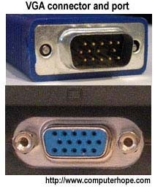

1. **Check the data cable**

Make sure that you are connecting the monitor's [VGA cable](http://www.computerhope.com/jargon/v/vga.htm) to the back of the computer in the 15-pin connector, as shown to the right, or the older computer 9-pin connection.

**Note:** Newer computers may be using a [DVI](http://www.computerhope.com/jargon/d/dvi.htm) or [HDMIc](http://www.computerhope.com/jargon/h/hdmi.htm)able for the monitor.

Make sure the data cable you are using is firmly connected to the computer.

1. **Check the power cable**

If the data cable is plugged in, make sure the monitor is getting power by verifying there is a light (blue, green, or orange) on the front of the monitor. If you see no lights on the monitor, make sure it is connected to a working [wall outlet.](http://www.computerhope.com/jargon/o/outlet.htm) If the power cord is removable from the back of the monitor, try replacing it with another power cable. If you still cannot power on the monitor after trying another wall outlet and cable, the monitor is bad and should be replaced.

1. **Check the LED status**

If the monitor has a light on the front, but that status light is orange or flashing, make sure the monitor is not in a suspend mode by moving the mouse or pressing a key on the keyboard. If this does not help, turn the computer and monitor off and reconnect the data cable on the back of the computer and, if removable, on the back of the monitor. Turn the computer and monitor back on. If you still encounter the same issue, continue reading through the other possibilities.

1. **Monitor settings are not correct**

Verify the [brightness](http://www.computerhope.com/jargon/b/brightne.htm) and [contrast](http://www.computerhope.com/jargon/c/contrast.htm) are turned up or adjust the brightness and contrast. If adjusting the brightness or contrast has no affect on the monitor, continue reading through the other possibilities.

1. **No POST**

Does the computer beep when it is turned on or does it sound like the computer is working? If the computer does not beep or beeps abnormally, the computer is experiencing a hardware issue or is exhibiting a No [POST.](http://www.computerhope.com/jargon/p/post.htm) Run through the [POST troubleshooting steps](http://www.computerhope.com/issues/ch000607.htm) to determine the failure.

1. **Hardware Issue**

If you have followed the above recommendations and still have the same issue, your computer may have either a bad [video card](http://www.computerhope.com/jargon/v/videadap.htm) or monitor. The best method of determining this is to do one or both of the suggestions below.

* + Disconnect your monitor and connect it to another computer. For example, try connecting it to a friend or family's computer or a computer at a service center.
  + Borrow a computer monitor and connect it to your computer.

If your monitor works on another computer, it is safe to assume that the video card or potentially the [motherboard](http://www.computerhope.com/jargon/m/mothboar.htm) in the computer is bad.

* + [Troubleshooting a bad video card.](http://www.computerhope.com/issues/ch001028.htm)
  + [Troubleshooting a bad motherboard.](http://www.computerhope.com/issues/ch001089.htm)

If another monitor works on your computer, it is safe to assume that your monitor is bad and should be replaced. While it may be possible to have the monitor serviced, it is often cheaper and easier to purchase a new monitor.