CENTRE DE DÉVELOPPEMENT DES TECHNOLOGIES AVANCÉES (CDTA)
INTERNSHIP PROGRESS REPORT
TASK 2 | Classical Machine Learning Model Development and Evaluation
Shimmer Human Activity Recognition Dataset
Supervisor: Dr Kerdjidj Oussama | Reporting period: October 2026
Status: Preliminary KNN experiments completed; recording structure and evaluation protocol pending verification.

1. Classical models and experiment design
The training script defines a standardized SVC pipeline, a standardized KNN pipeline, and an unscaled DecisionTreeClassifier. StandardScaler is inside the KNN/SVM pipelines, so scaling is learned only from the relevant training folds. Data are split 80% train / 20% test with class stratification, repeated using seeds 0–9. Within each outer training partition, KNN tuning uses five-fold StratifiedKFold and GridSearchCV scored by multiclass Matthews Correlation Coefficient (MCC).
Algorithm | Current configuration
KNN | Tuned using 1–30 neighbors, uniform/distance weights, Minkowski p=1 or 2
SVM | SVC defaults, with StandardScaler
Decision Tree | Default DecisionTreeClassifier, random_state=42
KNN grid: 30 × 2 × 2 = 120 candidates, each evaluated in five folds. The selected model is refitted on outer training data and evaluated on its held-out test partition. SVM and Decision Tree were not tuned; model comparisons therefore remain preliminary.

2. KNN model complexity and tuning
A model complexity curve evaluates training accuracy and mean five-fold validation accuracy for k=1 through k=30 on the first outer training partition. The reported search selected k=1, uniform weights, and p=1 (Manhattan distance) in all 10 runs. A consistent selection across overlapping random splits does not establish recording-independent robustness.
Figure 1 — KNN model complexity curve
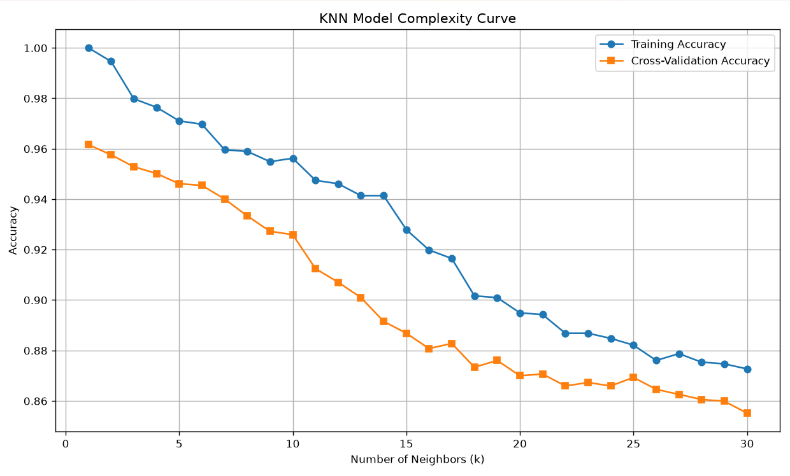

5. Evaluation metrics
The script computes accuracy, macro precision, macro recall, macro F1, and MCC for each model on each outer test partition. Macro averaging gives each activity equal weight, which is useful when Fall is underrepresented. Scores are summarized as mean and sample standard deviation over 10 repeated splits.
Figure 2 — Model performance comparison
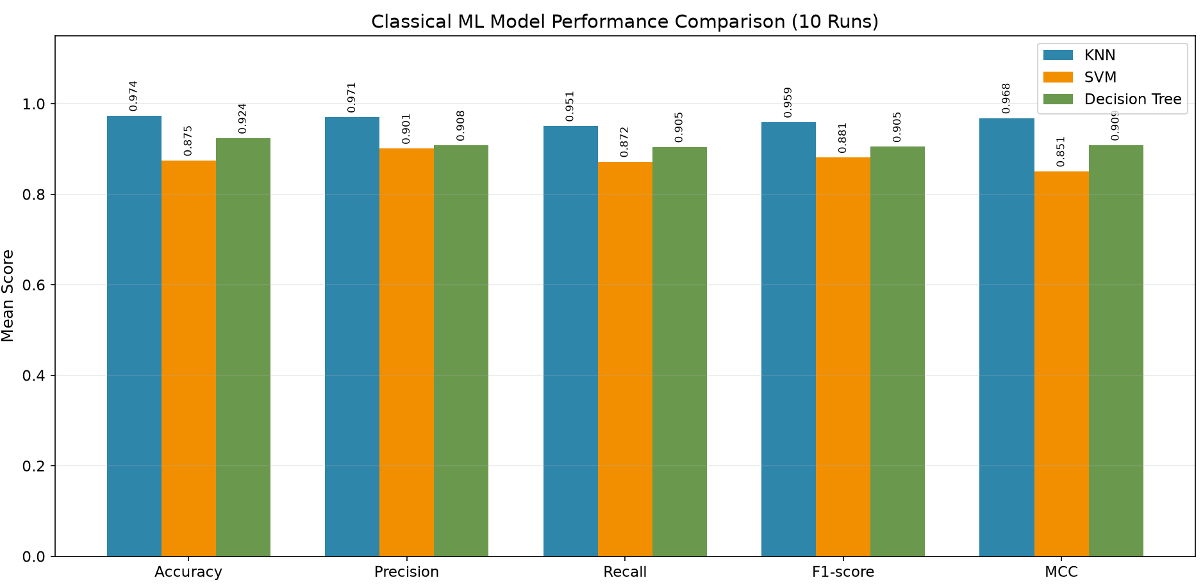

6. Preliminary experimental results
Model | Mean accuracy | Mean macro F1 | Mean MCC
KNN (tuned) | 0.9737 | 0.9593 | 0.9683
Decision Tree (default) | 0.9239 | — | 0.9086
SVM (default) | 0.8747 | — | 0.8508
The available summary confirms tuned KNN accuracy standard deviation of approximately 0.0063 and MCC standard deviation of approximately 0.0076. Values not independently available from the current chat are intentionally omitted.
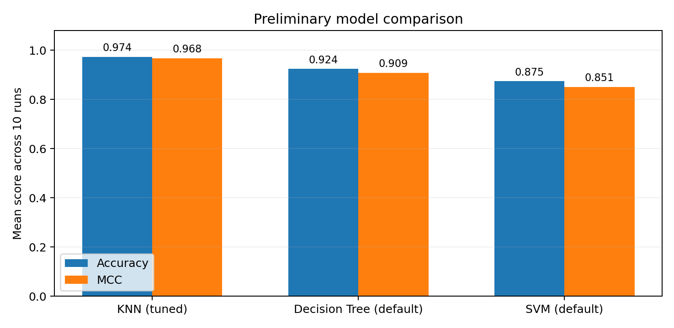
Figure 1. Comparison of reported mean accuracy and MCC across 10 random window-level splits. Reconstructed from supplied summary values.
Earlier default KNN (k=5) achieved mean accuracy 0.9427 and MCC 0.9312; tuning increased accuracy by 3.10 percentage points and MCC by 0.0371 under the reported protocol.
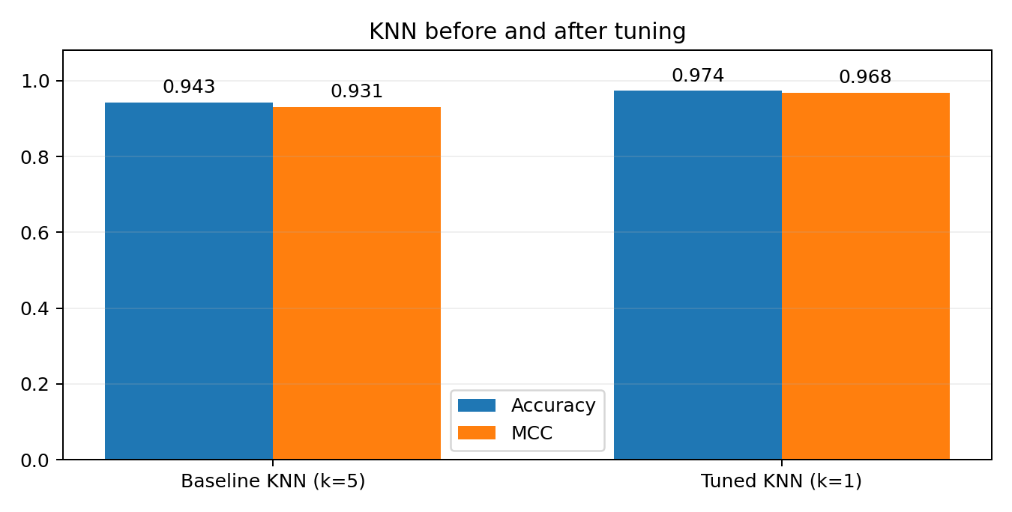
Figure 2. KNN baseline versus tuned performance, using reported mean values.

7. Class-level interpretation
In the reported first split, Fall recall was 7/9 (0.78) and Jump recall 24/28 (0.86). This illustrates why high aggregate accuracy can mask weaker recognition of minority or challenging activities. The Fall test support is small; interpretation should rely on per-class scores across runs where feasible.
Figure 3 — Confusion matrix |
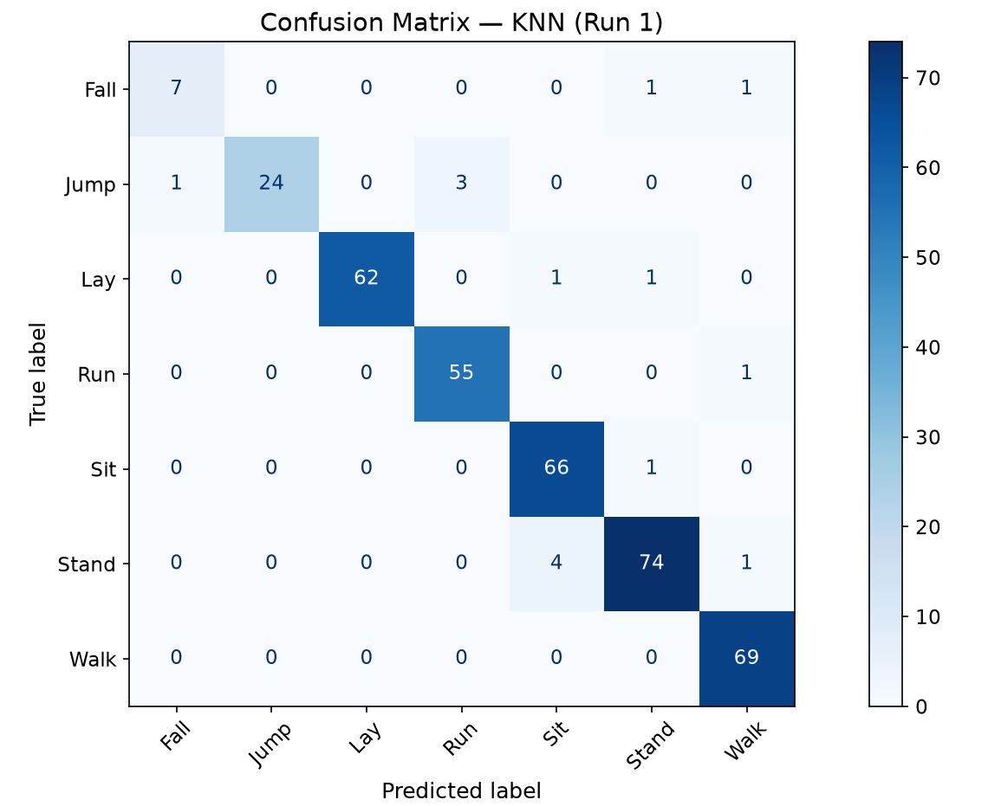

Figure 4 — Normalized confusion matrix
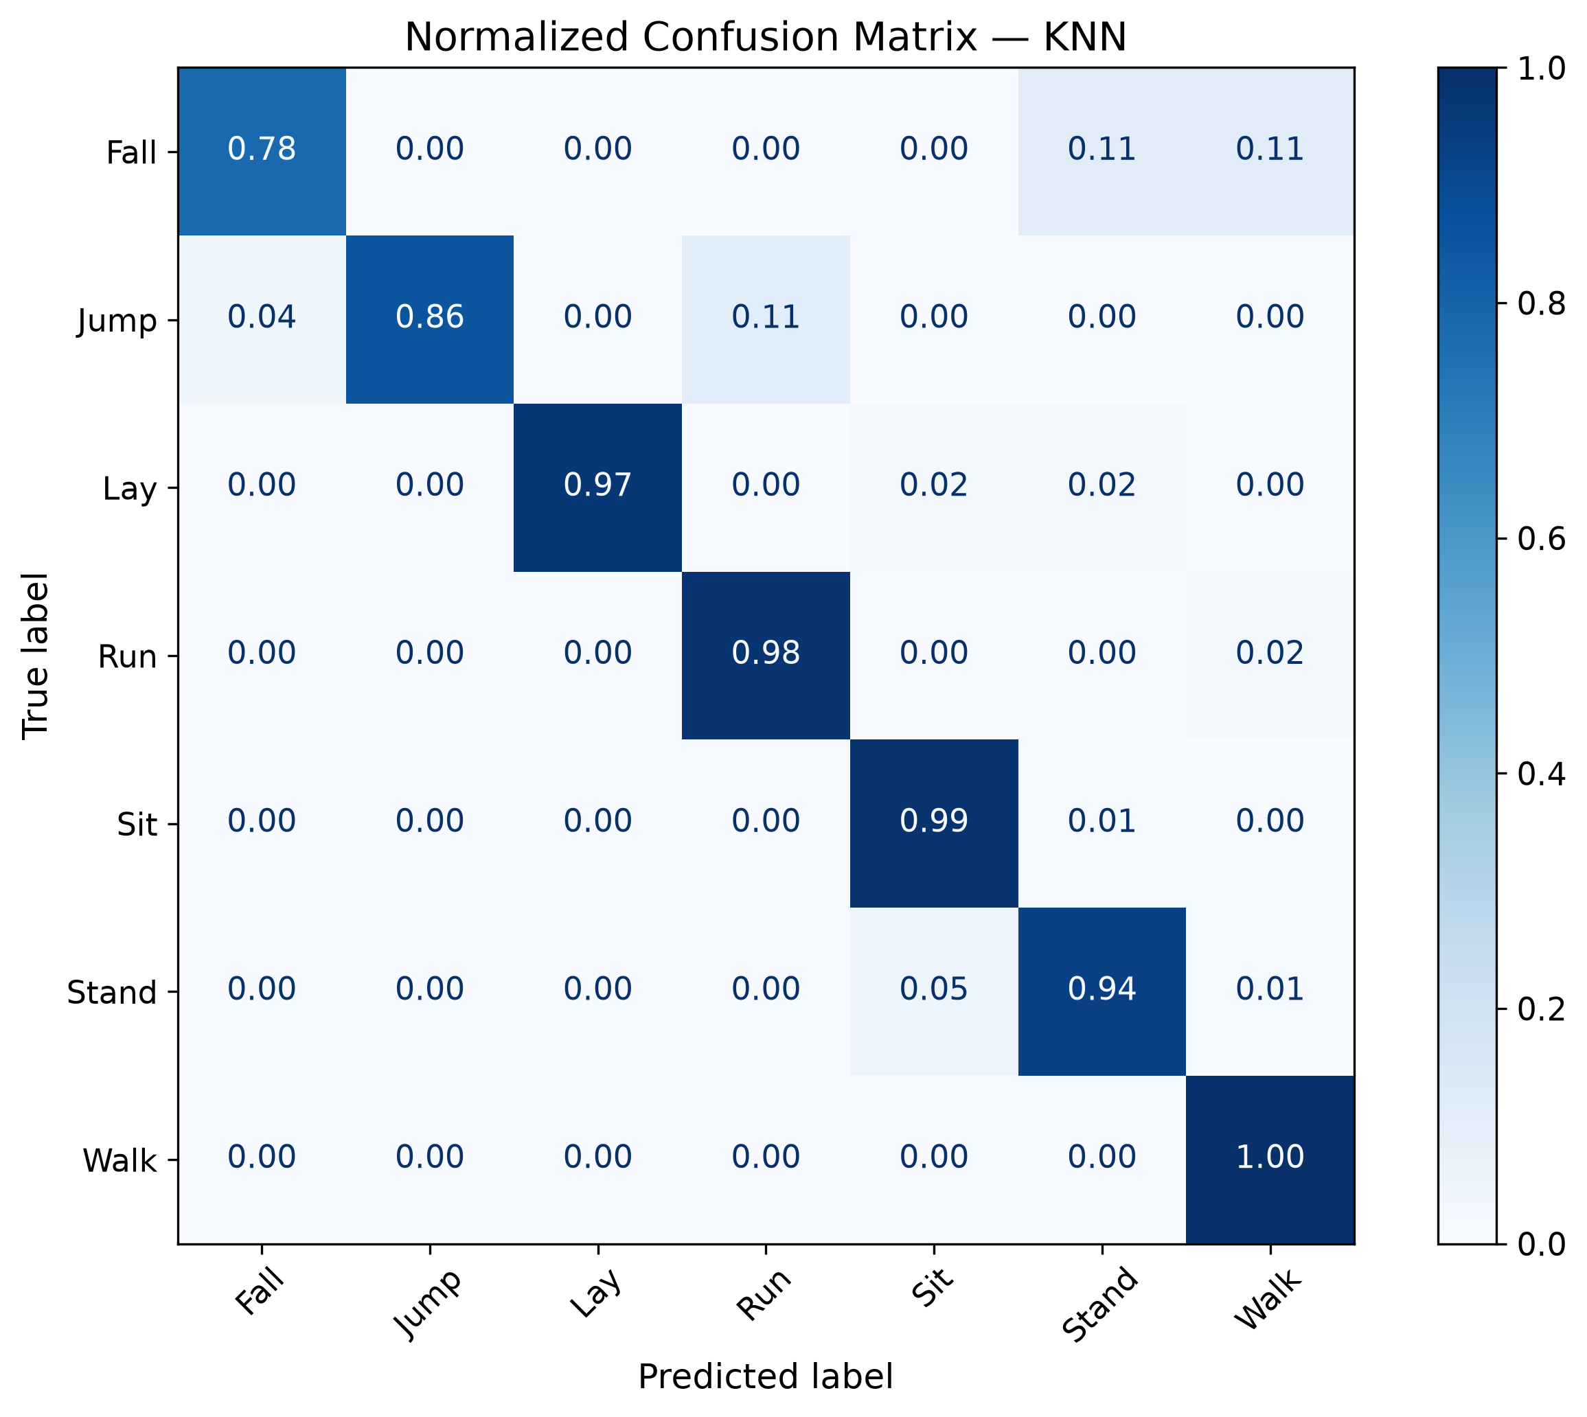
Figure 5 — Per-class precision, recall and F1 |
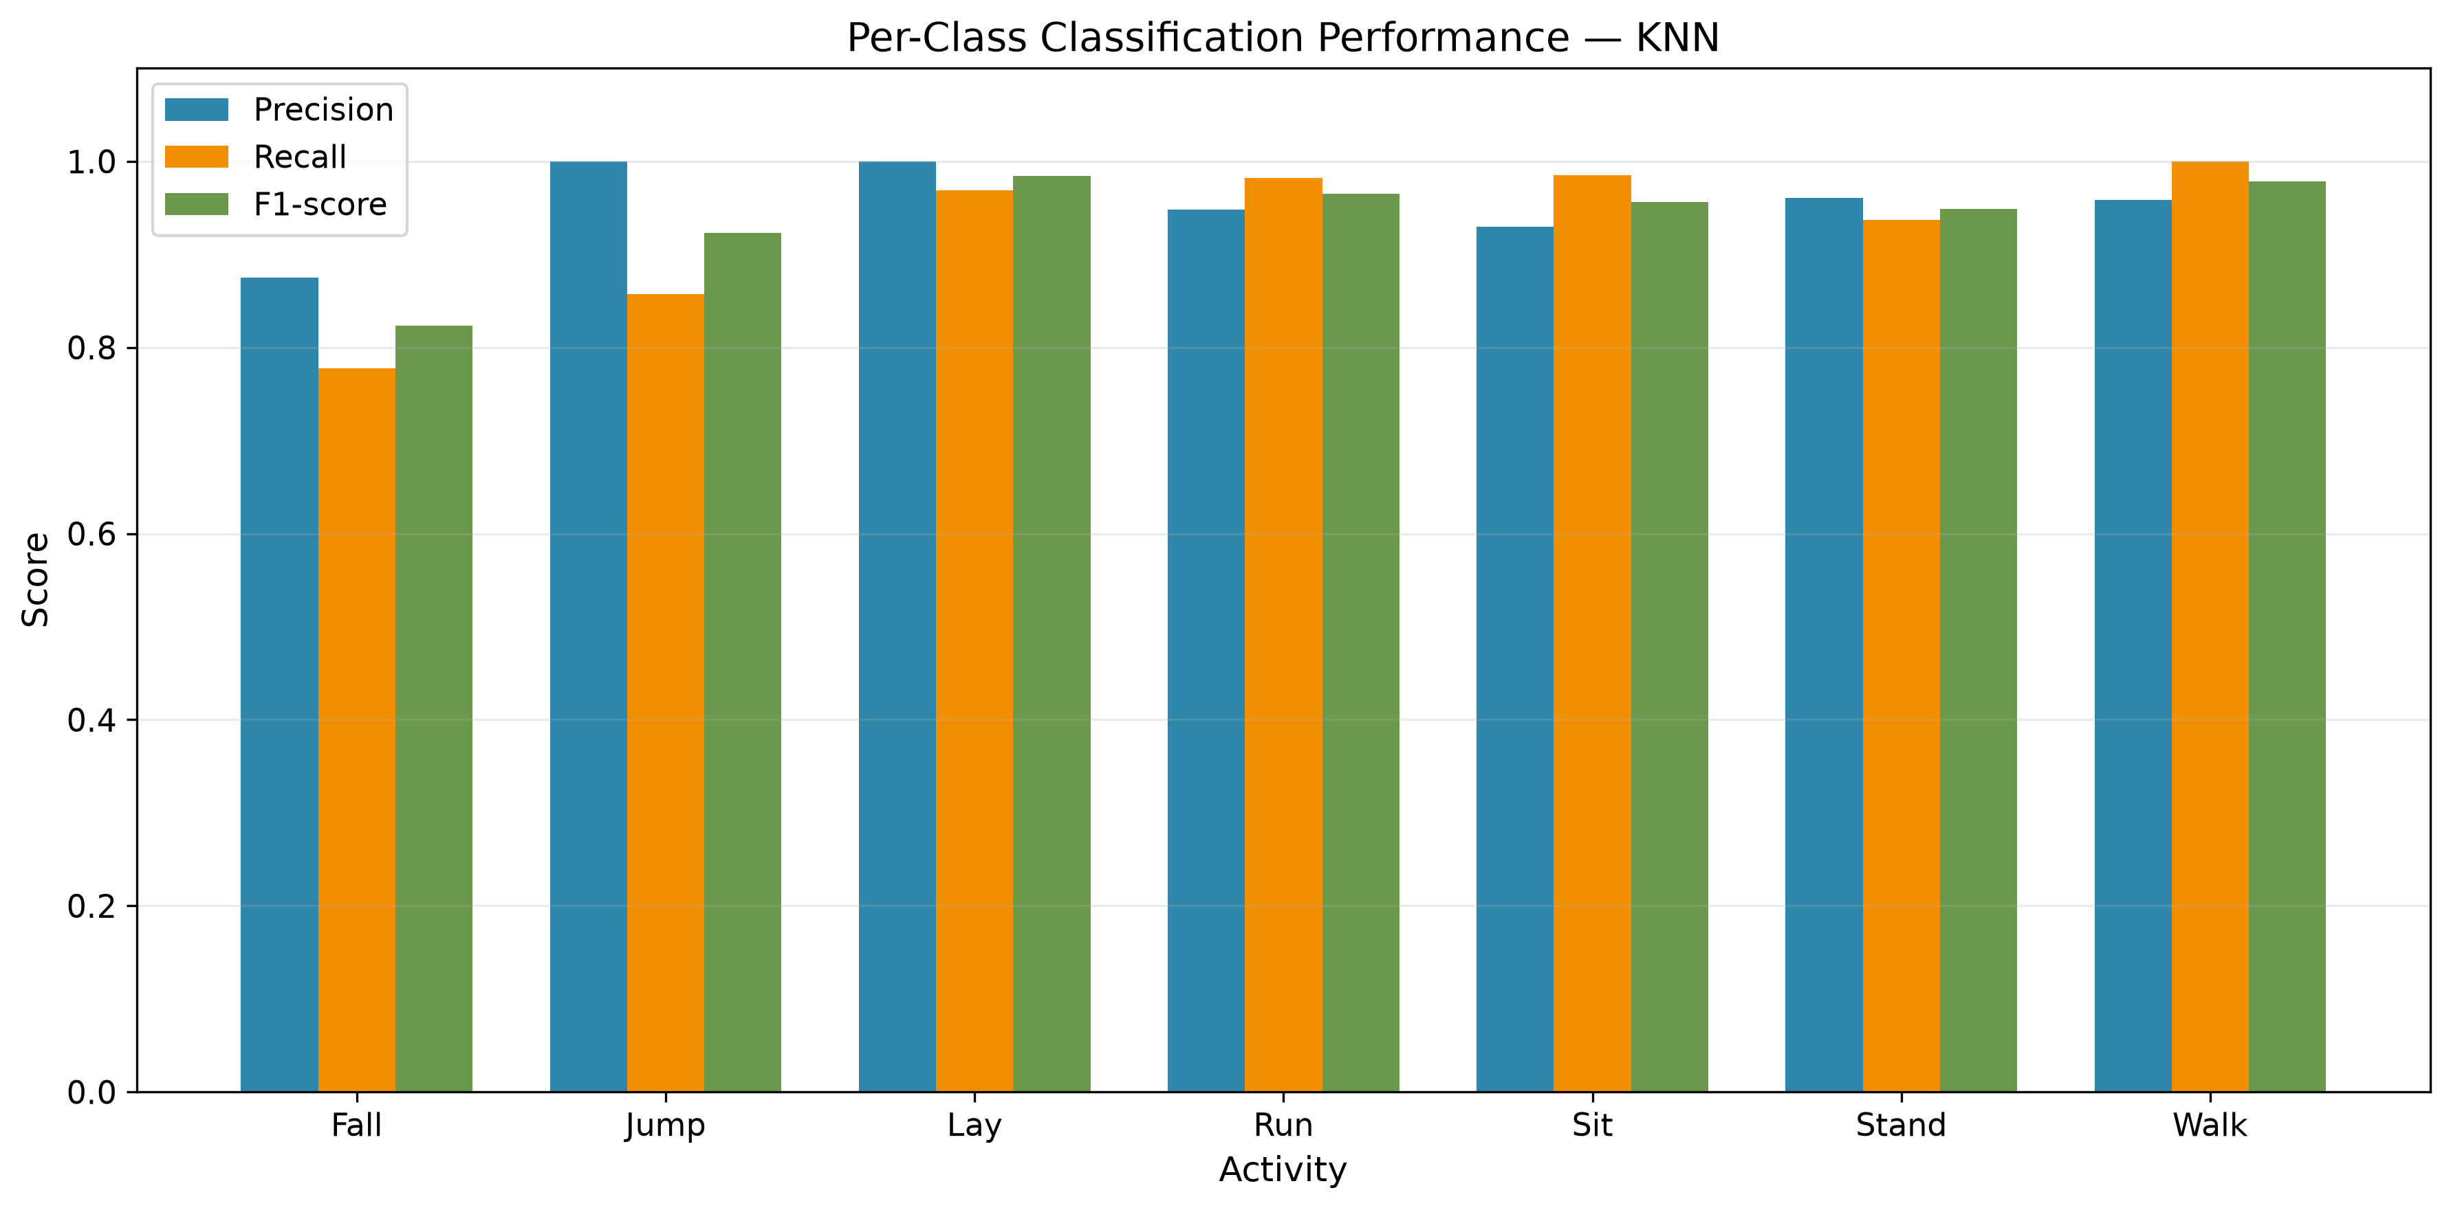

8. Stability and additional visualizations
Figure 6 — Accuracy across 10 runs | Insert: accuracy_across_runs.png
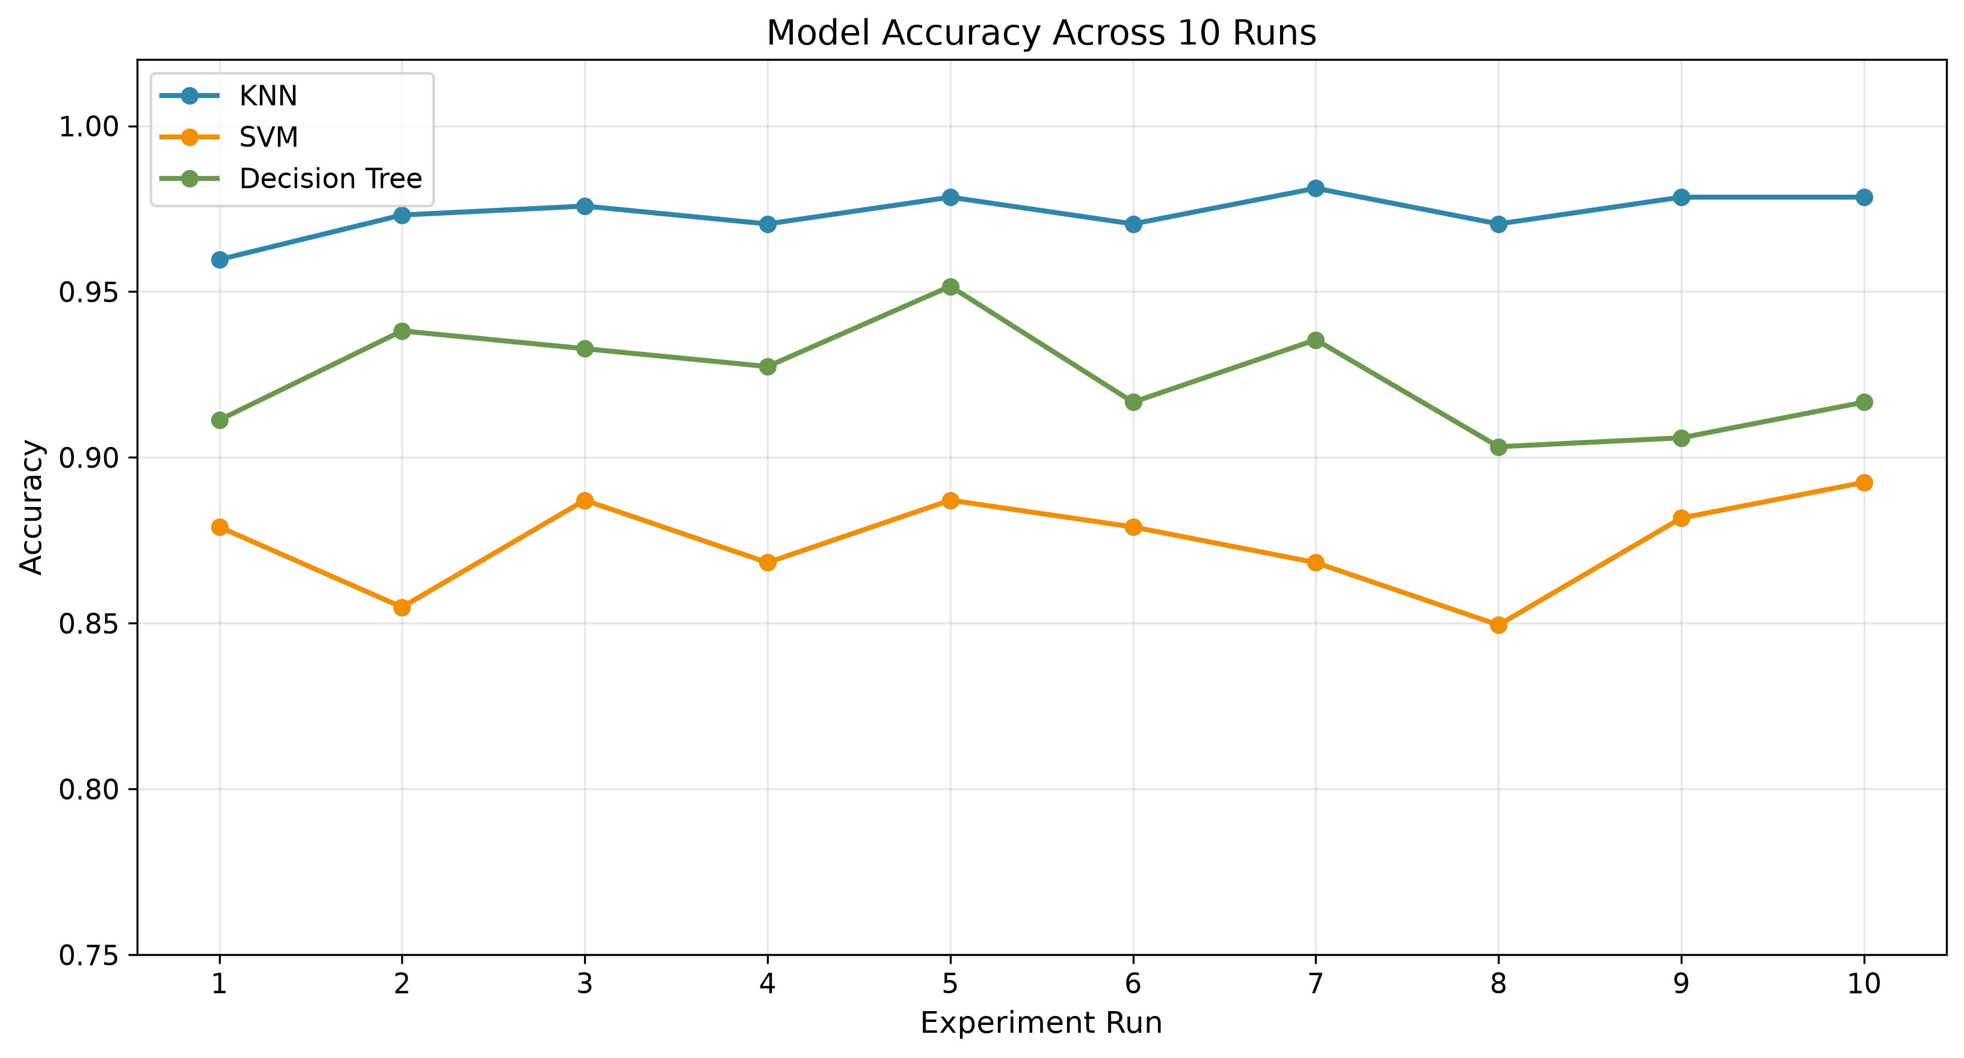
Figure 7 — MCC distribution across models | Insert: mcc_distribution.png
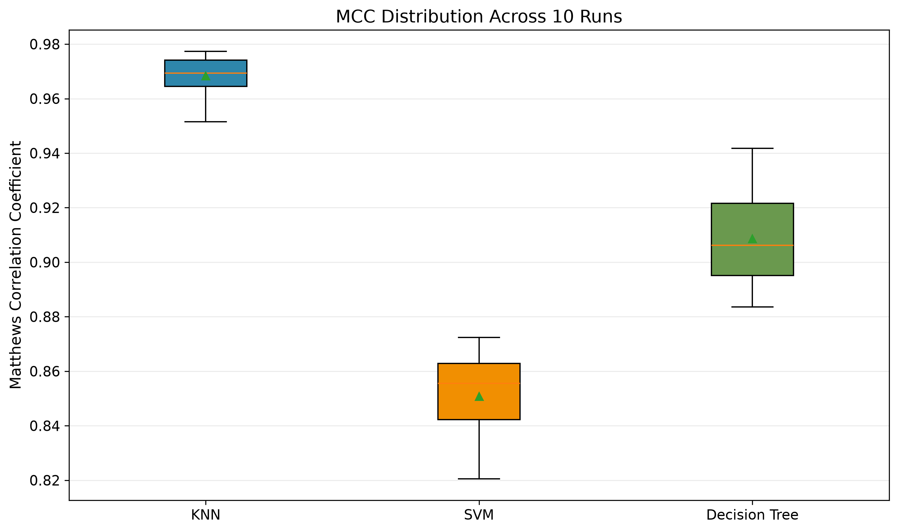
Figure 8 — Best KNN k distribution |
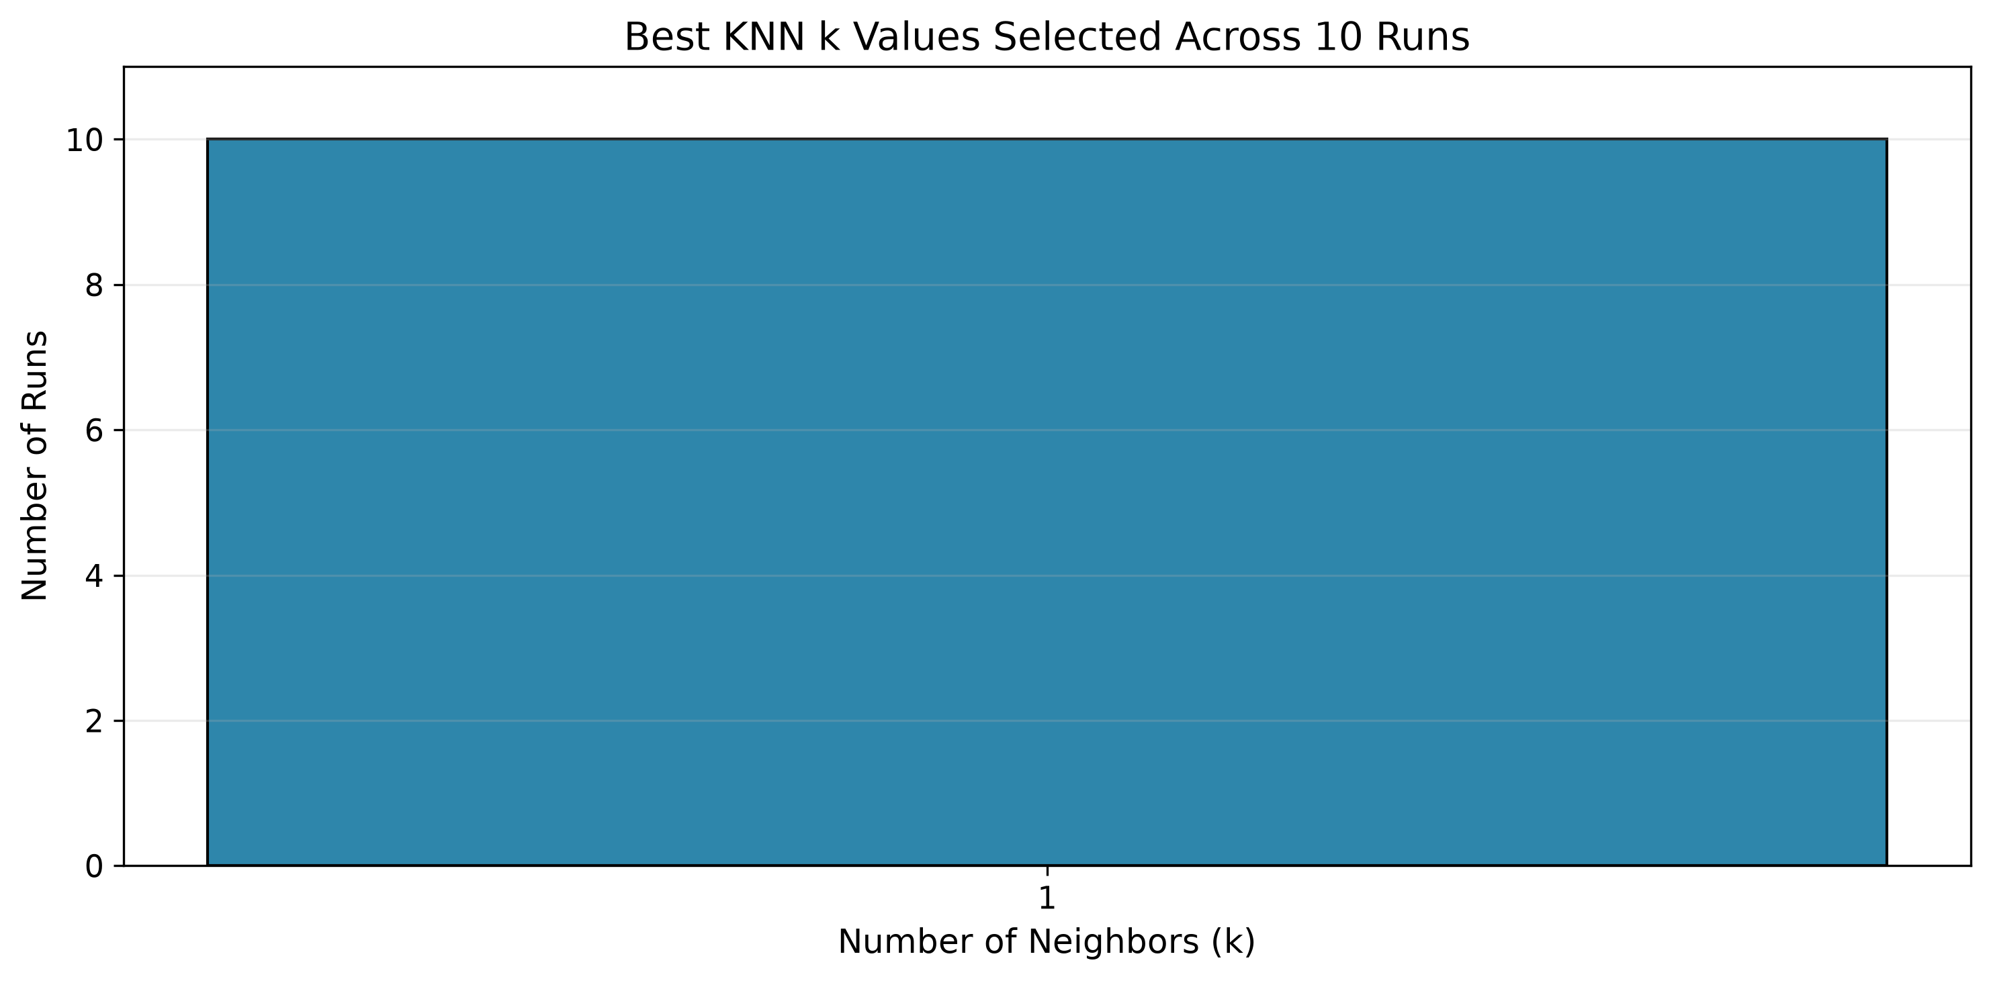The three

9. Data integrity and methodological limitations
- Window-level leakage risk: random splitting can place correlated windows from the same recording in both train and test. Recording- or participant-aware testing is preferred if reliable identifiers can be recovered.
- Original recording structure: each MATLAB file represents an activity, but a file may contain one or multiple recording sessions. Different file sizes do not establish independent sessions.
- Chronological split caveat: sorting by window_start_sample within activity is not necessarily a reliable global timeline when sample indices reset; a time split also cannot prove unseen-participant generalization.
- File consistency: the extraction code exports csv/features_128.csv while task2.py loads shimmer_features.csv. Confirm that the training file is the latest feature export, with identical rows and columns.
- Class imbalance and labeling: Fall has relatively few windows; whether all Fall-labeled windows contain the fall event should be checked against the recording protocol.
- Statistical inference: the 10 random holdouts overlap and are not independent observations for an ordinary t-test. Choose inferential methods only after settling the evaluation design.

10. Reproducibility and outputs
File | Purpose
classical_ml_tuned_10_runs.csv | Per-run model metrics
classical_ml_tuned_summary.csv | Aggregated mean and standard deviation
knn_best_parameters.csv | Selected KNN parameters and CV MCC
knn_complexity_curve.png | KNN training / cross-validation accuracy
results/figures/*.png | Optional diagnostic and comparison charts

11. Next steps
- Inspect original Fall.mat and Walk.mat (and dataset documentation) for timestamp structure, recording boundaries and participant/session metadata.
- Verify the training CSV is identical to the current extracted 12-feature dataset.
- Tune SVM and Decision Tree using a comparable training-only search strategy, then perform final evaluation.

Conclusion
Task 2 has produced a working end-to-end classical machine learning pipeline and a reproducible preliminary KNN benchmark. The reported tuned KNN performance is strong within the current random window-level protocol, but the next research priority is validating independence of the evaluation data. Once this is resolved, a fair optimized comparison with SVM and Decision Tree can be finalized.

