# Department of Computing

**CS-344: Web Engineering**

**Class:** BSCS-10AB

# Lab 04: CSS LAB ATTEMPTED BY HAIDER MUHAMMAD WAZIR 333657 SECTION CS 10 B

**Date: 24 February 2022**

# Instructor: Dr. Qaiser Riaz & Dr. Mehdi Hussain

# 

# Lab 04: CSS

### Introduction:

Students have learned advanced concepts of HTML and CSS which can be applied to design professional web pages. In this lab, student will practically design a web page using advanced HTML and CSS concepts.

### Lab Objectives:

The objective of this lab is to help students in designing layout of a web page using divisions and CSS. Students will apply different HTML tags and styling concepts they have learned in the lectures to design the layout of a web page.

### Tools:

Dreamweaver, notepad, browser.

### Helping Material:

Lecture slides.

W3Schools: <https://www.w3schools.com/tags/tag_div.asp>

Plenty of DIV examples: <http://www.mobilefish.com/tutorials/css/css_quickguide_div_examples_containers.html>

### Lab Task

### Task 1

In your previous lab, you have designed a website using tables which is similar to BBC’s website. Tables can be used to define the structure of a website; however, they are less flexible and difficult to handle complex structures. The layout of the BBC’s website can be designed using divisions (DIVs). A screenshot of the website is shown below:

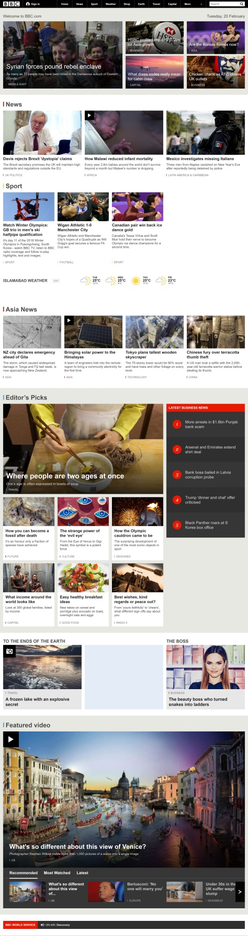

While carefully observing this layout, one can easily identify that this design consists of several nested DIVs. Some of the DIVs are highlighted below.

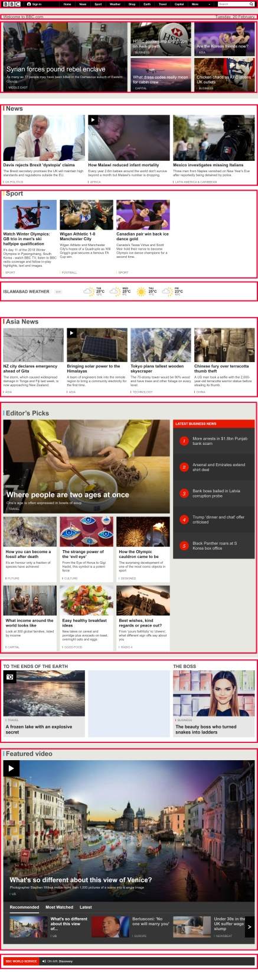

**Your Task:**

Design a web page which has similar layout as shown in the above screenshots. Your layout must be based on DIVs (no tables). You are encouraged to use either internal CSS (using <style> tag) or external CSS (creating a file with .css extension and linking it in the <head> section using <link> tag). You are also encouraged to use different HTML tags and CSS styles you learned so far to beautify the solution.

**Hints**

1. Feel free to browse BBC’s website and look into its page source to see how the layout is designed.
2. You can change the color scheme as per your choice.
3. BBC’s website has a menu (More) and a search bar. You can skip both in your layout.
4. You are encouraged to use most of the HTML tags and CSS styles you have learned so far or even new tags, which you can learn from W3Schools.
5. Make good use of HTML colors, fonts, font-family, font-sizes and other styles for the ***look and feel*** of the web page.
6. Make sure to test your website with different resolutions by changing the resolution of your screen.

**Important:** Upload your html and CSS files along with the solution.

|  |
| --- |
| Solution |
| Screenshot of web page    HTML Code  <!DOCTYPE html>  <html lang="en">  <head>      <meta charset="UTF-8">      <meta http-equiv="X-UA-Compatible" content="IE=edge">      <meta name="viewport" content="width=device-width, initial-scale=1.0">      <title>Document</title>      <link rel="stylesheet" href="Lab4.css">  </head>  <body style="background-color: black;">      <div style="background-color: black;">          <div class="nav_ele" style="padding-left: 300px; padding-top: 2px;  padding-bottom: 1px; padding-right: 20px;"              align="right"><a href="https://www.bbc.com"><img src="bbc.png" width="80px" height="24px"></a></div>          <div class="nav_ele"><a                  href="https://account.bbc.com/signin?realm=%2F&clientId=Account&context=homepage&ptrt=https%3A%2F%2Fwww.bbc.com%2F&userOrigin=HOMEPAGE_GNL&isCasso=false&action=sign-in&redirectUri=https%3A%2F%2Fsession.bbc.com%2Fsession%2Fcallback%3Frealm%3D%2F&service=IdSignInService&nonce=w46rJrm2-EBdNoUbGfuuGGQxgKr4gOvdszEw">                  Sign in</a></div>          <div class="nav_ele"><a href="https://bbc.com">Home</a> </div>          <div class="nav_ele"><a href="https://www.bbc.com/news">News</a> </div>          <div class="nav_ele"><a href="https://www.bbc.com/sport">Sport</a> </div>          <div class="nav_ele"><a href="https://www.bbc.com/reel">Reel</a> </div>          <div class="nav_ele"><a href="https://www.bbc.com/worklife">Worklife</a> </div>          <div class="nav_ele"><a href="https://www.bbc.com/travel">Travel</a> </div>          <div class="nav_ele"><a href="https://www.bbc.com/future">Future</a> </div>          <div class="nav_ele"><a href="https://www.bbc.com/culture">Culture</a> </div>          <div class="nav_ele" style="padding-bottom: 5px;"><select id="More">                  <option value="" disabled selected hidden>More</option>                  <option value="">Weather</option>                  <option value="">Music</option>                  <option value="">TV</option>                  <option value="">Sounds</option>              </select></div>          <div>              <textarea style="padding-top: 10px;margin: 0%;" name="" id="" cols="30" rows="1"></textarea>              <img src="glass.png" alt="">          </div>      </div>      <div style="background-color: white; ">      <div style="padding-top: 25px; ">          <div class="welcome" style="padding-left:300px"><b> Welcome To BBC</b></div>          <div class="welcome" style="padding-left: 834px;"><b>Monday, 28th February</b></div>      </div>      <br>      <div>          <div class="main" style="padding-left: 300px;padding-top: 10px;"><a                  href="https://www.bbc.com/news/live/world-europe-60542877"><img src="big_main.png" alt=""></a></div>          <div class="main" style="padding-left: 38px ;padding-top: 10px;">              <div><a href="https://www.bbc.com/news/world-europe-60551140"><img src="putin.png" alt=""></a></div>          </div>          <div class="main" style="padding-left: 24px ;padding-top: 10px;">              <div><a href="https://www.bbc.com/news/business-60559513"><img src="russia.png" alt=""></a></div>          </div>          <div class="main" style="padding-left: 38px ;padding-top: 10px;">              <div><a                      href="https://www.bbc.com/worklife/article/20220223-are-workers-really-quitting-over-company-values"><img                          src="quit.png" alt=""></a></div>          </div>          <div class="main" style="padding-left: 24px ;padding-top: 10px;">              <div><a href="https://www.bbc.com/travel/article/20220227-dunwich-the-british-town-lost-to-the-sea"><img                          src="sunken.png" alt=""></a></div>          </div>      </div>      <div class="rest" ><img src="news.png" alt=""></div>      <div class="rest2" style="padding-top:10px ;"><img src="sport.png" alt=""></div>      <div class="rest2" ><img src="weather.png" alt=""></div>      <div class="rest2" style="padding-left: 0;"><img src="Reel.png" alt=""></div>      <div class="rest2" "><img src="Asia.png" alt=""></div>      <div class="rest2" "><img src="editor.png" alt=""></div>      <div class="rest2" style="padding-left: 0;"><img src="ending.png" alt=""></div>  </div>  </body>  </html>  CSS FILE:  .nav_ele {  */* display:inline-block; */*      background-color: black;      text-align: center;      color: white;      padding-top: 7px;      padding-bottom: 6px;      padding-left: 32px;      padding-right: 32px;      float: left;      margin-right: 2px;  }  .nav_ele:hover {      text-decoration: underline;      text-decoration-color: rgb(0, 123, 255);      text-decoration-thickness: 3px;      text-underline-offset: 5px;  }  div a:link {      color: white;      background-color: transparent;      text-decoration: none;  }  div a:visited {      color: white;      background-color: transparent;      text-decoration: none;  }  div a:hover {      color: white;      background-color: transparent;      text-decoration: underline;      text-decoration-color: rgb(0, 110, 255);  }  select:invalid{      color: gray;  }  option{      color: black;  }  .welcome{      display: inline-block;      color: rgb(73, 73, 73);      text-align: center;      font-size: 24px;    }  .main{      float: left;      position: static;  }  .cbody {      height: 100%;      padding: 0;      margin: 0;    }      .cdiv {      width: 50%;      height: 50%;      float: left;    }        .rest{        padding-left: 299px;        padding-top: 400px;    }    .rest2{        padding-left: 300px;        padding-top: 20px;    } |

### Deliverables

Compile a single word document by filling in the solution part and submit this Word file with the code files on LMS. You must include your name, ID, and class on first page. The lab grading policy is as follows: The lab is graded between 0 to 10 marks. For some of the labs, students have to present their solutions in a viva session. In case of any problems with submissions on LMS, you should contact your lab engineer Ms. Ayesha Asif by email at [ayesha.asif@seecs.edu.pk](mailto:ayesha.asif@seecs.edu.pk).