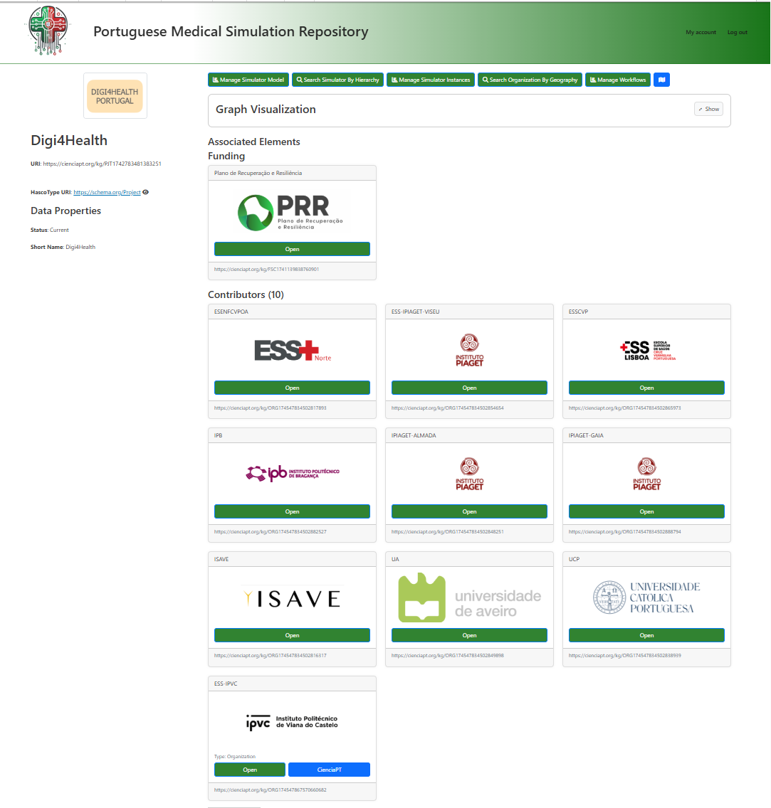
Table of Contents
1. General Introduction 5
About this Documentation 5
Entity Relationship Diagram 6
Review and Approval Workflow 7
Model vs. Instance - Key Concept 8
General Prerequisites 9
Conventions used in this documentation 9
2. Instruments / Simulators 10
Overview 10
Accessing Instrument/Simulator Management 11
The Management Page (List) 12
Creating a New Instrument/Simulator 13
Editing an Instrument/Simulator 16
Container Slot Management (Internal Structure) 18
Submitting for Review 22
The Review Process (Reviewer’s Perspective) 23
Lifecycle and Versioning 26
Field Reference 27
Troubleshooting 28
3. Component Stems 28
Overview 28
What is a Component Stem? 29
Accessing Component Stem Management 30
The Management Page (List) 31
Creating a New Component Stem 32
Deriving a Component Stem 34
Editing a Component Stem 37
Submitting for Review 39
The Review Process (Reviewer’s Perspective) 39
Lifecycle and Versioning 41
Field Reference 42
Troubleshooting 44
4. Components 44
Overview 45
What is a Component? 46
Prerequisites 46
Accessing Component Management 47
The Management Page (List) 48
Creating a New Component 49
Associating a Component with a Slot (Container Slot) 52
Understanding Detectors and Actuators 55
Editing a Component 56
The Review Process (Reviewer’s Perspective) 58
Lifecycle and Versioning 60
Field Reference 61
Troubleshooting 62
5. Instrument / Simulator Instances 63
Overview 63
What is an Instrument/Simulator Instance? 64
Prerequisites 65
Accessing Instance Management 65
The Management Page (List) 66
Creating a New Instance 66
Editing an Instance 69
Deployments - Associating Instances 70
Field Reference 71
Troubleshooting 72
6. Platforms / Laboratories 73
Overview 73
What is a Platform / Laboratory? 74
Accessing Platform Management 75
The Management Page (List) 76
View Modes 76
Creating a New Platform / Laboratory 77
Editing a Platform / Laboratory 79
Field Reference 81
Troubleshooting 81
7. Platform / Laboratory Instances 82
Overview 82
What is a Platform / Laboratory Instance? 83
Prerequisites 84
Accessing Instance Management 84
The Management Page (List) 85
Creating a New Instance 86
Editing an Instance 88
Complete Scenario: From Laboratory to Deployment 90
Field Reference 91
Troubleshooting 92

This document is the complete English manual for PMSR, covering general concepts and all operational workflows from definitions to instances and deployments.

1. General Introduction

About this Documentation
This set of manuals provides detailed instructions for using the semantic instrument management system, covering components, platforms and their instances within the PMSR project context. The manuals are intended for system users and reviewers, covering everything from element creation to the review and approval workflow.
Note on PMSR terminology: Within the PMSR context, the system’s default terms have been customized by the administrator. For example, “Instrument” appears as “Simulator”, and “Platform” may appear as “Laboratory”. In these manuals, we use both designations (e.g., Instrument/Simulator) for clarity.

Entity Relationship Diagram

The diagram below illustrates how the different entities relate to each other in the system:
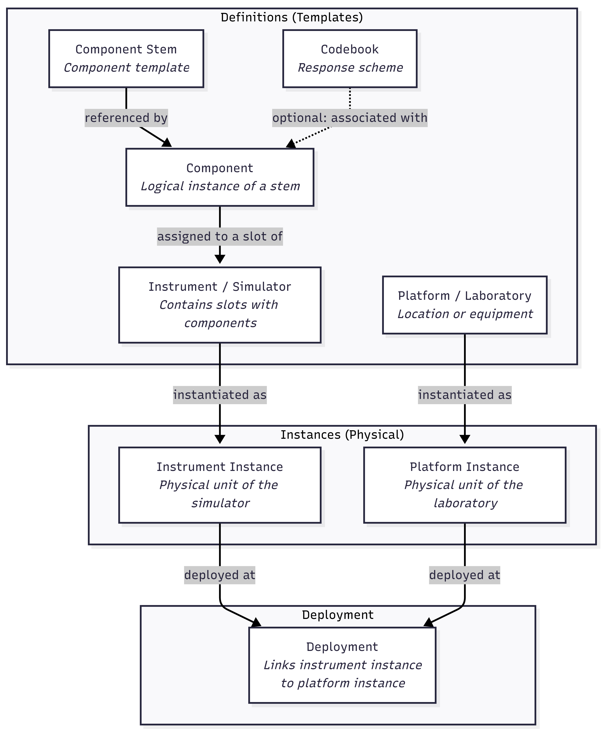
Diagram PNG: Entity Relationship Diagram

Review and Approval Workflow
All elements of type Instrument/Simulator, Component, Component Stem, Codebook and Response Option follow a review workflow before becoming available for use (status Current):
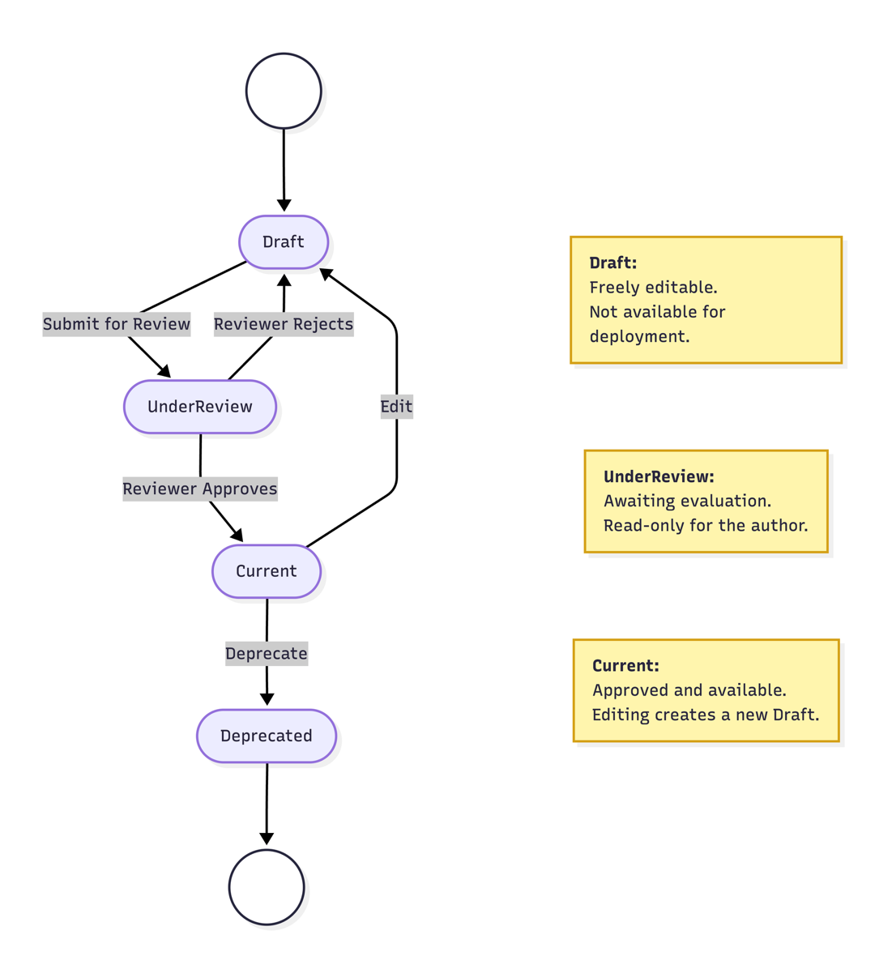
Diagram PNG: Review and Approval Workflow

Roles in the Review Workflow
Role | System Role | Description | Available Actions
User / Author | Authenticated User | Creates and edits elements. Submits for review. | Create, Edit, Submit for Review
Reviewer | Content Editor | Evaluates submitted elements. Can approve or reject. Requires a special permission assigned by an Administrator. | Approve, Reject (with mandatory notes)

Note on permissions: These manuals are aimed at users with the Authenticated User role. The review sections describe what the Reviewer does so you understand the full workflow, but the review action is only available to users with the Content Editor permission. Role management and system configuration are the Administrator’s responsibility and are not covered in this documentation.

Model vs. Instance - Key Concept

An essential concept for understanding the system is the distinction between Model (definition/design) and Instance (concrete unit).
Concept | What it represents | PMSR Example
Model (Definition) | The design, the “blueprint” - describes what it is and how it works. It’s abstract, serves as a template. It can contain slots, components, and goes through the review process. | “Lyophilization Simulator LF-2000” - the simulator definition, with its 5 slots and associated components.
Instance (Physical Unit) | A real, concrete unit of that model - with serial number, owner, location. It’s the “object you can touch”. | “Lyophilizer #SN-001 at PMSR Lab, acquired in 2025” - the physical machine in the laboratory.

Why both? Because the same simulator model can exist in multiple copies (physical units) across different laboratories. The model is defined and approved once; instances track each individual unit for operational control and deployment.
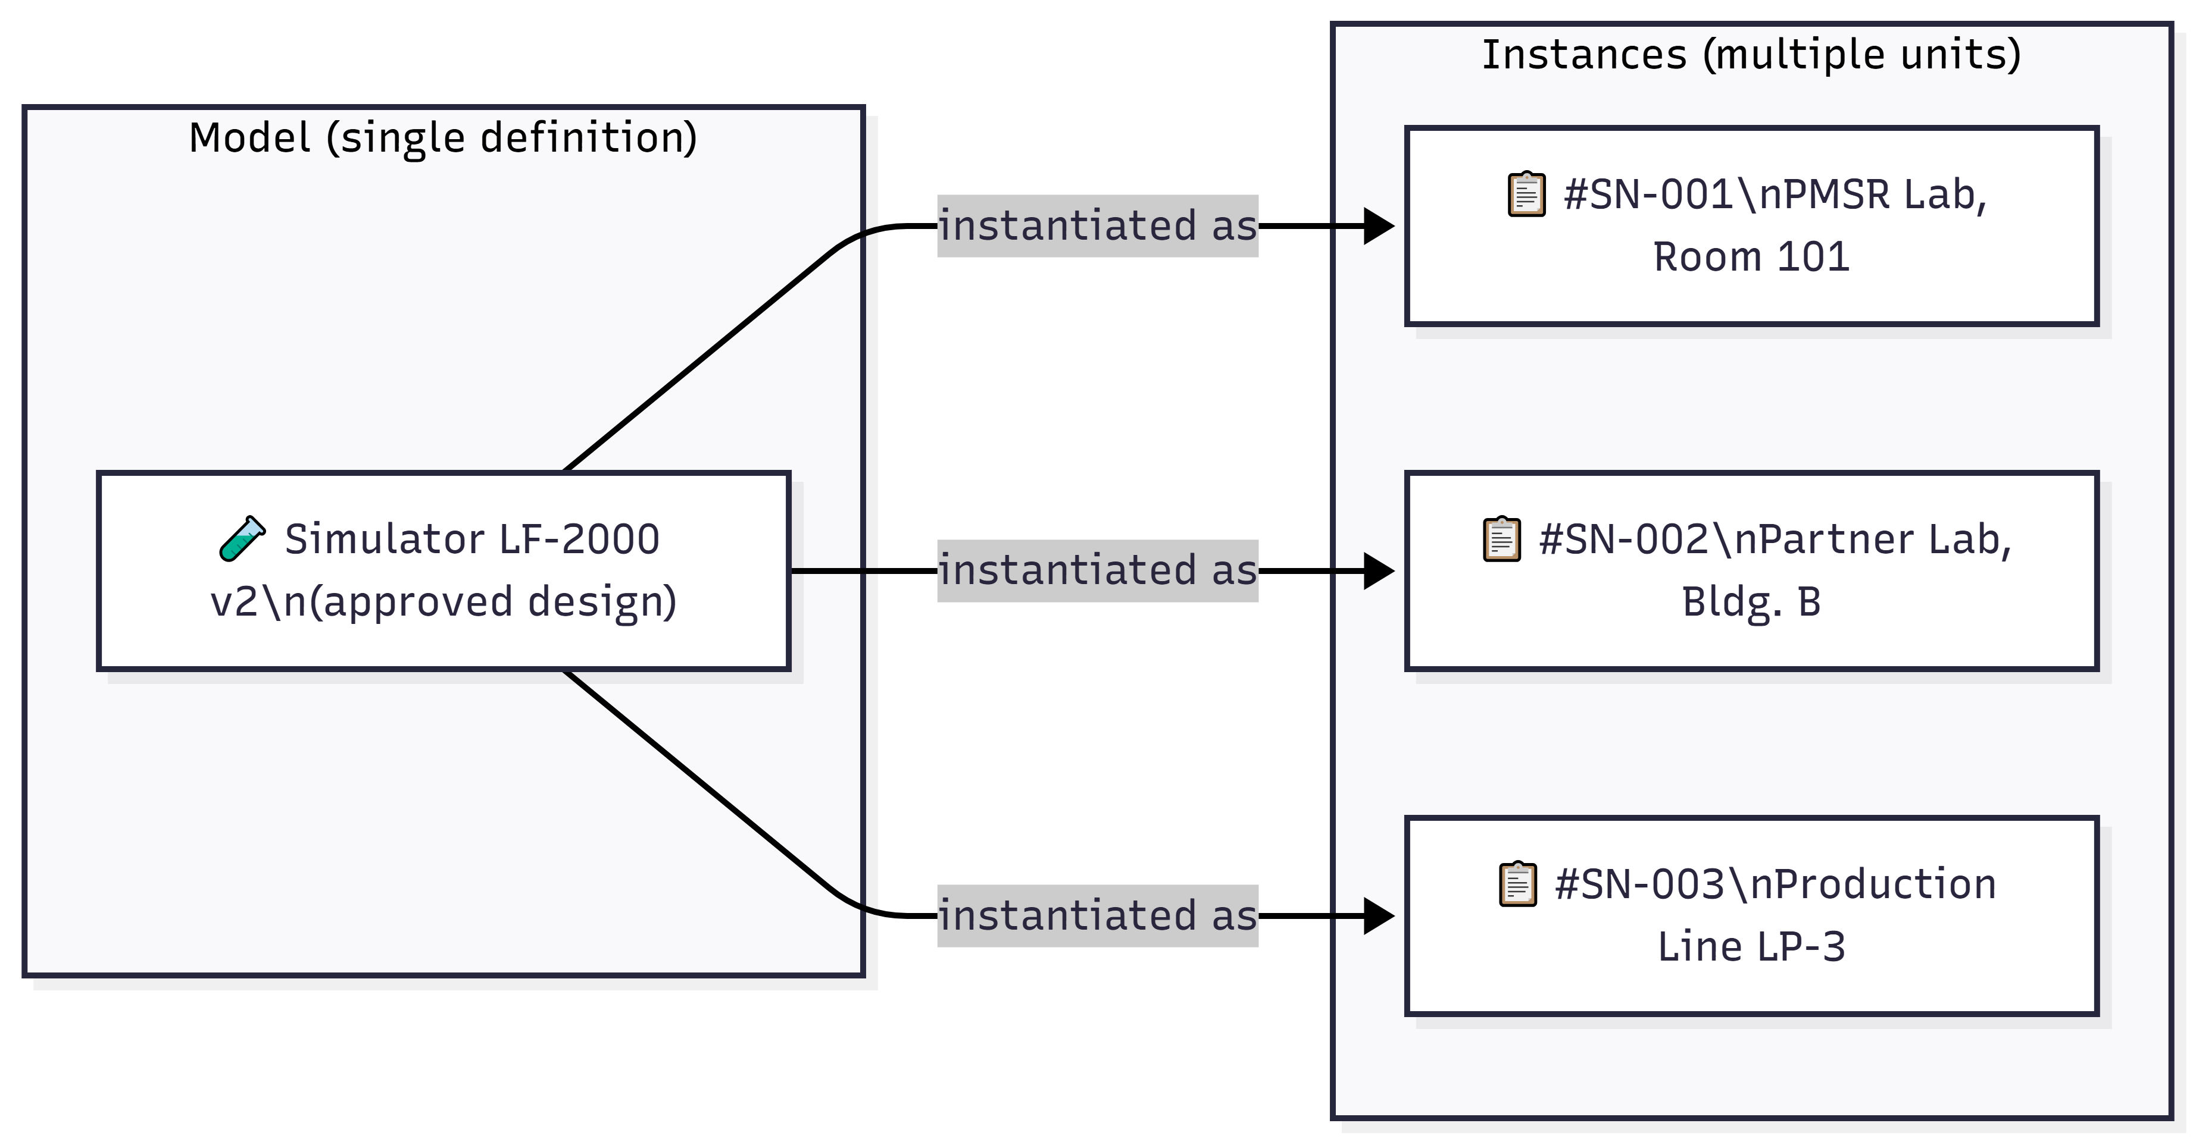
Diagram PNG: Model vs. Instance - Key Concept

The same applies to Platforms/Laboratories: the model defines the type of laboratory, and each instance represents a specific, physical laboratory.

General Prerequisites
- Authentication: All manuals assume that the user is authenticated in the system.
- Minimum role: Authenticated User. Review actions require the Content Editor permission, assigned by an Administrator.
- PMSR Terminology: The names displayed in the system (Simulator, Laboratory, etc.) have been configured by the administrator to reflect the PMSR context.

Conventions used in this documentation
Icon/Format | Meaning
Bold | Button names, fields or menus in the system
code | URL paths, technical values
> Note | Important information or tips
⚠️ | Warnings and precautions
📋 | Step to follow in a sequence
🔗 | Cross-reference to another section in this manual

2. Instruments / Simulators
Module: SIR (Semantic Instrument Repository)
PMSR Context: In PMSR, “Instrument” is typically referred to as “Simulator”

Overview
An Instrument (or Simulator in the PMSR context) represents a measurement instrument, questionnaire, simulator, or data collection device in the semantic system. Examples in PMSR include pharmaceutical process simulators, quality measurement instruments, or assessment questionnaires.
Each Instrument/Simulator: - Has a unique automatically generated URI - Is classified by a hierarchical type (Parent Type) - Contains Container Slots that hold Components or sub-containers, enabling recursive hierarchies (see 🔗 Section 4 - Components) - Follows a review workflow: Draft → Under Review → Current - Has automatic versioning
📘 Model vs. Instance: An Instrument/Simulator is a model (definition/design) - it describes the instrument’s structure, slots, and components. Think of it as a blueprint. To register concrete physical units of this model (with serial number, owner, location), see Section 5 - Instrument / Simulator Instances. The same model can have multiple instances across different laboratories.

Conceptual Diagram

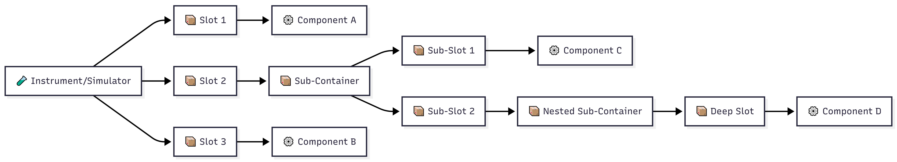
Diagram PNG: Conceptual Diagram

PMSR Note: The term displayed in the menu and forms depends on the Preferred Names configuration. If configured as “Simulator”, all menus and labels will show “Simulator” instead of “Instrument”.

Accessing Instrument/Simulator Management

Navigation Path

Main Menu → Instrument Elements → Manage Elements → Manage Instruments

Direct URL: https://www.pmsr.net/sir/select/instrument/1/9

Detailed Steps:
📋 Step 1. In the main navigation bar of the site, locate and click on “Instrument Elements” (or the name configured by PMSR).
📋 Step 2. In the submenu that appears, hover over “Manage Elements”.
📋 Step 3. Click on “Manage Instruments” (or “Manage Simulators” if configured).
You will be directed to the management page with the list of all Instruments you manage.

The Management Page (List)

The management page displays a list of Instruments/Simulators for which you are the author. It offers two views and several filtering options.

Display Modes
Button | Description
Table View | Table view with detailed columns (recommended for management)
Card View | Card view with visual preview

Available Filters
Filter | Description | Options
Text Filter | Keyword search by name/URI | Free text field
Language | Filters by instrument language | All / English / Português / etc.
Status | Filters by lifecycle state | All Status / Draft / Under Review / Current / Deprecated

Table Columns (Table View)
Column | Description
URI | Unique identifier (clickable link to the description page)
Parent Type | Hierarchical type of the instrument (clickable link)
Abbreviation | Short code/abbreviation
Name | Instrument name + version
Language | Language
Downloads | Download links in formats: TXT, HTML, RDF, FHIR (when applicable)
Status | Current state: Draft, Under Review, Current, Deprecated

Tip: If an element was rejected by the Reviewer, the status will appear as “Draft (Already Reviewed)” to indicate that it has already been reviewed and returned.

Action Buttons
Button | Function | Condition
Add New Instrument | Opens the creation form | Always available
Edit Selected | Opens the editing form for the selected element | Requires selection of 1 element
Delete Selected | Deletes the selected element | Requires selection + confirmation
Send for Review | Submits for review | Only for elements in Draft state

Creating a New Instrument/Simulator

Creation Sequence
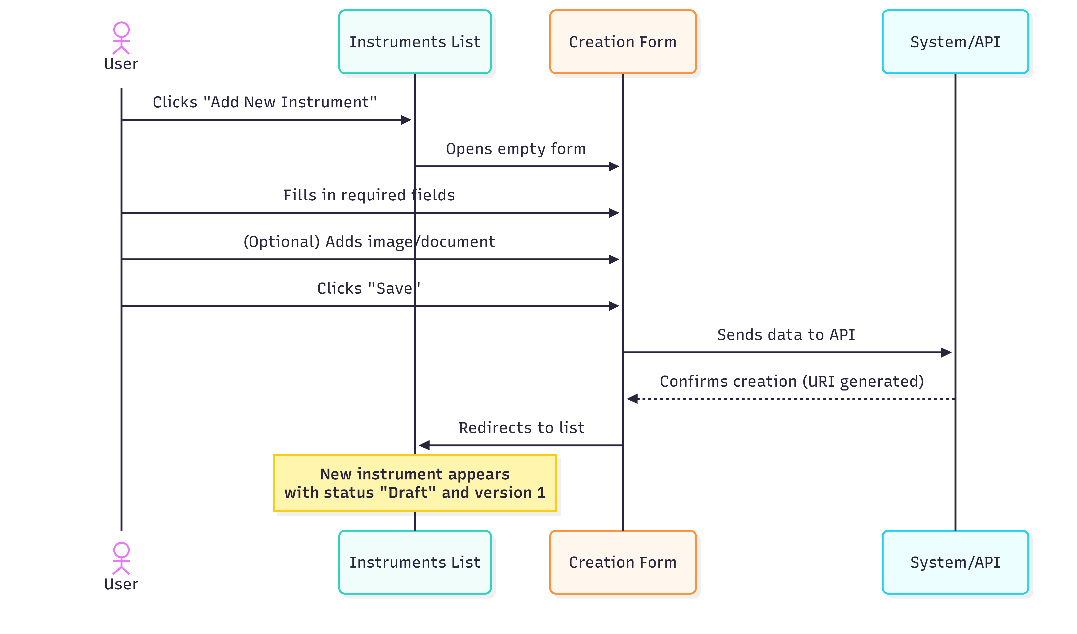
Diagram PNG: Creation Sequence

Detailed Steps
📋 Step 1. On the management page, click the “Add New Instrument” (or “Add New Simulator”) button.
📋 Step 2. Fill in the creation form with the following fields:

Form Fields
Field | Type | Required | Detailed Description
Parent Type | Modal selection (tree) | No | Defines the hierarchical type of the instrument. When clicked, a modal window opens with a tree of available types in the ontology. Select the most specific applicable type (e.g., vstoi:Questionnaire, vstoi:Simulator). If you are unsure which to choose, consult the administrator.
Name | Text field | Yes | Descriptive name of the instrument. Should be clear and unique within your context. E.g., “PHQ-9 Depression Screening”, “Lyophilization Process Simulator”.
Abbreviation | Text field | No | Short code or acronym. E.g., “PHQ-9”, “SIM-LIO-01”. Useful for quick reference.
Maker | Text field with autocomplete | No | Manufacturing/creating organization. Start typing and select from the list of registered organizations.
Informant | Dropdown list | No | Defines the language informant (e.g., en_US for American English).
Language | Dropdown list | Yes | Primary language of the instrument. Default: English (en).
Version | Field (read-only) | Auto | Automatic value: starts at 1. Increments automatically when editing Current versions.
Description | Text area | No | Detailed description of the instrument, its purpose, usage context, and any relevant notes.

Image Fields
Field | Description
Image Type | Choose between URL (external link) or Upload (upload file)
Image (URL) | If you chose URL: paste the full image address
Upload Image | If you chose Upload: click to select a file. Accepted formats: PNG, JPG, JPEG. Maximum size: 2 MB

Web Document Fields
Field | Description
Web Document Type | Choose between URL (external link) or Upload (upload file)
Web Document (URL) | If you chose URL: paste the full document address
Upload Document | If you chose Upload: click to select a file. Accepted formats: PDF, DOC, DOCX, TXT, XLS, XLSX. Maximum size: 2 MB

📋 Step 3. After filling in all required fields, click “Save”.
📋 Step 4. The system creates the instrument with: - Automatically generated URI - Version = 1 - Status = Draft - Author = your user email

You will be redirected to the management page, where the new instrument appears in the list.

⚠️ Important: The instrument is created in Draft state. For it to become available for use (Current state), it must be submitted for review and approved by a Reviewer.

Parent Type Selection (Tree Modal)

When you click the Parent Type field, a modal window opens with an 800px width containing a hierarchical type tree:

vstoi:Instrument
├── vstoi:Questionnaire
│ ├── vstoi:SelfAdministeredQuestionnaire
│ └── vstoi:InterviewerAdministeredQuestionnaire
├── vstoi:Simulator
│ ├── vstoi:ProcessSimulator
│ └── vstoi:PharmaceuticalSimulator
├── vstoi:PhysicalDevice
│ ├── vstoi:Sensor
│ └── vstoi:MeasurementDevice
└── ...

Note: The type tree is defined by the system’s ontology. Available types may vary depending on your environment’s configuration.

To select: Click on the desired type in the tree. The field will be automatically populated and the modal window will close.

Editing an Instrument/Simulator

How to Access Editing

📋 Step 1. On the management page, select the instrument you want to edit by clicking the corresponding radio button in the table.
📋 Step 2. Click the “Edit Selected” button.
📋 Step 3. The editing form opens with all fields populated with the current data.

Editing Form

The editing form contains all the fields from the creation form, with the following differences:

Difference | Description
URI | Displayed as a read-only field (clickable link to the description page)
Version | Automatically calculated: if the current state is Current or Deprecated, the displayed version will be incremented (+1)
Container Elements | Additional section showing the internal structure of slots and components (see section 6)
Review Notes | If the instrument has already been reviewed, shows the Reviewer’s notes (read-only)
Reviewer Email | Email of the last Reviewer (read-only)

Editing Process Diagram
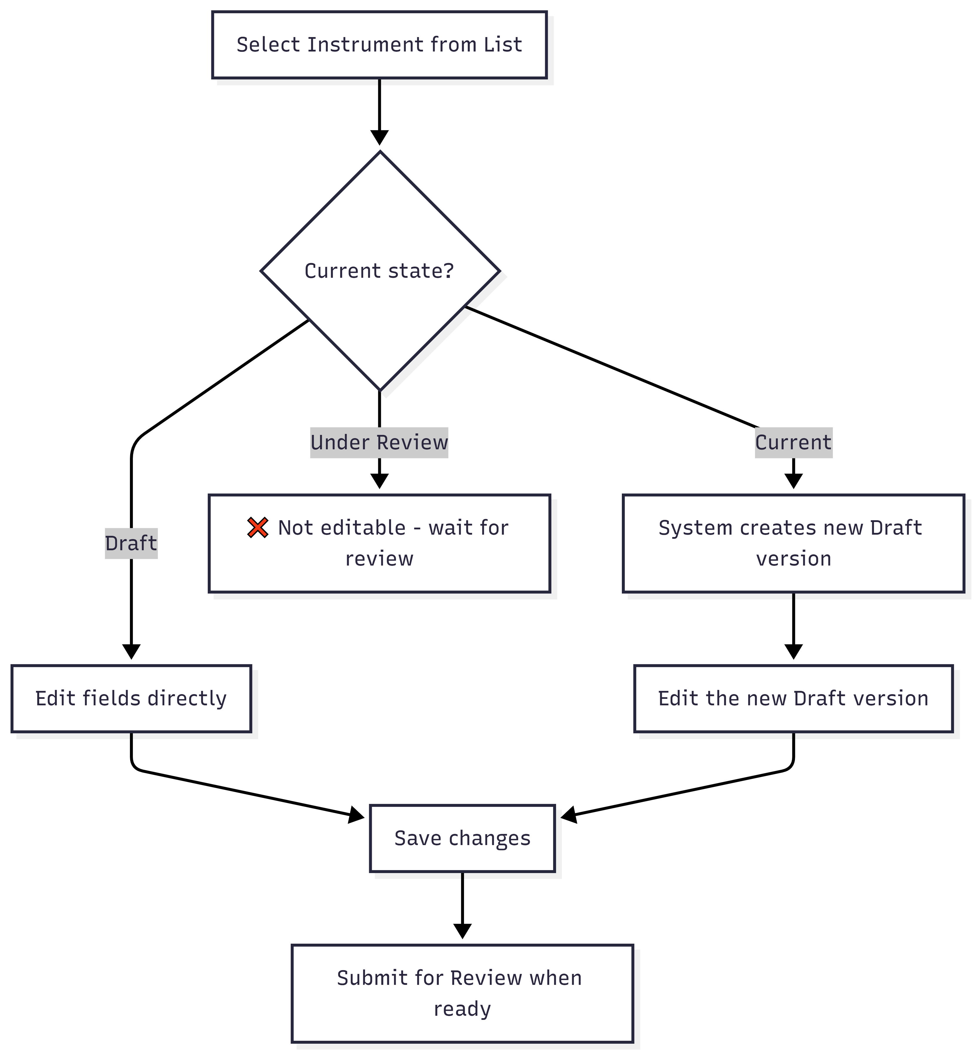
Diagram PNG: Editing Process Diagram
⚠️ Editing a Current instrument: When you edit an instrument with Current status, the system automatically creates a new version in Draft state with an incremented version number. The Current version remains unchanged until the new version is approved.

Editing Form Buttons
Button | Function
Update | Saves changes and redirects to the list
Cancel | Discards changes and returns to the list

Container Slot Management (Internal Structure)

An Instrument/Simulator contains Container Slots - numbered positions where Components or sub-containers are associated. The structure is recursive: a sub-container can contain additional slots, which can in turn hold components or more sub-containers, allowing deep hierarchies. This section appears in the editing form, within the “Container Elements” section.

Container Slots Concept
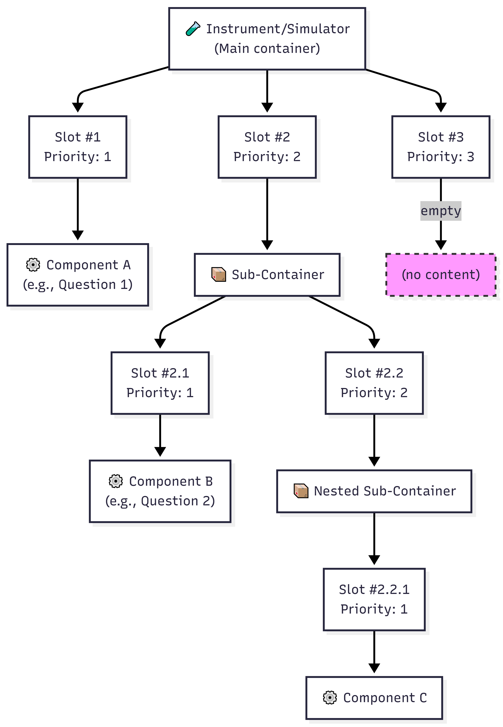
Diagram PNG: Container Slots Concept

Adding Slots to an Instrument

📋 Step 1. In the Instrument editing form, locate the “Container Elements” section.
📋 Step 2. Click the “Add Slots” button (or + icon).
📋 Step 3. In the form that opens:

Field | Description
Container | URI of the instrument (automatically filled, read-only)
Number of Slots | Number of slots to add. Enter a positive integer.

📋 Step 4. Click “Save”. The slots are created with sequential priorities.
Example: Adding 5 slots creates Slot #1, Slot #2, …, Slot #5 in the instrument.

Associating a Component with a Slot

📋 Step 1. In the “Container Elements” section of the Instrument editing form, identify the desired slot.
📋 Step 2. Click the slot’s edit button (pencil icon or “Edit Slot”).
📋 Step 3. In the slot editing form:
Field | Description
Slot URI | Slot identifier (read-only)
Priority | Slot priority/order (read-only)
Component | Click to open the component selection modal. In the tree, select the desired Component.
📋 Step 4. Available options:
Button | Function
New Item | Creates a new Component and associates it with this slot (redirects to the Component creation form - see 🔗 Section 4 - Components)
Reset this Item | Removes the Component currently associated with the slot (frees the slot)
Update | Saves the selected Component association (only active when a component is selected)
Cancel | Returns without making changes

⚠️ Recursive structure: A slot can point to a Component or a sub-container. When it points to a sub-container, that sub-container has its own slots and can be nested further as needed.

Visual Structure of Container Slots

When editing an Instrument, the Container Elements section displays a hierarchical view similar to:

📦 Container Elements
├── Slot #1 (Priority: 1) - ⚙️ Component: "Inlet Temperature" [Edit] [Remove]
├── Slot #2 (Priority: 2) - 📦 Sub-Container: "Pressure Measurements" [Edit] [Remove]
│ ├── Slot #2.1 (Priority: 1) - ⚙️ Component: "Chamber Pressure" [Edit] [Remove]
│ └── Slot #2.2 (Priority: 2) - 📦 Sub-Container: "Fine Control" [Edit] [Remove]
│ └── Slot #2.2.1 (Priority: 1) - ⚙️ Component: "Pillow Pressure" [Edit] [Remove]
├── Slot #3 (Priority: 3) - 🔲 (empty) [Edit] [Add Component or Sub-Container]
└── [+ Add More Slots]

Submitting for Review

ℹ️ Note on permissions: Submitting for review can be done by the element’s author (authenticated user). Approval or rejection requires the Content Editor (Reviewer) permission.

After creating or editing an Instrument/Simulator in Draft state, you need to submit it for review so it can advance to the Current state.

Submission Sequence
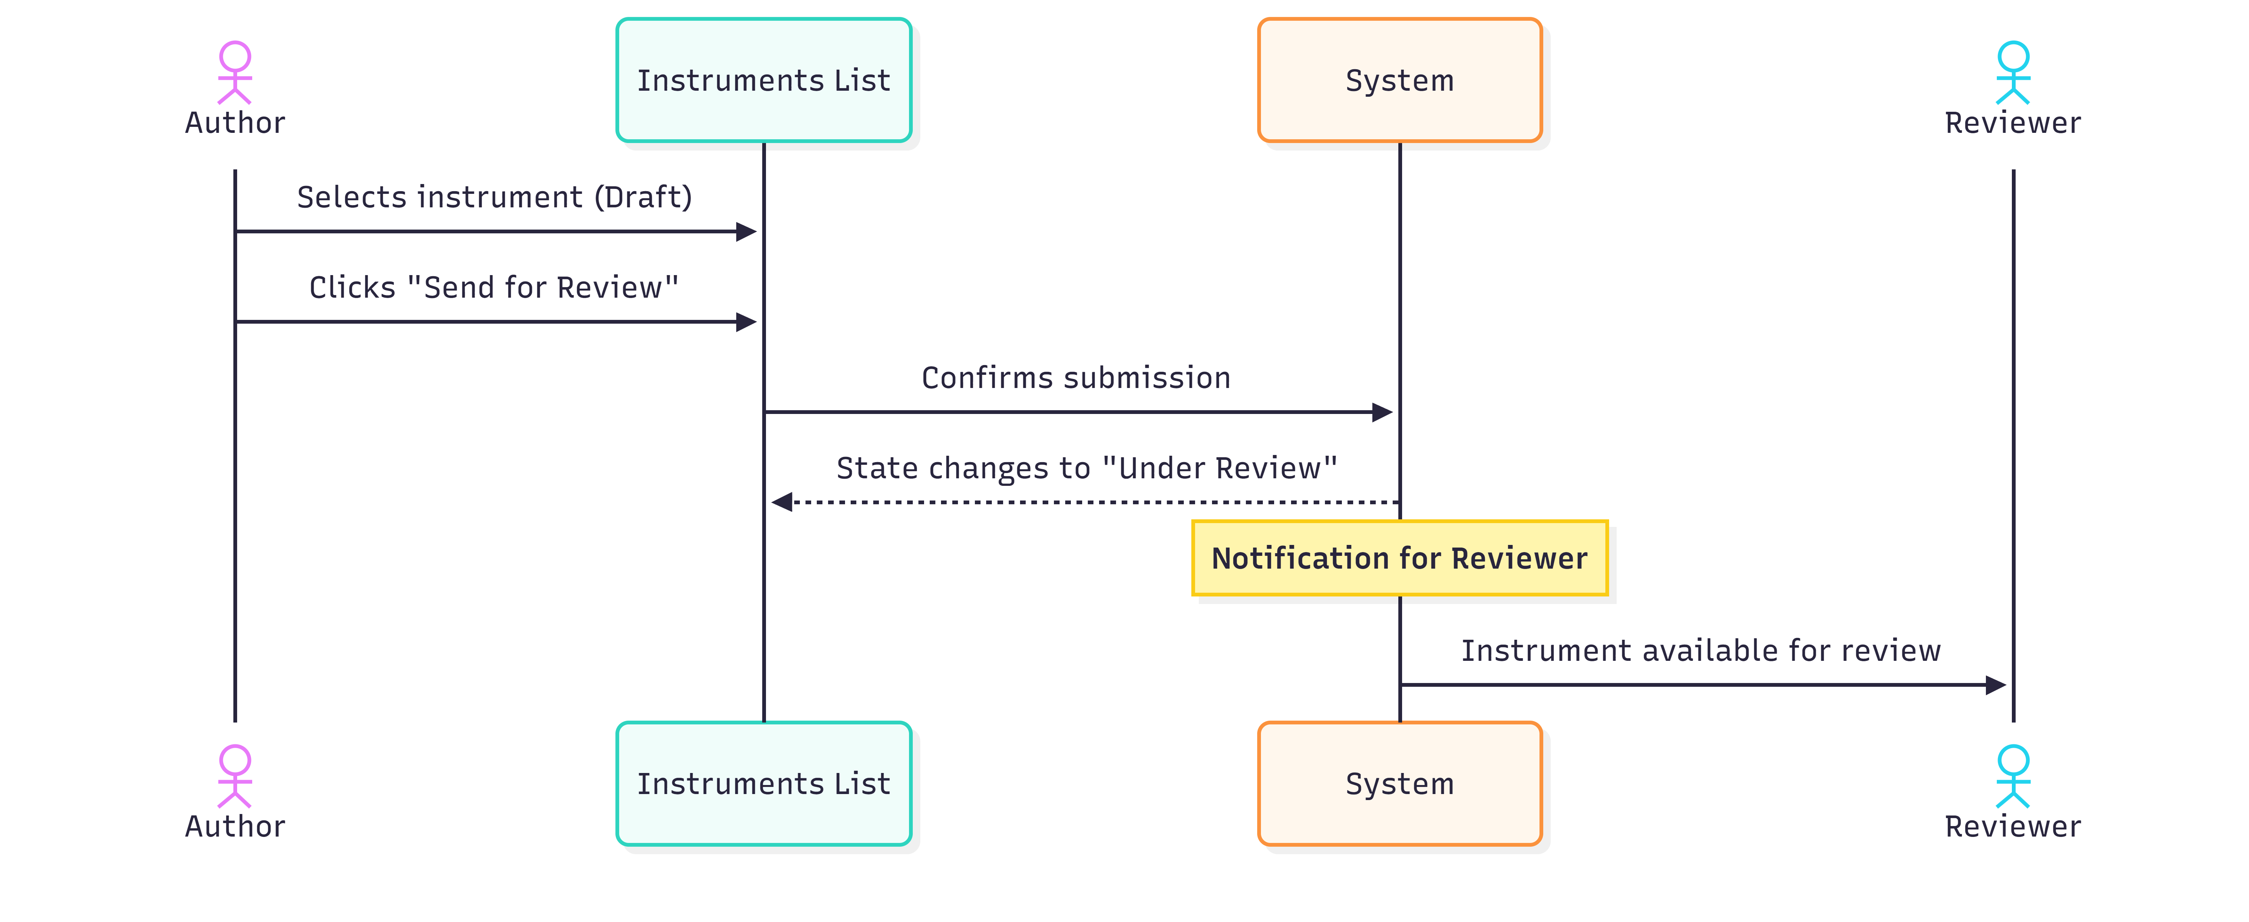
Diagram PNG: Submission Sequence

Detailed Steps
📋 Step 1. On the management page, filter by Status: Draft to locate instruments ready for review.
📋 Step 2. Select the instrument you want to submit by clicking the corresponding radio button.
📋 Step 3. Click the “Send for Review” button.
📋 Step 4. A confirmation dialog appears: “Are you sure you want to submit for Review selected entry?”
📋 Step 5. Confirm by clicking OK.
📋 Step 6. The instrument’s state changes to Under Review. From this moment: - The instrument cannot be edited by the author - The instrument becomes available for evaluation by a Reviewer - The submission is recursive: all Components associated with the instrument are also submitted for review
⚠️ Recursive submission: When you submit an Instrument for review, all Components in its slots are automatically submitted as well. Make sure all Components are complete before submitting the Instrument.

The Review Process (Reviewer’s Perspective)

⚠️ Required permission: This section describes actions available only to users with the Content Editor (Reviewer) role. It is included so you understand the full review workflow.

Who is the Reviewer?

The Reviewer is a user with the content_editor role in the system. Their function is to evaluate whether submitted elements are compliant and correct before approving them for general use.

Accessing the Review

Main Menu → Instrument Elements → Review Elements → Review Instruments

The Reviewer navigates to the list of Instruments with Under Review status.

Review Form

The review form presents the instrument in read-only mode (the Reviewer does not edit the data), organized into:
- Vertical Tabs with all instrument fields (name, type, description, image, document, etc.)
- Container Elements - visualization of the slots and components structure
- Review Section - Reviewer action fields

Review Section Fields
Field | Type | Required | Description
Review Notes | Text area | Yes (for rejection) | Reviewer’s notes and comments. Required in case of rejection to indicate the reason. Optional in case of approval.
Reviewer Email | Text field (read-only) | Auto | Current Reviewer’s email, automatically filled.

Reviewer Actions
Action | Button | Notes Required? | Result
Approve | Approve | No (optional) | State → Current. The instrument becomes available for instantiation and deployment. Confirms that the instrument is compliant.
Reject | Reject | Yes (required) | State → Draft. The instrument returns to the author with the Reviewer’s notes explaining the reasons for rejection. The rejection is recursive: all associated Components are rejected as well.

Review Flow Diagram
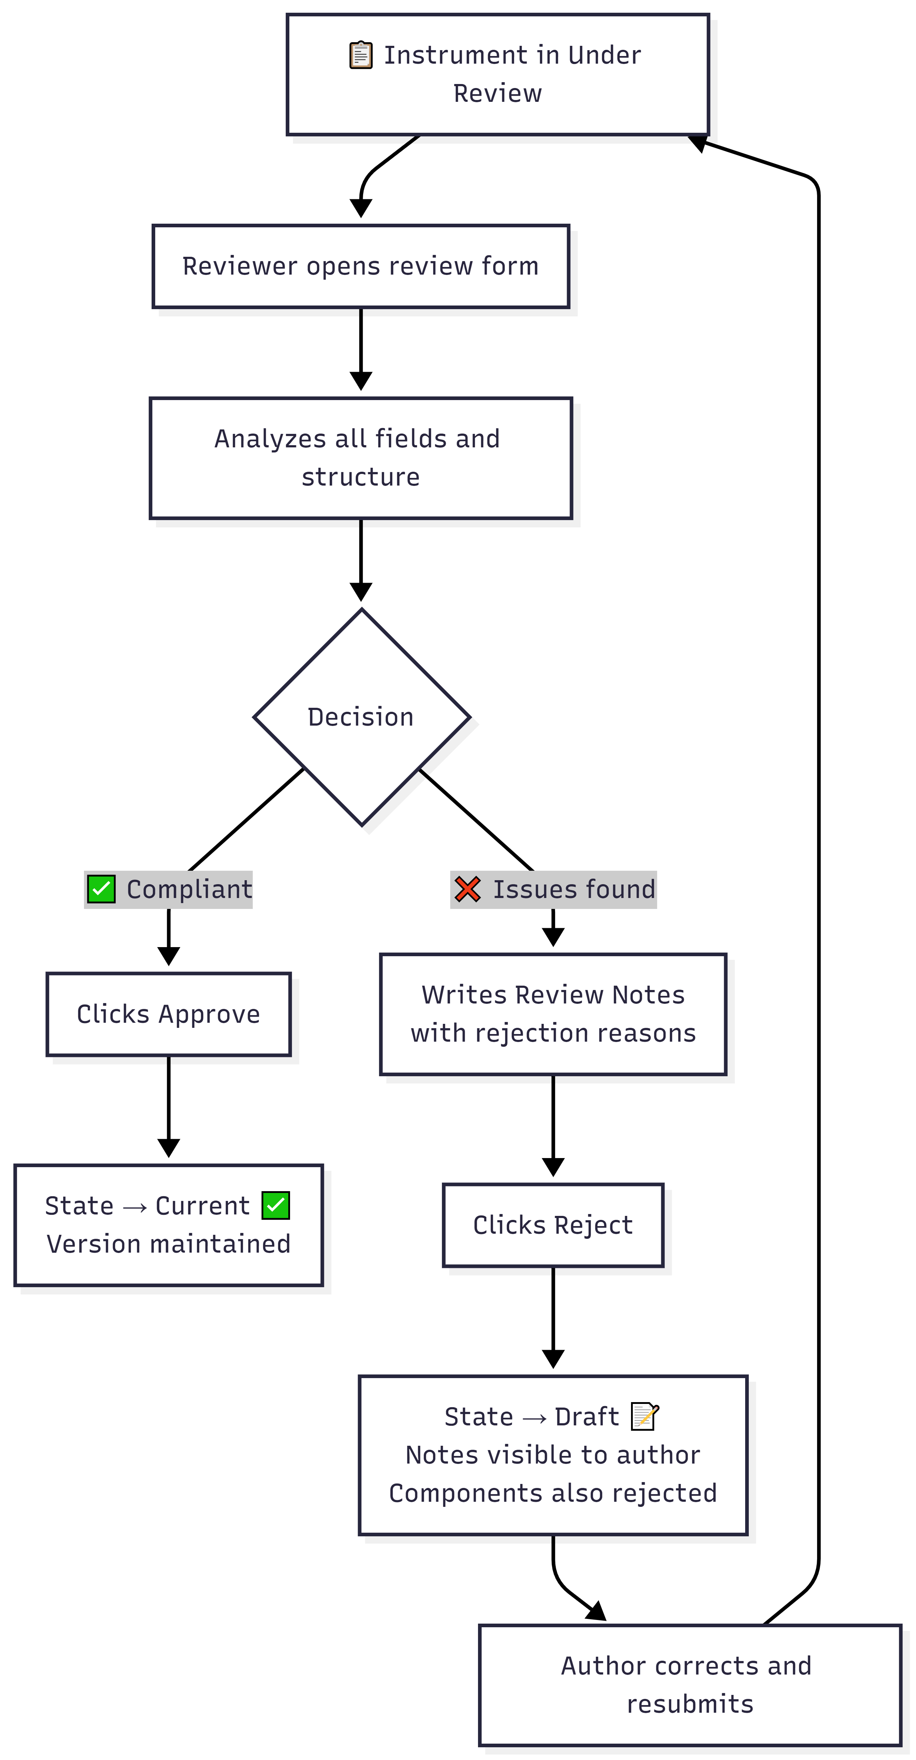
Diagram PNG: Review Flow Diagram
Tip for Reviewers: When rejecting, be specific in the Review Notes. Indicate exactly which fields or aspects need correction so the author can resolve issues quickly.

Lifecycle and Versioning

Possible States

State | Description | Can Edit? | Can Deploy?
Draft | Work in progress | ✅ Yes | ❌ No
Under Review | Awaiting Reviewer evaluation | ❌ No | ❌ No
Current | Approved and available for use | ⚠️ Creates new version | ✅ Yes
Deprecated | Discontinued, replaced by a newer version | ❌ No | ❌ No

Automatic Versioning

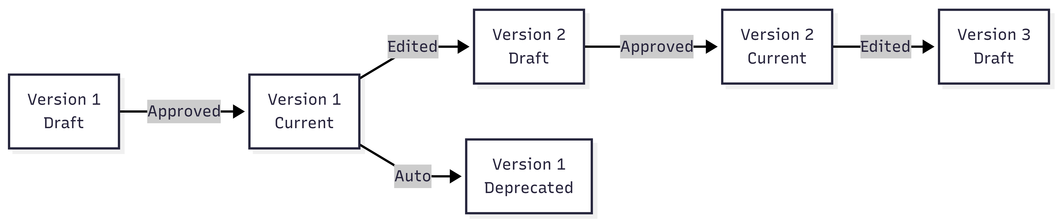
Diagram PNG: Automatic Versioning

- Creation: Version starts at 1
- Editing a Current version: Creates a new version (incremented) in Draft state
- Approval of new version: Previous version is automatically Deprecated

Field Reference

Complete Field Table - Creation Form
Field | Technical Name | HTML Type | Required | Default Value | Validation
Parent Type | instrument_type | Modal textfield | No | (empty) | Valid ontology URI
Name | instrument_name | Textfield | Yes | (empty) | Not empty
Abbreviation | instrument_abbreviation | Textfield | No | (empty) | -
Maker | instrument_maker | Textfield + autocomplete | No | (empty) | Valid organization
Informant | instrument_informant | Select | No | (empty) | Informants list
Language | instrument_language | Select | Yes | en | Languages list
Version | instrument_version | Textfield (disabled) | Auto | 1 | Positive integer
Description | instrument_description | Textarea | No | (empty) | -
Image Type | instrument_image_type | Select | No | (empty) | URL / Upload
Image URL | instrument_image_url | Textfield | Conditional | (empty) | Valid URL
Image Upload | instrument_image_upload | Managed file | Conditional | (empty) | PNG/JPG/JPEG, max 2MB
Web Doc Type | instrument_webdocument_type | Select | No | (empty) | URL / Upload
Web Doc URL | instrument_webdocument_url | Textfield | Conditional | (empty) | Valid URL
Web Doc Upload | instrument_webdocument_upload | Managed file | Conditional | (empty) | PDF/DOC/DOCX/TXT/XLS/XLSX, max 2MB

Troubleshooting
Problem | Possible Cause | Solution
I cannot see the “Send for Review” button | The instrument is not in Draft state | Check the state in the Status column. Only Draft elements can be submitted.
The instrument was rejected | The Reviewer found issues | Open the editing form and check the “Review Notes” field to see the reason for rejection. Correct and resubmit.
The Parent Type modal is empty | Connection issue with the ontology | Contact the system administrator.
The image does not upload | Invalid format or size | Check: PNG/JPG/JPEG, maximum 2MB.
I cannot edit - the fields are locked | The instrument is in Under Review state | Wait for the Reviewer’s decision. Editing is not possible during review.
The version changed automatically | You edited a Current instrument | Expected behavior: the system creates a new (incremented) version in Draft.

🔗 Internal Navigation: Components • Component Stems • Instrument / Simulator Instances • Internal Table of Contents

3. Component Stems
Module: SIR (Semantic Instrument Repository)
PMSR Context: Component Stems are the reusable base templates for components

Overview
A Component Stem is a reusable template that defines the base properties of a component. It works as a “mold” from which concrete Components are created. Before creating a Component, it is mandatory that at least one suitable Component Stem exists.
⚠️ Important dependency: Creating Components depends on the existence of Component Stems. If you need to create a Component and cannot find a suitable Stem, you must first create the Stem following this manual, and then follow 🔗 Section 4 - Components.
📘 What is a Component Stem? A Component Stem is a reusable template - a “recipe” or base model for components. It defines the content (question, text, measurement) that can be reused across multiple Components and Instruments/Simulators. Think of it as a building block that can be adapted, translated, or derived for different contexts.

Practical Analogy

Imagine a questionnaire:
- The Component Stem would be the model question (e.g., “How often do you feel X?”)
- The Component would be the concrete usage of that question in a specific instrument (e.g., in a PHQ-9 questionnaire)

What is a Component Stem?

Definition
A Component Stem is a semantic entity that defines: - Textual content (the question, indicator, or base description) - Hierarchical type in the ontology (e.g., vstoi:ComponentStem) - Language of the content - Origin (original or derived from another Stem) - Associated documentation (images and documents)

Relationship with other elements
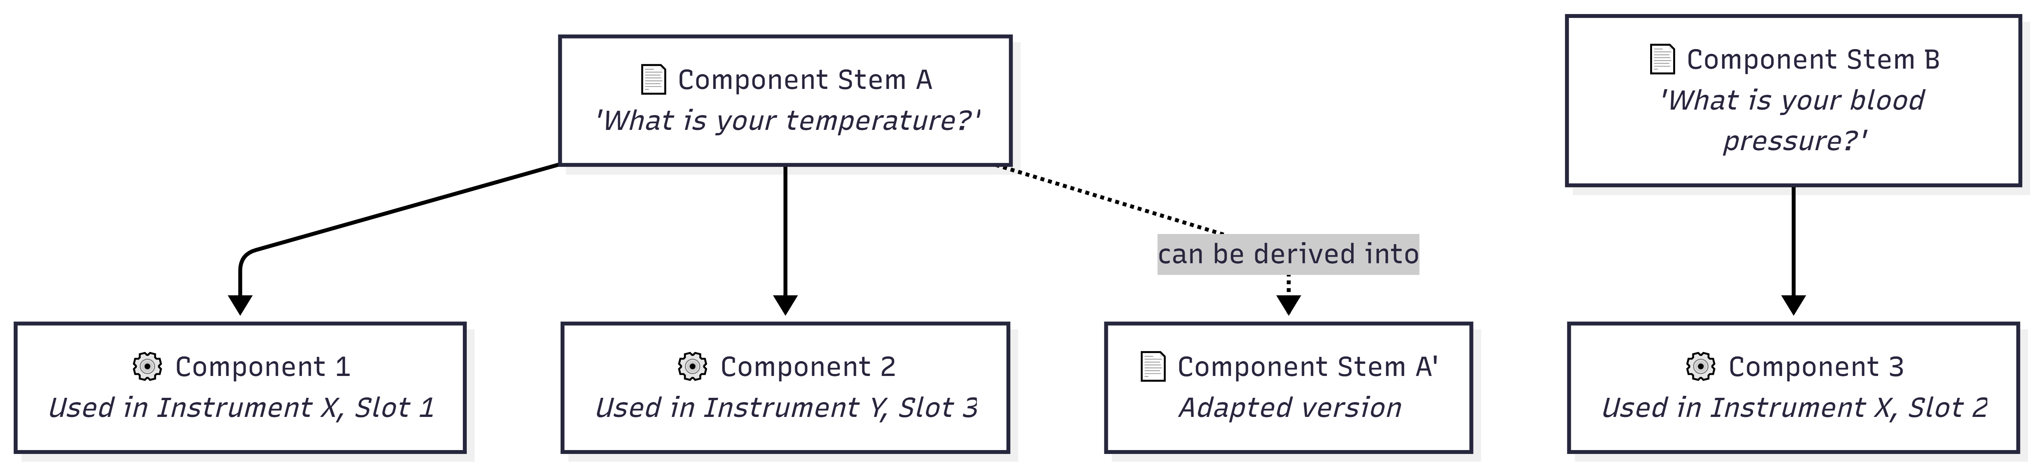
Diagram PNG: Relationship with other elements

A Component Stem can be used by multiple Components across different Instruments. This promotes reuse and consistency.

Note on historical terminology

⚠️ Updated ontology: The old term “DetectorStem” (prefix DSM) has been discontinued. Always use “ComponentStem” (prefix CST). If you encounter old entities with the DSM prefix, these reflect the previous naming convention and may need migration.

Accessing Component Stem Management

Navigation Path

Main Menu → Instrument Elements → Manage Elements → Manage Component Stems

Direct URL: https://www.pmsr.net/sir/select/componentstem/1/9

Detailed steps:
📋 Step 1. In the main navigation bar, click on “Instrument Elements”.
📋 Step 2. Hover over “Manage Elements”.
📋 Step 3. Click on “Manage Component Stems”.

The Management Page (List)

The page displays the list of Component Stems for which you are a user/author.

Available Filters
Filter | Description | Options
Text Filter | Keyword search in content/URI | Free text field
Language | Filter by language | All / English / Português / etc.
Status | Filter by state | All Status / Draft / Under Review / Current / Deprecated

Table Columns
Column | Description
URI | Unique identifier (clickable link)
Content | The text/content of the Stem (label)
Version | Version number
Status | Current state: Draft, Under Review, Current, Deprecated

Action Buttons
Button | Function | Description
Add New Component Stem | Creates an original Stem | Opens creation form
Derive New Component Stem | Creates a Stem derived from the selected one | Opens pre-filled form with reference to the source Stem
Edit Selected | Edits the selected Stem | Opens editing form
Delete Selected | Deletes the selected Stem | With confirmation
Send for Review | Submits for review | Only for Stems in Draft state

Note: The “Derive New Component Stem” button is exclusive to Component Stems. It allows creating variants based on existing Stems.

Creating a New Component Stem

Creation Sequence
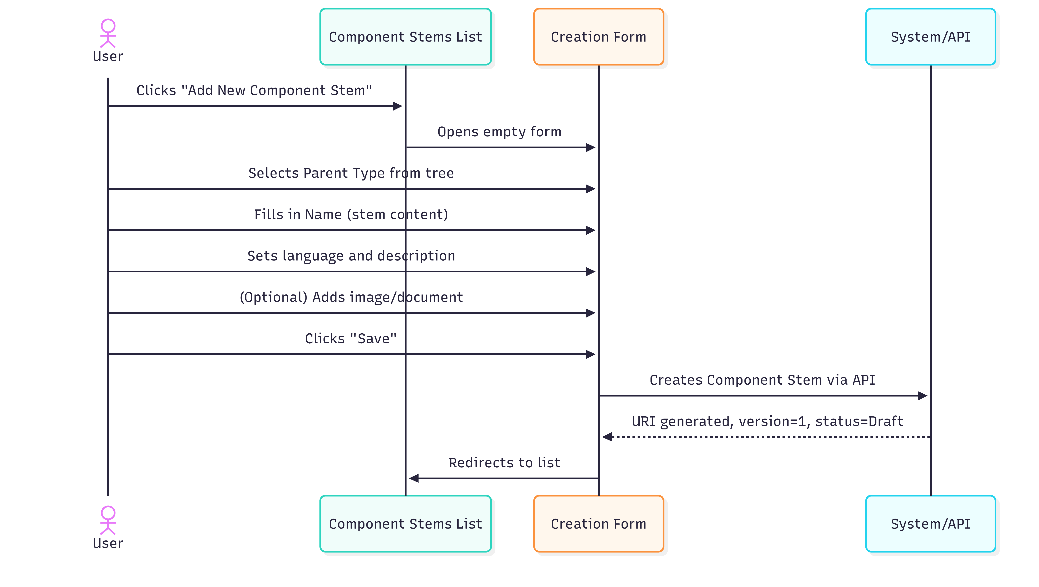
Diagram PNG: Creation Sequence

Detailed Steps
📋 Step 1. On the management page, click the “Add New Component Stem” button.
📋 Step 2. Fill in the form:

Creation Form Fields
Field | Type | Required | Detailed Description
Parent Type | Modal selection (tree) | Yes | Defines the Stem’s hierarchical type in the ontology. When clicked, a modal window (800px) opens with the Component Stems type tree. Select the most appropriate type for your content. By default, the root type is vstoi:ComponentStem.
Name | Text field | Yes | The textual content of the Component Stem. This is the text that will be reused by Components referencing this Stem. Example: “How often do you experience headaches?”, “Fluid inlet temperature (°C)”, “Lyophilization chamber pressure”.
Language | Selection list | Yes | Content language. Default: English (en). Select the language corresponding to the text in the Name field.
Version | Field (read-only) | Auto | Always starts at 1. Not editable.
Description | Text area | No | Additional description of the Stem: usage context, technical notes, scientific meaning, etc.
Was Generated By | Selection list | Yes | Indicates the Stem’s origin. For Stems created from scratch, select “ORIGINAL”. Other options indicate derivation methods (automatic, adaptation, etc.). Default: ORIGINAL.

Image Fields
Field | Type | Description
Image Type | Select | Choose between URL (external link) or Upload (upload file)
Image (URL) | Textfield | If URL: paste the full image address
Upload Image | File upload | If Upload: PNG, JPG, JPEG. Maximum 2 MB

Web Document Fields
Field | Type | Description
Web Document Type | Select | Choose between URL or Upload
Web Document (URL) | Textfield | If URL: paste the full address
Upload Document | File upload | If Upload: PDF, DOC, DOCX, TXT, XLS, XLSX. Maximum 2 MB
📋 Step 3. Click “Save” to create the Component Stem.
📋 Step 4. The system creates the Stem with: - URI automatically generated (prefix CST) - Version = 1 - Status = Draft - Was Generated By = ORIGINAL

Parent Type Selection (Tree Modal)

When clicking the Parent Type field, the modal opens with the hierarchical tree:

vstoi:ComponentStem
├── vstoi:QuestionStem
│ ├── vstoi:LikertQuestionStem
│ └── vstoi:OpenEndedQuestionStem
├── vstoi:SensorReadingStem
│ ├── vstoi:TemperatureStem
│ └── vstoi:PressureStem
└── ...

Click the desired type to select it. The field is populated and the modal closes.

Deriving a Component Stem
Derivation allows creating a new Component Stem based on an existing one, maintaining the reference to the source Stem. It is used when you want to create a variation (e.g., translation, adaptation, specialization).

When to derive?
- Adapt a question for a different context
- Translate a Stem to another language
- Specialize a generic Stem for a specific domain

Derivation Sequence
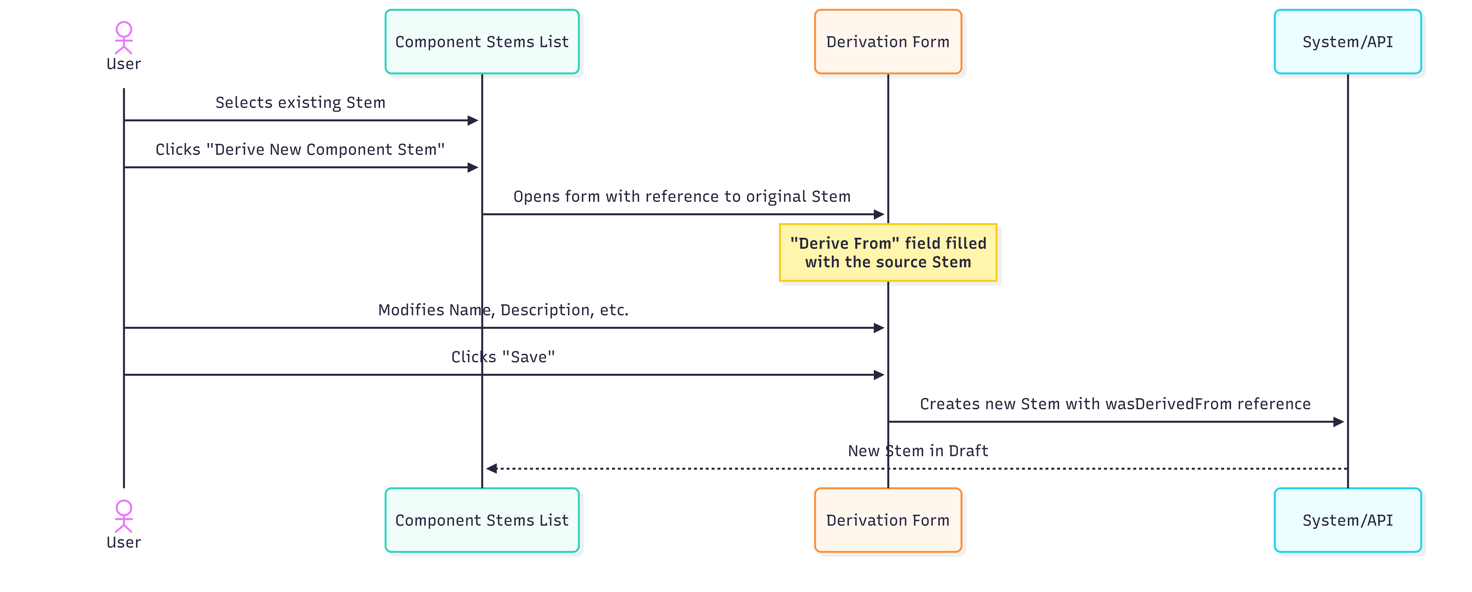
Diagram PNG: Derivation Sequence

Detailed Steps
📋 Step 1. In the Component Stems list, select the Stem that will serve as the base (radio button).
📋 Step 2. Click the “Derive New Component Stem” button.
📋 Step 3. The form opens with differences compared to the normal creation form:

Difference | Description
Type field label | Changes from “Parent Type” to “Derive From”
Reference to original | The field shows the selected source Stem
Was Generated By | The “ORIGINAL” option is removed. You must select the derivation method (e.g., DERIVED, ADAPTED, TRANSLATED).
📋 Step 4. Modify the fields as needed: - Change the Name to the new content - Adjust the Language if it is a translation - Update the Description to reflect the nature of the derivation - Select the method in Was Generated By (e.g., “DERIVED” for derivation, “ADAPTED” for adaptation)
📋 Step 5. Click “Save”.

The new Stem is created with a reference (wasDerivedFrom) to the original Stem, enabling traceability.

Derivation Diagram
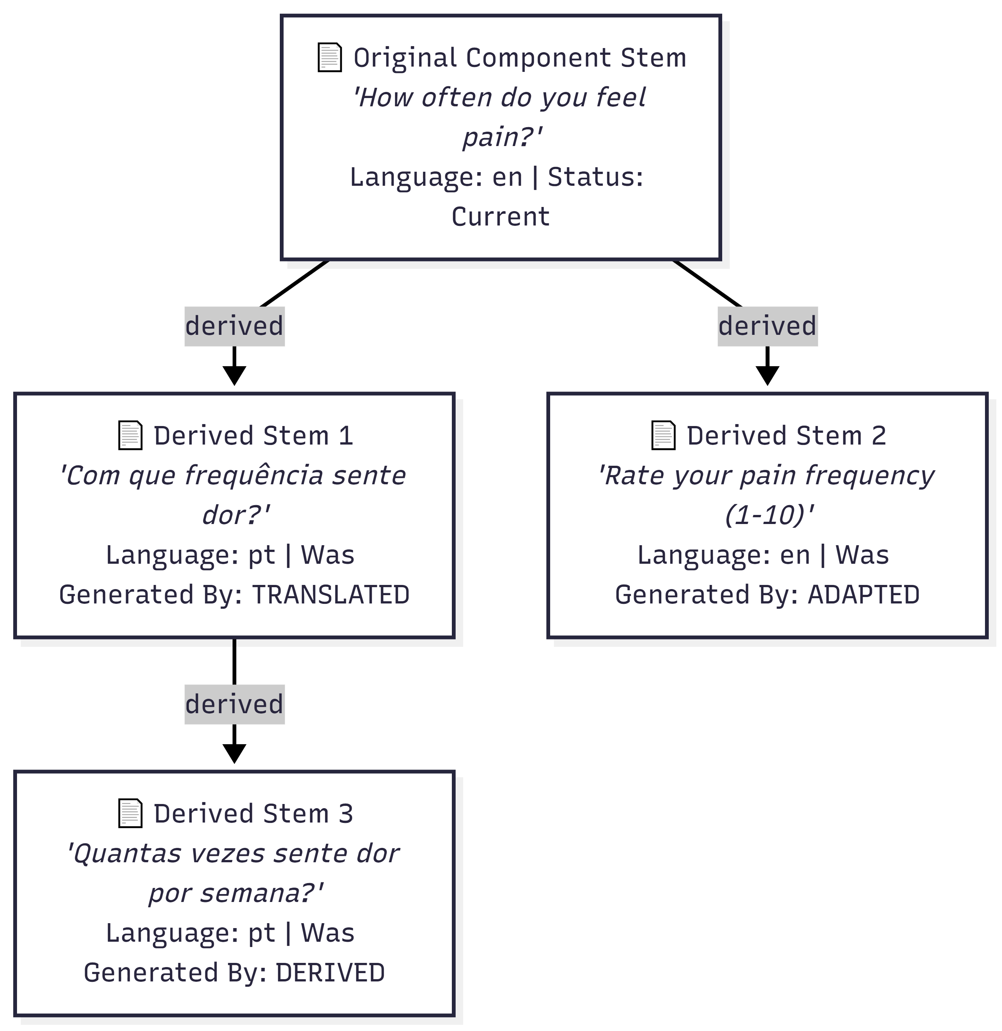
Diagram PNG: Derivation Diagram

Editing a Component Stem

How to access editing
📋 Step 1. In the Component Stems list, select the Stem to edit (radio button).
📋 Step 2. Click “Edit Selected”.

Editing Form
The editing form contains all the fields from the creation form, with additional elements:
Additional Element | Description
URI | Displayed as a read-only field (clickable link)
Version | If the state is Current or Deprecated, the version is automatically incremented
Derived From | If the Stem was derived, shows the source Stem URI with a “Check Element” button to view details
Review Notes | If previously reviewed, shows the Reviewer’s notes (read-only)
Reviewer Email | Email of the last Reviewer (read-only)

Editing Flow
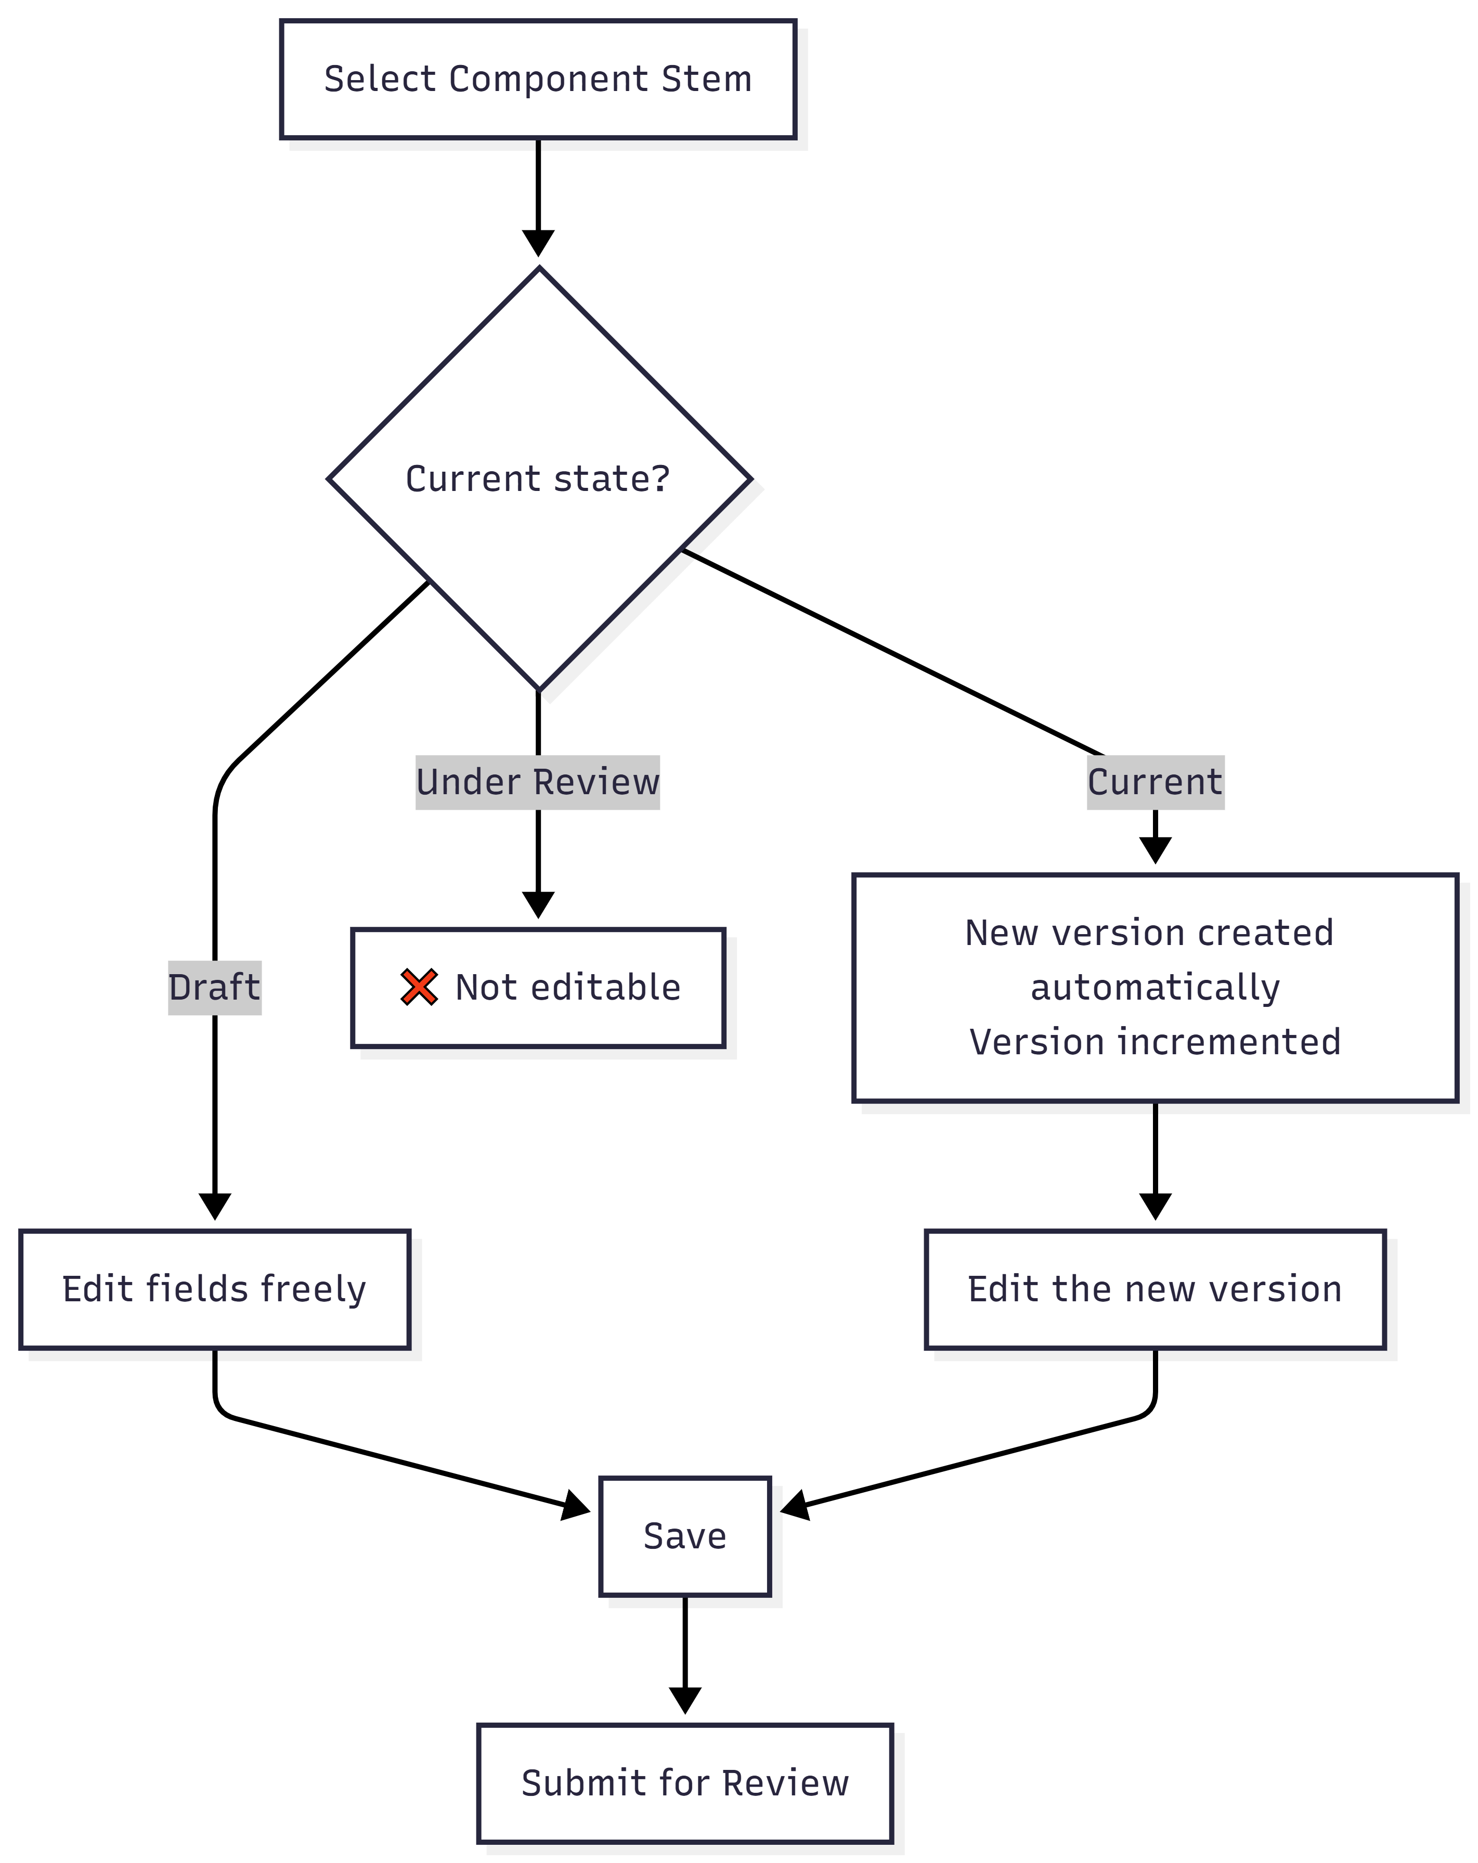
Diagram PNG: Editing Flow

⚠️ Editing a Current Stem: When editing a Component Stem with Current state, the system creates a new version in Draft with an incremented version number. The Current version remains until the new one is approved.

Submitting for Review

Steps
📋 Step 1. In the list, filter by Status: Draft.
📋 Step 2. Select the Component Stem to submit.
📋 Step 3. Click “Send for Review”.
📋 Step 4. Confirm in the dialog box: “Are you sure you want to submit for Review selected entry?”
📋 Step 5. The state changes to Under Review.
Note: Unlike Instruments, submitting a Component Stem is individual - it does not affect other elements.
ℹ️ Note on permissions: Submitting for review can be done by the element’s author (authenticated user). Approval or rejection requires the Content Editor (Reviewer) permission.

The Review Process (Reviewer’s Perspective)

⚠️ Required permission: This section describes actions available only to users with the Content Editor (Reviewer) role. It is included so you understand the full review workflow.

Accessing Component Stem Review

Main Menu → Instrument Elements → Review Elements → Review Component Stems

Review Form

The Reviewer sees the Component Stem in read-only mode, with:
- Vertical Tabs with: Type, Name, Language, Version, Description
- Derived From (if applicable): link to the source Stem + “Check Element” button
- Was Derived By: derivation/generation method
- Review Section: Review Notes + Reviewer Email

Reviewer Actions
Action | Button | Notes Required? | Result
Approve | Approve | No | State → Current. The Stem becomes available for use in Components.
Reject | Reject | Yes | State → Draft. The author receives the notes with the reason for rejection.

What the Reviewer should verify
Aspect | What to evaluate
Content (Name) | Is the text clear, grammatically correct, and appropriate for the context?
Type (Parent Type) | Is the hierarchical type correct in the ontology?
Language | Does the selected language match the content?
Derivation | If derived, is the reference to the original valid? Is the derivation justified?
Description | Is the description sufficiently detailed?

Lifecycle and Versioning

State Diagram
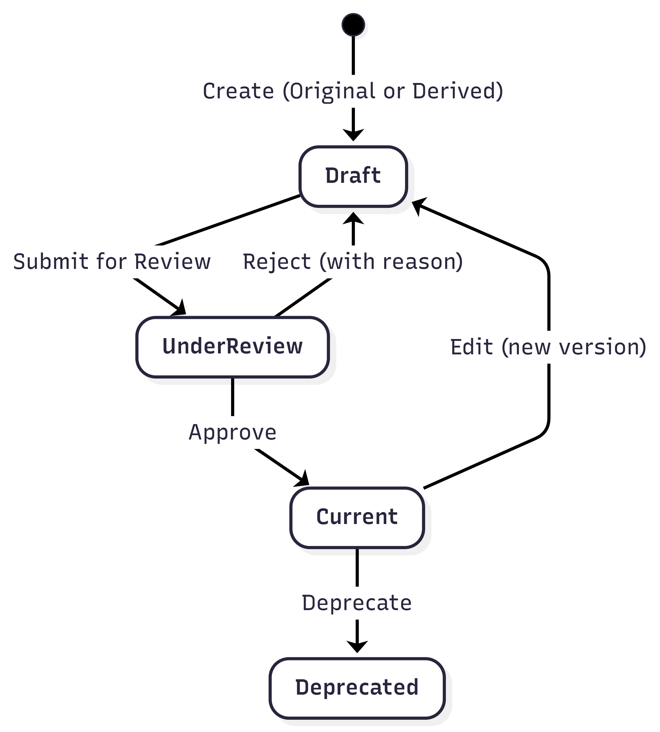
Diagram PNG: State Diagram

Impact on Dependent Components

⚠️ Warning: Changing or deprecating a Component Stem may impact all Components that reference it. Before deprecating a Stem, check whether there are active Components using it.
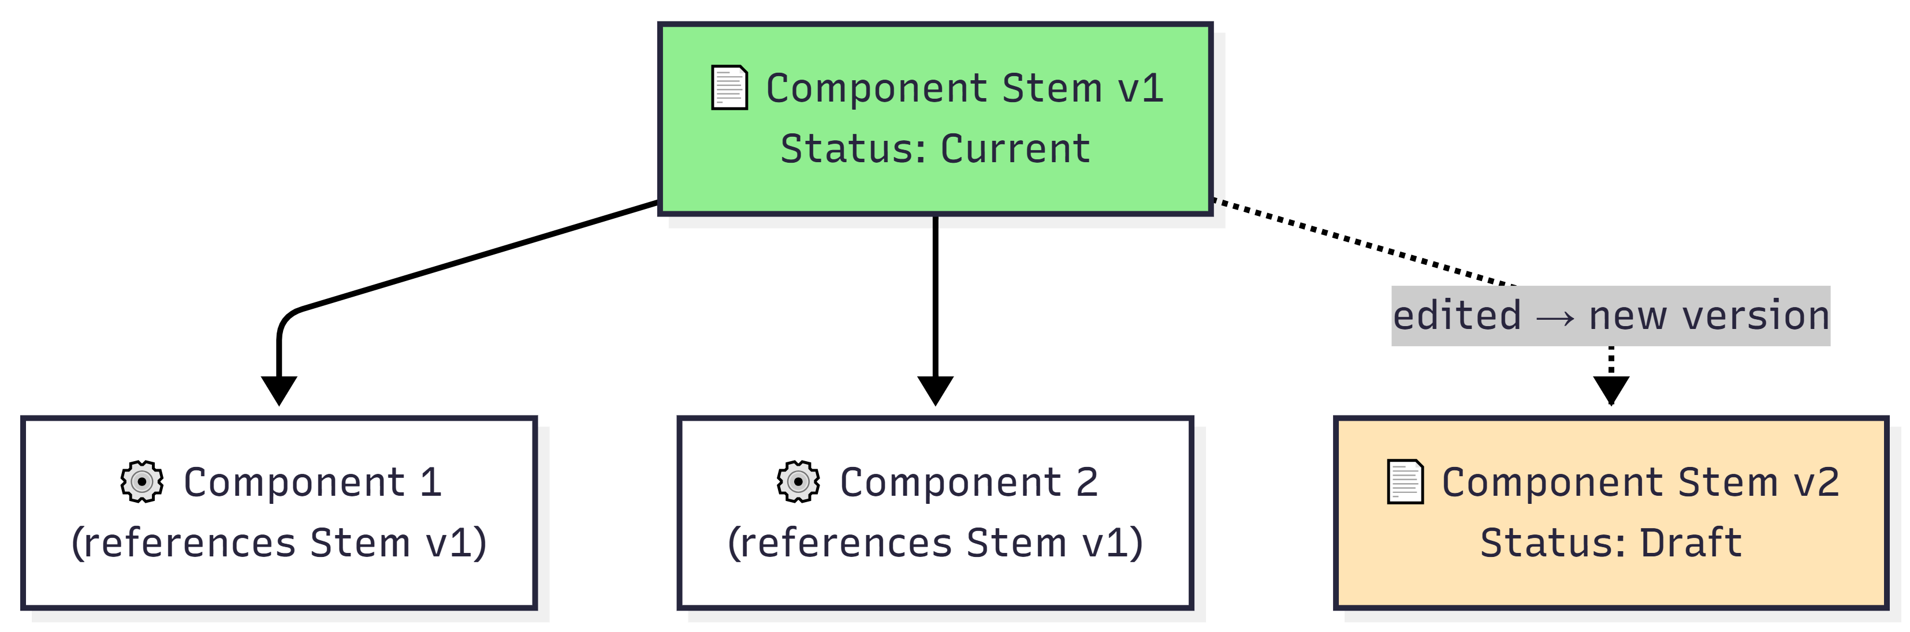
Diagram PNG: Impact on Dependent Components

Field Reference

Complete Table - Creation Form
Field | Technical Name | Type | Required | Default Value | Description
Parent Type | componentstem_type | Modal textfield | Yes | (empty) | Type in the ontology, selected via modal tree
Name | componentstem_content | Textfield | Yes | (empty) | Textual content of the Stem
Language | componentstem_language | Select | Yes | en | Content language
Version | componentstem_version | Hidden / Textfield (disabled) | Auto | 1 | Numeric version
Description | componentstem_description | Textarea | No | (empty) | Detailed description
Was Generated By | componentstem_was_generated_by | Select | Yes | ORIGINAL | Creation/derivation method
Image Type | componentstem_image_type | Select | No | (empty) | URL or Upload
Image URL | componentstem_image_url | Textfield | Conditional | (empty) | Image URL (if URL type)
Image Upload | componentstem_image_upload | Managed file | Conditional | (empty) | File (PNG/JPG/JPEG, max 2MB)
Web Doc Type | componentstem_webdocument_type | Select | No | (empty) | URL or Upload
Web Doc URL | componentstem_webdocument_url | Textfield | Conditional | (empty) | Document URL (if URL type)
Web Doc Upload | componentstem_webdocument_upload | Managed file | Conditional | (empty) | File (PDF/DOC/DOCX/TXT/XLS/XLSX, max 2MB)

Additional Editing Fields
Field | Technical Name | Type | Description
URI | componentstem_uri | Item (read-only) | Clickable link to the description page
Derived From | (display) | Markup + Button | Source Stem URI + “Check Element” button
Review Notes | componentstem_hasreviewnote | Textarea (read-only) | Reviewer’s notes (if any)
Reviewer Email | componentstem_haseditoremail | Textfield (read-only) | Last Reviewer’s email

“Was Generated By” Field Options
Option | Description | When to use
ORIGINAL | Stem created from scratch | Direct creation (not based on another Stem)
DERIVED | Derived from another Stem | Variation or evolution of an existing Stem
ADAPTED | Adapted from another Stem | Adaptation for a different context
TRANSLATED | Translated from another Stem | Translation to another language
Note: When using the derivation form (via the “Derive New” button), the ORIGINAL option is automatically removed, since the Stem is being derived.

Troubleshooting
Problem | Possible Cause | Solution
I cannot find the Stem I need to create a Component | The Stem may not exist or may be in another language | Create a new Stem or use “Derive” to create an adapted version
The “Derive” button is disabled | No Stem is selected in the list | Select a Stem by clicking the radio button before clicking “Derive”
The “Was Generated By” field does not show “ORIGINAL” | You are using the derivation form | Expected behavior for derivations. Use “Add New” to create original Stems.
The version incremented on its own | You edited a Stem with Current state | Expected behavior - new Draft version created automatically
The Stem was rejected in review | The Reviewer found issues | Open the editing form and check the Review Notes to see the reason

🔗 Internal Navigation: Components • Instruments / Simulators • Internal Table of Contents

4. Components
Module: SIR (Semantic Instrument Repository)
PMSR Context: Components represent the functional elements of a Simulator (detectors, actuators, questions, etc.)

Overview
A Component is a logical instance of a Component Stem - the concrete materialization of a template in a specific context. Components are the “functional building blocks” that make up Instruments/Simulators, being associated with Container Slots (including slots inside sub-containers) within those instruments.
In the PMSR context, Components can represent: - Detectors - sensors or questions that collect data (inputs) - Actuators - elements that produce actions or outputs - Questionnaire questions - assessment items - Measurements - data collection points
📘 Stem vs. Component: A Component Stem (Manual 02) is the reusable template (the “recipe”). A Component is a logical instance of that template, associated with a specific slot within an Instrument/Simulator. When you place a Component Stem into an instrument’s slot, a Component is created. Think of the Stem as the mold and the Component as the piece placed in the right position of the machine.

Relationship Diagram

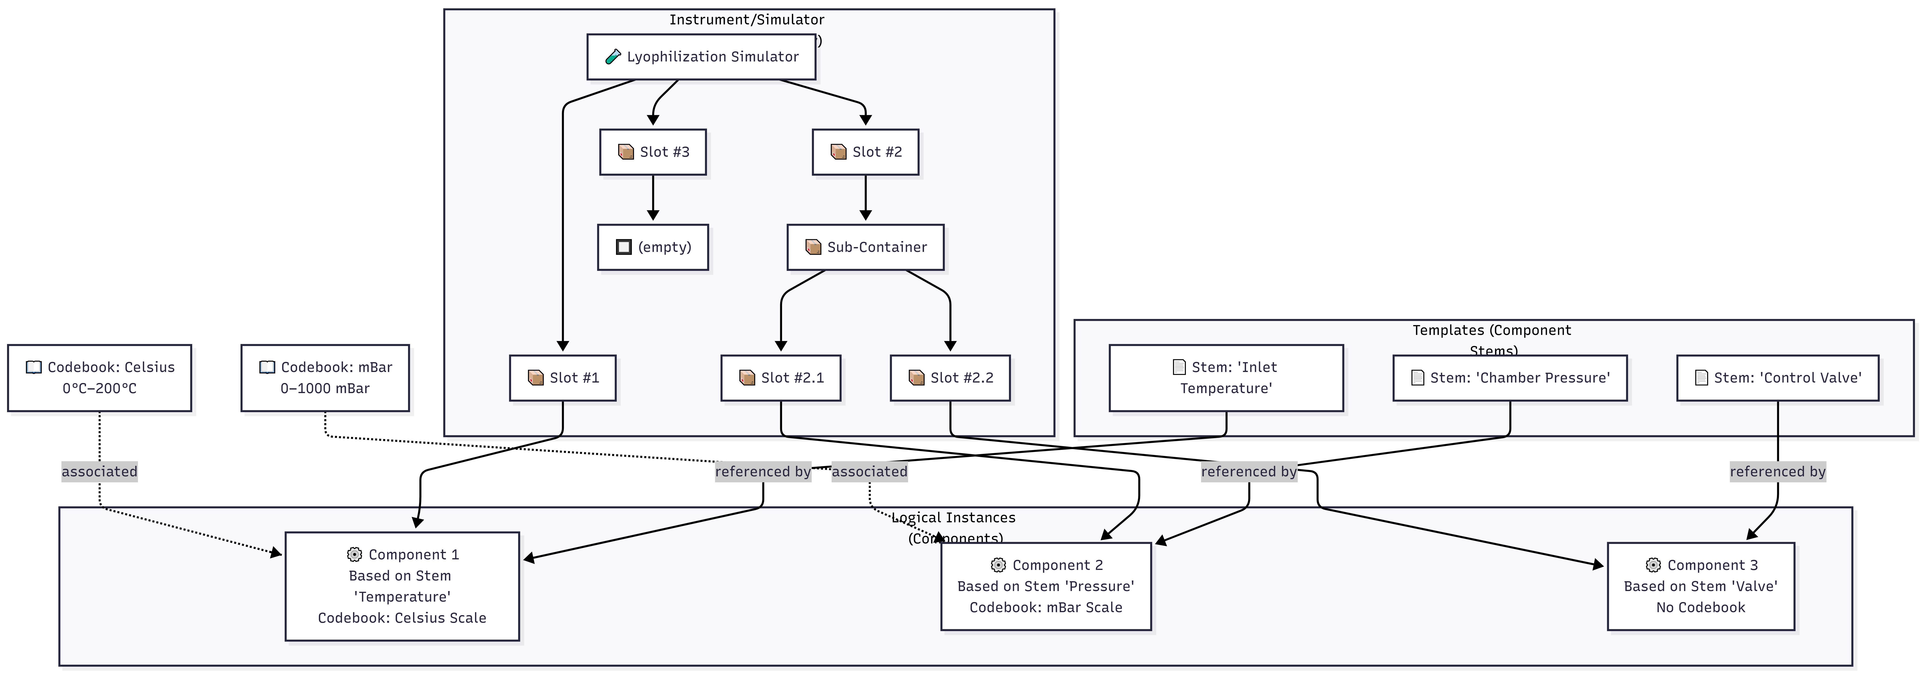
Diagram PNG: Relationship Diagram

What is a Component?

Definition
A Component is an entity that: - Mandatorily references a Component Stem (its template) - May have an associated Codebook (response/value scheme) - Is associated with a Container Slot (at any hierarchy level) within an Instrument/Simulator - Follows the review workflow (Draft → Under Review → Current) - Has automatic versioning

Difference Between Component Stem and Component
Aspect | Component Stem | Component
Nature | Reusable template | Concrete instance
Content | Defines the “base text” (question, description) | Inherits content from the Stem
Reusability | Can be used by multiple Components | Belongs to a specific context
Codebook | Does not have a Codebook | May have an associated Codebook
Slot | Not associated with slots | Associated with a slot in an Instrument or sub-container

Prerequisites
Before creating a Component, make sure that:
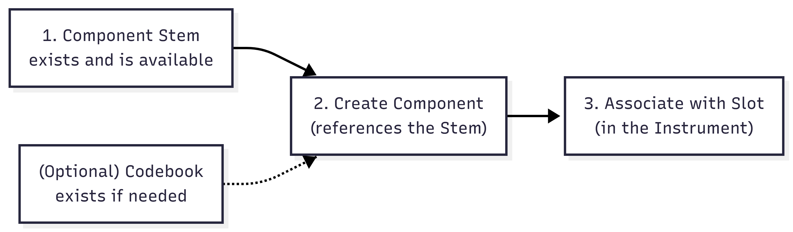
Diagram PNG: 3. Prerequisites

Prerequisite | Required? | Where to create?
Component Stem | Yes | 🔗 Section 3 - Component Stems
Codebook | No | Instrument Elements → Manage Elements → Manage Codebooks
Instrument/Simulator (for slot association) | For association | 🔗 Section 2 - Instruments / Simulators

⚠️ If you cannot find a suitable Component Stem, you must create it first. Refer to 🔗 Section 3 - Component Stems and then return to this section.

Accessing Component Management

Navigation Path

Main Menu → Instrument Elements → Manage Elements → Manage Component

Direct URL: https://www.pmsr.net/sir/select/component/1/9

Steps:
📋 Step 1. In the navigation bar, click on “Instrument Elements”.
📋 Step 2. Hover over “Manage Elements”.
📋 Step 3. Click on “Manage Component”.

The Management Page (List)

Available Filters
Filter | Description | Options
Text Filter | Search by content or URI | Free text field
Language | Filter by language | All / English / etc.
Status | Filter by state | All Status / Draft / Under Review / Current / Deprecated

Table Columns
Column | Description
URI | Unique identifier (clickable link to the description page)
Content | Component content/label (inherited from the Stem)
Version | Version number
Codebook | Associated Codebook (if any) - clickable label
Attribute Of | “Attribute Of” reference (if configured)
Status | State: Draft, Under Review, Current, Deprecated

Action Buttons
Button | Function | Condition
Add New Component | Creates a new Component | Always available
Edit Selected | Edits the selected Component | Requires selection
Delete Selected | Deletes the selected Component | With confirmation
Send for Review | Submits for review | Only for Draft state

Creating a New Component

Complete Creation Sequence
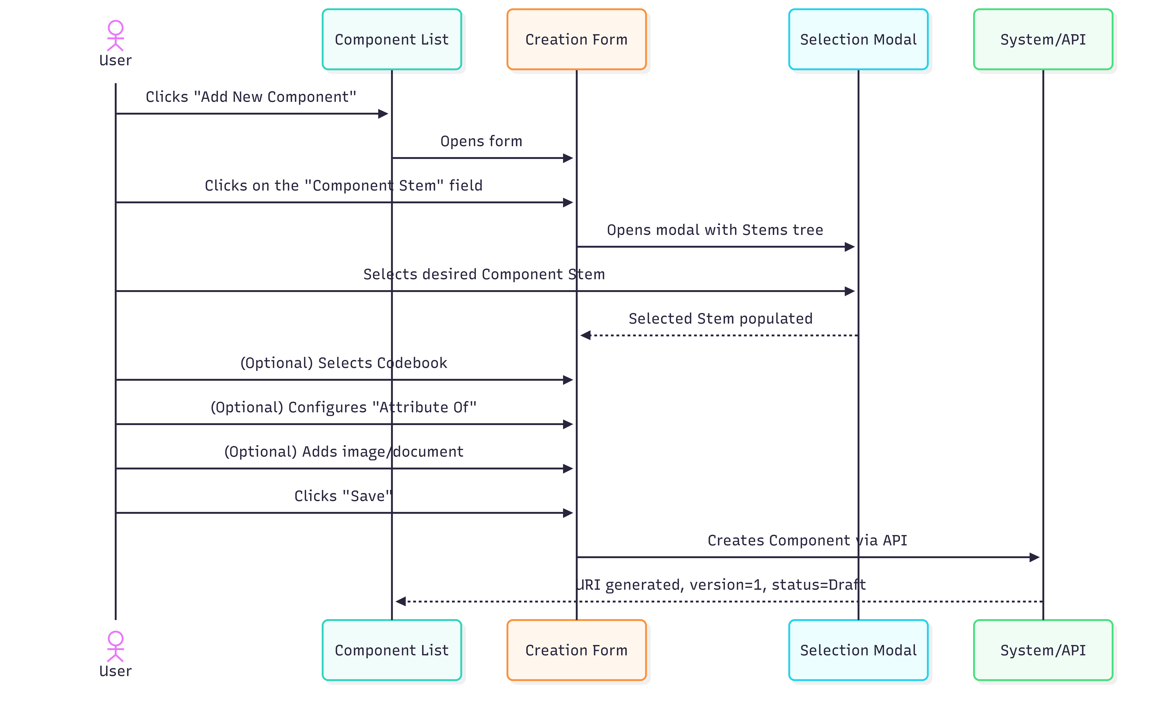
Diagram PNG: Complete Creation Sequence

Detailed Steps

📋 Step 1. On the management page, click on “Add New Component”.
📋 Step 2. Fill in the form:

Creation Form Fields
Field | Type | Required | Detailed Description
Component Stem | Modal selection (tree) | Yes | The base template for this Component. Click on the field to open the modal with the tree of available Component Stems. Select the Stem that best matches the function of this Component. If you cannot find a suitable Stem, close the form and create it first (🔗 Section 3 - Component Stems).
Codebook | Autocomplete field | No | Response/value scheme associated with the Component. Start typing the Codebook name and select from the suggestion list. E.g.: “5-point Likert Scale”, “Celsius Scale 0-200”. Leave blank if the component does not require coded responses.
Maker | Autocomplete field | No | Manufacturer organization.
Version | Hidden (automatic) | Auto | Starts at 1.
Attribute Of | Modal selection (tree) | No | Optional: allows linking this Component as an attribute of another Component. Used to create measurement hierarchies (e.g., a sub-indicator belongs to a main indicator).

Image Fields
Field | Type | Description
Image Type | Select | URL or Upload
Image (URL) | Textfield | Full image address (if URL)
Upload Image | File upload | PNG, JPG, JPEG. Maximum 2 MB

Web Document Fields
Field | Type | Description
Web Document Type | Select | URL or Upload
Web Document (URL) | Textfield | Document address (if URL)
Upload Document | File upload | PDF, DOC, DOCX, TXT, XLS, XLSX. Maximum 2 MB
📋 Step 3. Click on “Save”.
📋 Step 4. The Component is created with: - URI generated automatically - Status = Draft - Version = 1

Component Stem Selection (Modal)
When clicking on the Component Stem field, a modal (800px) opens with the hierarchical Stem tree:

vstoi:ComponentStem
├── vstoi:QuestionStem
│ ├── "How often do you...?"
│ ├── "Rate on a scale of 1 to 5..."
│ └── ...
├── vstoi:SensorReadingStem
│ ├── "Inlet temperature"
│ ├── "Chamber pressure"
│ └── ...
└── ...

Click on the desired Stem to select it. The field is populated automatically.

Codebook Selection (Autocomplete)

In the Codebook field, start typing the Codebook name:

Codebook: [Likert Sc...]
├── 5-point Likert Scale (pmsr:/CB001)
├── 7-point Likert Scale (pmsr:/CB002)
└── Likert Frequency (pmsr:/CB003)

Select the desired Codebook from the suggestion list. Each suggestion format includes the name and URI for clear identification.

Associating a Component with a Slot (Container Slot)
After creating a Component, it needs to be associated with a Container Slot within an Instrument/Simulator to become functional. This association can happen at the root instrument level or inside nested sub-containers.

Association Methods
There are two paths to associate a Component with a Slot:

Method 1: From the Instrument (Recommended)

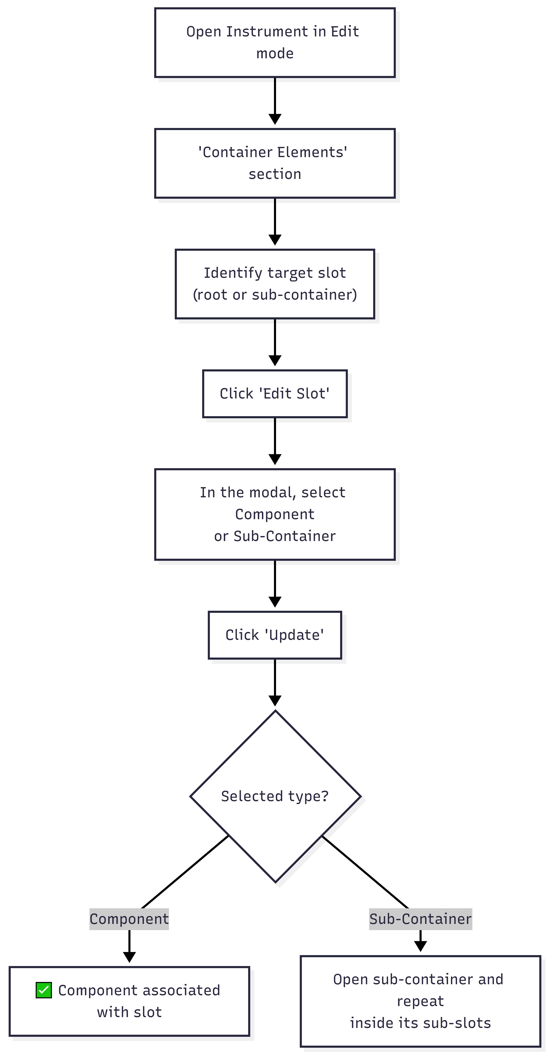
Diagram PNG: Association Methods
📋 Step 1. Navigate to the Instrument editing page (🔗 see Section 2 - Instruments / Simulators, section 5).
📋 Step 2. In the “Container Elements” section, identify the slot to which you want to associate the Component.
📋 Step 3. Click the slot edit button (“Edit Slot” or pencil icon).
📋 Step 4. In the slot edit form, click on the “Component” field to open the selection modal.
📋 Step 5. Select the desired Component from the tree.
📋 Step 6. Click “Update” to confirm the association.

Method 2: Create Component Directly in the Slot
📋 Step 1. In the Slot edit form, instead of selecting an existing Component, click on “New Item”.
📋 Step 2. The system redirects to the Component creation form, already pre-configured for association with this slot.
📋 Step 3. Fill in the Component fields (as in section 6).
📋 Step 4. Upon saving, the Component is created AND automatically associated with the slot.

Container Slot Edit Form
Field | Type | Description
Slot URI | Text (read-only) | Slot identifier
Priority | Text (read-only) | Slot order/priority within the Instrument
Component | Modal (tree) | Associated Component - click to select

Button | Function
New Item | Creates a new Component and associates it with this slot
Reset this Item | Removes the Component from the slot (slot becomes empty)
Update | Saves the association (active only with a Component selected)
Cancel | Closes without changes

⚠️ Recursive structure: The edited slot can belong to the main container or to a sub-container. The hierarchy can be nested across multiple levels.

Complete Structure Visualization
After associating Components with Slots, the “Container Elements” section of the Instrument shows:
📦 Container Elements of the Lyophilization Simulator
│
├── Slot #1 (Priority: 1)
│ └── ⚙️ Component: "Inlet Temperature" (Stem: 'Inlet Temp.', Codebook: Celsius)
│ [Edit Component] [Remove from Slot]
│
├── Slot #2 (Priority: 2)
│ └── 📦 Sub-Container: "Pressure Measurements"
│ ├── Slot #2.1 (Priority: 1)
│ │ └── ⚙️ Component: "Chamber Pressure" (Stem: 'Chamber Pressure', Codebook: mBar)
│ │ [Edit Component] [Remove from Slot]
│ └── Slot #2.2 (Priority: 2)
│ └── 📦 Sub-Container: "Fine Control"
│ └── Slot #2.2.1 (Priority: 1)
│ └── ⚙️ Component: "Pillow Pressure" [Edit Component] [Remove from Slot]
│
├── Slot #3 (Priority: 3)
│ └── 🔲 (empty)
│ [Add Component or Sub-Container] [Edit Slot]
│
└── [+ Add More Slots]

Understanding Detectors and Actuators
In the context of PMSR and the VSTOI ontology, Components can assume different roles depending on their hierarchical type (defined by the Component Stem):

Detectors
What they are: Components that function as sensors, inputs, or data collectors. They capture information from the environment or from the user.
PMSR Examples | Description
Temperature Sensor | Collects the inlet fluid temperature
Questionnaire Question | Collects the participant’s response
Pressure Sensor | Measures the chamber pressure
Input Field | Receives numerical data from the operator

Actuators
What they are: Components that function as action, output, or control elements. They produce effects on the system or the environment.
PMSR Examples | Description
Control Valve | Controls fluid flow
Result Display | Presents calculated results
Threshold Alert | Triggers a notification when a value exceeds a limit
Mechanical Actuator | Activates a physical component of the simulator

How is the Classification Done?
The classification as Detector or Actuator is determined by the Component Stem selected, which belongs to a specific branch of the ontology:
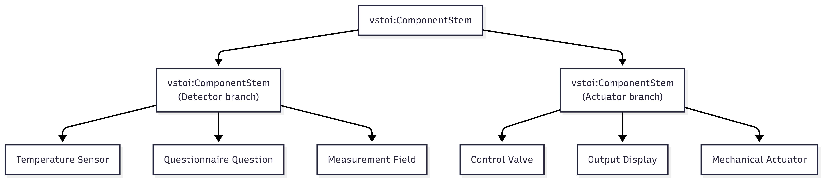
Diagram PNG: How is the Classification Done?

In practice: When creating a Component, the classification as Detector or Actuator is implicit - it depends on the selected Component Stem. Choose the correct Stem and the classification will be automatic.
Note: The current system interface does not explicitly display “Detector” or “Actuator” as labels in the forms. The distinction is made at the ontology level and is visible in the type hierarchy when selecting the Component Stem in the tree modal.

Editing a Component

How to Access
📋 Step 1. In the Component list, select the Component to edit.
📋 Step 2. Click on “Edit Selected”.

Edit Form
The form includes all creation fields, with additions:
Additional Element | Description
URI | Read-only link to the description page
Component Stem | Editable via modal - the associated Stem can be changed
Codebook | Shows label + URI of the current Codebook; editable
Version | Automatically incremented if state is Current/Deprecated
Review Notes | Reviewer’s notes (read-only, if any)
Reviewer Email | Reviewer’s email (read-only)

Edit Flow
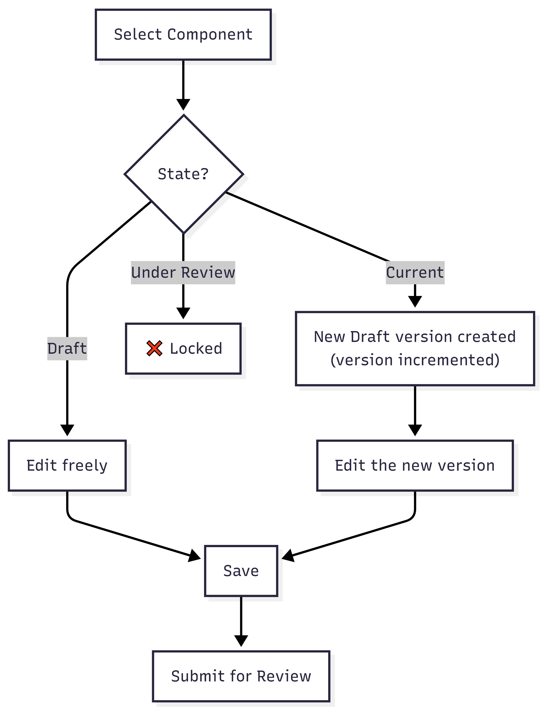
Diagram PNG: Edit Flow

Submitting for Review

Steps
📋 Step 1. In the Component list, filter by Status: Draft.
📋 Step 2. Select the Component to submit.
📋 Step 3. Click on “Send for Review”.
📋 Step 4. Confirm: “Are you sure you want to submit for Review selected entry?”
📋 Step 5. The state changes to Under Review.
Note: Components can also be submitted automatically when the Instrument containing them is submitted for review (recursive submission). See 🔗 Section 2 - Instruments / Simulators, section 7.
ℹ️ Note on permissions: Submitting for review can be done by the element’s author (authenticated user). Approval or rejection requires the Content Editor (Reviewer) permission.

The Review Process (Reviewer’s Perspective)

⚠️ Required permission: This section describes actions available only to users with the Content Editor (Reviewer) role. It is included so you understand the full review workflow.

Accessing the Review

Main Menu → Instrument Elements → Review Elements → Review Components

Review Form
The Reviewer sees the Component in read-only mode:
- Component Details: Associated Stem, Codebook, Attribute Of, version
- Reference links: Clickable links to the associated Stem and Codebook
- Review Section: Review Notes and Reviewer Email

Reviewer Actions
Action | Button | Notes Required? | Result
Approve | Approve | No | State → Current
Reject | Reject | Yes | State → Draft + reason notes

What the Reviewer Should Verify
Aspect | What to Evaluate
Component Stem | Is the selected Stem appropriate? Is it in Current state?
Codebook | Is the associated Codebook correct for this type of Component?
Attribute Of | Does the attribute relationship make sense in context?
Completeness | Are all necessary fields filled in?

⚠️ Recursive Instrument rejection: If a Reviewer rejects an Instrument, all associated Components are automatically rejected as well. The Instrument’s rejection notes are propagated.

Lifecycle and Versioning
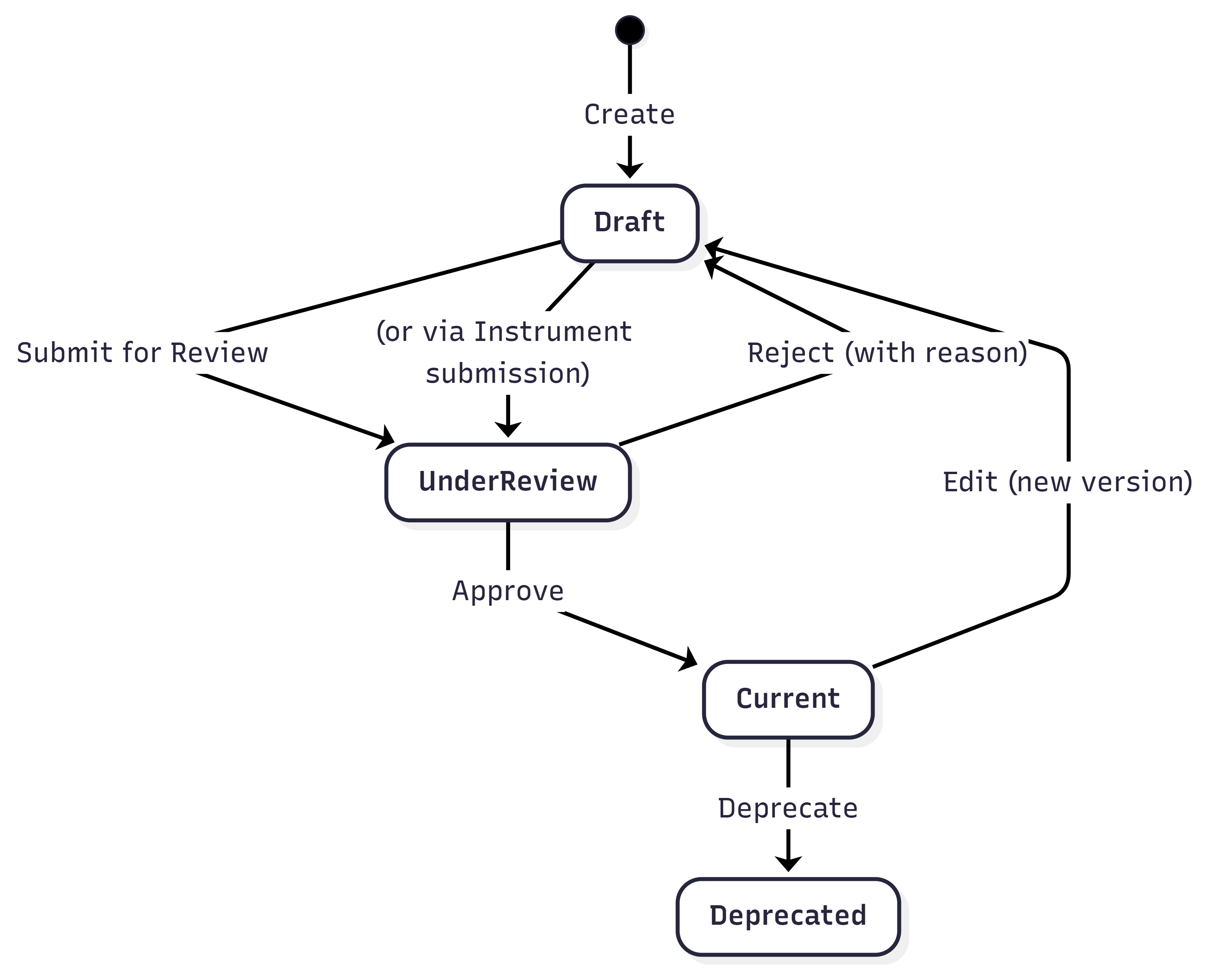
Diagram PNG: 12. Lifecycle and Versioning

Relationship with the Instrument Lifecycle

Diagram PNG: Relationship with the Instrument Lifecycle

Field Reference

Complete Table - Creation Form
Field | Technical Name | Type | Required | Default Value | Description
Component Stem | component_stem | Modal textfield | Yes | (empty) | Base template selected via modal tree
Codebook | component_codebook | Textfield + autocomplete | No | (empty) | Response/value scheme
Maker | component_maker | Textfield + autocomplete | No | (empty) | Manufacturer organization
Version | component_version | Hidden | Auto | 1 | Numeric version
Attribute Of | component_isAttributeOf | Modal textfield | No | (empty) | Parent component (attribute hierarchy)
Image Type | component_image_type | Select | No | (empty) | URL or Upload
Image URL | component_image_url | Textfield | Conditional | (empty) | Image URL
Image Upload | component_image_upload | Managed file | Conditional | (empty) | PNG/JPG/JPEG, max 2MB
Web Doc Type | component_webdocument_type | Select | No | (empty) | URL or Upload
Web Doc URL | component_webdocument_url | Textfield | Conditional | (empty) | Document URL
Web Doc Upload | component_webdocument_upload | Managed file | Conditional | (empty) | PDF/DOC/DOCX/TXT/XLS/XLSX, max 2MB

Route Parameters (Contextual)
Parameter | Encoding | Description
{sourcecomponenturi} | Base64 | Source Component URI (for derivation)
{containersloturi} | Base64 | Destination slot URI (for direct association)

Troubleshooting
Problem | Possible Cause | Solution
I cannot find the Component Stem I need | The Stem may not exist | Create it first: 🔗 Section 3 - Component Stems
The Codebook field does not show suggestions | No Codebooks have been created or the search term does not match | Check in Manage Codebooks whether Codebooks exist. Create one if needed.
I cannot associate the Component with the Slot | The slot may already be occupied or the Component is not correctly selected | Use “Reset this Item” on the slot to free it, then select again
The Component was rejected | Individual or recursive rejection (via Instrument) | Check the Review Notes in the edit form
“Attribute Of” - I don’t know what to select | Optional field for measurement hierarchies | Leave blank unless the Component is a sub-attribute of another one
The “Update” button on the slot is disabled | No Component was selected in the modal | Open the Component field modal and select an item

🔗 Internal Navigation: Component Stems • Instruments / Simulators • Instrument / Simulator Instances • Internal Table of Contents

5. Instrument / Simulator Instances
Module: DPL (Deployment)
PMSR Context: Instances represent physical/concrete units of a Simulator

Overview
An Instrument Instance (or Simulator Instance in PMSR) represents a physical or concrete unit of a previously defined and approved Instrument/Simulator. While the Instrument is the “definition” (the design), the Instance is a “real copy” of that design - a specific piece of equipment, with a serial number, acquisition date, owner, etc.

Analogy
Concept | Analogy
Instrument/Simulator | The model of a car (e.g., Toyota Corolla 2026)
Instrument Instance | A specific car of that model (e.g., license plate AA-00-BB, purchased on 03/15/2026)

Position in the General Flow
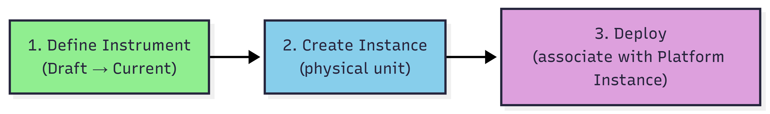
Diagram PNG: Position in the General Flow

Important note: Instrument Instances do not follow the review flow (Draft → Under Review → Current). They are created directly as operational records. The review flow applies only to the definition of the Instrument/Simulator.
📘 Why create Instances?
In Manual 01, you created an Instrument/Simulator - this is the model (definition/design), which describes the structure, slots, and components. It’s like the engineering blueprint for a machine.
An Instance is a concrete physical unit of that model. Each real machine in your laboratory is an instance: - The model “Lyophilization Simulator LF-2000” is defined once, approved once. - But you may have 3 physical machines of that model: #SN-001 in Room 101, #SN-002 in Room 205, #SN-003 on the production line.
Each instance has its own serial number, owner, and can be deployed (associated with a specific laboratory for operation).
Analogy: The model is like a car model (e.g., “Toyota Corolla 2025”). The instance is the specific car you bought, with its own license plate and mileage.

What is an Instrument/Simulator Instance?
An Instance contains: - Reference to the source Instrument/Simulator (the type/design) - Identification number (serial number / ID) - Acquisition date - Owner (organization) - Maintenance responsible (person) - Status (operational or damaged) - Additional description

Relationship with Deployments
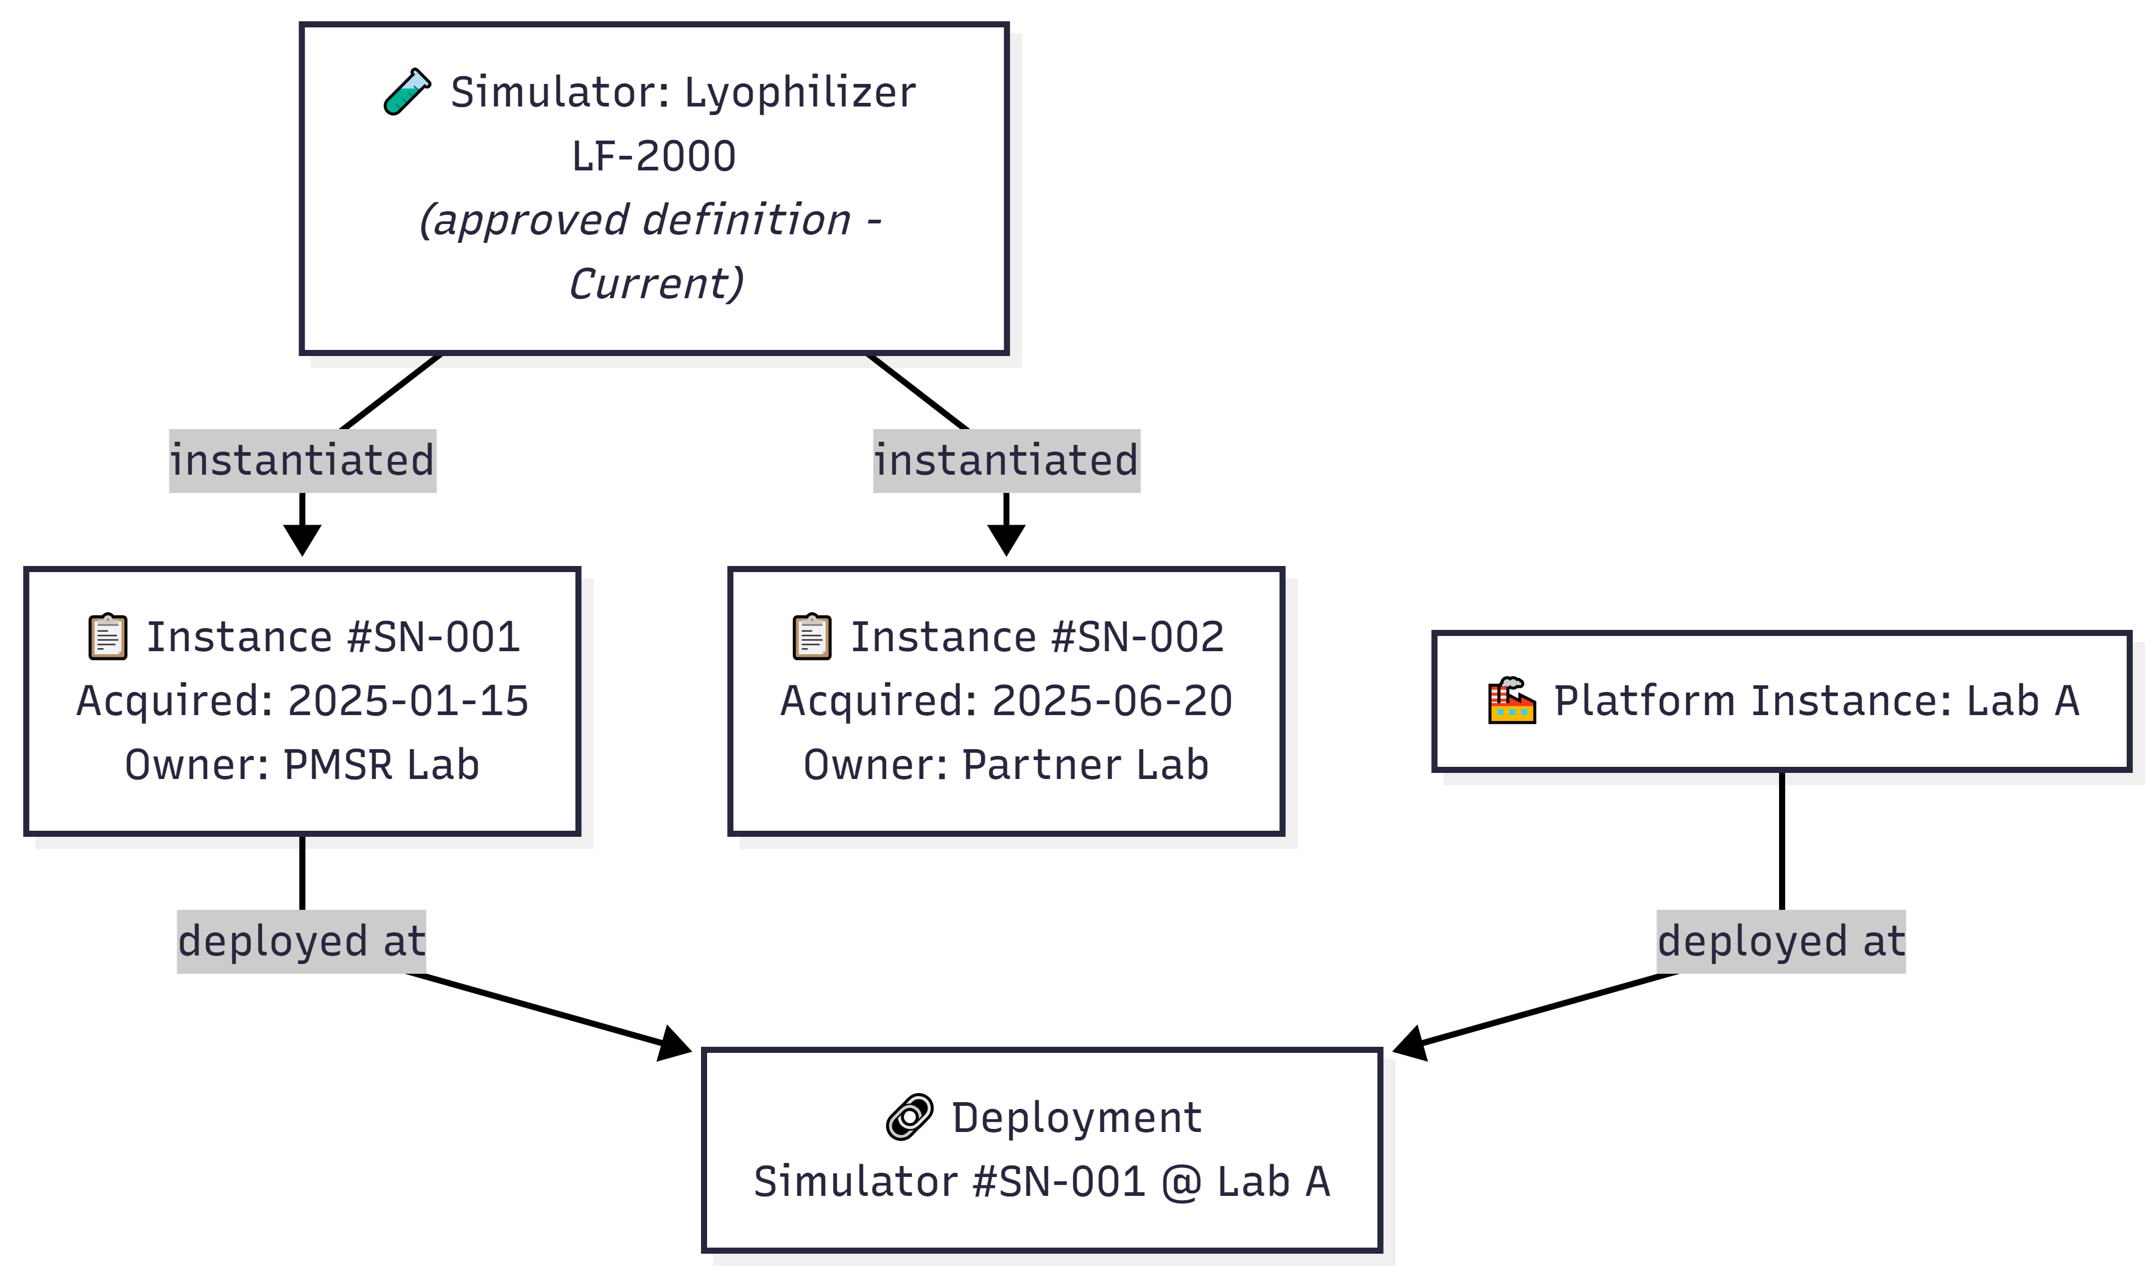
Diagram PNG: Relationship with Deployments

Prerequisites
Prerequisite | Required? | Description
Instrument/Simulator in Current state | Yes | You can only instantiate Instruments that have been approved (Current state). See 🔗 Section 2 - Instruments / Simulators
Platform Instance | For deploy | Only required if you want to create a Deployment. See 🔗 Section 7 - Platform / Laboratory Instances

Accessing Instance Management

Navigation Path

Main Menu → Deployment Elements → Manage Elements → Manage Instrument Instances

PMSR Note: The menu may show “Manage Simulator Instances” depending on the Preferred Names configuration, as configured by the system administrator.

Direct URL: https://www.pmsr.net/dpl/select/instrumentinstance/1/9

Steps:
📋 Step 1. In the navigation bar, click on “Deployment Elements”.
📋 Step 2. Hover over “Manage Elements”.
📋 Step 3. Click on “Manage Instrument Instances” (or “Manage Simulator Instances”).

The Management Page (List)

View Modes
Button | Description
Table View | Table view
Card View | Card view

Table Columns
Columns are dynamically generated by the system. They typically include:
Column | Description
URI | Unique identifier of the instance
Type | Type of the source Instrument/Simulator
ID Number | Serial number / identification
Label | Automatically generated name (format: “Type with #ID (serial_number)”)
Owner | Owner organization
Status | Operational status

Action Buttons
Button | Function
Add New [Simulator] Instance | Opens creation form (modal)
Back | Returns to previous page
Load More | Loads more items (card view)

Creating a New Instance

🔑 Required Role: You must be an authenticated user (User / Author) to create Instrument/Simulator instances.

Creation Sequence
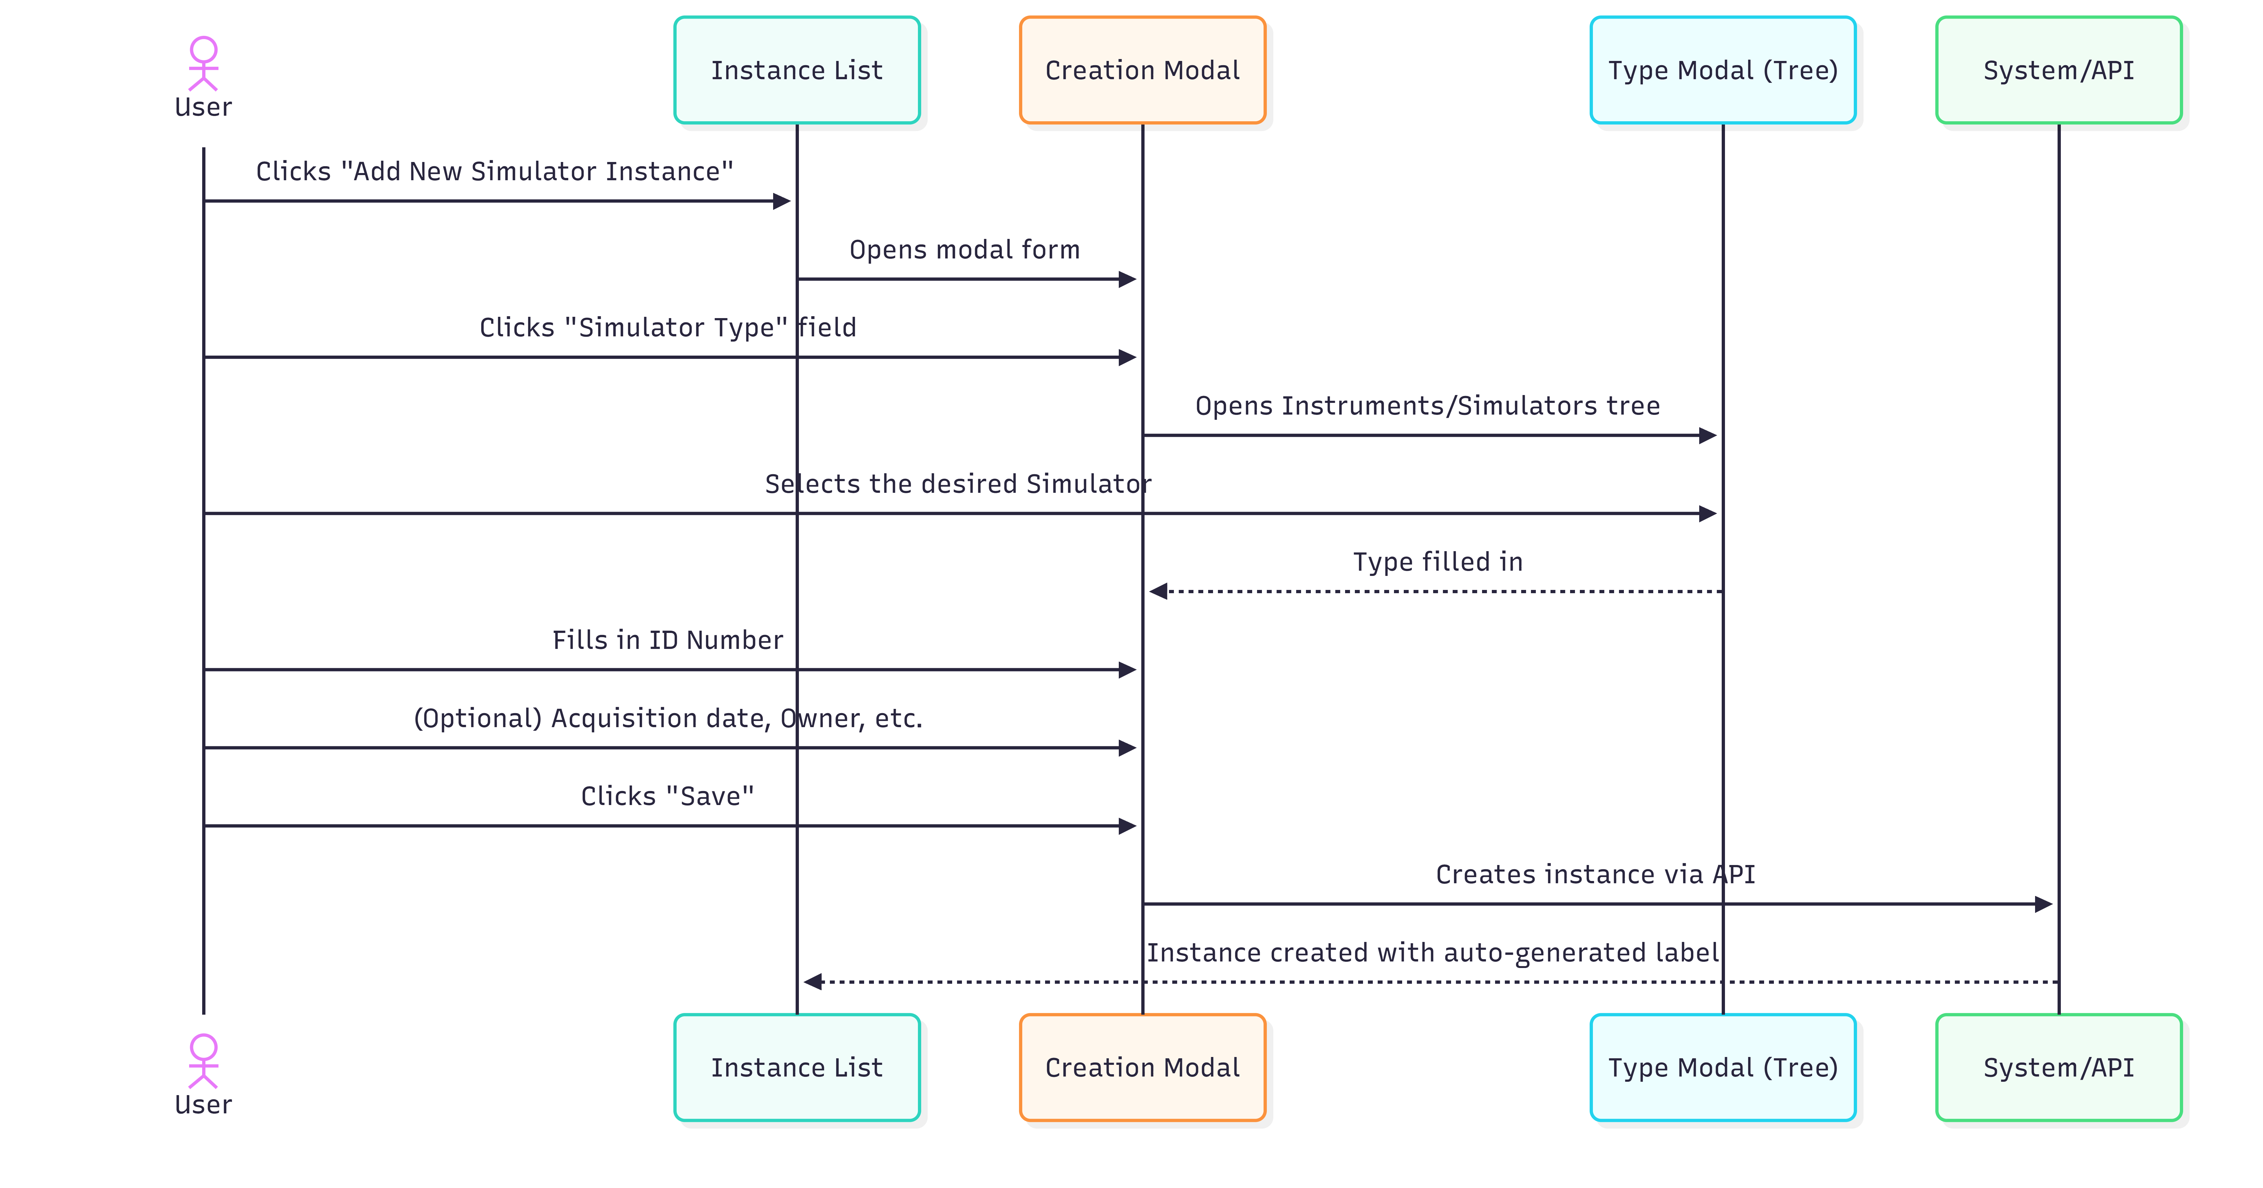
Diagram PNG: Creation Sequence

Detailed Steps
📋 Step 1. On the management page, click on “Add New Simulator Instance” (or “Add New Instrument Instance”).
📋 Step 2. A modal form (overlay window) opens.
📋 Step 3. Fill in the fields:

Creation Form Fields
Field | Type | Required | Detailed Description
Simulator Type (or Instrument Type) | Selection by modal (tree) | Yes | The Instrument/Simulator that this instance represents. Click to open the type tree. Only elements in Current state are shown. Select the specific design (e.g., “Lyophilizer LF-2000 v2”).
ID Number | Text field | Yes | Serial number or unique identification of this physical unit. Examples: “SN-001”, “LF2000-PT-003”, “EQ-2026-0042”. This number must be unique and allow physical identification of the equipment.
Acquisition Date | Date picker | No | Date when this equipment was acquired/received. Format: calendar with day selection.
Owner | Field with autocomplete | No | Organization that owns the equipment. Start typing and select from the list of organizations registered in the system.
Maintainer | Field with autocomplete | No | Person responsible for equipment maintenance. Start typing and select from the list of people.
Description | Text area | No | Additional notes about this instance: location, condition, operational notes, etc.

📋 Step 4. Click “Save”.
📋 Step 5. The instance is created with:
- URI automatically generated
- Label automatically generated in the format: "[Type] with #ID ([serial_number])"
- Example: “Lyophilizer LF-2000 with #ID (SN-001)” - Version = 1

Type Selection (Modal)
When clicking on the type field, the modal shows the Instruments/Simulators tree in Current state:

Available Instruments / Simulators
├── Lyophilizer LF-2000 v2 (Current)
├── Compression Simulator SC-500 v1 (Current)
├── PHQ-9 Questionnaire v3 (Current)
└── ...

⚠️ Only Instruments/Simulators in Current state appear in the list. If the design you need does not appear, make sure it has been approved (see 🔗 Section 2 - Instruments / Simulators).

Editing an Instance

🔑 Required Role: You must be an authenticated user (User / Author) to edit Instrument/Simulator instances.

How to Access

📋 Step 1. In the instance list, select the instance to edit.
📋 Step 2. Click the edit button (pencil icon or “Edit”).

Edit Form
The form includes all the creation fields, plus:
Additional Field | Type | Description
Damaged | Checkbox | Check if the equipment is damaged
Damage Date | Date picker | Date of damage (visible only when Damaged is checked)

Editable Fields
Field | Editable? | Notes
Simulator Type | Yes | You can change the source type/design
ID Number | Yes | You can correct the serial number
Acquisition Date | Yes
Owner | Yes
Maintainer | Yes
Description | Yes
Damaged | Yes | Check/uncheck damage status
Damage Date | Conditional | Appears only when Damaged is checked

📋 After editing, click “Save” to save the changes.

Deployments - Associating Instances

🔑 Required Role: You must be an authenticated user (User / Author) to create and manage Deployments.
After creating instances of Instruments/Simulators and Platforms/Laboratories, you can create Deployments to associate a Simulator with a Laboratory.

What is a Deployment?
A Deployment is the record that an Instrument/Simulator instance is installed/operational at a Platform/Laboratory instance.

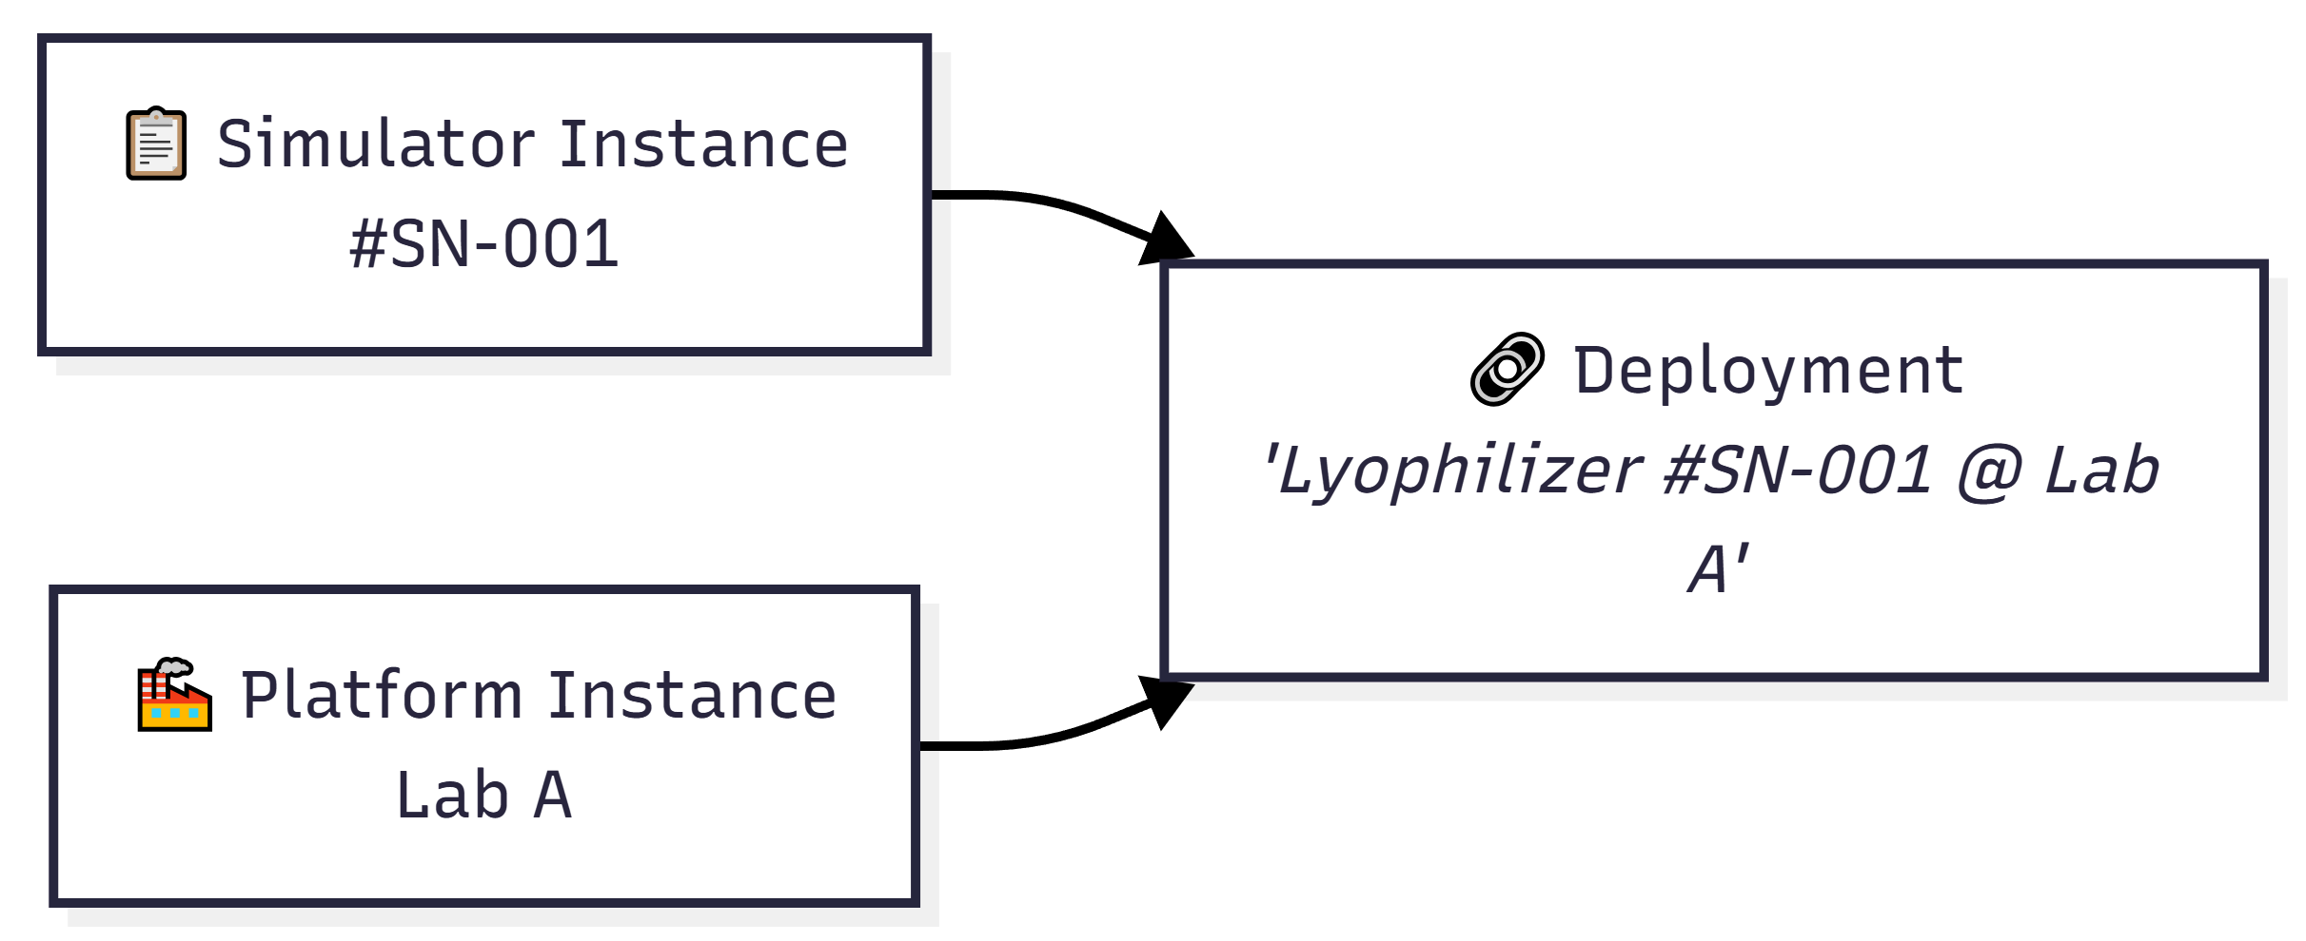
Diagram PNG: What is a Deployment?

Creating a Deployment

Main Menu → Deployment Elements → Manage Elements → Manage Deployments

📋 Step 1. In Deployment management, click on “Add New Deployment”.
📋 Step 2. Fill in:
Field | Type | Required | Description
Platform Instance | Autocomplete | Yes | The Platform/Laboratory instance where the equipment is installed
Simulator Instance | Autocomplete | Yes | The Instrument/Simulator instance to install
Version | Automatic | Auto | Version 1
Description | Textarea | No | Notes about the deployment

📋 Step 3. Click “Save”.

The system automatically generates the label: "[Instrument Label] @ [Platform Label]".

Field Reference

Creation Form - Complete Fields
Field | Technical Name | Type | Required | Description
Type | instance_type | Modal textfield | Yes | Source Instrument/Simulator
ID Number | instance_serial_number | Textfield | Yes | Unique serial number
Acquisition Date | instance_acquisition_date | Date | No | Acquisition date
Owner | instance_owner | Textfield + autocomplete | No | Owner organization
Maintainer | instance_maintainer | Textfield + autocomplete | No | Person responsible for maintenance
Description | instance_description | Textarea | No | Additional notes

Edit Form - Additional Fields
Field | Technical Name | Type | Description
Damaged | instance_damaged | Checkbox | Equipment damage status
Damage Date | instance_damage_date | Date | Date of damage (conditional)

Troubleshooting
Problem | Possible Cause | Solution
The Instrument/Simulator I need does not appear in the type selection | The Instrument is not in Current state | Submit the Instrument for review and wait for approval. See 🔗 Section 2 - Instruments / Simulators
The creation form appears as a very small modal | Normal behavior for instances | Instance creation uses a modal form (compact)
I cannot create a Deployment | Missing Platform or Instrument instances | Create both instances first: 🔗 Section 7 - Platform / Laboratory Instances
The Owner/Maintainer field does not show suggestions | The Social module is not active or there are no registered organizations/people | Contact the administrator to check the Social module
The generated label is not correct | The ID Number may be incorrect | Edit the instance and correct the ID Number field

🔗 Internal Navigation: Instruments / Simulators • Platforms / Laboratories • Platform / Laboratory Instances • Internal Table of Contents

6. Platforms / Laboratories
Module: DPL (Deployment)
PMSR Context: In PMSR, “Platform” can represent a “Laboratory” or operational site

Overview
A Platform (or Laboratory in the PMSR context) represents a location, space, or infrastructure equipment where instruments/simulators operate and data is collected. In PMSR, Platforms typically correspond to laboratories, simulation rooms, or industrial units.

Position in the General Flow
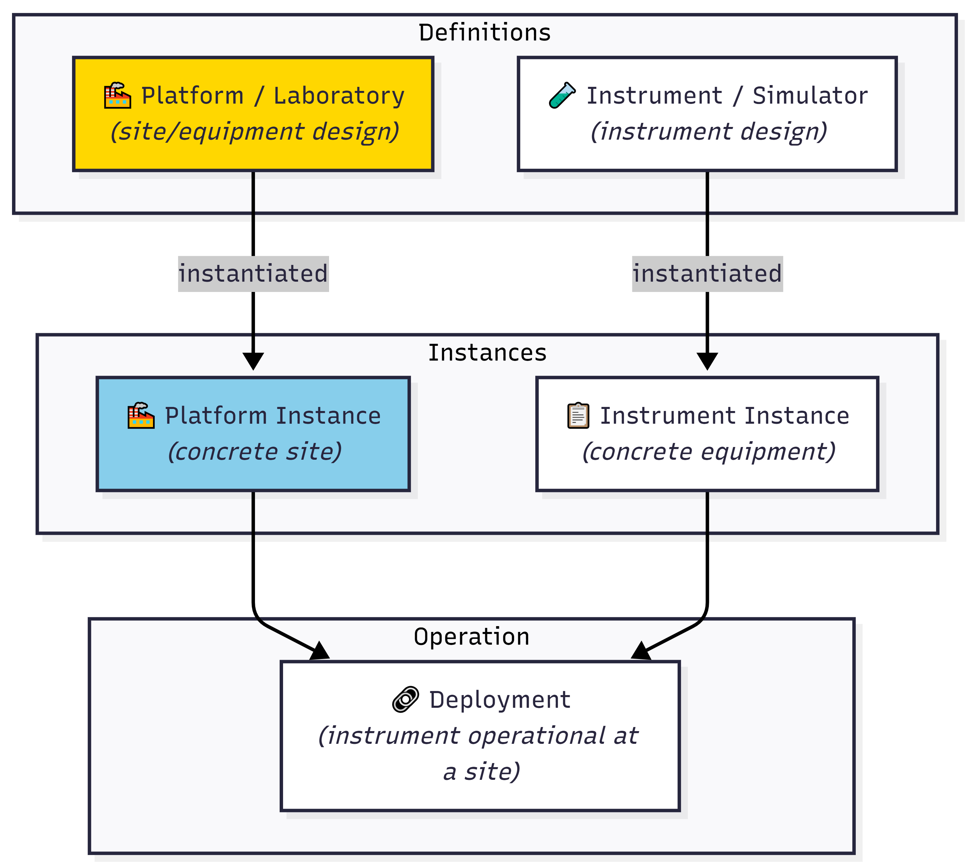
Diagram PNG: Position in the General Flow
Note: Unlike Instruments and Components, Platforms do not follow the full review flow (Draft → Under Review → Current). Platform management is more streamlined.
📘 Model vs. Instance: A Platform/Laboratory is a model (definition) - it describes the type of platform or laboratory (e.g., “Lyophilization Laboratory Type A”). To register a specific, concrete laboratory (e.g., “Lyophilization Laboratory, Building B, Room 203”), create an Instance - see Section 7 - Platform / Laboratory Instances. The same model can have multiple instances across different locations.

What is a Platform / Laboratory?

Definition
A Platform defines: - Hierarchical type in the ontology (e.g., Laboratory, Clean Room, Production Floor) - Name of the location or equipment - Version of the design - Description of the purpose and characteristics

Examples in PMSR
Type | Platform Example | Description
Laboratory | PMSR Lab - Room 101 | Main pharmaceutical simulation laboratory
Clean Room | Clean Room Class 100 | Clean room for sterile production
Industrial Unit | Production Line PL-3 | Lyophilized production line
Workstation | Control Station CS-2 | Process control station

Type Hierarchy
The Platform type selection is done through a hierarchical tree from the ontology:
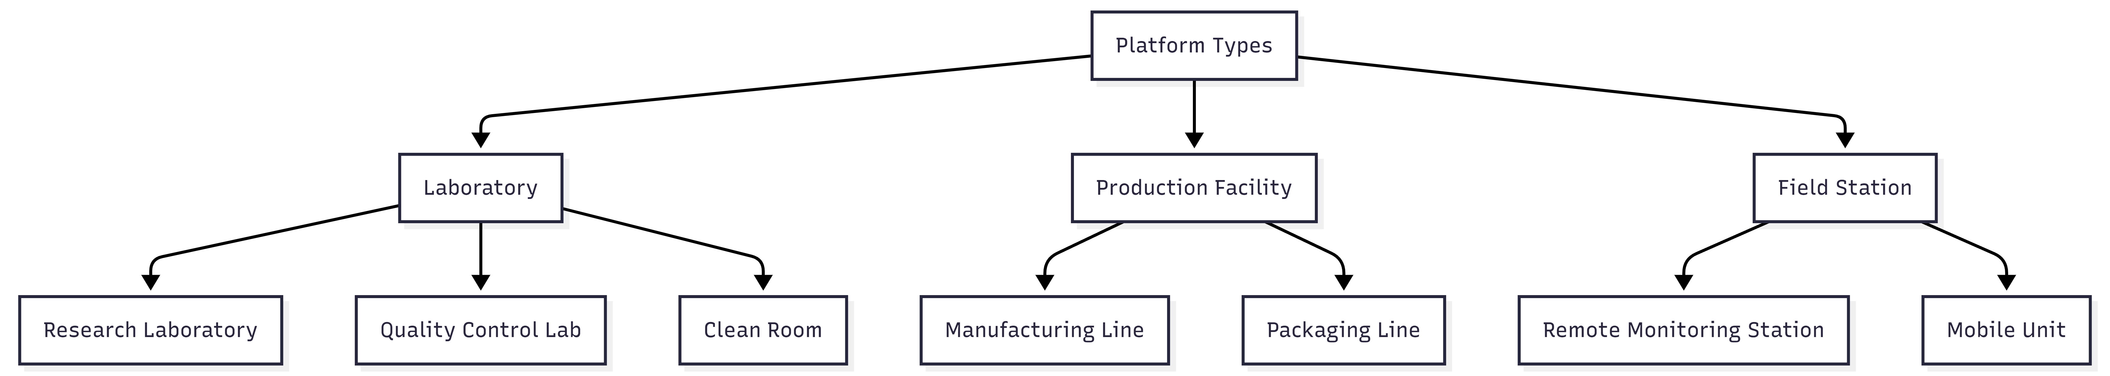
Diagram PNG: Type Hierarchy

In the PMSR context, “Laboratory” is typically the most commonly used type. The displayed naming depends on the Preferred Names configuration.

Accessing Platform Management

Navigation Path

Main Menu → Deployment Elements → Manage Elements → Manage Platforms

Direct URL: https://www.pmsr.net/dpl/select/platform/1/9

Steps:
📋 Step 1. In the main navigation bar, click on “Deployment Elements”.
📋 Step 2. Hover over “Manage Elements”.
📋 Step 3. Click on “Manage Platforms”.

The Management Page (List)

View Modes
Button | Description
Table View | Table view (recommended)
Card View | Card view

Table Columns
Column | Description
URI | Unique identifier of the Platform
Name | Name of the Platform/Laboratory
Version | Design version

Action Buttons
Button | Function
Add New Platform | Opens the creation form
Back | Returns to the previous page
Load More | Loads more items (card view)

Creating a New Platform / Laboratory

Creation Sequence
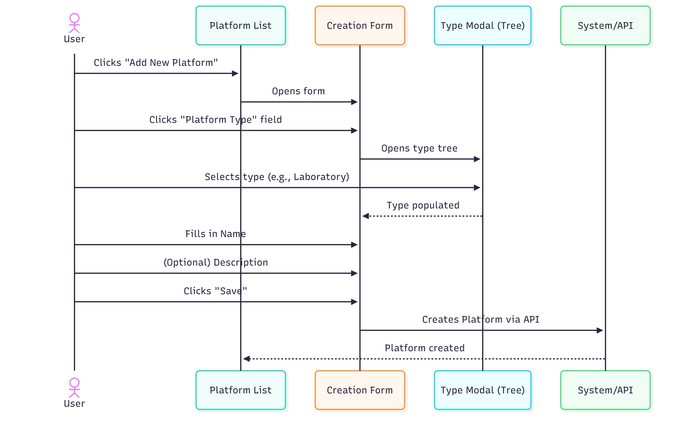
Diagram PNG: Creation Sequence

🔐 Required permission: Creating and editing Platforms/Laboratories requires an authenticated user.

Detailed Steps
📋 Step 1. On the management page, click “Add New Platform”.
📋 Step 2. The creation form opens.
📋 Step 3. Fill in the fields:

Form Fields
Field | Type | Required | Detailed Description
Platform Type | Selection via modal (tree) | Yes | Defines the hierarchical type of the Platform. When clicked, a modal window (800px) opens with the tree of available types in the ontology. In PMSR, typically select “Laboratory” or the most specific subtype. The tree shows the entire hierarchy of Platform types defined in the system.
Name | Text field | Yes | Descriptive and identifiable name for the Platform/Laboratory. Must be unique and clear. Examples: “PMSR Simulation Laboratory - Room 101”, “GMP Clean Room - Building B”, “Main Control Station CS-Main”.
Version | Field (read-only) | Auto | Starts at 1. Not editable by the user. Increments automatically on subsequent edits.
Description | Text area | No | Detailed description of the Platform: physical location, capabilities, fixed equipment, access restrictions, environmental conditions, etc.

📋 Step 4. Click “Save” to create.
📋 Step 5. The Platform is created and the system redirects to the management list.

Platform Type Selection (Modal)

When clicking the Platform Type field, the modal displays the hierarchical tree:
Platform Types (Ontology)
├── 🏭 Laboratory
│ ├── Research Laboratory
│ ├── Quality Control Laboratory
│ ├── Clinical Laboratory
│ └── Clean Room
├── 🏗️ Production Facility
│ ├── Manufacturing Line
│ └── Packaging Area
├── 📡 Field Station
│ ├── Remote Monitoring Station
│ └── Mobile Unit
└── 💻 Workstation
├── Control Station
└── Analysis Terminal
To select: Navigate through the tree and click on the desired type. The field is automatically populated and the modal closes.
PMSR Tip: For most PMSR scenarios, select “Laboratory” or one of its subtypes. Consult the team if you are unsure which type to use.

Editing a Platform / Laboratory

🔐 Required permission: Creating and editing Platforms/Laboratories requires an authenticated user.

How to Access

📋 Step 1. In the Platform list, locate the Platform you wish to edit.
📋 Step 2. Select it (radio button or click).
📋 Step 3. Click the edit button (or double-click).

Edit Form

The form is similar to the creation form, with all fields editable:

Field | Editable? | Notes
Platform Type | Yes | You can change the type via the tree modal
Name | Yes | You can change the name
Version | Read-only | Increments automatically if the current version is Current/Deprecated
Description | Yes | You can update the description

Buttons
Button | Function
Update | Saves the changes
Cancel | Discards and returns to the list

Edit Flow
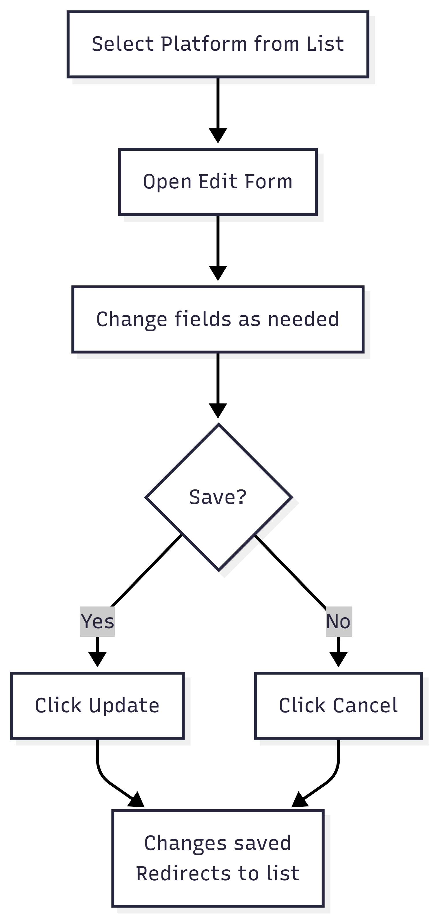
Diagram PNG: Edit Flow

Field Reference

Creation and Edit Form
Field | Technical Name | HTML Type | Required | Default Value | Validation
Platform Type | platform_type | Modal textfield | Yes | (empty) | Valid ontology URI
Name | platform_name | Textfield | Yes | (empty) | Not empty
Version | platform_version | Textfield (disabled) | Auto | 1 | Positive integer, managed by the system
Description | platform_description | Textarea | No | (empty) | -

Comparison with Instruments
Aspect | Platform | Instrument
Number of fields | 4 (simple) | 15+ (complex)
Image/Document | No | Yes
Review flow | No | Yes (Draft → Under Review → Current)
Container Slots | No | Yes
Maker/Language | No | Yes

Troubleshooting
Problem | Possible Cause | Solution
The Platform Type modal is empty | Connection issue with the ontology | Contact the system administrator
Cannot find the “Laboratory” type | The ontology may not have this exact subtype | Browse through the tree or contact the administrator to verify the available types
I want to add more details to the Platform | The form only has 4 fields | Use the Description field to include detailed information. Operational details are managed in Instances (🔗 Section 7 - Platform / Laboratory Instances)
The version incremented on its own | Expected behavior when editing Current versions | Normal: the system creates a new version automatically
Cannot delete the Platform | There may be associated instances | Delete the associated instances and deployments first

🔗 Internal Navigation: Platform / Laboratory Instances • Instruments / Simulators • Instrument / Simulator Instances • Internal Table of Contents

7. Platform / Laboratory Instances
Module: DPL (Deployment)
PMSR Context: Instances represent physical/concrete units of a Laboratory

Overview
A Platform Instance (or Laboratory Instance in PMSR) represents a concrete physical unit of a previously defined Platform. While the Platform is the “design” or “type” of the location/infrastructure, the Instance is the actual, specific, and identifiable location.

Analogy
Concept | Analogy
Platform / Laboratory | The blueprint of a laboratory type (e.g., “Class 100 Clean Room”)
Platform Instance | A concrete laboratory of that type (e.g., “Clean Room - Bldg. B, Room 204, ID: CR-204”)

Position in the Pipeline
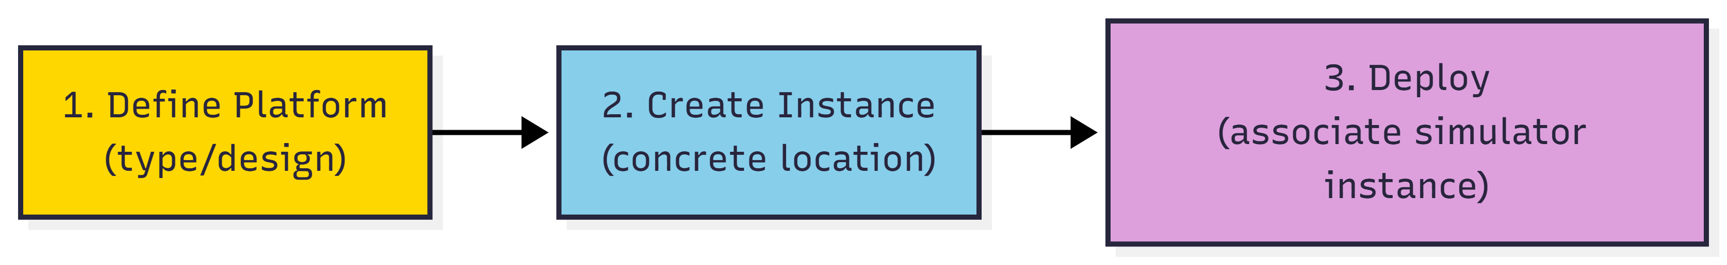
Diagram PNG: Position in the Pipeline

📘 Why create Instances?
In Manual 05, you created a Platform/Laboratory - this is the model (definition), which describes the type of platform or laboratory. It’s like the standard blueprint for a laboratory.
An Instance is a specific, concrete laboratory of that model: - The model “Lyophilization Laboratory Type A” is defined once. - But you may have 2 physical laboratories of that type: one in Building B, Room 203 and another in Building D, Room 105.
Each instance has its own location, responsible person, and can receive deployments (association of instrument/simulator instances).
Analogy: The model is like the type of classroom (e.g., “Chemistry Laboratory”). The instance is the specific room (e.g., “Chemistry Lab, Block C, Room 301”).

What is a Platform / Laboratory Instance?
A Platform Instance records:
- Reference to the type of Platform (the design/category)
- Identification number (unique ID of the location)
- Acquisition/creation date
- Owner (organization)
- Maintenance responsible (maintainer)
- Status (operational or damaged)
- Operational description

Relationship with Deployments
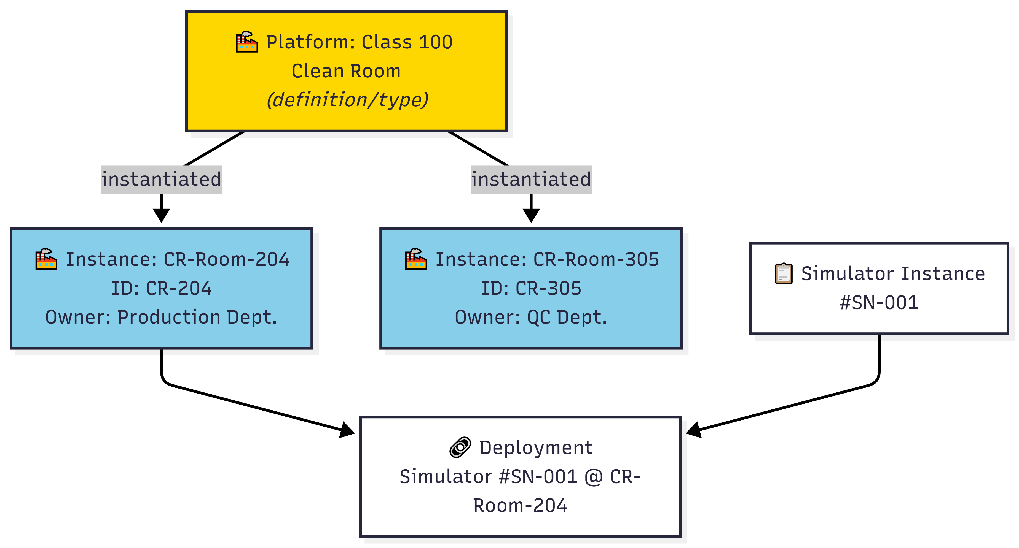
Diagram PNG: Relationship with Deployments

Prerequisites
Prerequisite | Required? | Description
Platform / Laboratory defined | Yes | The Platform must exist in the system. See 🔗 Section 6 - Platforms / Laboratories
Instrument/Simulator Instance | For deploy | Only needed to create Deployments. See 🔗 Section 5 - Instrument / Simulator Instances

Accessing Instance Management

Navigation Path

Main Menu → Deployment Elements → Manage Elements → Manage Platform Instances
Direct URL: https://www.pmsr.net/dpl/select/platforminstance/1/9

Steps:
📋 Step 1. In the navigation bar, click on “Deployment Elements”.
📋 Step 2. Hover over “Manage Elements”.
📋 Step 3. Click on “Manage Platform Instances”.

The Management Page (List)

View Modes
Button | Description
Table View | Table view (recommended for management)
Card View | Card view with a more compact layout

Table Columns
Column | Description
URI | Unique identifier of the instance
Type | Source Platform type
ID Number | Location identification number
Label | Automatically generated name
Owner | Owning organization
Status | Operational status

Action Buttons
Button | Function
Add New Platform Instance | Opens the creation form (modal)
Back | Returns to the previous page
Load More | Loads more items (card view)

Creating a New Instance

🔐 Required permission: Creating instances requires an authenticated user.

Creation Sequence
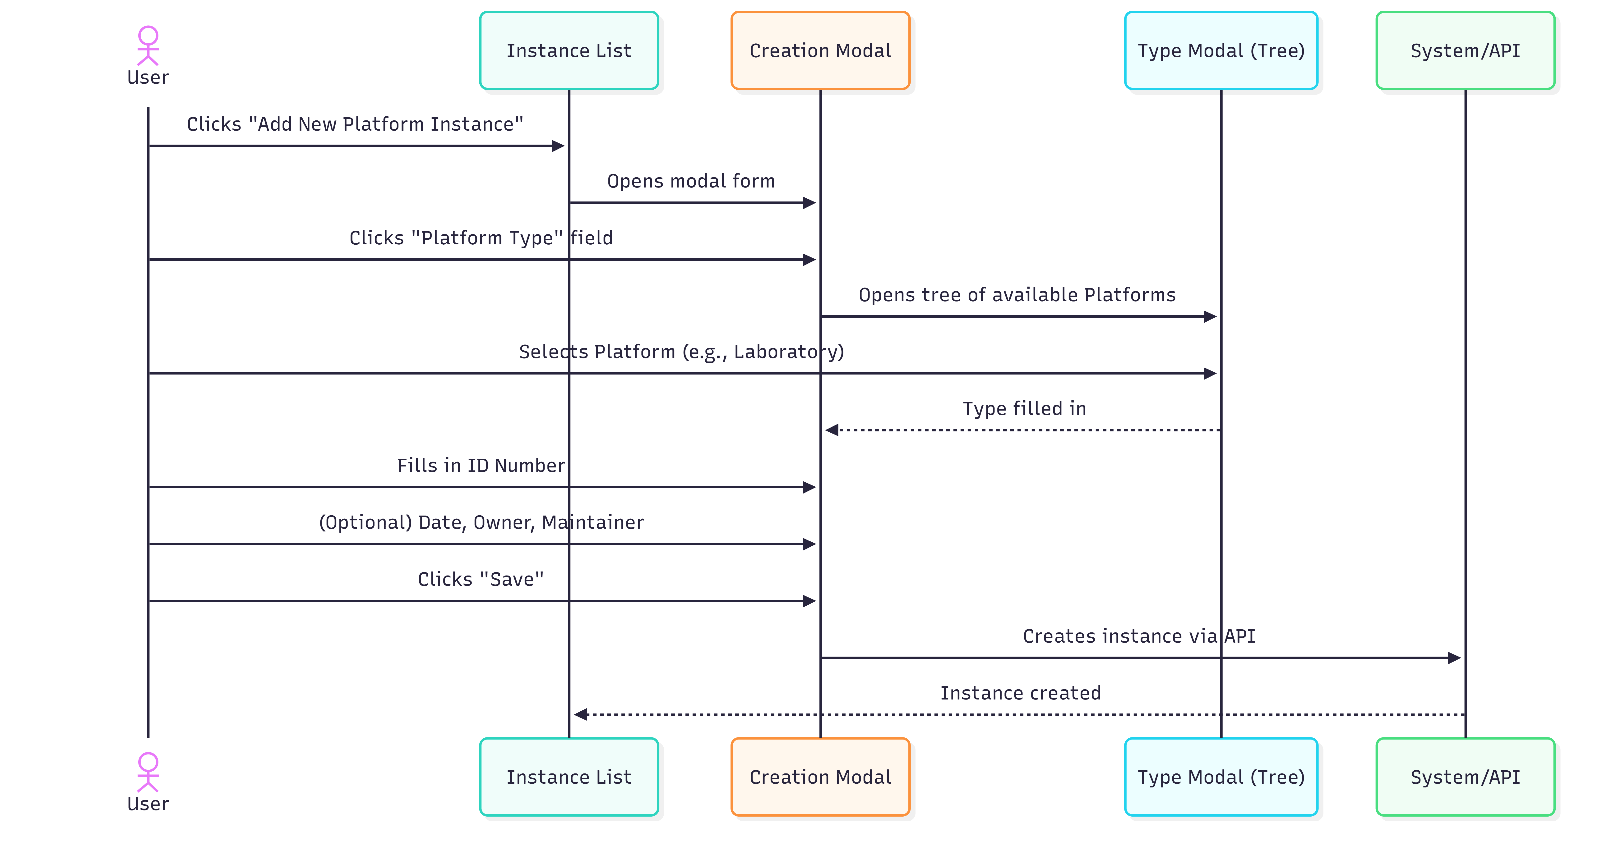
Diagram PNG: Creation Sequence

Detailed Steps
📋 Step 1. On the management page, click “Add New Platform Instance”.
📋 Step 2. A modal form (overlay window) opens.
📋 Step 3. Fill in the fields:

Creation Form Fields
Field | Type | Required | Detailed Description
Platform Type | Modal selection (tree) | Yes | The Platform that this instance materializes. Click to open the tree of Platforms defined in the system. Select the appropriate Platform type. PMSR Example: Select “Class 100 Clean Room” or “Simulation Laboratory”.
ID Number | Text field | Yes | Unique identifier for this instance/location. Must allow unambiguous identification. Examples: “ROOM-101”, “CR-204”, “LAB-PMSR-01”, “LP3-EAST”. Use a consistent naming convention within your organization.
Acquisition Date | Date picker | No | Date of inauguration, acquisition, or start of operation of the location. Click the field to open the calendar and select the date.
Owner | Autocomplete field | No | Owning organization or entity responsible for the location. Start typing the organization name and select from the list. Example: “PMSR Production Department”.
Maintainer | Autocomplete field | No | Person responsible for maintenance and management of the space. Start typing the name and select from the list.
Description | Text area | No | Additional information: exact location (building, floor, wing), capacity, special conditions (controlled temperature, pressure, classification), operating hours, access restrictions, etc.

📋 Step 4. Click “Save”.
📋 Step 5. The instance is created with: - URI automatically generated - Label automatically set: "[Type] with #ID ([ID Number])" - Example: “Class 100 Clean Room with #ID (CR-204)” - Version = 1

Platform Type Selection (Modal)
When clicking the type field, the modal shows the available Platforms:

Available Platforms
├── 🏭 Laboratory - PMSR Simulation Laboratory
├── 🏭 Class 100 Clean Room
├── 🏭 Production Line LP-3
├── 🏭 Main Control Station
└── ...

Select the appropriate Platform by clicking on it.

Editing an Instance

🔐 Required permission: Creating instances requires an authenticated user.

How to Access
📋 Step 1. In the instance list, select the instance to edit.
📋 Step 2. Click the edit button.

Edit Form
All creation fields are available for editing, plus additional fields:
Field | Editable? | Notes
Platform Type | Yes | You can change the Platform type
ID Number | Yes | You can correct the identifier
Acquisition Date | Yes
Owner | Yes
Maintainer | Yes
Description | Yes
Damaged | Yes | Checkbox to mark damage status
Damage Date | Conditional | Only visible when Damaged is checked

Marking as Damaged

If the location/equipment suffers damage:
📋 Step 1. Open the edit form for the instance.
📋 Step 2. Check the “Damaged” checkbox.
📋 Step 3. The “Damage Date” field appears. Select the date when the damage occurred.
📋 Step 4. (Optional) Update the Description with details about the damage.
📋 Step 5. Click “Save”.
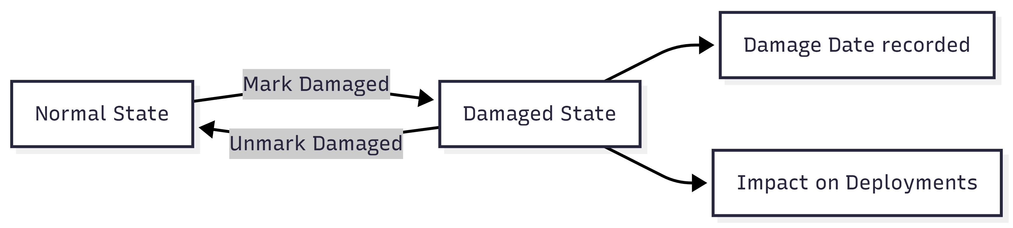
Diagram PNG: Marking as Damaged

⚠️ Impact: Marking a Platform Instance as damaged may affect active Deployments at that location. Check the associated Deployments before making this change.

Complete Scenario: From Laboratory to Deployment

🔐 Required permission: Deployment management may require additional permissions beyond the basic authenticated user.
This scenario demonstrates the complete flow for a PMSR user, from defining a Laboratory to Deploying a Simulator at that location.

Scenario Steps
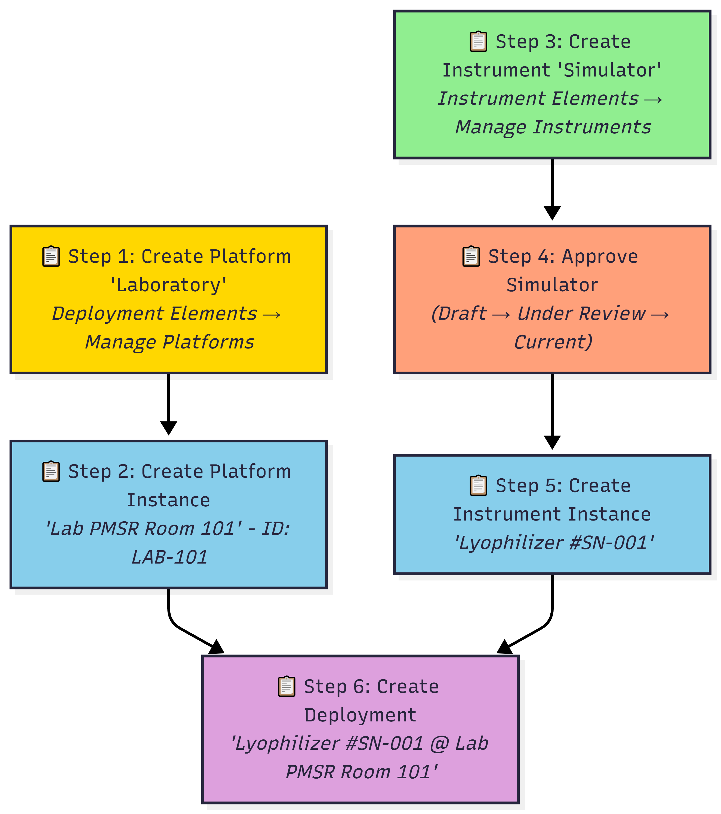
Diagram PNG: Scenario Steps
Step | Action | Reference Manual
1 | Create Platform “Laboratory” | 🔗 Section 6 - Platforms / Laboratories, section 5
2 | Create Platform Instance “Lab PMSR Room 101” | This manual, section 6
3 | Create Instrument/Simulator | 🔗 Section 2 - Instruments / Simulators
4 | Submit and approve the Simulator | 🔗 Section 2 - Instruments / Simulators, sections 7-8
5 | Create Instrument Instance | 🔗 Section 5 - Instrument / Simulator Instances
6 | Create Deployment | 🔗 Section 5 - Instrument / Simulator Instances, section 8

Final Result

After completing all steps:
🔗 Deployment: "Lyophilizer LF-2000 #SN-001 @ Lab PMSR Room 101"
├── 📋 Simulator Instance: Lyophilizer #SN-001
│ └── 🧪 Simulator: Lyophilizer LF-2000 v2 (Current)
│ ├── ⚙️ Component: Inlet Temperature (Slot #1)
│ ├── ⚙️ Component: Chamber Pressure (Slot #2)
│ └── ⚙️ Component: Control Valve (Slot #3)
└── 🏭 Platform Instance: Lab PMSR Room 101 (LAB-101)
└── 🏭 Platform: PMSR Simulation Laboratory

Field Reference

Creation Form
Field | Technical Name | Type | Required | Default Value | Description
Platform Type | instance_type | Modal textfield | Yes | (empty) | Source Platform
ID Number | instance_serial_number | Textfield | Yes | (empty) | Unique identifier
Acquisition Date | instance_acquisition_date | Date | No | (empty) | Acquisition/inauguration date
Owner | instance_owner | Textfield + autocomplete | No | (empty) | Owning organization
Maintainer | instance_maintainer | Textfield + autocomplete | No | (empty) | Responsible person
Description | instance_description | Textarea | No | (empty) | Operational description

Edit Form - Additional Fields
Field | Technical Name | Type | Description
Damaged | instance_damaged | Checkbox | Indicates whether the location is damaged
Damage Date | instance_damage_date | Date | Date of damage (conditional)

Troubleshooting
Problem | Possible Cause | Solution
I cannot find the Platform I need in the type selection | The Platform has not been created yet | Create the Platform first: 🔗 Section 6 - Platforms / Laboratories
The Owner/Maintainer field does not show suggestions | Social module not active or no registered organizations | Contact the administrator
I want to associate a Simulator to this instance | You need to create a Deployment | Use Manage Deployments and follow the instructions in 🔗 Section 5 - Instrument / Simulator Instances, section 8
I marked as Damaged by mistake | - | Open the edit form, uncheck the Damaged checkbox and Save
I cannot see Platform Instances | There may be no instances created | Create the first instance with “Add New Platform Instance”
The form appears too small | Normal behavior - instances use a modal | The modal form is compact by design

🔗 Internal Navigation: Platforms / Laboratories • Instruments / Simulators • Instrument / Simulator Instances • Internal Table of Contents

PMSR Working Group - March 2026

