OUTCOMES
WhatsApp-based Malicious URL Detection System

- Ultramsg website: A link between API and the WhatsApp
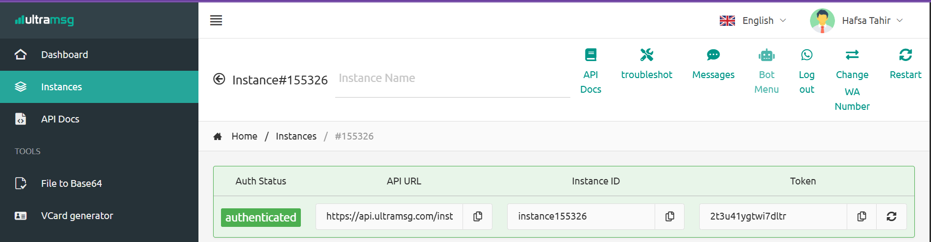
- Connect our WhatsApp with Ultramsg by Linking our WhatsApp:
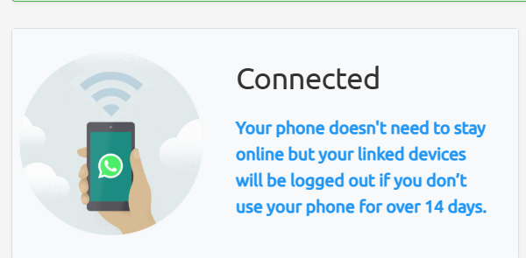
- Ultramsg URL for API Connection:
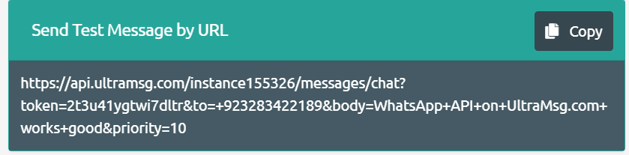
*****
- Public URL (ngrok) For connecting with the Ultramsg:
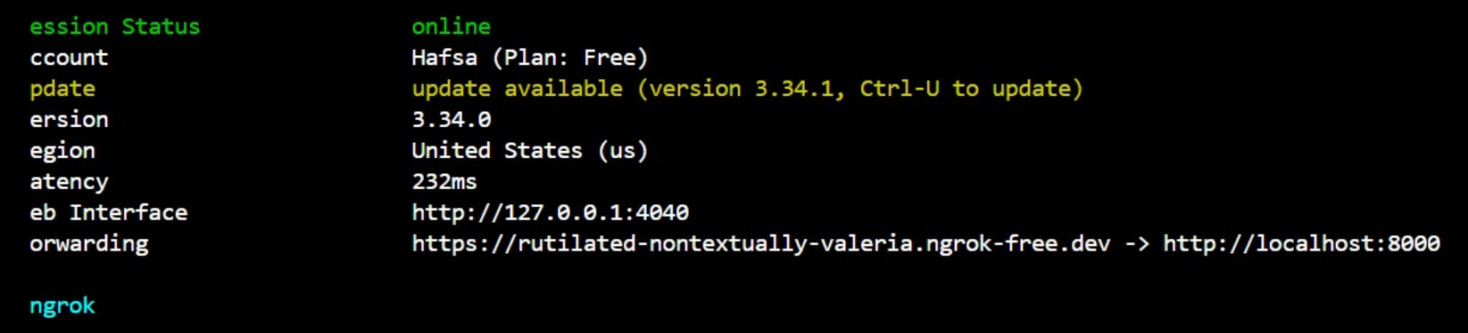
- Response Of API To Ultramsg which forward it to our Whatsapp:
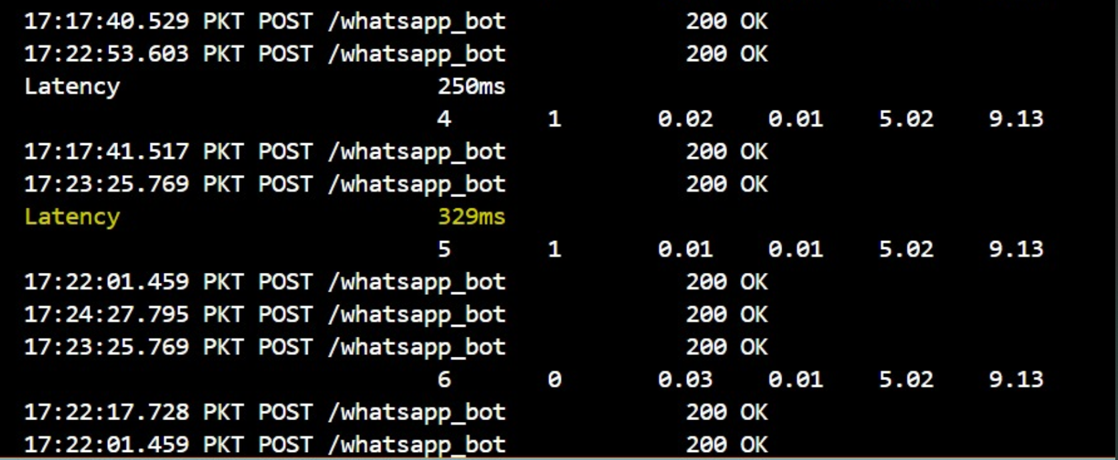
- URL sends by someone else to our whatsapp:
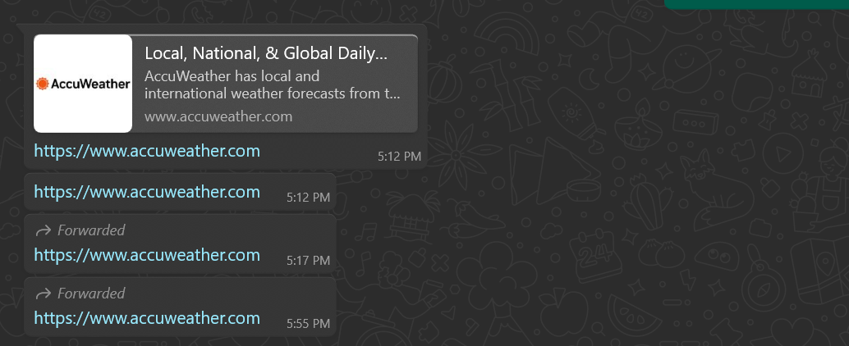
- Output shows to our whatsapp:
