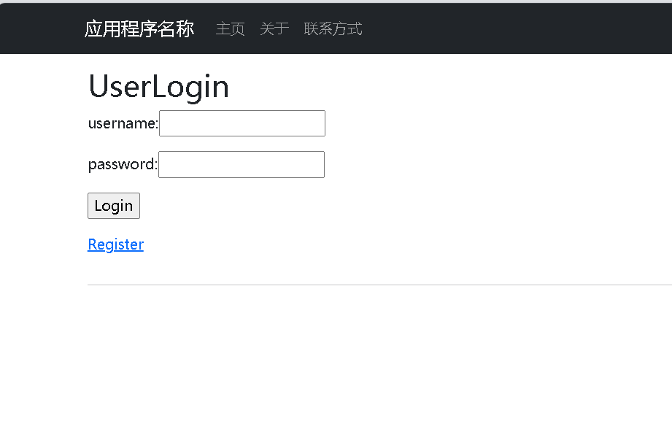This is the login page. If you don't have an account, you need to click on the bottom right corner to register first, which will take you to the registration page

This login page has made an error message stating that the account and password cannot be empty，This account password is stored in the database with ID as the primary key

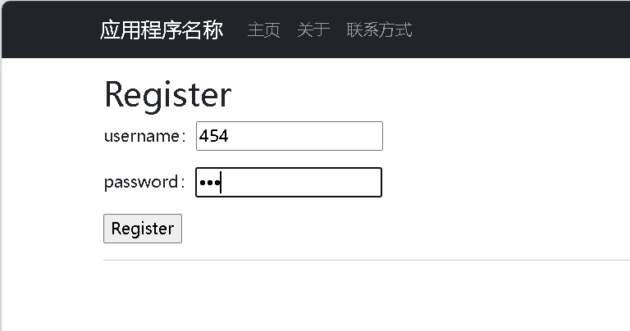 This is the registration page. After successful registration, you will be redirected to the login page. This page has also been processed with an account password that cannot be empty 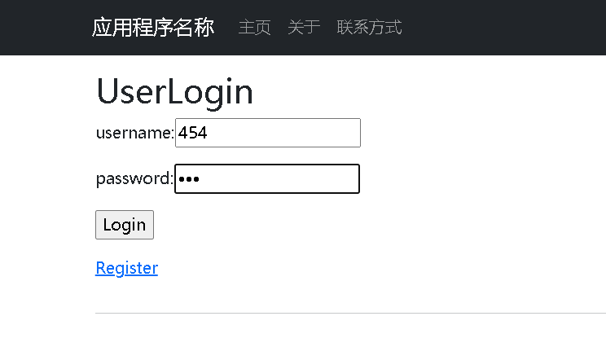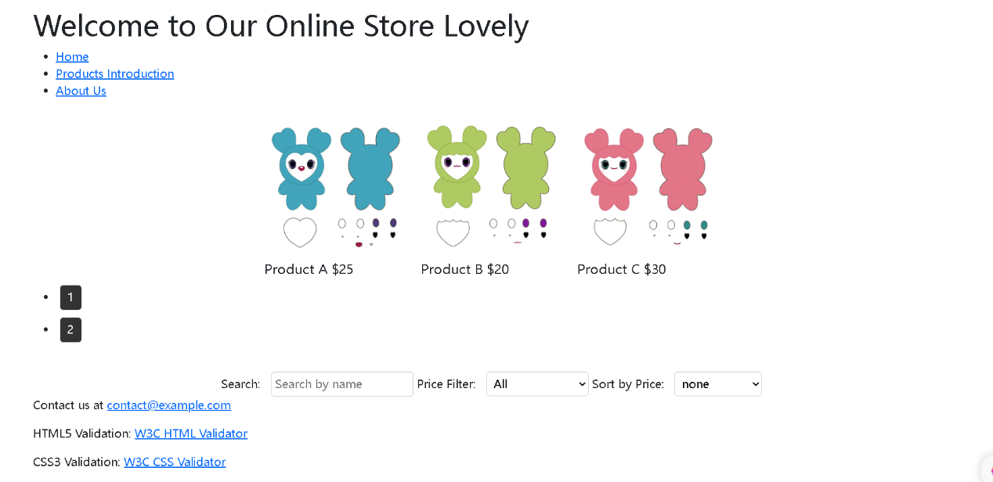 This is the main page after logging in, which is a shopping website around Twice. It includes two sub pages: product and purchase contact information, and implements functions for searching, filtering, sorting, or pagination. All applied to the following products, with added links including HTML5 and CSS3 validators: W3C Validator API, CSS Validator 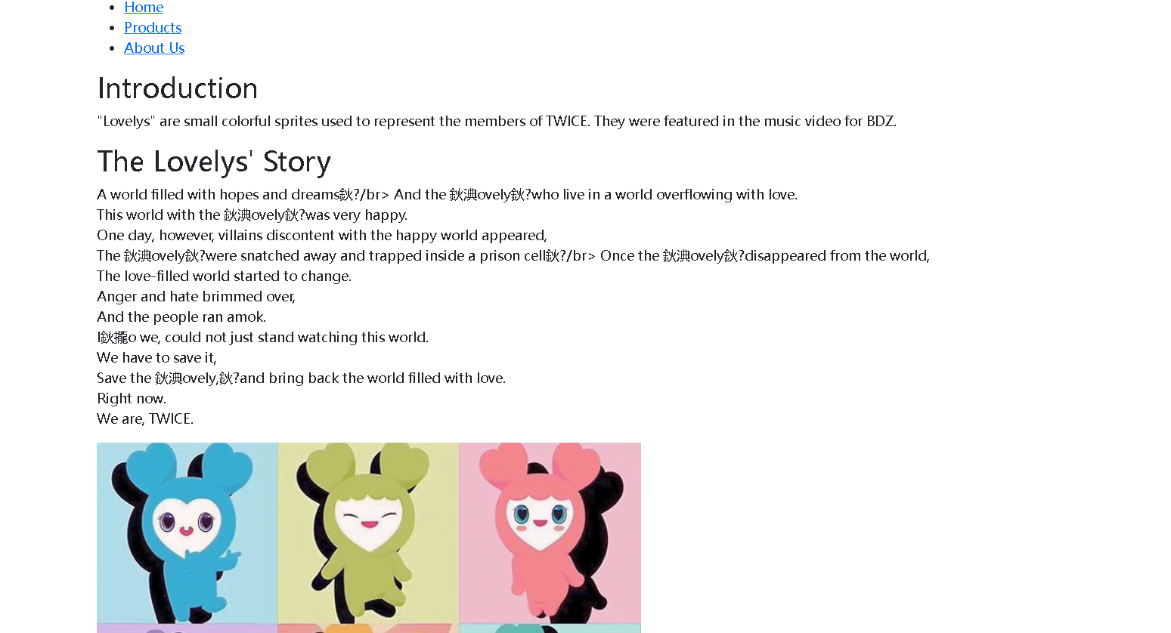 This is an introduction to my product around Twice - lovely

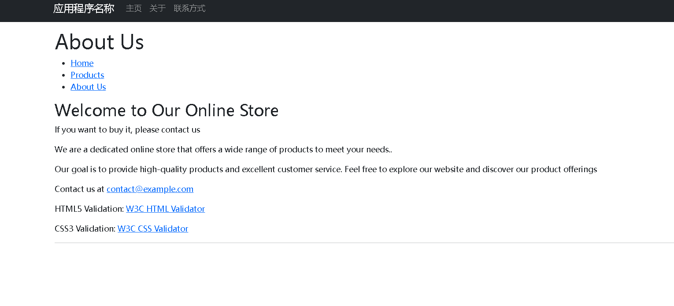

This page is the contact information for purchasing products,