LINUX ASSIGNMENT - 10

Name: H AKSHAR

Roll no.: 51

USN: ENG24CY0110

Subject: Linux

Topic: ASSIGNMENT 10

Section: CY-“A”

CONTENTS:

nl – Number lines of a file

yum update – Update system

nl – Number Lines of a File

1. What is nl command?
- The nl command is a standard Unix/Linux utility used to number the lines of a file or standard input.
- It is more flexible than a "cat -n" command.
- Syntax of the command is:
nl [options] [file]
- nl is like giving every line in your file an address number. It's a simple but handy tool for working with text files.

2. History of the Command?
- The nl command has a long history, deeply rooted in the early days of Unix and the tools that influenced it.
- Predecessor: pr
Before nl became a standalone command, its functionality was often part of the pr (print) command. The pr command was used to format files for printing, and one of its key features was adding line numbers, page headers, and footers. You can think of nl as a specialized offshoot of pr that focuses only on line numbering, but does it with more granular control.
- Invention and Authorship:
Like most core utilities from the early Unix era, nl was developed at AT&T Bell Labs. It was not the invention of a single person but rather a contribution from the group of developers working on the Unix operating system.
It was first appeared in the 3rd Edition of Unix (1973) or shortly thereafter, as the need for a dedicated, scriptable line-numbering tool grew.

3. Why "nl" is Useful for System Administrators?
- Helps identify specific lines in log files for debugging.
- Useful in scripting to manipulate line-based data.
- Makes it easier to refer to specific lines during troubleshooting.
- Assists in documentation and code reviews.
- Useful in file comparison tasks.

4. How the Command Works – Examples
- Basic usage:
nl filename.txt
- Number only non-empty lines:
nl -b t filename.txt
- Number all lines including empty lines:
nl -b a filename.txt
- Custom numbering format:
nl -n rz filename.txt

5. Example Output Illustration
- Input file (example.txt):
Hello
World
Sample
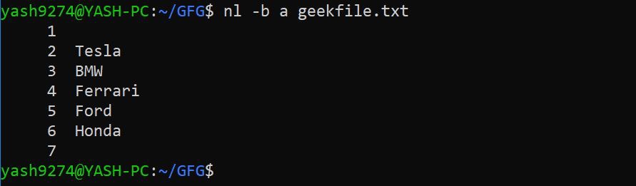
- Output:
1 Hello
2 World
3 Sample

6. Options and Flags of the command?
- - -b <type> → Numbering style: "a" (all lines), "t" (non-empty), "n" (none).
- -n <format> → Line numbering format: "ln" (left), "rn" (right), "rz" (right zero-padded).
- -s <string> → Separator between line numbers and text.
- -w <number> → Width of the line number field.
- -v <number> → Set initial line numbering.
- --help → Display detailed options and usage.

7. Sources for Options & Flags?
- Run: man nl
Online: https://www.gnu.org/software/coreutils/
Command help: nl --help
yum update – Update System

1. What is yum update – Update system command?
- The 'yum update' command is used in RPM-based Linux distributions such as Red Hat, CentOS, and Fedora to update all installed software packages to their latest available versions from configured repositories.
It ensures system stability, security, and performance by upgrading packages while automatically resolving dependencies.

2. History of yum update command?
- YUM stands for Yellowdog Updater, Modified.
It was originally developed for the Yellow Dog Linux distribution by Seth Vidal and his team at Duke University around the year 2000. YUM was designed to make RPM package management easier with features like dependency resolution and repository access. It was later adopted by Red Hat Enterprise Linux (RHEL), CentOS, and Fedora. Since Fedora 22 and RHEL 8, YUM has been replaced by DNF (Dandified YUM), but the 'yum' command still functions as a symlink to 'dnf' for compatibility.

3. Why yum update command is Useful for System Administrators?
- The 'yum update' command is useful for system administrators because:
- It keeps the system up-to-date with the latest package versions.
- Installs crucial security patches to reduce vulnerabilities.
- Improves system stability and performance.
- Automatically resolves dependency issues.
- Simplifies maintenance and troubleshooting.
- Useful during system upgrades or before installing new software.

4. How the Command Works – Examples?
- Example:
sudo yum update
Step-by-step explanation:
1. 'sudo' grants root privileges.
2. YUM checks for updates from enabled repositories.
3. Compares installed packages with available versions.
4. Displays packages to be updated.
5. Prompts user for confirmation (y/N).
6. Downloads and installs updates.
7. Shows completion message: 'Complete!'.

5. Options and Flags of the command?
- Commonly used options and flags:
1. -y or --assumeyes: Automatically answers yes to all prompts.
Example: sudo yum update -y
2. --security: Updates only security-related packages.
Example: sudo yum update --security
3. --exclude=package_name: Excludes specific package(s) from being updated.
Example: sudo yum update --exclude=kernel*
4. --downloadonly: Downloads packages without installing them.
Example: sudo yum update --downloadonly
5. --skip-broken: Skips packages with dependency issues.
Example: sudo yum update --skip-broken
6. --enablerepo=repo_name: Temporarily enables a specific repository during update.
Example: sudo yum update --enablerepo=epel

6. Sources for Options & Flags
- Sources for detailed flags and options:
- Run 'man yum' in terminal.
- Official Red Hat documentation: https://access.redhat.com/documentation
- CentOS Wiki: https://wiki.centos.org
- DNF documentation (YUM replacement): https://dnf.readthedocs.io
- Online Linux manual pages: https://linux.die.net or https://man7.org

