HALT Games

PRESENTS

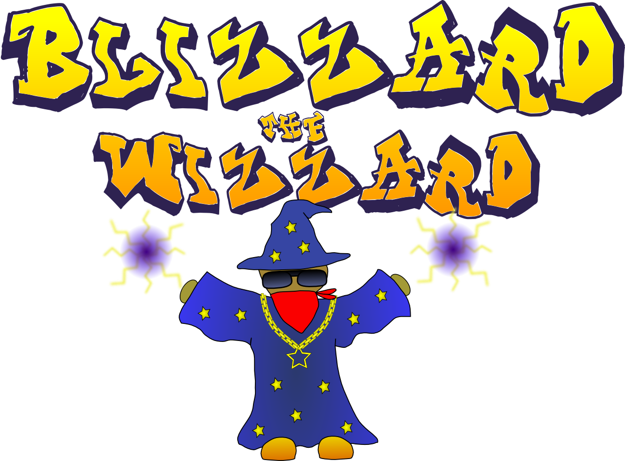

Game Concept Document

Written by Hamish Carrier, Arran Ford, Liam Doherty and Timothy Veletta

Version 0.03 (11/09/12)

Table of Contents

**Revision History** 3

**Introduction** 4

**Technical Background** 4

Engines/Libraries 4

Tools 4

Premade Classes 4

Licensing 4

**Description** 4

Gameplay 4

Controls 4

**Key Features** 5

**Genre** 5

Game Elements 5

Theme 5

**Platforms** 6

**Concept Art** 6

# **Revision History**

|  |  |
| --- | --- |
| **Version** | **Changelog** |
| 0.01 (09/09/12) | Added:   * Introduction * Technical Background * Description   + Game Play   + Controls * Genre |
| 0.02 (10/09/12) | Added:   * Key Features * Platforms   Modified:   * Game Play |
|  |  |
| 0.03 (11/09/12) | Added:   * Concept Art   Modified:   * Key Features |
|  |  |

# **Introduction**

Blizzard the Wizard is a 2nd person, top down survival combat game where the player plays as Blizzard, a gangster wizard trying to join the Gang of Wizards. But to do this he must pass his initiation test, to take the magic portal onto a remote island and take on its deadly inhabitants, trying to survive for as long as possible while searching for the ancient scrolls and tomes to increase his power.

# **Technical Background**

## Engines/Libraries

* OpenGL
  + freeglut
* SDL

## Tools

* GLM

## Premade Classes

* Model Importer – used to import OBJ model files into OpenGL programs.

## Licensing

* MIT License
  + LICENSE file included with distributions of the project.

# **Description**

## Gameplay

The main focus of Blizzard the Wizard is to survive for as long as possible against the endless onslaught of the creatures that inhabit the island.

Blizzard starts off stranded with no resources other than his own magical power, which he must use to defend himself. When he kills enemies they will drop resources that allow him to augment his own spells, in the form of scrolls and tomes.

Scrolls augment him for limited time, whereas tomes permanently upgrade his power, allowing him to cast new spells or even upgrade existing spells.

However the player must also be mindful of using Blizzard’s spells since they each use up spell power and have a cool down associated with them. This allows for a variety of strategic uses of spells and forces the player to choose when it is the best time to use a particular spell.

Once the player inevitably succumbs to the overwhelming waves of the islands inhabitants, they will be given an initiation rating, to determine whether they were successful in becoming a part of the Gang of Wizards. Also if they achieved a score worthy of the high score board; they will be able to add their name to the board.

## Controls

Since the camera view is top down, the player is restricted to moving and aiming along the XZ plane and although there are also some changes in elevation, this has no effect on the gameplay.

**Player Movement**

W - Up

A - Left

S - Down

D -Right

**W**

**D**

**A**

**S**

Q – Area of Effect Spell

E – Heal/Shield Spell

**E**

**Q**



Mouse Movement – Aim

Left Mouse Button – Default Spell

Right Mouse Button – Damage Spell

# **Key Features**

* Dynamic island setting which is both fun and challenging
* Numerous enemies including killer birds, mutant fish and the po-lice
* Highly addictive gameplay that will make you want to keep coming back for more
* Signature catch phrases such as “…”
* Challenge your friends to beat your high score using the online high score board
* A wide range of power ups to increase your limitless spell power.

# **Genre**

* Action
* Arcade
* Strategy

## Game Elements

* Top Down
* Combat
* Resource Management
* Obstacles
* Shooting

## Theme

* Fantasy
* Gangsters

# **Platforms**

Windows 7

# **Concept Art**