# User Guide

When you launch **BlizzardtheWizard.exe** you will be greeted with the menu screen.

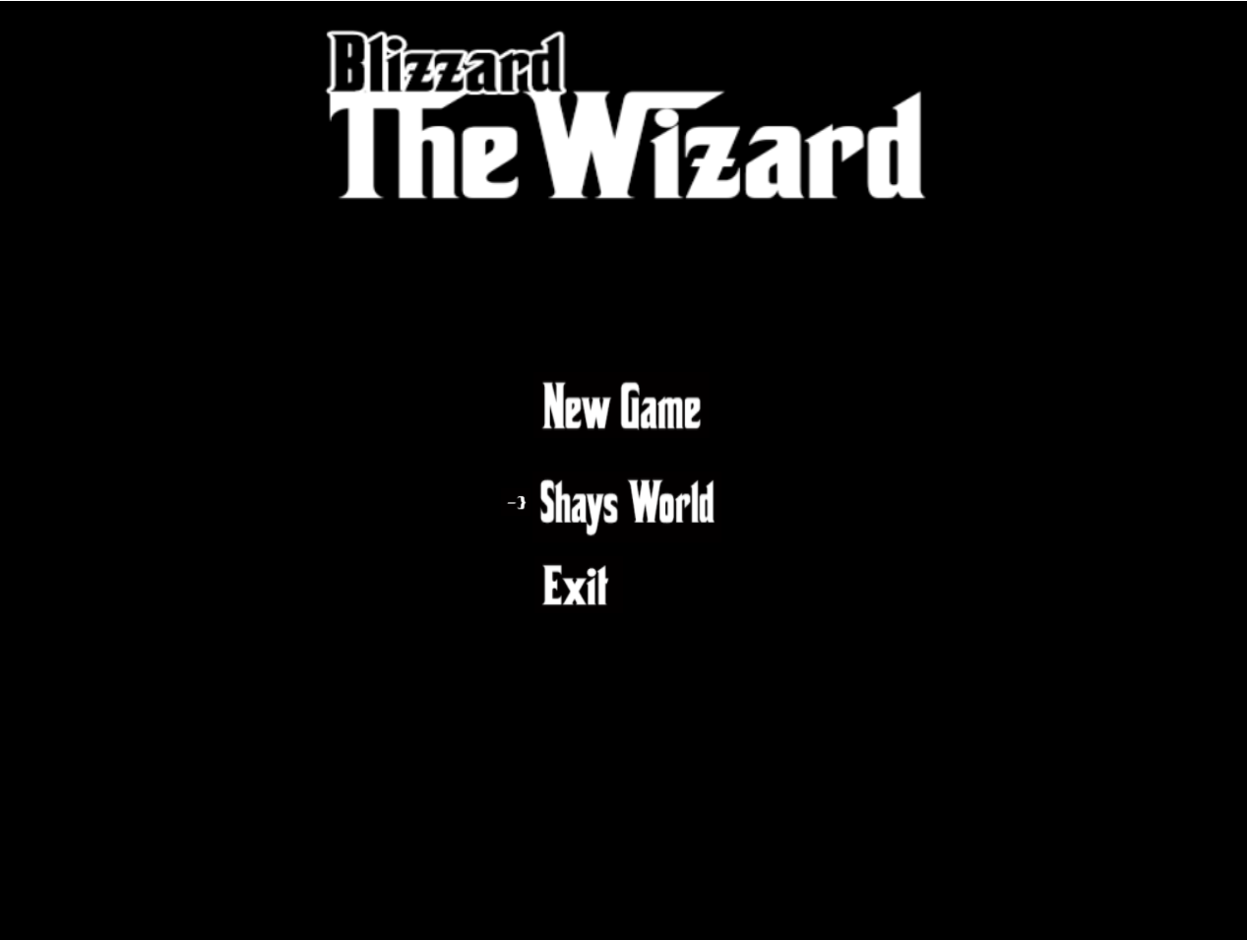

Start a new game of Blizzard the Wizard

Exit the program

View Shays World

After choosing **New Game** you will be launched into the world of Blizzard the Wizard.