Journal Entry #1 – Henry Manning

Steps for each source:

1. APA Style reference

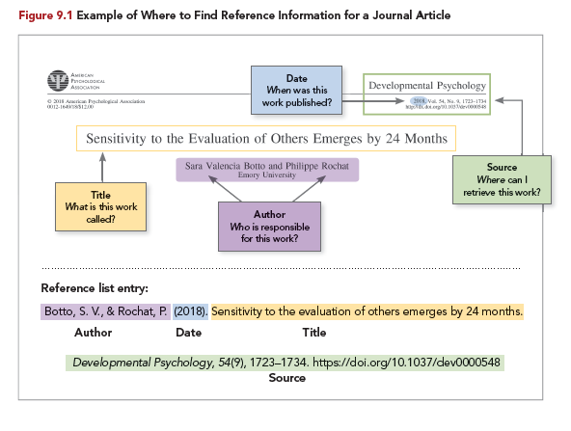

1. Search terms/location
2. Source assessment
   1. [Type of source](https://ohiostate.pressbooks.pub/choosingsources/chapter/categorizing-sources/)
   2. Authorship – describe who is responsible for the source
   3. Quality and Relevance – Comment on currency, comprehensiveness, or level of complexity, and purpose for the communication
3. Summary (about/less than 100 words)

# Source 1

Warker, M., (2021). Agents of Influence: How to Make Fighting Fake News Fun. *Connected Learning Alliance.* https://clalliance.org/blog/agents-of-influence-how-to-make-fighting-fake-news-fun/

This source was found through the reference materials listed on the subcategory page for `Digital Literacy and Digital Citizenship.`

The source is a blog post from the Connected Learning Alliance, written by a man who studied theatre and screenwriting. He wrote the article on behalf of a company, Alterea Inc., and thus may be biased towards that company or pursuing their interests in some way. As a company focused on improving digital literacy, it seems reasonable that they would be well-informed on the issues they are trying to solve and are likely experts in the field.

**Summary:** The article essentially provides a small amount of background relating to recent misinformation in the internet, especially regarding the COVID-19 pandemic. It then describes a strategy being applied by *Alterea Inc.* to combat misinformation using “Inoculation Theory.” It also applies a video game as a learning technique, following the idea of “mastery orientations” which say that true knowledge comes from a desire for learning and understanding, and not a letter grade or other external factor.

# Source 2

Yoo, H. J., (2021). Empowering Older Adults: Improving Senior Digital Literacy. ERIC, https://files.eric.ed.gov/fulltext/ED611612.pdf

This source was found by searching “Improving digital literacy for older individuals” in google. Near the top of the results was a pdf hosted by the US Department of Education.

This source is an ERIC database reference, written by a student at Auburn University. The author makes an acknowledgement at the end of their paper, thanking a co-instructor of a “Basic Digital Literacy” course for their support, so they seem to have had an authoritative voice guiding their writing.

**Summary:** The article begins with the problem statement, that older individuals face a number of unique challenges when they attempt to embrace their digital lives due to age-related changes. It’s important for them to be able to participate in the digital world for their independence, access to information, and connections with family and friends. Due to these age related challenges, the paper claims that older adults might need special support when learning to use mobile devices and other new technology. Makes use of STAM (Senior Technology Acceptance Model) adapted from TAM, which has the core elements of PU (Perceived Usefulness) and PEOU (Perceived Ease Of Use).

# Prompt Responses

What drew you to the category, topic, and issue that you chose to explore?

*As a computer science student, I am especially interested in the digital components of anything. So, obviously I would be interested in digital literacy and citizenship. Also, in recent years digital misinformation and disinformation have been very prominent, and it’s something I am very aware of in my own life, as well as the lives of my friends and relatives. I know my grandparents are especially vulnerable to this, and even though I try to help them when I see them, I wish they were well-equipped to critically evaluate digital media on their own.*

What is one thing you learned you didn’t know before? Did anything surprise you?

*One thing I learned was about the many things that prevent learning about technology for older adults. What stood out to me the most was that “self efficacy” is especially low for them. Because they feel unprepared or anxious about the new technology, even small mistakes can be more discouraging than they need to be, and this leads to low self efficacy in digital learning.*

What questions did these sources raise? What more do you want to learn about the topic or issue?

*Digital media affects* everyone*, young and old. Education is usually focused on younger people, and those already in schools, so what I want to know more about is how to drive engagement in learning about digital literacy and citizenship for older adults. It’s as or more important for them, but without classes easily accessible for learning, it can be easy to miss.*

What did you find challenging about this process?

*I didn’t find this to be all that challenging, though I guess the hardest is probably evaluating the quality of a source. Sometimes the useful information you’re looking for isn’t all within the source itself, so you need to look outside to evaluate an individual or group’s credibility.*