Journal Entry #2 – Henry Manning

Steps for each source:

1. APA Style reference

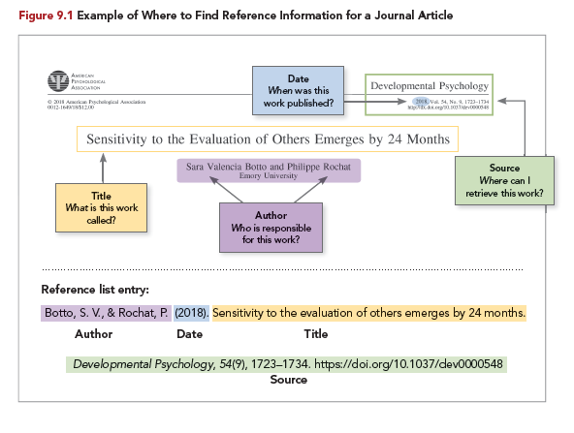

1. Search terms/location
2. Source assessment
   1. [Type of source](https://ohiostate.pressbooks.pub/choosingsources/chapter/categorizing-sources/)
   2. Authorship – describe who is responsible for the source
   3. Quality and Relevance – Comment on currency, comprehensiveness, or level of complexity, and purpose for the communication
3. Summary (about/less than 100 words)

# Source 1

Orazani, S. N., Reynolds, K. J., Osborne, H. (2023). What works and why in interventions to strengthen social cohesion: A systematic review. *Journal of Applied Social Psychology, https://doi.org/10.1111/jasp.12990*

Searched “Improve social cohesion and citizenship study” on Google.

This source is an academic journal, written by Orazani, a Psychology PhD, Reynolds, a Psychology professor, and I can’t find any results on Harry Osborne that aren’t about the Green Goblin so I can’t guarantee his credibility, but he likely is since he worked with these other professionals in the field of psychology. The source is high quality, with an in depth conversation about what social cohesion is and the effects it has on society.

**Summary:**

The journal begins with a short description of how social cohesion’s importance has been emphasized by the recent COVID-19 pandemic. The countries which “fared the best were ones where there was community connection, belonging, a volunteering ethos, and a belief in the legitimacy of official institutions, all deemed critical aspects of social cohesion.” The authors say that evidence from many countries indicates that despite its importance, this social fabric is at risk and requires constant investment to maintain and strengthen. This journal reviews a number of other studies which all have strong evidence pointing towards strategies which can effectively achieve these goals. The main conclusion’s drawn are that successful interventions implemented some of the recommendations from the G20 report, of which there are a number, including: “further support for facilitating people's participation in associations and community work,” “providing opportunities for citizens to get involved in the implementation of public goods,” “providing opportunities for citizens to get involved in the implementation of public goods,” “facilitating the opportunities for citizens' political engagement and improve the institutional reception to bottom-up initiatives,” and more things like this.

They make the assertion that although there was an amount of success, there are numerous ways to improve. For example, they claim that integrating social psychological theories like “social identity and self-categorizing theories, leadership, norms, and contact theory,” would lead to a significant advance. They also say, “there should be a greater focus on structural and leadership changes that lead to more cohesive societies rather than exclusively focusing on the manipulation or changing residents of communities or schools.”

# Source 2

Mackin P., (2022). How to Promote Citizen Engagement and Participation. *NLC.org, https://www.nlc.org/article/2022/09/12/how-to-promote-citizen-engagement-and-participation/*

Searched “improving civic engagement and participation” on Google.

This source is a blog article on NLC.org. It is written by Paul Mackin, the Vice President of eScribe Software Ltd.—a company focused on software for meeting management. He doesn’t seem to have much background in this field based on his professional life. The material is relevant and the quality is mostly good, though not as in depth as some other sources. The author is clearly biased when describing his software company’s product, but otherwise seems knowledgeable and well researched.

**Summary:**

The article begins with a short discussion of citizen engagement and participation and it’s different forms, noting that these different behaviors emerge from a sense of belonging to a community. Claiming that the more someone is aware of belonging to a community where everyone helps each other for the good of all, the more likely they are to be involved in civil society.

As ways to encourage more civic engagement, the article gives the advice that municipalities should showcase the work of exemplary citizens to provide recognition to those who are doing well, and encourage others to follow in their footsteps. Also, the author says that opportunities for community participation should be promoted and platformed by the local government. Finally, he tries to sell his software as a way to improve community engagement.

# Source 3

Everyday Activism Network, (2021 How To Increase Civic Engagement - What You Can Do To Be More Civically Engaged. *https://www.everydayactivismnetwork.org/archive/civic-engagement*

Searched “improving civic engagement and participation” on Google.

This source is a website from everydayactivismnetwork.org, a resource for activists. No specific author is listed, so the page was likely worked on by a number of people. It is highly relevant to the idea of civil engagement and participation, and the quality/depth of information is pretty strong. Unlike the other sources, this is more about instructions and advice for individuals to contribute and become more engaged citizens.

**Summary:**

Civic engagement and trust in the government have been waning in the United States for decades, the article says, and these are things which are crucial for a functioning democracy. But, the article prescribes a few ways to help with this. You should take part in the voting process. Vote, help others register, defend the right to vote, or become a poll worker. Stay informed and help others to be that way. Learn about how to spot fake news, fact check information, read the newspaper, and learn about other’s perspectives. Attend local meetings and events or join a local group. Volunteer or run for office. Promote civic education. All of these are ways to participate and be an engaged citizen.

# Prompt Responses

What drew you to this second category, topic, and issue that you chose to explore?

*I chose Civic Engagement and Participation for my second category because this is another area of citizenship I am just inherently interested in. I think these are important things thing encourage within civil society so I want to read about them.*

What is one thing you learned you didn’t know before? Did anything surprise you?

*I learned that people are becoming increasingly disengaged with politics. I think this is somewhat surprising to me because it runs in the opposite direction of my personal experiences. As I have grown to actually be an adult, I have become more interested in these things, so it feels natural that other people would be like me. But obviously that’s not always the case.*

What questions did these sources raise? What more do you want to learn about the topic or issue?

*I want to know more about specific things that can be done, especially in education (and civic education) to increase people’s awareness and participation in civics. It seems like a sense of belonging to community is also important. I’d like to know more about programs that improve this sense of belonging in communities, and also what has caused it to diminish. I would guess that social media has been a significant part of this.*

What did you find challenging about this process?

*I thought parsing through some of the first source I listed,* What works and why in interventions to strengthen social cohesion: A systematic review *was pretty difficult. I wasn’t able to read ALL of it, but I think I managed to get a good grasp of what it was talking about.*

At this point, which RFP category are you most interested in exploring further? What topics do you feel you are most likely interested in researching further for your individual problem definition project (the Lightning Talk)?

*I am most interested in the* Digital Literacy and Citizenship – Media Literacy *category. I think I connect with that the most.*