Business Description

1.1 the Benefits of implementing a database. Project Vision
I designed this database to handle a car-sharing service. The main goal was to track vehicles, users, and bookings efficiently without losing historical data like old prices. By enforcing 3NF, the database ensures we don't repeat information (like car brand names) and prevents anomalies. I used a historical table for pricing, so when prices change, we just add a new row with 'valid_from' and 'valid_to' dates instead of overwriting the old price. This allows the system to scale easily. I also added strict constraints like UNIQUE on emails and license plates to keep data clean as the platform grows.

2 Model description

2.1 Definitions & Acronyms
Booking: A specific instance of a user renting a car.
SCD: Slowly Changing Dimension (used for tracking price history).
PK/FK: Primary Key / Foreign Key.

2.2 Logical Scheme
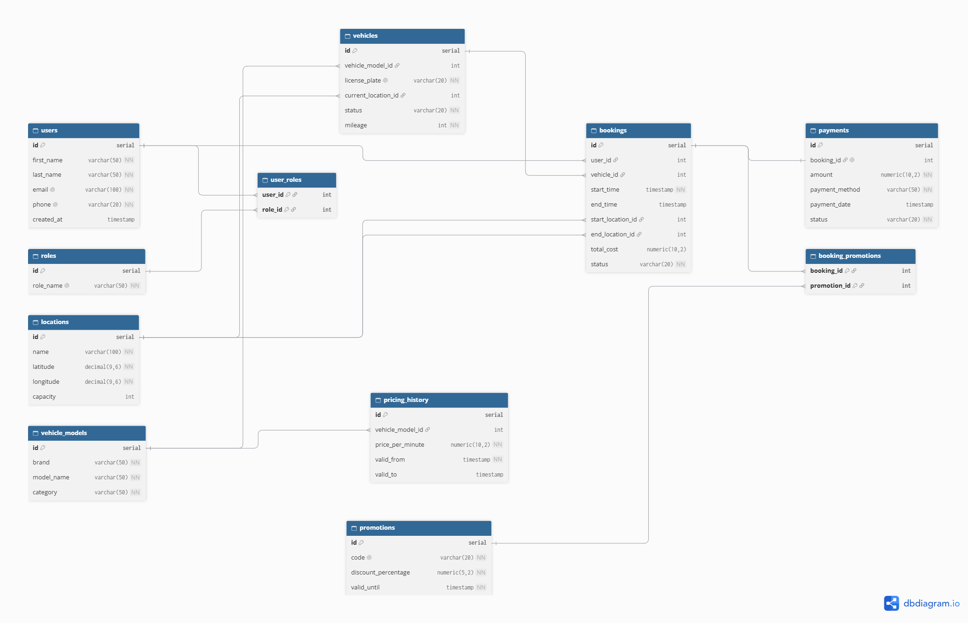
The most difficult modeling decision for me was handling the price changes. At first, I wanted to put the price in the vehicles table, but I realized that would mess up old booking receipts if the price changed in the future. Separating it into a pricing_history table solved this. To prevent anomalies, I used foreign keys everywhere to ensure you can't book a car that doesn't exist, and UNIQUE constraints on emails. If the business adds scooters or new vehicle types later, the model remains scalable because the 'vehicle_models' table can just accept a new category without breaking the bookings logic.

2.3 Objects

Table: users
Description: Represents the customers using the platform. Stored separately to manage personal details independently from their bookings.
Normalization: 3NF. Every attribute (name, phone) depends strictly on the user ID. There are no transitive dependencies.
Keys: I chose a surrogate PK (id) because emails might change. FKs are not needed here.
Field name | Field Description | Data Type
id | Primary key | Int
first_name | User first name | Varchar(50)
email | Unique email, UNIQUE | Varchar(100)
Example with data:
id | first_name | email
1 | Aram | aram@example.com
2 | Ani | ani@example.com

Table: vehicles
Description: Represents physical cars available for rent. Kept separate from models to avoid repeating model data for every single car.
Normalization: 3NF. Brand and category data were moved to vehicle_models to eliminate partial dependencies.
Keys: PK is id. FKs point to vehicle_models (to get brand info) and locations (for current parking spot).
Field name | Field Description | Data Type
id | Primary key | Int
vehicle_model_id | Points to model, FK | Int
license_plate | License plate, UNIQUE | Varchar(20)
Example with data:
id | vehicle_model_id | license_plate
1 | 5 | 35XX355
2 | 12 | 10OO010

Table: pricing_history
Description: Stores the cost per minute for different models over time.
Normalization: 3NF. Eliminates update anomalies by keeping a log of prices instead of a single overwritten field.
Keys: PK is id. FK points to vehicle_models.
Field name | Field Description | Data Type
id | Primary key | Int
vehicle_model_id | Points to model, FK | Int
price_per_minute | Cost | Numeric(10,2)
valid_from | Start date of price | Timestamp
Example with data:
id | vehicle_model_id | price_per_minute | valid_from
1 | 5 | 0.50 | 2025-01-01
2 | 5 | 0.60 | 2026-01-01

Table: bookings
Description: The core transaction when a user rents a car.
Normalization: 3NF. Connects users and vehicles. Cost and timestamps depend entirely on the booking ID.
Keys: PK is id. FKs point to users, vehicles, and locations.
Field name | Field Description | Data Type
id | Primary key | Int
user_id | The customer, FK | Int
vehicle_id | The car rented, FK | Int
start_time | Start of trip | Timestamp
Example with data:
id | user_id | vehicle_id | start_time
101 | 1 | 1 | 2026-10-25 10:00:00
102 | 2 | 2 | 2026-10-25 11:30:00

Note: The spelling, grammar, and formatting of this document were refined with the assistance of AI tools. However, the core ideas, database architecture, and design decisions presented here are entirely my own.

