**Corner Grocer Documentation**

**Author:** Hamna Khalid  
**Date:** June 18, 2025  
**Course:** CS 210

# **Project Overview:**

The Corner Grocer program is a C++ application designed to analyze grocery item sales data by reading item names from a text file, tracking how many times each item was purchased, and providing users with various ways to view this data. It was developed to support store layout decisions based on item popularity. The program features the ability to display item frequencies, search for specific items, and print a histogram using asterisks.

## **Code Structure:**

This program uses a class called *GroceryTracker*, which contains:

* A private map (*itemFrequency*) to store item names and their purchase counts.
* Public methods to load items from a file, return the frequency of a specific item, display all frequencies, and print a histogram.
* File input reads from **CS210_Project_Three_Input_File.txt**, and a backup frequency file (**frequency.dat**) is created at startup.

A menu-driven interface in *main()* allows the user to:

1. Search for the frequency of a specific item
2. Display all items with purchase frequencies
3. Print a text-based histogram
4. Exit the program

Input/output is handled using standard I/O streams (ifstream/ofstream), and maps are used for efficient lookups and frequency tracking.

## **Design Choices & Best Practices:**

* **The map** was chosen for its efficiency in tracking item counts.
* **In-line comments** were included throughout the code to describe each function and logic block.
* **Variable names** are clear and descriptive (e.g., *itemFrequency, item*, *choice*).
* Error checking was implemented for missing input files.

## **Screenshots:**

Below are the screenshots and explanation of the program and the stage it displays.

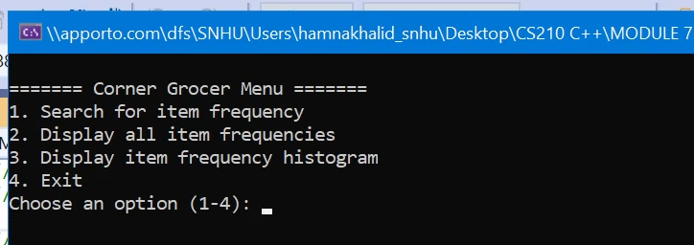

**Image 1:** Initial interface of the tracker.

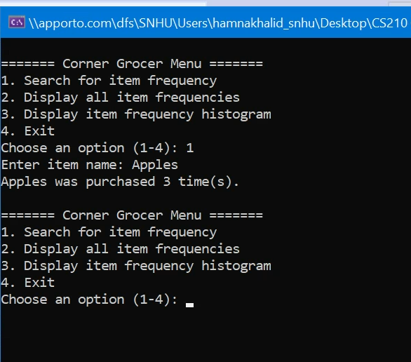

**Image 2:** Option 1 selection and results.

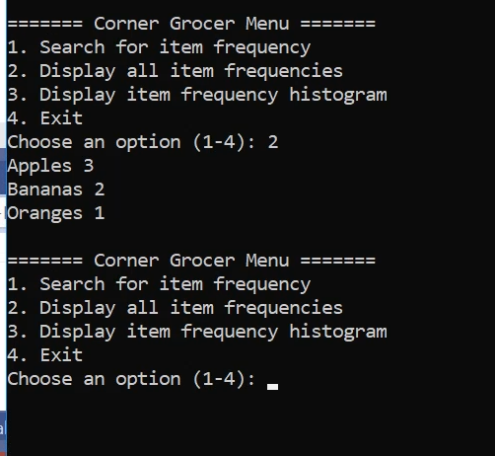

**Image 3:** Option 2 selection and results.

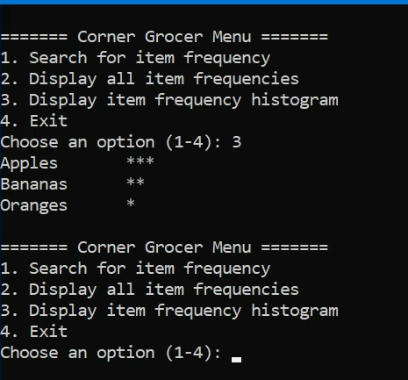

**Image 4:** Option 3 selection and results.

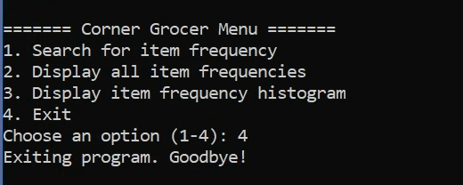

**Image 5:** Option 4 selection and results.

## **Sources:**

No external sources were used. All content is original and based on ZyBooks concepts.